Table of Contents

UNITED STATES

SECURITIES AND EXCHANGE COMMISSION

Washington, D.C. 20549

FORM 10-Q

(Mark One)

- QUARTERLY REPORT PURSUANT TO SECTION 13 OR 15(d) OF THE SECURITIES EXCHANGE ACT OF 1934

For the quarterly period ended September 30, 2023

OR

- TRANSITION REPORT PURSUANT TO SECTION 13 OR 15(d) OF THE SECURITIES EXCHANGE ACT OF 1934

For the transition period from _________ to _________

Commission file number 001-40103

AlTi Global, Inc.

(Exact name of registrant as specified in its charter)

Delaware

92-1552220

(State or other jurisdiction of incorporation or organization)

(I.R.S. Employer Identification No.)

520 Madison Avenue, 26th Floor New York, New York | 10022
(Address of Principal Executive Offices) | (Zip Code)
(212) 396-5904
(Registrant's telephone number, including area code)
Not Applicable

(Former name, former address and former fiscal year, if changed since last report)

Securities registered pursuant to Section 12(b) of the Act:

Title of each class | Trading Symbol(s) | Name of each exchange on which registered
Class A common stock, par value $0.0001 per share | ALTI | Nasdaq Capital Market

Indicate by check mark whether the registrant: (1) has filed all reports required to be filed by Section 13 or 15(d) of the Securities Exchange Act of 1934 during the preceding 12 months (or for such shorter period that the registrant was required to file such reports); and (2) has been subject to such filing requirements for the past 90 days. Yes ☒ No ☐

Indicate by check mark whether the registrant has submitted electronically every Interactive Data File required to be submitted pursuant to Rule 405 of Regulation S-T (§232.405 of this chapter) during the preceding 12 months (or for such shorter period that the registrant was required to submit such files). Yes ☒ No ☐

Indicate by check mark whether the registrant is a large accelerated filer, an accelerated filer, a non-accelerated filer, a smaller reporting company, or an emerging growth company. See the definitions of “large accelerated filer,” “accelerated filer,” “smaller reporting company” and “emerging growth company” in Rule 12b-2 of the Exchange Act.

Large accelerated filer | ☐ | Accelerated filer | ☐
Non-accelerated filer | ☒ | Smaller reporting company | ☒
 |  | Emerging growth company | ☒

If an emerging growth company, indicate by check mark if the registrant has elected not to use the extended transition period for complying with any new or revised financial accounting standards provided pursuant to Section 13(a) of the Exchange Act. ☐

Indicate by check mark whether the registrant is a shell company (as defined in Rule 12b-2 of the Act). Yes ☐ No ☒

The registrant had outstanding 64,770,908 shares of Class A Common Stock (as defined herein) and 53,219,713 shares of Class B Common Stock (as defined herein) as of November 14, 2023.

Table of Contents
Table of Contents
Part I Financial Information |  | 8
Item 1. Financial Statements (Unaudited) |  | 8
Condensed Consolidated Statement of Financial Position (Unaudited) |  | 8
Condensed Consolidated Statement of Operations (Unaudited) |  | 9
Condensed Consolidated Statement of Changes in Shareholders’ Equity (Unaudited) |  | 10
Condensed Consolidated Statement of Cash Flows (Unaudited) |  | 13
Notes to Condensed Consolidated Financial Statements (Unaudited) |  | 15
Item 2. Management’s Discussion and Analysis of Financial Condition and Results of Operations |  | 68
Item 3. Quantitative and Qualitative Disclosures about Market Risk |  | 87
Item 4. Controls and Procedures |  | 87
Part II Other Information |  | 89
Item 1. Legal Proceedings |  | 89
Item 1A. Risk Factors |  | 89
Item 2. Unregistered Sales of Equity Securities and Use of Proceeds |  | 89
Item 3. Defaults Upon Senior Securities |  | 89
Item 4. Mine Safety Disclosures |  | 89
Item 5. Other Information |  | 89
Item 6. Exhibits |  | 77
Signatures |  | 92
2

Table of Contents

Defined Terms

Capitalized terms used herein but not otherwise defined herein shall have the respective meanings ascribed to them in the Amended and Restated Business Combination Agreement, a copy of which is attached to our Annual Report on Form 10-K filed April 17, 2023 (the “Annual Report”).

- “Alvarium” means AlTi Asset Management Holdings 2 Limited, formerly known as Alvarium Investments Limited, an English private limited company.

- “Alvarium Contribution” means the contribution by Cartesian of all the issued and outstanding shares that it holds of AlTi Global Topco to Umbrella.

- “Alvarium Contribution Agreement” means the Contribution Agreement, dated as of January 3, 2023, by and among Cartesian and Umbrella.

- “Alvarium Exchange” means the exchange by each shareholder of AlTi Global Topco of his, her or its (a) ordinary shares of AlTi Global Topco and (b) class A shares of AlTi Global Topco for Class A Common Stock.

- “AlTi” or “Successor” means AlTi Global, Inc., together with its consolidated subsidiaries.

- “Alvarium Shareholders” means the shareholders of Alvarium.

- “Alvarium Tiedemann” means the Company, prior to being renamed “AlTi Global, Inc.”

- “AlTi Global Topco” means AlTi Global Topco Limited, formerly known as Alvarium Topco, an Isle of Man entity which was established by Alvarium and owned by the Alvarium Shareholders.

- “Asset Management” means the Segment that includes the Company's alternatives platform, public and private real estate and co-investment businesses.

- “AUA” means assets under advisement.

- “AUM” means assets under management.

- “Business Combination” means the transactions contemplated by the Business Combination Agreement.

- “Business Combination Agreement” means the Amended and Restated Business Combination Agreement, dated as of October 25, 2022, by and among Cartesian, Umbrella Merger Sub, TWMH, TIG GP, TIG MGMT, Alvarium and Umbrella.

- “Business Combination Earn-out” means the contingent additional equity consideration issued by the Company to the Sponsor and the Target Companies’ legacy equityholders.

- “Business Combination Earn-out Period” means the five years immediately after the Closing Date.

- “Business Combination Earn-out Securities” means the earn-out shares of Class A Common Stock in the Company and Class B Common Units that may be issued or become tradeable upon the achievement of certain stock price-based vesting conditions in accordance with the terms of the Business Combination Agreement.

- “Cartesian” means Cartesian Growth Corporation, a Cayman Islands exempted company, prior to the Business Combination.

- “Cayman Islands Companies Act” means the Cayman Islands Companies Act (as revised) of the Cayman Islands, as the same may be amended from time to time.

3

Table of Contents

- “Charter” means the certificate of incorporation of the Company.

- “Class A Common Stock” means the Class A Common Stock, par value $0.0001 per share, of the Company, including any shares of such Class A Common Stock issuable upon the exercise of any warrant or other right to acquire shares of such Class A Common Stock.

- “Class B Common Stock” means the Class B Common Stock, par value $0.0001 per share, of the Company, including any shares of such Class B Common Stock issuable upon the exercise of any warrant or other right to acquire shares of such Class B Common Stock.

- “Class B Units” means the limited liability company interests in Umbrella designated as Class B Common Units in the Umbrella LLC Agreement.

- “Closing” means the closing of the Business Combination.

- “Closing Date” means January 3, 2023, the date on which the Closing occurred.

- “Common Stock” refers to shares of the Class A Common Stock and the Class B Common Stock, collectively.

- “Company,” “our,” “we” or “us” means, prior to the Business Combination, Cartesian, as the context suggests, and, following the Business Combination, AlTi.

- “Condensed Consolidated Statement of Financial Position” refers to the consolidated balance sheet of AlTi Global, Inc.

- “Condensed Consolidated Statement of Operations” refers to the consolidated income statement of AlTi Global, Inc.

- “DGCL” refers to the Delaware General Corporation Law, as amended.

- “dollars” or “$” refers to U.S. dollars.

- “Domestication” means the continuation of Cartesian by way of domestication into a Delaware corporation, with the ordinary shares of Cartesian becoming shares of common stock of the Delaware corporation under the applicable provisions of the Cayman Islands Companies Act and the DGCL; the term includes all matters and necessary or ancillary changes in order to effect such Domestication, including the adoption of the Charter consistent with the DGCL and changing the name and registered office of Cartesian.

- “Employee Stock Purchase Plan” means the AlTi Global, Inc. 2023 Employee Stock Purchase Plan.

- “Equity Incentive Plan” means the AlTi Global, Inc. 2023 Stock Incentive Plan.

- “EU” means European Union.

- “Exchange Act” means the U.S. Securities Exchange Act of 1934, as amended.

- “External Strategic Managers” means global alternative asset managers with whom we partner by making strategic investments in which we actively participate in seeking to leverage the collective resources and synergies of the businesses to facilitate their growth.

- “Federal Reserve” means the Board of Governors of the Federal Reserve System.

- “FOS” means Family Office Service.

- “HNWI” means high net worth individual, being an individual having investable assets of $1 million or more, excluding primary residence, collectibles, consumables, and consumer durables.

4

Table of Contents

- “Holbein” means Holbein Partners, LLP.

- “Impact Investing” means investment practices seeking to generate various levels of financial performance together with the generation of positive measurable environmental and social impacts.

- “Managed Funds” means mutual funds, exchange traded funds, hedge funds, private equity, real estate or other funds.

- “Nasdaq” means The Nasdaq Capital Market.

- “NAV” means net asset value.

- “PIPE Investors” means the subscribers that agreed to purchase shares of Class A Common Stock at the Closing pursuant to the private placements, including without limitation, as reflected in the subscription agreements between Cartesian and each of the PIPE Investors.

- “SEC” means the United States Securities and Exchange Commission.

- “Segment” means collectively, or individually, how the Company manages its business including products and services.

- “Sponsor” means CGC Sponsor LLC, a Cayman Islands limited liability company.

- “Target Companies” means, collectively, TWMH, TIG GP, TIG MGMT, and Alvarium.

- “Tax Receivable Agreement” or “TRA” means that certain Tax Receivable Agreement, dated as of January 3, 2023, by and among the Company and the TWMH Members, the TIG GP Members, and the TIG MGMT Members.

- “TIG” means, collectively, the TIG Entities and their subsidiaries and their predecessor entities where applicable.

- “TIG Entities” means, collectively, TIG GP and TIG MGMT and their predecessor entities where applicable.

- “TIG GP” means TIG Trinity GP, LLC, a Delaware limited liability company.

- “TIG GP Members” means the former members of TIG GP.

- “TIG MGMT” means TIG Trinity Management, LLC, a Delaware limited liability company.

- “TIG MGMT Members” means the former members of TIG MGMT.

- “TIH” means Tiedemann International Holdings, AG.

- “TRA Exchange” means the series of transactions in which certain holders of Class B shares exchanged a portion of such Class B units to the Company, in exchange for Class A shares.

- “TRA Recipients” means the TWMH Members, the TIG GP Members and the TIG MGMT Members (including certain of our directors and officers) party to the Tax Receivable Agreement.

- “TWMH” means, collectively, Tiedemann Wealth Management Holdings, LLC, a Delaware limited liability company, and its subsidiaries, and their predecessor entities where applicable.

- “TWMH Members” means the former members of TWMH.

5

Table of Contents

- “Warrants” means the warrants, which were initially issued in Cartesian’s initial public offering of its units pursuant to its registration statement on Form S-1 declared effective by the SEC on February 23, 2021, entitling the holder thereof to purchase one of Cartesian’s Class A ordinary shares at an exercise price of $11.50, subject to adjustment.

- “Wealth Management” means the Segment that consists of the Company’s investment management and advisory services, trusts and administrative services, and family office services.

- “Umbrella” means AlTi Global Capital, LLC (formerly known as Alvarium Tiedemann Capital, LLC), a Delaware limited liability company.

- “Umbrella LLC Agreement” means the Third Amended and Restated Limited Liability Company Agreement of AlTi Global Capital, LLC, effective as of July 31, 2023.

- “Umbrella Merger Sub” means Rook MS, LLC, a Delaware limited liability company.

- “US GAAP” means United States generally accepted accounting principles, consistently applied.

6

Table of Contents

Available Information

We file annual, quarterly and current reports, proxy statements and other information required by the Exchange Act with the SEC. We make available free of charge on our website (www.alti-global.com) our annual reports on Form 10-K, quarterly reports on Form 10-Q, current reports on Form 8-K, proxy statements and other filings as soon as reasonably practicable after such material is electronically filed with or furnished to the SEC. We also use our website to distribute company information, including assets under management and performance information, and such information as may be deemed material. Accordingly, investors should monitor our website, in addition to our press releases, SEC filings and public conference calls and webcasts.

Also posted on our website in the “Investor Relations” section are the charters for our Audit, Finance and Risk Committee, Environmental, Social, Governance and Nominating Committee, and Human Capital and Compensation Committee, as well as our Corporate Governance Guidelines and Code of Business Conduct governing our directors, officers, and employees. Information on or accessible through our website is not a part of or incorporated into this Quarterly Report on Form 10-Q for the period ended September 30, 2023 (the “Quarterly Report”) or any other SEC filing. Copies of our SEC filings or corporate governance materials are available without charge upon written request to the Company at its principal place of business. Any materials we file with the SEC are also publicly available through the SEC’s website (www.sec.gov).

No statements herein, available on our website, or in any of the materials we file with the SEC constitute or should be viewed as constituting an offer to sell, or a solicitation of an offer to buy, securities in any jurisdiction.

Cautionary Note Regarding Forward-Looking Statements

This Quarterly Report contains forward-looking statements within the meaning of Section 27A of the Securities Act of 1933, as amended (the “Securities Act”), and Section 21E of the Exchange Act, which reflect our current views with respect to, among other things, future events, operations and financial performance. You can identify these forward-looking statements by the use of forward-looking words such as “outlook,” “believes,” “expects,” “potential,” “continues,” “may,” “will,” “should,” “seeks,” “approximately,” “predicts,” “projects,” “intends,” “plans,” “estimates,” “anticipates,” “target” or the negative version of those words, other comparable words or other statements that do not relate to historical or factual matters. The forward-looking statements are based on our beliefs, assumptions and expectations of our future performance, taking into account all information currently available to us. Such forward-looking statements are subject to various risks, uncertainties (some of which are beyond our control) or other assumptions relating to our operations, financial results, financial condition, business prospects, growth strategy and liquidity that may cause actual results or performance to be materially different from those expressed or implied by these forward-looking statements. Some of these factors are described under the headings “Part II. Item 1A. Risk Factors” and “Part 1. Item 2. Management’s Discussion and Analysis of Financial Condition and Results of Operations.” These factors should not be construed as exhaustive and should be read in conjunction with the risk factors and other cautionary statements that are included in this Quarterly Report and in our other periodic filings. If one or more of these or other risks or uncertainties materialize, or if our underlying assumptions prove to be incorrect, our actual results may vary materially from those indicated in these forward-looking statements. New risks and uncertainties arise over time, and it is not possible for us to predict those events or how they may affect us. Therefore, you should not place undue reliance on these forward-looking statements. Any forward-looking statement speaks only as of the date on which it is made. We do not undertake any obligation to publicly update or review any forward-looking statement, whether as a result of new information, future developments or otherwise, except as required by law.

7

Table of Contents

PART I – FINANCIAL INFORMATION

Item 1. Financial Statements (Unaudited)

AlTi Global, Inc.

Condensed Consolidated Statement of Financial Position (Unaudited)

(Prior to January 3, 2023, Tiedemann Wealth Management Holdings)

 |  | As of September 30, |  |  |  | As of December 31,
(Dollars in Thousands, except share data) |  | 2023 (Successor) |  |  |  | 2022 (Predecessor)
Assets
Cash and cash equivalents | $ | 12,196 |  |  | $ | 7,131
Fees receivable, net |  | 32,098 |  |  |  | 19,540
Other receivable, net |  | — |  |  |  | 5,167
Investments at fair value |  | 164,660 |  |  |  | 145
Equity method investments |  | 27,927 |  |  |  | 52
Intangible assets, net of accumulated amortization |  | 501,190 |  |  |  | 20,578
Goodwill |  | 409,432 |  |  |  | 25,464
Operating lease right-of-use assets |  | 28,184 |  |  |  | 10,095
Other assets |  | 47,192 |  |  |  | 3,817
Assets held for sale |  | 10,901 |  |  |  | —
Total assets | $ | 1,233,780 |  |  | $ | 91,989
Liabilities
Accounts payable and accrued expenses | $ | 36,914 |  |  | $ | 8,073
Accrued compensation and profit sharing |  | 20,056 |  |  |  | 15,660
Accrued member distributions payable |  | 8,049 |  |  |  | 11,422
Earn-out liability, at fair value |  | 45,549 |  |  |  | —
TRA liability |  | 18,042 |  |  |  | —
Delayed share purchase agreement |  | 1,818 |  |  |  | 1,818
Earn-in consideration payable |  | 1,708 |  |  |  | 1,519
Operating lease liabilities |  | 29,560 |  |  |  | 10,713
Debt, net of unamortized deferred financing cost |  | 172,804 |  |  |  | 21,187
Deferred tax liability, net |  | 25,812 |  |  |  | 82
Deferred income |  | 323 |  |  |  | —
Other liabilities |  | 25,207 |  |  |  | 3,662
Liabilities held for sale |  | 2,178 |  |  |  | —
Total liabilities | $ | 388,020 |  |  | $ | 74,136
Commitments and contingencies (Note 19)
Shareholders' Equity
Common stock, Class A, $0.0001 par value, 875,000,000 authorized 64,770,908 outstanding |  | 6 |  |  |  | 3
Common Stock, Class B, $0.0001 par value, 150,000,000 authorized 53,219,713 outstanding |  | — |  |  |  | 18,607
Additional paid-in capital |  | 519,996 |  |  |  | —
Retained earnings (accumulated deficit) |  | (141,965) |  |  |  | —
Accumulated other comprehensive income (loss) |  | 3,988 |  |  |  | (1,077)
Total AlTi Global, Inc. shareholders' equity |  | 382,025 |  |  |  | 17,533
Non-controlling interest in subsidiaries |  | 463,735 |  |  |  | 320
Total shareholders' equity |  | 845,760 |  |  |  | 17,853
Total liabilities and shareholders' equity | $ | 1,233,780 |  |  | $ | 91,989

The accompanying notes are an integral part of these condensed unaudited financial statements.

8

Table of Contents

AlTi Global, Inc.

Condensed Consolidated Statement of Operations (Unaudited)
(Prior to January 3, 2023, Tiedemann Wealth Management Holdings)

 |  | For the Period |  |  |  |  |  |  | For the Period
 | July 1, 2023 – September 30, |  |  |  | July 1, 2022 – September 30, |  |  | January 3, 2023 – September |  |  |  |  | January 1, 2022 – September
 |  |  |  |  |  |  |  |  | 30, |  |  |  | 30,
(Dollars in Thousands) |  | 2023 (Successor) |  |  |  | 2022 (Predecessor) |  |  | 2023 (Successor) |  |  |  | 2022 (Predecessor)
Revenue
Management/advisory fees | $ | 45,062 |  |  | $ | 18,583 |  | $ | 138,972 |  |  | $ | 57,445
Incentive fees |  | 885 |  |  |  | — |  |  | 1,931 |  |  |  | —
Distributions from investments |  | 2,596 |  |  |  | — |  |  | 14,829 |  |  |  | —
Other income/fees |  | 701 |  |  |  | — |  |  | 3,440 |  |  |  | —
Total income |  | 49,244 |  |  |  | 18,583 |  |  | 159,172 |  |  |  | 57,445
Operating Expenses
Compensation and employee benefits |  | 38,585 |  |  |  | 12,048 |  |  | 134,393 |  |  |  | 37,468
Systems, technology and telephone |  | 3,812 |  |  |  | 1,719 |  |  | 11,751 |  |  |  | 4,577
Sales, distribution and marketing |  | 658 |  |  |  | 241 |  |  | 1,752 |  |  |  | 678
Occupancy costs |  | 3,223 |  |  |  | 1,295 |  |  | 9,755 |  |  |  | 3,399
Professional fees |  | 14,398 |  |  |  | 2,397 |  |  | 52,741 |  |  |  | 5,480
Travel and entertainment |  | 1,082 |  |  |  | 297 |  |  | 4,334 |  |  |  | 1,134
Depreciation and amortization |  | 3,676 |  |  |  | 583 |  |  | 11,848 |  |  |  | 1,790
General, administrative and other |  | 7,455 |  |  |  | 381 |  |  | 11,426 |  |  |  | 1,044
Total operating expenses |  | 72,889 |  |  |  | 18,961 |  |  | 238,000 |  |  |  | 55,570
Total operating income (loss) |  | (23,645) |  |  |  | (378) |  |  | (78,828) |  |  |  | 1,875
Other Income (Expenses)
Impairment loss on goodwill and intangible assets |  | (153,589) |  |  |  | — |  |  | (182,982) |  |  |  | —
Loss on investments |  | (1,959) |  |  |  | (45) |  |  | (3,663) |  |  |  | (20)
Gain (loss) on TRA |  | 761 |  |  |  | — |  |  | (1,331) |  |  |  | —
Loss on warrant liability |  | — |  |  |  | — |  |  | (12,866) |  |  |  | —
Gain on earnout liability |  | 9,335 |  |  |  | — |  |  | 46,212 |  |  |  | —
Interest expense |  | (3,668) |  |  |  | (131) |  |  | (10,300) |  |  |  | (310)
Other expenses |  | (91) |  |  |  | (60) |  |  | (738) |  |  |  | (58)
Income (loss) before taxes |  | (172,856) |  |  |  | (614) |  |  | (244,496) |  |  |  | 1,487
Income tax (expense) benefit |  | 1,782 |  |  |  | (82) |  |  | 12,578 |  |  |  | (385)
Net income (loss) |  | (171,074) |  |  |  | (696) |  |  | (231,918) |  |  |  | 1,102
Net loss attributed to non-controlling interests in subsidiaries |  | (82,353) |  |  |  | (22) |  |  | (117,899) |  |  |  | (87)
Net income (loss) attributable to AlTi Global, Inc. | $ | (88,721) |  |  | $ | (674) |  | $ | (114,019) |  |  | $ | 1,189
Other Comprehensive Income (Loss)
Foreign currency translation adjustments |  | (10,035) |  |  |  | (519) |  |  | 7,873 |  |  |  | (1,481)
Other comprehensive income (loss) |  | 72 |  |  |  | — |  |  | (610) |  |  |  | —
Total comprehensive loss |  | (181,037) |  |  |  | (1,215) |  |  | (224,655) |  |  |  | (379)
Other loss attributed to non-controlling interests in subsidiaries |  | (87,124) |  |  |  | (22) |  |  | (114,625) |  |  |  | (87)
Comprehensive loss attributable to AlTi Global, Inc. |  | (93,913) |  |  |  | (1,193) |  |  | (110,030) |  |  |  | (292)
Net Income (Loss) Per Share
Basic | $ | (1.40) |  |  | $ | (96.19) |  | $ | (1.89) |  |  | $ | 169.69
Diluted | $ | (1.40) |  |  | $ | (96.19) |  | $ | (1.89) |  |  | $ | 169.69
Weighted Average Shares of Class A Common Stock Outstanding
Basic |  | 63,568,646 |  |  |  | 7,007 |  |  | 60,174,678 |  |  |  | 7,007
Diluted |  | 63,568,646 |  |  |  | 7,007 |  |  | 60,174,678 |  |  |  | 7,007

The accompanying notes are an integral part of these condensed unaudited financial statements.

9

Table of Contents

AlTi Global, Inc.

Condensed Consolidated Statement of Changes in Shareholders’ Equity (Unaudited)
(Prior to January 3, 2023, Tiedemann Wealth Management Holdings)

 |  |  |  |  |  |  |  |  |  |  |  |  |  |  | Retained
 |  |  |  |  |  |  |  |  |  |  |  |  |  |  | earnings |  | Accumulated other |  |  | Non-controlling |  |  |  | Total
(Dollars in Thousands, except share |  |  |  |  |  |  |  |  |  |  | Additional paid- |  |  |  | (accumulated |  |  | comprehensive |  |  | interest in |  |  | Shareholders'
data) | Class A Common Stock |  |  |  |  | Class B Common Stock |  |  |  |  |  | in-capital |  |  | deficit) |  |  | income |  |  | subsidiaries |  |  | Equity
 | Shares |  |  | Amount |  | Shares |  | Amount
Balance at June 30, 2023 (Successor) | 62,957,671 |  | $ | 6 |  | 55,032,961 |  | $ | — |  | $ | 515,000 |  | $ | (53,244) |  | $ | 9,182 |  | $ | 550,857 |  | $ | 1,021,801
Net income (loss) | — |  |  | — |  | — |  |  | — |  |  | — |  |  | (88,721) |  |  | — |  |  | (82,353) |  |  | (171,074)
Currency translation adjustment | — |  |  | — |  | — |  |  | — |  |  | — |  |  | — |  |  | (5,223) |  |  | (4,812) |  |  | (10,035)
Other comprehensive income | — |  |  | — |  | — |  |  | — |  |  | — |  |  | — |  |  | 29 |  |  | 43 |  |  | 72
Share based compensation | — |  |  | — |  | — |  |  | — |  |  | 2,964 |  |  | — |  |  | — |  |  | — |  |  | 2,964
Issuance of shares for business
combination | — |  |  | — |  | — |  |  | — |  |  | 1,377 |  |  | — |  |  | — |  |  | — |  |  | 1,377
TRA Exchange | — — |  |  | — |  | — — |  |  | — |  |  | 655 |  |  | — |  |  | — |  |  | — |  |  | 655
Conversion of Class B shares | 1,813,248 |  |  | — |  | (1,813,248) |  |  | — |  |  | — |  |  | — |  |  | — |  |  | — |  |  | —
Issuance of shares - exercise of
warrants | (11) |  |  | — |  | — |  |  | — |  |  | — |  |  | — |  |  | — |  |  | — |  |  | —
Balance at September 30, 2023 | 64,770,908 |  | $ | 6 |  | 53,219,713 |  | $ | — |  | $ | 519,996 |  | $ | (141,965) |  | $ | 3,988 |  | $ | 463,735 |  | $ | 845,760
(Successor) | 64,770,908 |  | $ | 6 |  | 53,219,713 |  |  |  |  |  |  |  | $ | (141,965) |  | $ | 3,988 |  | $ | 463,735 |  | $ | 845,760

10

Table of Contents

AlTi Global, Inc.

Condensed Consolidated Statement of Changes in Shareholders’ Equity (Unaudited)
(Prior to January 3, 2023, Tiedemann Wealth Management Holdings)

 |  |  |  |  |  |  |  |  |  |  |  |  |  |  | Retained
 |  |  |  |  |  |  |  |  |  |  |  |  |  |  | earnings |  | Accumulated other |  |  | Non-controlling |  |  |  | Total
(Dollars in Thousands, except share |  |  |  |  |  |  |  |  |  |  | Additional paid- |  |  |  | (accumulated |  |  | comprehensive |  |  | interest in |  |  | Shareholders'
data) | Class A Common Stock |  |  |  |  | Class B Common Stock |  |  |  |  |  | in-capital |  |  | deficit) |  |  | income |  |  | subsidiaries |  |  | Equity
 | Shares |  |  | Amount |  | Shares |  | Amount
Balance at January 3, 2023
(Successor) | 55,388,023 |  | $ | 6 |  | 55,032,961 |  | $ | — |  | $ | 434,620 |  | $ | (27,946) |  | $ | — |  | $ | 606,973 |  | $ | 1,013,653
Issuance of shares to Alvarium
Employee Benefit Trust | 2,100,000 |  |  | — |  | — |  |  | — |  |  | 21,000 |  |  | — |  |  | — |  |  | — |  |  | 21,000
Net income (loss) | — |  |  | — |  | — |  |  | — |  |  | — |  |  | (114,019) |  |  | — |  |  | (117,899) |  |  | (231,918)
Currency translation adjustment | — |  |  | — |  | — |  |  | — |  |  | — |  |  | — |  |  | 4,323 |  |  | 3,550 |  |  | 7,873
Cancellation of AHRA call option | — |  |  | — |  | — |  |  | — |  |  | — |  |  | — |  |  | — |  |  | 154 |  |  | 154
Other comprehensive income | — |  |  | — |  | — |  |  | — |  |  | — |  |  | — |  |  | (335) |  |  | (275) |  |  | (610)
Payment for partner’s tax | — |  |  | — |  | — |  |  | — |  |  | (998) |  |  | — |  |  | — |  |  | — |  |  | (998)
AHRA deconsolidation | — |  |  | — |  | — |  |  | — |  |  | 28,768 |  |  | — |  |  | — |  |  | (28,768) |  |  | —
Share based compensation | — |  |  | — |  | — |  |  | — |  |  | 5,095 |  |  | — |  |  | — |  |  | — |  |  | 5,095
Issuance of shares for business
combination | — |  |  | — |  | — |  |  | — |  |  | 1,377 |  |  | — |  |  | — |  |  | — |  |  | 1,377
TRA Exchange | — — |  |  | — |  | — — |  |  | — |  |  | 655 |  |  | — |  |  | — |  |  | — |  |  | 655
Conversion of Class B shares | 1,813,248 |  |  | — |  | (1,813,248) |  |  | — |  |  | — |  |  | — |  |  | — |  |  | — |  |  | —
Issuance of shares - exercise of
warrants | 5,469,637 |  |  | — |  | — |  |  | — |  |  | 29,479 |  |  | — |  |  | — |  |  | — |  |  | 29,479
Balance at September 30, 2023 | 64,770,908 |  | $ | 6 |  | 53,219,713 |  | $ | — |  | $ | 519,996 |  | $ | (141,965) |  | $ | 3,988 |  | $ | 463,735 |  | $ | 845,760
(Successor) | 64,770,908 |  | $ | 6 |  | 53,219,713 |  |  |  |  |  |  |  | $ | (141,965) |  | $ | 3,988 |  | $ | 463,735 |  | $ | 845,760

The accompanying notes are an integral part of these condensed unaudited financial statements.

11

Table of Contents

AlTi Global, Inc.

Condensed Consolidated Statement of Changes in Shareholders’ Equity (Unaudited)
(Prior to January 3, 2023, Tiedemann Wealth Management Holdings)

 |  |  |  |  |  |  |  |  |  | Accumulated other
 |  |  |  |  |  |  |  | Total Members' |  |  | comprehensive |  |  | Non-controlling
(Dollars in Thousands, except share data) |  | Class A |  |  | Class B |  |  | Capital |  |  | income (loss) |  |  | interest |  |  | Total Equity
Balance at June 30, 2022 (Predecessor) | $ | 4 |  | $ | 33,201 |  | $ | 33,205 |  | $ | (962) |  | $ | 368 |  | $ | 32,611
Member capital distributions |  | — |  |  | (2,000) |  |  | (2,000) |  |  | — |  |  | — |  |  | (2,000)
Member tax distributions |  | — |  |  | (1,215) |  |  | (1,215) |  |  | — |  |  | — |  |  | (1,215)
Reallocation of book capital as a result of member
transactions |  | — |  |  | 591 |  |  | 591 |  |  | — |  |  | — |  |  | 591
Net income (loss) for the period |  | — |  |  | (674) |  |  | (674) |  |  | — |  |  | (22) |  |  | (696)
Other comprehensive income (loss) for the period |  | — |  |  | — |  |  | — |  |  | (519) |  |  | — |  |  | (519)
Balance at September 30, 2022 (Predecessor) | $ | 4 |  | $ | 29,903 |  | $ | 29,907 |  | $ | (1,481) |  | $ | 346 |  | $ | 28,772

 |  |  |  |  |  |  |  |  |  | Accumulated other
 |  |  |  |  |  |  |  | Total Members' |  |  | comprehensive |  |  | Non-controlling
(Dollars in Thousands, except share data) |  | Class A |  |  | Class B |  |  | Capital |  |  | income (loss) |  |  | interest |  |  | Total Equity
Balance at January 1, 2022 | $ | 6 |  | $ | 39,582 |  | $ | 39,588 |  | $ | — |  | $ | 433 |  | $ | 40,021
Member capital distributions |  | (1) |  |  | (6,299) |  |  | (6,300) |  |  | — |  |  | — |  |  | (6,300)
Member tax distributions |  | (1) |  |  | (6,343) |  |  | (6,344) |  |  | — |  |  | — |  |  | (6,344)
Reallocation of book capital as a result of member
transactions |  | — |  |  | 1,774 |  |  | 1,774 |  |  | — |  |  | — |  |  | 1,774
Net income (loss) for the period |  | — |  |  | 1,189 |  |  | 1,189 |  |  | — |  |  | (87) |  |  | 1,102
Other comprehensive income (loss) for the period |  | — |  |  | — |  |  | — |  |  | (1,481) |  |  | — |  |  | (1,481)
Balance at September 30, 2022 (Predecessor) | $ | 4 |  | $ | 29,903 |  | $ | 29,907 |  | $ | (1,481) |  | $ | 346 |  | $ | 28,772

The accompanying notes are an integral part of these condensed unaudited financial statements.

12

Table of Contents

AlTi Global, Inc.

Condensed Consolidated Statement of Cash Flows (Unaudited)
(Prior to January 3, 2023, Tiedemann Wealth Management Holdings)

 |  | For the Period
 |  | January 3, 2023 – September |  |  |  | January 1, 2022 – September
 |  | 30, 2023 |  |  |  | 30, 2022
(Dollars in Thousands) |  | (Successor) |  |  |  | (Predecessor)
Cash Flows from Operating Activities
Net income (loss) | $ | (231,918) |  |  | $ | 1,102
Adjustments to reconcile net income (loss) to net cash provided by (used in) operating activities:
Depreciation and amortization |  | 11,848 |  |  |  | 1,790
Amortization of debt discounts and deferred financing costs |  | (4,106) |  |  |  | —
Unrealized (gain) loss on investments |  | 3,275 |  |  |  | 108
Impairment loss on goodwill and intangible assets |  | 182,982 |  |  |  | —
Gain (loss) on TRA |  | 1,331 |  |  |  | —
Gain (loss) on Earn-in |  | — |  |  |  | (121)
(Income) loss on equity method investments |  | 2,439 |  |  |  | (32)
Restricted unit compensation |  | — |  |  |  | 1,774
Fair value of warrant liability |  | 12,866 |  |  |  | —
Fair value of earn-out liability |  | (46,212) |  |  |  | —
Deferred income tax (benefit) expense |  | (16,146) |  |  |  | (82)
Equity-settled share-based payments |  | 35,090 |  |  |  | —
Unrealized foreign currency (gains)/losses |  | 444 |  |  |  | —
(Gain) loss from retirement of debt |  | (73) |  |  |  | —
Forgiveness of debt shareholder loan |  | — |  |  |  | 619
Forgiveness of debt of notes receivable from members |  | 196 |  |  |  | 205
Fair value of interest rate swap |  | 33 |  |  |  | (299)
Cash flows due to changes in operating assets and liabilities
Fees receivable |  | 7,132 |  |  |  | 2,318
Other assets |  | (4,110) |  |  |  | (3,064)
Operating cash flow from operating leases |  | 838 |  |  |  | 631
Accounts payable and accrued expenses |  | (17,654) |  |  |  | 1,521
Accrued compensation and profit sharing |  | (4,288) |  |  |  | (3,628)
Other liabilities |  | (14,718) |  |  |  | 364
Other operating activities |  | (250) |  |  |  | —
Net cash provided by (used in) operating activities |  | (81,001) |  |  |  | 3,206

(Continued on the following page)

13

Table of Contents

AlTi Global, Inc.

Condensed Consolidated Statement of Cash Flows (Unaudited)
(Prior to January 3, 2023, Tiedemann Wealth Management Holdings)

(Continued from the previous page) |  | For the Period
 | January 3, 2023 – September |  |  |  |  | January 1, 2022 – September
 | 30, 2023 |  |  |  |  | 30, 2022
(Dollars in Thousands) | (Successor) |  |  |  |  | (Predecessor)
Cash Flows from Investing Activities
Cash acquired from consolidation of variable interest entity |  | — |  |  |  | 471
Cash payment for acquisition of TWMH and TIG historical equity |  | (99,999) |  |  |  | —
Receipt of payments of notes receivable from members |  | 226 |  |  |  | 345
Loans to members |  | — |  |  |  | (301)
Cash receipts from the repayment of advances and loans |  | 305 |  |  |  | —
Purchases of investments |  | (15,499) |  |  |  | (184)
Distributions from investments |  | — |  |  |  | 4
Purchase of TIH shares |  | — |  |  |  | (382)
Purchase of Holbein |  | — |  |  |  | (8,097)
Payment of Payout Right |  | (760) |  |  |  | —
Acquisition of AIMS, net of cash acquired |  | (3,783) |  |  |  | —
Acquisition of AL Wealth Partners, net of cash acquired |  | (14,430) |  |  |  | —
Sales of investments |  | 1,818 |  |  |  | 922
Sale of fixed assets |  | 8 |  |  |  | —
Purchases of fixed assets |  | (269) |  |  |  | (55)
Net cash provided by (used in) investing activities |  | (132,383) |  |  |  | (7,277)
Cash Flows from Financing Activities
Member contribution (distribution) |  | (8,494) |  |  |  | (9,644)
Payments on term notes and lines of credit |  | (155,489) |  |  |  | (2,170)
Borrowings on term notes and lines of credit |  | 206,660 |  |  |  | 12,300
Increase (decrease) in distributions due to former TIG members |  | (13,419) |  |  |  | —
Cash payment for purchase of shares to be transferred as part of Alvarium share compensation |  | (4,215) |  |  |  | —
Cash receipts from exercise of Warrants |  | 5,836 |  |  |  | —
Net cash provided by (used in) financing activities |  | 30,879 |  |  |  | 486
Effect of exchange rate changes on cash |  | 2,782 |  |  |  | 22
Net increase (decrease) in cash |  | (179,723) |  |  |  | (3,563)
Cash and cash equivalents at beginning of the period |  | 194,086 |  |  |  | 8,040
Cash and cash equivalents at end of the period | $ | 14,363 |  | $ |  | 4,477
Reconciliation of balance sheet cash and cash equivalents to cash flows:
Cash and cash equivalents on balance sheet | $ | 12,196 |  | $ |  | 4,477
Cash and cash equivalents included in Assets held for sale (Note 3) |  | 2,167 |  | $ |  | —
Cash and cash equivalents, including cash in Assets held for sale | $ | 14,363 |  | $ |  | 4,477
Supplemental Disclosure of Cash Flow Information
Cash Paid During the Period for:
Income taxes |  | 797 |  | $ |  | 514
Interest payments on term notes and lines of credit |  | 10,145 |  |  |  | 370

The accompanying notes are an integral part of these condensed unaudited financial statements.

14

AlTi Global, Inc.
Notes to Condensed Consolidated Financial Statements (Unaudited)
(Prior to January 3, 2023, Tiedemann Wealth Management Holdings)

- Description of the Business

AlTi Global, Inc. is a multi-disciplinary financial services business, with a diverse array of investment, advisory, and administrative capabilities. The Company is a global organization that manages or advises approximately $68.2 billion in combined assets as of September 30, 2023. The Company provides holistic solutions for Wealth Management clients through a full spectrum of Wealth Management services, including discretionary investment management services, non-discretionary investment advisory services, trust services, administration services, and family office services. It also structures, arranges, and provides a network of investors with co-investment opportunities in a variety of alternative assets which are either managed intra-group or by carefully selected managers in the relevant asset class. The Company manages and advises both public and private investment funds.

Amounts disclosed throughout this document for the three and nine month period ended September 30, 2023, relate to AlTi Global, Inc, the Successor company in the business combination. Amounts disclosed throughout this document for the three and nine month period ended September 30, 2022 relate to TWMH, the predecessor company. Due to the Business Combination and the conforming of significant accounting policies, the results of operations, cash flows, and other financial information for the Successor Period are not comparable to the Predecessor periods.

Business Combination

The Registrant was initially incorporated in the Cayman Islands as Cartesian Growth Capital, a special purpose acquisition company. In anticipation of the Business Combination:

- The holders of the equity of the TIG Entities contributed their TWMH and TIG equity to Umbrella making TWMH and the TIG wholly owned subsidiaries of Umbrella.

- Alvarium reorganized such that it became the wholly owned indirect subsidiary of AlTi Global Topco.

- Cartesian SPAC formed Umbrella Merger Sub.

Pursuant to the Business Combination on January 3, 2023:

- The Registrant was redomiciled as a Delaware corporation and changed its name to Alvarium Tiedemann Holdings, Inc. Effective April 19, 2023, Alvarium Tiedemann Holdings, Inc. changed its name to AlTi Global, Inc.

- The Registrant acquired all the outstanding share capital of AlTi Global Topco.

- Umbrella Merger Sub, LLC merged into Umbrella with AlTi Global Capital, LLC, formerly known as Alvarium Tiedemann Capital, LLC as the surviving entity.

- The Company acquired 51% of the equity interests of Umbrella, while the existing TWMH and TIG rollover shareholders hold a 49% economic interest in Umbrella. Umbrella holds 100% of the equity interests of TWMH, TIG, and Alvarium.

15

AlTi Global, Inc.
Notes to Condensed Consolidated Financial Statements (Unaudited)
(Prior to January 3, 2023, Tiedemann Wealth Management Holdings)

- Through a series of intercompany transactions, AlTi was restructured to reflect the final structure depicted below:
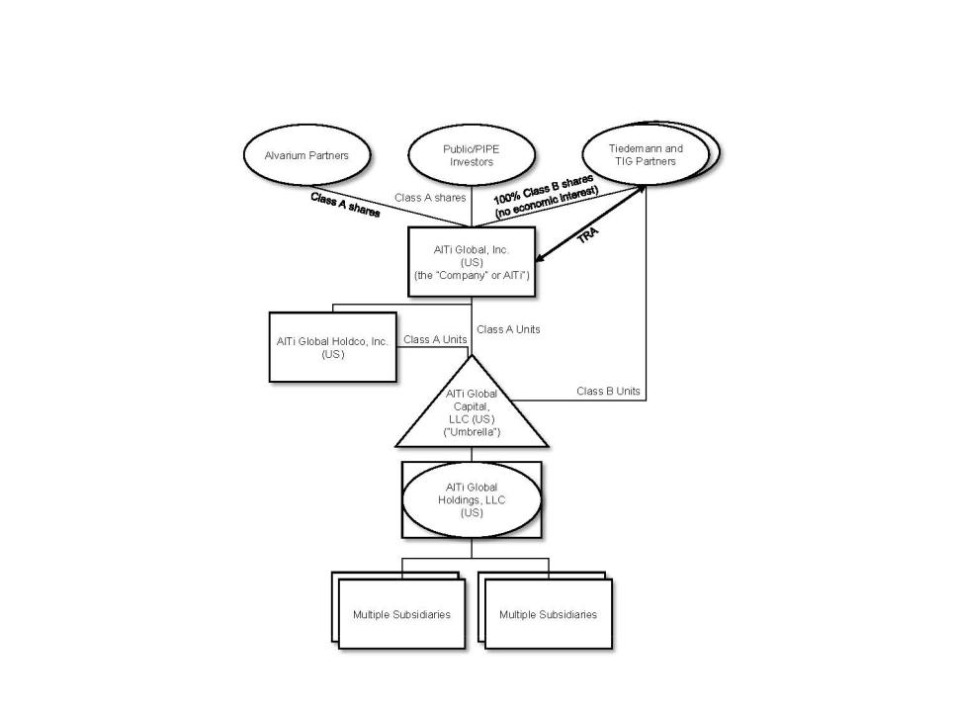

Capital Structure

The Registrant has the following classes of shares and other instruments outstanding:

- Class A Common Stock – Shares of Class A Common Stock that are publicly traded. Class A shareholders are entitled to declared dividends from shares of Class A Common Stock. As of September 30, 2023, the shares of Class A Common Stock represent 55% of the total voting power of all shares.

- Class B Common Stock – Shares of Class B Common Stock that are not publicly traded. Class B shareholders are entitled to distributions declared by the Company’s board of directors. The distributions are paid by Umbrella. As of September 30, 2023, the shares of Class B Common Stock represent 45% of the total voting power of all shares.

- Prior to the Business Combination, the Company issued warrants to purchase shares of Class A Common Stock at a price of $11.50 per share. Throughout the period from January 3, 2023 to March 31, 2023, 428,626 Warrants were exercised. On April 3, 2023, 78,864 Warrants were exercised. On June 7, 2023, the Company closed an offer and consent solicitation and entered into a warrant amendment, pursuant to which the remaining 19,892,387 Warrants were exchanged for 4,864,275

16

AlTi Global, Inc.
Notes to Condensed Consolidated Financial Statements (Unaudited)
(Prior to January 3, 2023, Tiedemann Wealth Management Holdings)

shares of Class A Common Stock. The exercises and exchanges throughout the period from January 3, 2023 to June 30, 2023 resulted in an increase in Additional Paid-in-Capital amount of $29.5 million. Following the exchanges, none of the Warrants were outstanding as of September 30, 2023.

The following table presents the number of shares of the Registrant that were outstanding as of September 30, 2023:

 | As of September 30,
 | 2023 (Successor)
Class A Common Stock | 64,770,908
Class B Common Stock | 53,219,713

Segments

Our business is organized into two operating segments: Wealth Management and Asset Management. Described below are the segments and the revenue generated by each, which

broadly fall into three categories: recurring management, advisory, or administration fees; performance or incentive fees; and transaction fees.

Wealth Management

Within our Wealth Management segment, services provided principally consist of investment management and advisory services, trusts and administrative services, and family office services. The Wealth Management client base includes high net worth individuals, families, single family offices, foundations, and endowments globally. Investment management or advisory fees are the primary source of revenue in our Wealth Management segment. These fees are generally calculated based on a percentage of the value of each client’s billable AUM or AUA (as applicable). As of September 30, 2023, this segment had $48.5 billion in AUM/AUA.

Investment Management and Advisory Services

In our investment management and advisory services teams, we diversify our clients’ portfolios across risk factors, geographies, traditional asset classes such as money markets, equities and fixed income, and alternative asset classes including private equity, private debt, hedge funds, real estate, and other assets through highly experienced third-party managers.

Trusts and Administration Services

The trust and administration services that we provide include entity formation and management, creating or modifying trust instruments and/or administrative practices to meet beneficiary needs, full corporate, trustee-executor, and fiduciary services. We also offer provision of directors and company secretarial services, administering entity ownership of intellectual property rights, advice and administration services in connection with investments in marine and aviation assets, and administering entity ownership of fine art and collectibles.

Family Office Services (FOS)

Family office services are tailored outsourced family office solutions and administrative services which we provide primarily to our larger clients. These services include bookkeeping and back-office services, private foundation management and grantmaking, oversight of trust administration, financial tracking and reporting, cash flow management and bill pay, and other financial services.

17

AlTi Global, Inc.
Notes to Condensed Consolidated Financial Statements (Unaudited)
(Prior to January 3, 2023, Tiedemann Wealth Management Holdings)

Asset Management

Asset Management services include the alternatives platform and public and private real estate (including co-investment) businesses.

Alternatives Platform

The alternatives platform embodies our legacy TIG business, which is an alternative asset manager and includes our TIG Arbitrage strategy and funds managed by our External Strategic Managers, predominantly for institutional investors. The TIG Arbitrage strategy is an event-driven strategy fund that earns management fees and incentive fees based on the performance of its underlying funds and accounts. The investment strategies of the External Strategic Managers include Real Estate Bridge Lending, European Equities and Asian Credit and Special Situations. Distributions are received from the External Strategic Managers through profit or revenue sharing arrangements that are generated through management and incentive fees based on the performance of the underlying investments. As of September 30, 2023, this platform had $7.7 billion in AUM/AUA.

Co-Investment

Real estate co-investment oversees deal origination, documentation, and structuring from inception to exit for a variety of strategies, including development, income, value-add, and planning. Investors are typically HNWIs, single family offices, and institutional investors. Fees earned include private market, incentive fees, management and advisory fees, and placement and brokerage fees. As of September 30, 2023, our real estate co-investment platform had deployed more than $7.5 billion of capital (inclusive of capital raised for our public and private real estate funds), of which approximately 14% has been invested by legacy Alvarium shareholders and senior employees.

Real Estate - Public and Private

The real estate business includes fund management services as well as co-investment solutions. As of September 30, 2023, this business had approximately $12.0 billion of AUM/AUA.

Fund Management

Our real estate fund management business manages two funds based in the United Kingdom, LXi REIT plc (“LXi”), a publicly traded real estate investment trust, and Home Long Income Fund (“HLIF”) a private fund. Fees from our real estate fund management business are earned from management and advisory services.

Exit from management of Home REIT PLC

Prior to the Business Combination, AlTi RE Limited, formerly known as Alvarium RE Limited (“ARE”), an indirect wholly owned subsidiary of Alvarium, entered into an agreement to sell 100% of the equity of Alvarium Home REIT Advisors Ltd. (“AHRA”), the advisor to the publicly-traded fund Home REIT Plc (“Home REIT”), to a newly formed entity (“NewCo”) owned by the management of AHRA, for aggregate consideration approximately equal to $29 million. The consideration comprised a promissory note maturing December 31, 2023, subject to extension if mutually agreed upon by the parties thereto. Additionally, ARE was granted a call option pursuant to which ARE had the right to repurchase AHRA prior to the repayment of the note for a purchase price equal to the note balance then outstanding thereunder.

Subsidiaries are companies over which a company has the power indirectly and/or directly to control the financial and operating policies so as to obtain benefits. In assessing control for accounting purposes, potential voting rights that are presently exercisable or convertible (including rights which may arise on the exercise of an option) are taken into account. With respect to the AHRA, the above arrangements resulted in AHRA continuing to be consolidated by AlTi after its legal disposal to NewCo. Due to this consolidation, after the

18

AlTi Global, Inc.
Notes to Condensed Consolidated Financial Statements (Unaudited)
(Prior to January 3, 2023, Tiedemann Wealth Management Holdings)

Business Combination, an intangible asset was recognized related to the investment advisory agreement between AHRA and Home REIT.

On June 30, 2023, the Company entered into a series of agreements that resulted in the deconsolidation of AHRA from the Asset Management segment with immediate effect. The agreements removed ARE’s potential controlling voting rights in AHRA (previously ascertainable on the exercise of the option), and terminated other residual contractual relationships between AHRA and ARE. As a result, these agreements removed AlTi’s control of AHRA from an accounting perspective. AHRA’s results are included in the Company’s Condensed Consolidated Statement of Operations for the period from January 3, 2023 to June 30, 2023, and its accounts were removed from the Consolidated Statement of Financial Position as of June 30, 2023. The deconsolidation resulted in an intangible asset impairment charge of $29.4 million, which is recorded in Impairment loss on goodwill and intangible assets in the Condensed Consolidated Statement of Operations. Assets managed by AHRA, however, have been excluded from the Company’s AUM/AUA metrics since January 3, 2023.

- Summary of Significant Accounting Policies

  - Basis of Presentation

The accompanying unaudited condensed consolidated financial statements comprise the financial statements of the Company and its subsidiaries for the period from January 3, 2023 to September 30, 2023 and the Condensed Consolidated Statement of Financial Position of TWMH and its subsidiaries as of December 31, 2022 and the Condensed Consolidated Statement of Operations of TWMH for the period from January 1, 2022 to September 30, 2022. The condensed consolidated financial statements have been prepared under the accrual basis of accounting in accordance with U.S. GAAP and conforms to prevailing practices within the financial services industry, as applicable to the Company. The notes are an integral part of the Company’s condensed consolidated financial statements. In the opinion of management, all adjustments necessary for a fair presentation of the Company’s condensed consolidated financial statements have been included and are of a normal and recurring nature.

The condensed consolidated financial statements include the accounts of the Company and its subsidiaries. All significant intercompany balances and transactions have been eliminated in consolidation. Certain prior period presentations and disclosures, while not required to be recast, may be reclassified to ensure comparability with current period classifications.

- Use of Estimates

The preparation of financial statements in conformity with GAAP requires management to make assumptions and estimates that affect the amounts reported in the condensed consolidated financial statements of the Company. The most critical of these estimates are related to (i) the fair value of the investments included in the Billable Assets within AUM/AUA, as this impacts the amount of revenues the Company recognizes each period; (ii) the fair values of the Company’s investments and liabilities with respect to the TRA, Warrants, and Earn-out Securities, as changes in these fair values have a direct impact on the Company’s consolidated net income (loss); (iii) the estimate of future taxable income, which impacts the realizability and carrying amount of the Company’s deferred income tax assets; (iv) the qualitative and quantitative assessments of whether impairments of equity method investments, carried interest vehicles, acquired intangible assets, and goodwill exist; and (v) the determination of whether to consolidate a variable interest entity (“VIE”); and (vi) fair value of assets acquired and liabilities assumed in business combinations, including assumptions with respect to future cash inflows and outflows, discount rates, assets useful lives, market multiples, the allocation of purchase price consideration in the business combination valuation of acquired assets and liabilities, the estimated useful lives of intangible assets, goodwill impairment testing, assumptions used to calculate equity-based compensation, and the realization of deferred tax assets. Inherent in such estimates are judgements relating to future cash flows,

19

AlTi Global, Inc.
Notes to Condensed Consolidated Financial Statements (Unaudited)
(Prior to January 3, 2023, Tiedemann Wealth Management Holdings)

which include the Company’s interpretation of current economic indicators and market valuations, and assumptions about the Company’s strategic plans with regard to its operations. While management believes that the estimates utilized in preparing the condensed consolidated financial statements are reasonable and prudent, actual results could differ materially from those estimates.

- Consolidation

The Company consolidates those entities in which it has a direct or indirect controlling financial interest based on either a variable interest model or voting interest model. The Company determines whether an entity should be consolidated by first evaluating whether it holds a variable interest in the entity. Entities that are not VIEs are further evaluated for consolidation under the voting interest model (“VOE” model).

An entity is considered to be a VIE if any of the following conditions exist: (a) the total equity investment at risk is not sufficient to permit the entity to finance its activities without additional subordinated financial support, (b) the holders of equity investment at risk, as a group, lack either the direct or indirect ability through voting rights or similar rights to make decisions that have a significant effect on the success of the entity or the obligation to absorb the expected losses or right to receive the expected residual returns, or (c) the voting rights of some equity investors are disproportionate to their obligation to absorb losses of the entity, their rights to receive returns from an entity, or both and substantially all of the entity’s activities either involve or are conducted on behalf of an investor with disproportionately few voting rights.

Fees that are customary and commensurate with the level of services provided by the Company, and where the Company does not hold other economic interests in the entity that would absorb more than an insignificant amount of the expected losses or returns of the entity, are not considered a variable interest. The Company factors in all economic interests, including proportionate interests through related parties, to determine if fees are considered a variable interest. Where the Company’s interests in funds are primarily management fees and insignificant direct or indirect equity interests through related parties, the Company is not considered to have a variable interest in such entities.

The Company consolidates all VIEs for which it is the primary beneficiary. An entity is determined to be the primary beneficiary if it holds a controlling financial interest, which is defined as having (a) the power to direct the activities of the VIE that most significantly impact the entity’s economic performance and (b) the obligation to absorb losses of the entity or the right to receive benefits from the entity that could potentially be significant to the VIE. The Company does not consolidate any of the products it manages as it does not hold any direct or indirect interests in such entities that could expose the Company to an obligation to absorb losses of an entity or the right to receive benefits from an entity that could potentially be significant to such entities.

The Company determines whether it is the primary beneficiary of a VIE at the time it becomes involved with a VIE and continuously reconsiders that conclusion. In evaluating whether the Company is the primary beneficiary, the Company evaluates its direct and indirect economic interests in the entity. The consolidation analysis is generally performed qualitatively, however, if the primary beneficiary is not readily determinable, a quantitative analysis may also be performed. This analysis requires judgment, including: (1) determining whether the equity investment at risk is sufficient to permit the entity to finance its activities without additional subordinated financial support, (2) evaluating whether the equity holders, as a group, can make decisions that have a significant effect on the success of the entity, (3) determining whether two or more parties’ equity interests should be aggregated, (4) determining whether the equity investors have proportionate voting rights to their obligations to absorb losses or rights to receive returns from an entity and (5) evaluating the nature of relationships and activities of the parties involved in determining which party within a related-party group is most closely associated with a VIE and therefore would be deemed the primary beneficiary.

20

AlTi Global, Inc.
Notes to Condensed Consolidated Financial Statements (Unaudited)
(Prior to January 3, 2023, Tiedemann Wealth Management Holdings)

Under the voting interest model, the Company consolidates those entities it controls through a majority voting interest. The Company will generally not consolidate those voting interest entities where a single investor or simple majority of third-party investors with equity have the ability to exercise substantive kick-out or participation rights.

- Revenue Recognition

Revenue is recognized when the Company transfers promised goods or services to customers in an amount that reflects the consideration to which the Company expects to be entitled to in exchange for those goods or services. A five-step framework is utilized that requires an entity to: (i) identify the contract(s) with a customer, which includes assessing the collectability of the consideration to which it will be entitled in exchange for the goods or services transferred to the customer, (ii) identify the performance obligation in the contract, (iii) determine the transaction price, (iv) allocate the transaction price to the performance obligation in the contract, and (v) recognize revenue when the entity satisfies a performance obligation.

Management/Advisory Fees

Revenues from contracts with customers consist of investment management, trustee, and custody fees. The Company recognizes revenue at the time of transfer of promised goods or services to customers in an amount that reflects the consideration to which the Company expects to be entitled in exchange for those goods or services. Revenue recognized is calculated based on contractual terms, including the transaction price, whether a distinct performance obligation has been satisfied and control is transferred to the customer, and when collection of the revenue is assessed as probable.

Investment management, trustee and custody fees are recognized over the period in which the investment management services are performed, using a time-based output method to measure progress. The amount of revenue varies from one reporting period to another as levels of AUA change (from inflows, outflows, and market movements) and the number of days in the reporting period change.

For services provided to each client account, the Company charges an investment management fee, inclusive of custody and/or trustee fees, based on the fair value of the AUA of such account representing a single performance obligation. For assets for which valuations are not available on a daily basis, the most recent valuation provided to the Company is used as the fair value for the purpose of calculating the quarterly fee. In certain circumstances, fixed fees are charged to customers on a monthly basis. The nature of the Company’s performance obligation is to provide a series of distinct services in which the customer receives the benefits of the services over time. The Company’s performance obligation is satisfied at the end of each month or quarter, as applicable to the contract with the customer.

Fees are charged on a mixture of methodologies that include quarterly in arrears based upon the market value at the end of the quarter, quarterly based on the average daily balance, or monthly. Receivable balances from contracts with customers are included in the fees receivable line in the Condensed Consolidated Statement of Financial Position. There were no write-offs of such fees receivable as of September 30, 2023, and December 31, 2022.

Our FOS business is also included in this line item. FOS fees are generally structured to reflect an annual agreed upon fee or they can be structured on a project/time-based fee. FOS fees are typically billed quarterly in arrears. We also generate FOS project/time-based fees arising from accounting,

21

AlTi Global, Inc.
Notes to Condensed Consolidated Financial Statements (Unaudited)
(Prior to January 3, 2023, Tiedemann Wealth Management Holdings)

administration fees, set up, the Foreign Account Tax Compliance Act (“FATCA”), and other non-investment advisory services.

Incentive Fees

The Company is entitled to incentive fees if targeted returns have been achieved in accordance with customer contracts. Incentive fees are calculated using a percentage of net profit from the amount the customers earn. Incentive fees are variable consideration that is generally calculated as applicable to the contract with the customer. We recognize our incentive fees when it is no longer probable that a significant reversal of revenue will occur. Our incentive fees are not subject to clawback provisions.

Distributions from Investments

The Company has equity interests in three entities pursuant to which it is entitled to distributions based on the terms of the respective arrangements. Distributions from each investment will be recorded upon receipt of the distribution. These distributions are recurring under investment agreements and are structured as either a profit or revenue share of the investment’s management and incentive fees.

The Company generates arrangement fees in its co-investment division by arranging private debt or equity financing, generally in connection with an acquisition or an investment. Arrangement fees are typically 50 to 100 basis points of equity value contributed into a transaction. Acquisition fees are typically payable where there are no agency fees or where there is an off-market transaction sourced by the team. Such acquisition fees are usually in the range of 50 to 100 basis points of the purchase price of the relevant acquisition. The equity structures are long-term (five to ten years) closed-ended structures with fees normally ranging between 50 and 175 basis points of the equity value committed or drawn. The debt structure terms are generally between 12 and 36 months. The investment adviser, general partner or other entity entitled to fees in respect of each of our co-investments receives such fees either monthly, quarterly or annually.

- Cash and Cash Equivalents

Cash and cash equivalents primarily consist of cash and money market funds. Cash balances maintained by consolidated VIEs are not considered legally restricted and are included in cash and cash equivalents on the Condensed Consolidated Statement of Financial Position.

Cash was held across our US and international markets. A majority of cash in the U.S. was held in checking accounts within the credit facility bank group, including at a major global financial institution which management believes is creditworthy.

- Restricted Cash and Cash Equivalents

Restricted cash and cash equivalents consist of balances that are restricted as to withdrawal or usage.

As of September 30, 2023 restricted cash and cash equivalents amounted to $3.4 million and are included in the line item Cash and cash equivalents on the Condensed Consolidated Statement of Financial Position. These amounts represent the level of liquidity to be maintained by Company’s certain subsidiaries to meet regulatory requirements. Failing to meet the requirement could lead to censure, fines and ultimately a loss of license.

22

AlTi Global, Inc.
Notes to Condensed Consolidated Financial Statements (Unaudited)
(Prior to January 3, 2023, Tiedemann Wealth Management Holdings)

- Compensation and Employee Benefits Cash-Based Compensation
Compensation and benefits consist of salaries, bonuses, commissions, benefits and payroll taxes. Compensation is accrued over the related service period. Equity-Based Compensation
Equity-based compensation awards are reviewed to determine whether such awards are equity-classified or liability-classified. Compensation expense related to equity-classified awards is equal to their grant-date fair value and generally recognized on a straight-line basis over the awards’ requisite service period. When certain settlement features require an award to be liability-classified, compensation expense is recognized over the service period, and such amount is adjusted at each statement of financial position date through the settlement date to the then current fair value of such award.

The Company recognizes equity-based award forfeitures in the period they occur as a reversal of previously recognized compensation expense. The reduction in compensation expense is determined based on the specific awards forfeited during that period. Furthermore, the Company recognizes all excess tax benefits and deficiencies as income tax benefit or expense in the Condensed Consolidated Statement of Operations.

- Foreign Currency and Transactions

The Company has multiple functional currencies across various consolidated entities. All functional currencies that are not the U.S. dollar are converted upon consolidation at the reporting date. Monetary assets and liabilities denominated in foreign currency are remeasured into U.S. dollars at the closing rates of exchange on the date of the Condensed Consolidated Statement of Financial Position. Non-monetary assets and liabilities denominated in foreign currencies are remeasured into U.S. dollars using the historical exchange rate. The profit or loss arising from foreign currency transactions is remeasured using the rate in effect on the date of the relevant transaction. Gains and losses on transactions denominated in foreign currencies due to changes in exchange rates are recorded within Foreign currency translation adjustments. Gains and losses on certain financing transactions which the Company intends to repay in the foreseeable future are recorded in net income.

- Income Taxes

The Company accounts for income taxes under the asset and liability method in accordance with ASC 740. Under this method, deferred tax assets and liabilities are determined based on differences between the condensed consolidated financial statement carrying amounts and tax bases of assets and liabilities and operating loss and tax credit carryforwards and are measured using the enacted tax rates that are expected to be in effect when the differences reverse. The effect on deferred tax assets and liabilities of a change in tax rates is recognized in the Condensed Consolidated Statement of Operations in the period that includes the enactment date. Valuation allowances are established when necessary to reduce deferred tax assets to an amount that, in the opinion of management, is more likely than not to be realized, meaning the likelihood of realization is greater than 50%.

The Company accounts for uncertain tax positions by reporting a liability for unrecognizable tax benefits resulting from uncertain tax positions taken or expected to be taken in a tax return. The Company recognizes interest and penalties, if any, related to unrecognized tax benefits in income tax expense.

23

AlTi Global, Inc.
Notes to Condensed Consolidated Financial Statements (Unaudited)
(Prior to January 3, 2023, Tiedemann Wealth Management Holdings)

- Other assets

Other assets include prepaid expenses, miscellaneous receivables, current income taxes receivable, fixed assets, and software licenses. The Company amortizes assets over their respective useful lives, as applicable.

- Investments

Investments in Debt Securities. The Company classifies debt investments as held-to-maturity or trading based on the Company’s intent and ability to hold the debt security to maturity or its intent to sell the security. The Company does not have any held-to-maturity debt investments.

Trading securities are those investments that are purchased principally for the purpose of selling them in the near term. Trading securities are carried at fair value on the Condensed Consolidated Statement of Financial Position with changes in fair value recorded in nonoperating income (expense) on the Condensed Consolidated Statement of Operations.

Investments in Equity Securities. Equity securities are generally carried at fair value on the Condensed Consolidated Statement of Financial Position in accordance with ASC 321, “Investments – Equity Securities.” Changes in fair value are recorded in net gains (losses) in the Condensed Consolidated Statement of Operations.

Equity Method. The Company applies the equity method of accounting for equity investments where the Company does not consolidate the investee but can exert significant influence over the financial and operating policies of the investee. The evaluation of whether the Company exerts control or significant influence over the financial and operational policies of its investees is based on the facts and circumstances surrounding each individual investment. The Company’s share of the investee’s underlying net income or loss is recorded as net gain (loss) on investments within current period earnings. The Company’s share of net income of the investee is recorded based upon the most current information available at the time, which may precede the date of the Condensed Consolidated Statement of Financial Position. Due to the nature and size of its investees, the Company has adopted a lag in reporting for certain equity method investees for which the Company cannot reliably obtain financial information on a regular basis. Distributions received reduce the Company’s carrying value of the investee and the cost basis if deemed to be a return of capital. For certain investments, the Company may apply the alternative fair value option to the investment at initial measurement. The fair value measurement of investments in which the option is elected will be measured in accordance with ASC 825.

For equity method investments and nonmarketable investments, impairment evaluation considers qualitative factors, including the financial conditions and specific events related to an investee, which may indicate the fair value of the investment is less than the carrying value. For held-to-maturity investments, impairment is evaluated using market values, when available, or the expected cash flows of the investment.

- Leases

The Company accounts for its leases in accordance with ASC 842, Leases and recognizes a lease liability and right-of-use asset in the Condensed Consolidated Statement of Financial Position for contracts that it determines are leases or contain a lease. The Company evaluates leases at their inception to determine if they are to be accounted for as an operating lease or a finance lease. A lease is accounted for as a finance lease if it meets one of the following five criteria: (i) the lease has a purchase option that is reasonably certain of being exercised, (ii) the present value of the future cash flows is substantially all of the fair market value of the underlying asset, (iii) the lease term is for a significant portion of the remaining

24

AlTi Global, Inc.
Notes to Condensed Consolidated Financial Statements (Unaudited)
(Prior to January 3, 2023, Tiedemann Wealth Management Holdings)

economic life of the underlying asset, (iv) the title to the underlying asset transfers at the end of the lease term, or (v) if the underlying asset is of such a specialized nature that it is expected to have no alternative uses to the lessor at the end of the term. Leases that do not meet the finance lease criteria are accounted for as an operating lease. At the inception of a finance lease, an asset and finance lease obligation are recorded at an amount equal to the lesser of the present value of the minimum lease payments and the property’s fair market value. Finance lease obligations are classified as either current or long-term based on the due dates of future lease payments, net of interest. The Company’s lease portfolio primarily consists of operating leases for office space in various countries around the world. The Company also has operating leases for office equipment and vehicles, which are not significant. The Company does not separate non-lease components from lease components for its office space and equipment operating leases and instead accounts for each separate lease component and its associated non-lease component as a single lease component. Right-of-use assets represent the Company’s right to use an underlying asset for the lease term and lease liabilities represent the Company’s obligation to make lease payments arising from the leases. The Company’s right-of-use assets and lease liabilities are recognized at lease commencement based on the present value of lease payments over the lease term. Lease right-of-use assets include initial direct costs incurred by the Company and are presented net of deferred rent and lease incentives. Absent an implicit interest rate in the lease, the Company uses its incremental borrowing rate, adjusted for the effects of collateralization, based on the information available at commencement in determining the present value of lease payments. The Company’s lease terms may include options to extend or terminate the lease when it is reasonably certain that the Company will exercise those options. Lease expense for lease payments is recognized on a straight-line basis over the lease term. Lease right-of-use assets are reviewed for impairment whenever events or changes in circumstances indicate that the carrying amount of the asset may not be recoverable.

The Company does not recognize a lease liability or right-of-use asset on the balance for short-term leases. Instead, the Company recognizes short-term lease payments as an expense on a straight-line basis over the lease term. A short-term lease is defined as a lease that, at the commencement date, has a lease term of 12 months or less and does not include an option to purchase the underlying asset that the lessee is reasonably certain to exercise. When determining whether a lease qualifies as a short-term lease, the Company evaluates the lease term and the purchase option in the same manner as all other leases.

(m) Intangible assets other than goodwill, net

The Company recognized certain finite-lived intangible assets as a result of the Business Combination. The Company’s finite-lived intangible assets consist of Trade Names, Customer Relationships, Investment Management Agreements, and Backlog. Finite-lived intangible assets are amortized on a straight-line basis over their estimated useful lives.

The Company tests finite-lived intangible assets for impairment if certain events occur or circumstances change indicating that the carrying amount of the intangible asset may not be recoverable. The Company evaluates impairment by comparing the estimated fair value attributable to the intangible asset with its carrying amount. If an impairment exists, the Company adjusts the carrying value to equal the fair value by taking a charge through earnings.

The Company also recognized certain indefinite-lived intangible assets as a result of the Business Combination consisting of certain investment management agreements. These indefinite-lived intangibles are not subject to amortization, but are evaluated for impairment at least annually. In assessing its indefinite-lived intangible assets for impairment, the Company has the option to first perform a qualitative assessment to determine whether events or circumstances exist that lead to a determination that it is unlikely that the fair value of the indefinite-lived intangible asset is less than its carrying amount. If the Company determines that it is unlikely that the fair value of an indefinite-lived intangible asset is less than its carrying amount, the Company is not required to perform any additional tests in assessing the

25

AlTi Global, Inc.
Notes to Condensed Consolidated Financial Statements (Unaudited)
(Prior to January 3, 2023, Tiedemann Wealth Management Holdings)

asset for impairment. However, if the Company concludes otherwise or elects not to perform the qualitative assessment, then it is required to perform a quantitative analysis to determine if the fair value of an indefinite-lived intangible asset is less than its carrying value. If through this quantitative analysis the Company determines the fair value of an indefinite-lived intangible asset exceeds its carrying amount, the indefinite-lived intangible asset is considered not to be impaired. If the Company concludes that the fair value of an indefinite-lived intangible asset is less than its carrying value, an impairment loss will be recognized for the amount by which the carrying amount exceeds the indefinite-lived intangible asset’s fair value.

- Goodwill

Goodwill represents the excess of the purchase price in a business combination over the fair value of the tangible and intangible assets acquired and the liabilities assumed. Under ASC 350, Intangibles—Goodwill and Other, goodwill is not amortized, but rather is subject to an annual impairment test. Goodwill represents the excess of consideration over identifiable net assets of an acquired business. Goodwill is allocated at a reporting unit level. The Company has two reporting units, Asset Management and Wealth Management, and tests goodwill annually for impairment at each reporting unit. If, after assessing qualitative factors, the Company believes that it is more-likely-than-not that the fair value of the reporting unit inclusive of goodwill is less than its carrying amount, the Company will perform a quantitative assessment to determine whether an impairment exists. If an impairment exists, the Company adjusts the carrying value of goodwill so that the carrying value of the reporting unit is equal to its fair value by taking a charge through earnings. The Company also tests goodwill for impairment in other periods if an event occurs or circumstances change such that it is more-likely-than-not to reduce the fair value of the reporting unit below its carrying amount. As of September 30, 2023, the Company recognized goodwill impairment charges of $153.6 million for the Asset Management segment in Impairment loss on goodwill and intangible assets in the Condensed Consolidated Statement of Operations. The Company concluded that the estimated fair value of the Wealth Management reporting unit was greater than its carrying value, and as such, no impairment charge was required. See Note 13 (Goodwill, net).

- Fixed Assets, Net

Fixed assets are recorded at cost, less accumulated depreciation and amortization, and are included in the “Other assets” line item in the Company’s Condensed Consolidated Statement of Financial Position. Fixed assets are depreciated or amortized on a straight-line basis, with the corresponding depreciation and amortization expense included within general, administrative and other expenses in the Company’s Condensed Consolidated Statement of Operations. The estimated useful life for leasehold improvements is the lesser of the remaining lease term and the life of the asset, while other fixed assets are generally depreciated over a period of two to seven years. Fixed assets are reviewed for impairment whenever events or changes in circumstances indicate that the carrying amount of an asset may not be recoverable.

- Debt Obligations, Net

The Company’s debt obligations are recorded at amortized cost, net of any debt issuance costs, discounts and premiums. Debt issuances costs are deferred and along with discounts and premiums are amortized to interest expense in the Condensed Consolidated Statement of Operations over the life of the related debt instrument using the effective interest method. Unamortized debt issuance costs, discounts and premiums are written off to net losses on retirement of debt in the Condensed Consolidated Statement of Operations when the Company prepays borrowings prior to maturity.

26

AlTi Global, Inc.
Notes to Condensed Consolidated Financial Statements (Unaudited)
(Prior to January 3, 2023, Tiedemann Wealth Management Holdings)

- Tax Receivable Agreement

The TRA liability represents amounts payable to certain pre-Business Combination equity holders of the Company. The portion of the TRA liability related to the Business Combination is deemed contingent consideration payable to the previous owners and is carried at fair value, with changes in fair value reported within other gain (loss) in the Condensed Consolidated Statement of Operations. Future exchanges of Class B Units for shares of Class A Common Stock may increase the TRA liability. Those increases will be carried at a value equal to the expected future payments due under the TRA. On August 31, 2023, holders of shares of Class B Common Stock exchanged a portion of such Class B Units to the Company, in exchange for shares of Class A Common Stock on a 1:1 basis totaling an amount equal to $7.31 multiplied by the total number of shares of Class B Common Stock exchanged at the time of the transaction. For future increases due to exchanges the Company will record an initial estimate of future payments under the TRA portion as a decrease to additional paid-in capital in the Condensed Consolidated Statement of Financial Position. Subsequent adjustments to the liability for future payments under the TRA related to changes in estimated future tax rates or state income tax apportionment are recognized through current period earnings in the Condensed Consolidated Statement of Operations.

- Warrant Liability

The Company evaluated the Warrants in accordance with ASC 815-40 and concluded that a provision in the warrant agreement related to certain tender or exchange offers precludes the Warrants from being accounted for as components of equity. As the Warrants meet the definition of a derivative, the Warrants are recorded as derivative liabilities on the balance sheet and measured at fair value at each reporting date in accordance with ASC 820, Fair Value Measurement, with changes in fair value recognized in Other Income/(Expenses) in the Condensed Consolidated Statement of Operations in the period of change. Prior to the Business Combination the Sponsor held private warrants that were contributed to the Company and legally cancelled. The contribution and cancellation of these warrants resulted in derecognition of the private warrants and accounted for in additional paid in capital as of January 3, 2023. The Company subsequently issued new warrants with terms identical to those of the public warrants to the Target Companies’ selling shareholders classified as derivative liabilities. On June 7, 2023, the Company closed an offer and consent solicitation and entered into a warrant amendment, pursuant to which the remaining Warrants were exchanged. In total, the Warrants were exchanged for approximately 4,962,221 shares of Class A Common Stock. See Note 1 (Description of the Business). Following the exchange, none of the Warrants remain outstanding as of September 30, 2023.

- Business Combination Earn-out Liability

The Business Combination Earn-out Securities, comprised of 3.3 million Class A Shares, 7.1 million shares of Class B Common Stock, and 7.1 million Class B Units (one Class B share and one Class B Unit comprising a Paired Interest, as described in Note 3 (Business Combination)), are payable to the Sponsor and the selling shareholders of TWMH, TIG, and Alvarium upon the achievement of certain vesting conditions in accordance with the terms of the Business Combination Agreement. Upon the Company’s Class A Share price meeting a volume-weighted average price threshold of $12.50 for 20 out of 30 trading days within five years of the Closing, fifty percent of the Business Combination Earn-out Securities will vest and be issued in settlement of the Business Combination Earn-out Liability (or, in the case of the Sponsor, which shares have already been issued, will no longer be subject to forfeiture). Upon the Company’s Class A Share price meeting a volume-weighted average price threshold of $15.00 for 20 out of 30 trading days within five years of the Closing, the remaining fifty percent of the Business Combination Earn-out Securities will vest and be issued. If, within five years of the Closing, a change of control event occurs (as defined in the Business Combination Agreement), any Business Combination Earn-out Securities not previously issued will be deemed to have vested and will be issued (or, in the case of the Sponsor, which shares have already been issued, will no longer be subject to forfeiture). The Company evaluated the terms of the Business Combination earn-out agreement in accordance with ASC 815-40 and concluded that the Business Combination Earn-out Securities are precluded from being

27

AlTi Global, Inc.
Notes to Condensed Consolidated Financial Statements (Unaudited)
(Prior to January 3, 2023, Tiedemann Wealth Management Holdings)

accounted for as a component of equity. Since the Business Combination earn-out agreement meets the definition of a derivative, the Business Combination Earn-out Securities are recorded in Earn-out liability, at fair value as a derivative liability on the Condensed Consolidated Statement of Financial Position and measured at fair value at each reporting date in accordance with ASC 820, Fair Value Measurement, with changes in fair value recognized in Gain (loss) on earn-out liability in the Condensed Consolidated Statement of Operations and in Fair value of earn-out liability in the Condensed Consolidated Statement of Cash Flows in the period of change.

- AIMS Earn-out Liability

On August 2, 2023, (the “AIMS Acquisition Date”), the Company acquired the remaining 70% of the issued and outstanding ownership and membership interests of Alvarium Investment Managers (Suisse) SA (“AIMS”), increasing its interest from 30% to 100% (the “AIMS Acquisition”). The AIMS Acquisition was accounted for using the

acquisition method of accounting and the fair value of the total purchase consideration transferred was $16.8 million. The total purchase consideration transferred consists of cash consideration, equity consideration, deferred cash consideration, earn-out consideration (“AIMS earn-out liability”), and the payment of assumed liabilities. As of

September 30, 2023, the AIMS earn-out liability of $2.7 million is reported in Other liabilities in the Condensed Consolidated Statement of Financial Position. Since the AIMS

earn-out liability meets the definition of a derivative, it is recorded at fair value as a derivative liability on the Condensed Consolidated Statement of Financial Position and measured at fair value at each reporting date in accordance with ASC 820, Fair Value Measurement, with changes in fair value to be recognized in Gain (loss) on earn-out

liability in the Condensed Consolidated Statement of Operations and in Fair value of earn-out liability in the Condensed Consolidated Statement of Cash Flows in the period of change. See Note 3 (Business Combinations and Divestiture) for further information.

- Delayed share purchase agreement

Prior to the Business Combination, TWMH entered into an agreement to purchase a remaining non-controlling interest in its consolidated subsidiary representing 51.1% of shares in TIH. This arrangement was agreed upon for consideration of $2.1 million in cash and $1.2 million in Class A Common Stock. As of September 30, 2023 and December 31, 2022, the delayed share purchase agreement liability is reported as $1.8 million and $1.8 million, respectively. As of September 30, 2023 and December 31, 2022, the portion of the Delayed share purchase agreement reported in Accrued compensation and profit sharing is $0.3 million and $0.4 million, respectively. The stock purchase price has been recognized in the Condensed Consolidated Statement of Financial Condition as additional paid-in capital. As of September 30, 2023 and December 31, 2022, the portion of the delayed share purchase agreement reported in Additional paid-in capital is reported as $1.2 million and $0.0 million, respectively.

- Non-controlling Interests

Non-controlling interests in the net assets of consolidated subsidiaries are identified separately from the Company’s equity. Non-controlling interests consist of the amount of those interests at the date of the original Business Combination and the minority’s share of changes in equity since the date of the Business Combination. The proportions of profit and loss and changes in equity allocated to the owners of the parent and to the non-controlling interests are determined on the basis of existing ownership interests.

- Derivative Financial Instruments

The Company accounts for derivative financial instruments in accordance with ASC 815, Derivatives and Hedging, which requires the Company to recognize all derivative instruments on the Condensed Consolidated Statement of Financial Position as either assets or liabilities and to measure them at fair value each reporting period unless they qualify for a normal purchases and normal sales exception. Normal purchases and normal sales contracts are those that provide for the purchase or sale of something

28

AlTi Global, Inc.
Notes to Condensed Consolidated Financial Statements (Unaudited)
(Prior to January 3, 2023, Tiedemann Wealth Management Holdings)

other than a financial instrument or derivative instrument that will be delivered in quantities expected to be used or sold by a reporting entity over a reasonable period in the normal course of business.

- Segment Reporting

Our business is organized into two operating segments: Wealth Management and Asset Management. Described below are the segments and the revenue generated by each,

which broadly fall into three categories: recurring management, advisory, or administration fees; performance or incentive fees; and transaction fees.

Wealth Management

Our Wealth Management services principally consist of investment management and advisory services, trusts and administrative services, and family office services. Our Wealth Management client base includes HNWIs, families, single family offices, foundations, and endowments globally. Investment management or advisory fees are the primary source of revenue in our Wealth Management segment. These fees are generally calculated based on a percentage of the value of each client’s AUM or AUA (as applicable). As of September 30, 2023, this segment had $48.5 billion in AUM/AUA.

Investment Management and Advisory Services

In our investment management and advisory services teams, we diversify our clients’ portfolios across risk factors, geographies, and asset classes including private equity, private debt, hedge funds, real estate, and other assets through highly experienced third-party managers, who may be hard to access.

Trusts and Administration Services

The trusts and administration services that we provide include entity formation and management, creating or modifying trust instruments and/or administrative practices to meet beneficiary needs, full corporate, trustee-executor, and fiduciary services. We also offer provision of directors and company secretarial services, administering entity ownership of intellectual property rights, advice and administration services in connection with investments in marine and aviation assets, and administering entity ownership of fine art and collectibles.

Family Office Services

Our family office services are tailored outsourced family office solutions and administrative services which we provide primarily to our larger clients. These services include bookkeeping and back-office services, private foundation management and grantmaking, oversight of trust administration, financial tracking and reporting, cash flow management and bill pay, and other financial services.

Asset Management

Our Asset Management services include alternatives platform and public and private real estate (including co-investment) businesses.

Alternatives Platform

Our alternatives platform represents our legacy TIG business which is an alternative asset manager. This platform includes our TIG Arbitrage strategy and funds managed by

our External Strategic Managers. Our alternatives platform client base is predominantly comprised of institutional investors. The TIG Arbitrage strategy is our event-driven strategy through which management fees and incentive fees based on performance are received from the underlying funds and accounts. The strategies of our External

Strategic Managers include Real Estate Bridge Lending, European Equities and Asian Credit and Special Situations. We receive distributions from our External Strategic Managers through our profit or revenue sharing arrangements that are generated through their management and incentive fees based on

29

AlTi Global, Inc.
Notes to Condensed Consolidated Financial Statements (Unaudited)
(Prior to January 3, 2023, Tiedemann Wealth Management Holdings)

performance of the underlying investments. As of September 30, 2023, this platform had $7.7 billion in AUM/AUA.

Real Estate - Public and Private

Our real estate business includes fund management services as well as co-investment solutions. As of September 30, 2023, this business had approximately $12.0 billion of AUM/AUA.

Fund Management

Our real estate fund management business manages two funds based in the United Kingdom, LXi, a publicly traded REIT, and HLIF, a private fund. The funds are marketed primarily in the United Kingdom to institutional investors, primarily pension funds, as well as to retail investors. Fees from our real estate fund management business are earned from management and advisory fees.

Co-Investment

Our real estate co-investment business, oversees deal origination, documentation, and structuring from inception to exit for a variety of strategies including development, income, value-add, and planning. Investors are typically HNWIs, single family offices, and institutional investors. Fees earned related to our real estate co-investment business include private market, incentive fees, management and advisory fees, and placement and brokerage fees. As of September 30, 2023, our real estate co-investment platform has deployed more than $7.5 billion of capital (inclusive of capital raised for our public and private real estate funds), of which approximately 14% has been invested by legacy Alvarium shareholders and senior employees.

- Other Income / Expenses

Other income and expenses is comprised of unrealized gains (losses) on investments, interest and dividend income (expense), income from equity method investees, and other items.

The Company holds investments in common stock, mutual funds, exchange-traded funds, and exchange-traded notes, which represent investments in equity and debt securities. The Company earns realized and unrealized gains and losses which depend on investment performance.

Interest income is earned through its investments in exchange-traded notes. These generally include debt securities held on a short- or medium-term basis when the Company has excess cash. The Company recognizes and records interest income using the effective interest method.

Dividend income is earned through investments in common stock, mutual funds, and exchange-traded funds. Dividend income is recorded on the ex-dividend date.

The Company holds interests in various affiliated limited partnerships and limited liability companies, whose purpose is to achieve capital appreciation through investments in financial instruments and investment vehicles. The Company accounts for investments in which it has significant influence but not a controlling financial interest using the equity method of accounting and may earn income related to its equity in income of equity method investees. The equity method investments are in various fund complexes, including funds focused on infrastructure and utilities, high income yields, and multi-strategy, among others.

- Held for Sale Accounting

In circumstances when the Company is evaluating its components, we may establish plans that require us to evaluate whether a component qualifies for held-for-sale accounting under ASC 360, Property, Plant,

30

AlTi Global, Inc.
Notes to Condensed Consolidated Financial Statements (Unaudited)
(Prior to January 3, 2023, Tiedemann Wealth Management Holdings)

and Equipment. If a sale is deemed probable within a twelve-month period, the component is classified to either the assets held for sale or liabilities held for sale line items on the Consolidated Statement of Financial Position. The disposal group will be measured at the lower of its carrying amount or fair value less cost to sell. Any long-lived assets shall not be depreciated or amortized while classified as held for sale. Subsequently on November 6, 2023, the Company entered into an agreement to sell FOS for a cash consideration of approximately $20.1 million. See Note 21 (Subsequent Events) for more detail.

(aa) Recent Accounting Pronouncements

In October 2021, the FASB issued ASU 2021-08, Business Combinations (Topic 805): Accounting for Contract Assets and Contract Liabilities from Contracts with Customers, which modifies ASC 805 to require an acquiring entity in a business combination to recognize and measure contract assets and contract liabilities acquired in a business combination in accordance with ASC 606. At the acquisition date, an acquirer should account for the related revenue contracts in accordance with ASC 606 as if it had originated the contracts. Under current GAAP, an acquirer generally recognizes such items at fair value on the acquisition date. This guidance is effective for annual and interim periods beginning after December 15, 2022, with early adoption permitted. The Company adopted this guidance on January 1, 2022 and applied the guidance prospectively to business combinations that occurred after this date. The adoption of this guidance did not have a material effect on the Company’s condensed consolidated financial statements.

In June 2022, the FASB issued ASU 2022-03, Fair Value Measurement (Topic 820): Fair Value Measurement of Equity Securities Subject to Contractual Sale Restrictions. The amendments in this update clarify the guidance in ASC 820 when measuring the fair value of an equity security subject to contractual sale restrictions and introduce new disclosure requirements related to such equity securities. The amendments are effective for fiscal years beginning after December 15, 2023, with early adoption permitted. The Company does not expect the impact of this guidance to be material to its condensed consolidated financial statements.

The Company has considered all newly issued accounting guidance that is applicable to its operations and the preparation of its unaudited condensed consolidated statements, including those it has not yet adopted. The Company does not believe that any such guidance has or will have a material effect on its financial position or results of operations.

- Business Combinations and Divestitures

On January 3, 2023, the Company entered into the Business Combination described in Note 1 (Description of the Business). The primary purpose of the Business Combination was to combine established high-growth companies that can benefit from access to capital and public markets and continue value-creation by management.

The Business Combination is a forward merger and is accounted for using the acquisition method of accounting. The Company is the accounting acquirer and Umbrella, including the Target Companies, is the accounting acquiree. The Company has been determined to be the accounting acquirer because Umbrella meets the definition of a VIE, and the Company is the primary beneficiary of Umbrella. ASC 805 requires the primary beneficiary of a VIE to be identified as the accounting acquirer. The Company is the primary beneficiary

31

AlTi Global, Inc.
Notes to Condensed Consolidated Financial Statements (Unaudited)
(Prior to January 3, 2023, Tiedemann Wealth Management Holdings)

because it controls all activities of Umbrella, and the non-managing members of Umbrella do not have substantive kick-out or participating rights.

The Business Combination met the requirements to be considered a business combination under ASC 805. The assets and liabilities acquired from the Target Companies, affected for preliminary adjustments to reflect fair market values assigned to assets purchased and liabilities assumed, and results of operations, are included in the Company’s condensed consolidated financial statements from the date of acquisition. The Company has allocated the purchase price to the tangible and identifiable intangible assets based on their estimated fair market values at the acquisition date as required under ASC 805. The excess of the purchase price over the fair value of the net identifiable tangible and intangible assets was recorded as goodwill and is deductible for tax purposes.

The Business Combination resulted in the Company acquiring 51% of the equity interests of Umbrella which holds 100% of the equity interests of Alvarium, TWMH, and TIG. The remainder of Umbrella is held by the historical equity holders of TWMH and TIG through their ownership of Class B Units, which are presented as non-controlling interest on the Company’s Condensed Consolidated Statement of Financial Position.

As a result of the Business Combination, Umbrella, which represents substantially all of the economic activity of the Company, became a subsidiary of the Company. Since the Company is the sole managing member of Umbrella following the Business Combination, the Class B Units held by the former equity holders of TWMH and TIG are classified as non-controlling interests in the Company’s financial statements. An allocation of net income or loss representing the percentage of ownership of Umbrella not controlled by the Company will be attributed to the non-controlling interests in the Company’s Condensed Consolidated Statement of Operations.

Each Class B Unit of Umbrella is paired with a share of Class B Common Stock (collectively, the “Paired Interests”). Pursuant to the Umbrella LLC Agreement, a Paired Interest is exchangeable on certain dates designated by the Company for a share of Class A Common Stock on a one-for-one basis, subject to equitable adjustments for stock splits, stock dividends and reclassifications. As the holder exchanges the Paired Interests pursuant to the Umbrella LLC Agreement, the shares of Class B Common Stock included in the Paired Interests will automatically be canceled and the Class B Common Units included in the Paired Interests shall be automatically transferred to the Company and converted into and become an equal number of Class A Common Units in Umbrella. Alternatively, if approved by the disinterested members of the board of directors of the Company, such Class B Common Stock can be settled in cash funded from the proceeds of a private sale or a public offering of Class A Common Stock.

The Sponsor, in connection with the Business Combination, purchased 8,625,000 shares of Class B Common Stock (the “Founder Shares”) for $25,000 (approximately $0.03 per share). These shares had no value until the Business Combination completed. At this point, the Founder Shares automatically converted into Class A Common Stock. This conversion was solely contingent upon the completion of the Business Combination and did not include any future service requirements. As such, this cost of 8,625,000 shares at $10.33 per share for $89.1 million will be presented “on the line” and is not reflected in either predecessor or successor financial statement periods. “On the line” describes those expenses triggered by the consummation of a business combination that are not recognized in the Condensed Consolidated Statement of Operations as they are not directly attributable to either period but instead were contingent on the Business Combination.

As part of the Business Combination, the Company incurred $17.8 million of acquisition-related costs during the three months ended March 31, 2023 which are included predominantly in the “Professional fees” line in the Condensed Consolidated Statements of Operations. The Predecessor incurred $1.0 million of acquisition-related costs during the three months ended March 31, 2022. In addition, the Company incurred $4.6 million of debt issuance costs related to debt issued to finance the Business Combination. Of the total debt issuance costs, $1.8 million is related to the Term Loan and drawn amount of the Revolver and is recorded as an offset to the “Debt, net of unamortized deferred financing cost” line item of the Condensed Consolidated Statement of Financial

32

AlTi Global, Inc.
Notes to Condensed Consolidated Financial Statements (Unaudited)
(Prior to January 3, 2023, Tiedemann Wealth Management Holdings)

Position. $2.8 million of the debt issuance costs related to the undrawn amount of the Revolver were recorded in the “Other assets” line item of the Condensed Consolidated Statements of Financial Position.

The Business Combination was accounted for using the acquisition method of accounting, and the fair value of the total purchase consideration transferred was $1,071.1 million. Included in total purchase consideration is contingent consideration of $85.1 million, which is payable to the selling shareholders upon achievement of certain volume-weighted average price targets for the shares of Class A Common Stock or upon a change of control of the Company occurring between the Closing Date and the fifth anniversary of the Closing Date. The contingent consideration was measured at fair value at the acquisition date and recorded as a liability in the “Earn-out liability” line of the Condensed Consolidated Statement of Financial Position. See Note 2 (Summary of Significant Accounting Policies) for additional information.

(Dollars in Thousands) |  | Amount
Cash consideration | $ | 99,999
Equity consideration:
Class A | $ | 294,159
Class B | $ | 573,205
Warrants | $ | 4,896
Earn-out consideration | $ | 85,097
Tax Receivable Agreement | $ | 13,000
Payment of assumed liabilities | $ | 760
Total purchase consideration transferred | $ | 1,071,116

The consideration transferred is subject to customary closing adjustments in the post-combination period. While the valuation of consideration transferred is substantially completed, fair value estimates related to the consideration transferred are subject to adjustment for up to one year after the closing date of the acquisition as additional information becomes available. Valuations subject to adjustment include, but are not limited to, the Tax Receivable Agreement and Business Combination Earn-out consideration as management continues to review the estimated fair values and evaluate the assumed tax position. When the valuation is final, any changes to the preliminary valuation of consideration transferred could result in adjustments to identified intangibles and goodwill. The fair values of consideration transferred is expected to be finalized during the remeasurement period, which ends on December 31, 2023. During the period from January 3, 2023 to September 30, 2023, there were no measurement period adjustments made to purchase consideration transferred.

33

AlTi Global, Inc.
Notes to Condensed Consolidated Financial Statements (Unaudited)
(Prior to January 3, 2023, Tiedemann Wealth Management Holdings)
The following table sets forth the fair values of the assets acquired and liabilities assumed in connection with the Business Combination (in thousands):
 |  | Business
 |  | Combination
(Dollars in Thousands) |  | Date Fair Value
Cash and cash equivalents | $ | 24,023
Management/advisory fees receivable |  | 42,494
Investments at fair value |  | 148,674
Equity method investments |  | 42,307
Property, plant and equipment |  | 3,996
Intangible assets |  | 520,161
Goodwill |  | 543,956
Operating lease right-of-use assets |  | 28,487
Other assets |  | 47,251
Total Assets Acquired | $ | 1,401,349
Accounts payable and accrued expenses |  | 75,647
Accrued compensation and profit sharing |  | 25,051
Accrued member distributions payable |  | 12,803
Delayed share purchase agreement |  | 1,818
Earn-in consideration payable |  | 1,519
Operating lease liabilities |  | 29,047
Debt |  | 124,533
Deferred tax liability, net |  | 43,906
Other liabilities |  | 15,149
Total Liabilities Assumed | $ | 329,473
Total Assets Acquired and Liabilities Assumed |  | 1,071,876
Non-controlling interest in subsidiaries |  | (760)
 | $ | 1,071,116

For the period from January 3, 2023 to September 30, 2023, cash and cash equivalents at the beginning of the period of $194.1 million included the proceeds from the PIPE Investors related to the private placement issuances, remaining cash held in the trust account, and the beginning balance sheet cash from each of Alvarium, TIG, and TWMH.

While the valuation of acquired assets and liabilities is substantially complete, fair value estimates are subject to adjustment for up to one year after the closing date of the acquisition as additional information becomes available. Valuations subject to adjustment include, but are not limited to, equity method investments, intangible assets, and the Tax Receivable Agreement liability, as management continues to review the estimated fair values and evaluate the assumed tax position. The fair values of assets acquired and liabilities assumed is expected to be finalized during the measurement period, which ends no later than December 31, 2023.

During the nine months ended September 30, 2023, the Company made certain measurement period adjustments to the preliminary purchase price allocation, which resulted in an increase to goodwill of $19.2 million. The increase in goodwill was due to a $21.6 million decrease in the fair value of acquired intangible assets, a $5.4 million decrease in the fair

value of acquired equity method investments, offset by a $6.4 million decrease to deferred tax liabilities, a $0.8 million increase in Management/advisory fees receivable, a $0.3 million decrease in Other liabilities, a $0.2 million increase in Accounts payable and accrued expenses, and a

34

AlTi Global, Inc.
Notes to Condensed Consolidated Financial Statements (Unaudited)
(Prior to January 3, 2023, Tiedemann Wealth Management Holdings)

$0.1 million increase in Other assets, that arose from the measurement period adjustments. Additionally, the Company made certain measurement period adjustments to the opening

equity balance as a result of the Business Combination, which resulted in a decrease to opening additional paid-in capital of $1.3 million and an immaterial decrease to non-controlling interest in subsidiaries as of January 3, 2023. The measurement period adjustments were a result of the change in net assets described earlier.

The fair values of assets acquired and liabilities assumed are expected to be finalized during the measurement period, which ends no later than December 31, 2023.

There is no income statement impact of the measurement period adjustments during the period from July 1, 2023 to September 30, 2023, because the amortization expense relating to intangible assets was adjusted in the prior quarter, and equity method investments are reported on a lag basis.

Fair Value of Net Assets Acquired and Intangibles

With the exception of operating right-of-use assets and operating lease liabilities accounted for under Topic 842, in accordance with Accounting Standards Codification, or ASC 805, the assets and liabilities were recorded at their respective fair values as of January 3, 2023. The Company developed the fair value of intangible assets, which include trade names, customer relationships, investment management agreements, developed technology and backlog, using various techniques including discounted cash flow, relief from royalty, multi-period excess earnings, and a Monte Carlo simulation approach. The Company developed the fair value of equity method investments using various techniques including discounted cash flow and a guideline public company approach. The investments at fair value and earn-in consideration are carried at fair value and no adjustment was made. For all other major assets and liabilities acquired, the Company determined that book value approximated fair value.

Goodwill is comprised of expected synergies for the combined operations and the assembled workforce acquired in the Business Combination, which does not qualify as a separately recognized intangible asset. Goodwill is allocated between the two reporting segments: Wealth Management and Asset Management. The initial goodwill allocation between Wealth Management and Asset Management at the acquisition date was $293.7 million and $250.2 million, respectively.

Below is a summary of the intangible assets acquired in the Business Combination (in thousands):
 |  | Acquisition Date |  | Estimated Life
(Dollars in Thousands) |  | Fair Value |  | (Years)
Trade Names | $ | 14,695 | 11.5
Customer Relationships |  | 163,392 | 27.1
Investment Management Agreements (definite life) |  | 94,575 | 18.4
Investment Management Agreements (indefinite life) |  | 245,900 |  | Indefinite
Developed Technology |  | 1,000 | 5
Backlog |  | 599 | 0.5
Total Intangible Assets | $ | 520,161

The intangible assets acquired and subject to amortization have a weighted average useful life of 23.1 years.

AL Wealth Partners Pte. Ltd.

On April 6, 2023, (the “ALWP Acquisition Date”), the Company acquired all of the issued and outstanding ownership and membership interests of AL Wealth Partners Pte. Ltd. (“AL Wealth Partners”) pursuant to the

35

AlTi Global, Inc.
Notes to Condensed Consolidated Financial Statements (Unaudited)
(Prior to January 3, 2023, Tiedemann Wealth Management Holdings)

terms of the share purchase agreement between the Company and AL Wealth Partners (the “ALWP Acquisition”). The primary purpose of the ALWP Acquisition is to acquire AL Wealth Partners’ extensive business within Southeast Asia to further expand the Company’s global operations.

The ALWP Acquisition met the requirements to be considered a business combination under ASC 805. The assets and liabilities acquired from AL Wealth Partners, affected for preliminary adjustments to reflect the fair market values assigned to assets purchased and liabilities assumed, and results of operations, are included in the Company’s condensed consolidated financial statements from the ALWP Acquisition Date. The Company has allocated the purchase price to the tangible and identifiable intangible assets and liabilities assumed based on their estimated fair market values at the ALWP Acquisition Date as required under ASC 805.

The ALWP Acquisition was accounted for using the acquisition method of accounting and the fair value of the total purchase consideration transferred was $15.5 million, with the total amount paid in cash. The Company will make second and third payments to the sellers of AL Wealth Partners on the third and fifth anniversary of the ALWP Acquisition Date, respectively. Management has determined that these payments are compensatory in nature and will be treated as future compensation expense. There is no contingent consideration as part of the ALWP Acquisition.

The Company incurred $0.3 million of direct acquisition-related expenses, which are recognized in the Professional fees line item of the Condensed Consolidated Statement of Operations.

The following table sets forth the fair values of the assets acquired and liabilities assumed in connection with the ALWP Acquisition:
 |  | ALWP Acquisition Date Fair
(Dollars in Thousands) |  | Value
Cash and cash equivalents | $ | 1,092
Management/advisory fees receivable |  | 1,952
Property, plant and equipment |  | 654
Intangible assets |  | 12,300
Goodwill |  | 987
Operating lease right-of-use assets |  | 1,048
Other assets |  | 484
Total Assets Acquired |  | 18,517
Accounts payable and accrued expenses |  | 358
Operating lease liabilities |  | 1,048
Other liabilities |  | 1,581
Total Liabilities Assumed | $ | 2,987
Total Assets Acquired and Liabilities Assumed | $ | 15,530

The purchase price allocation is preliminary and subject to change during the measurement period, which is not to exceed one year from the ALWP Acquisition Date. During the period ended September 30, 2023, there were no measurement period adjustments made to the assets acquired or liabilities assumed. When the valuation is final, changes to the valuation of acquired assets and liabilities could result in adjustments to identified intangibles and goodwill.

Fair Value of Net Assets Acquired and Intangibles

36

AlTi Global, Inc.
Notes to Condensed Consolidated Financial Statements (Unaudited)
(Prior to January 3, 2023, Tiedemann Wealth Management Holdings)

Goodwill is comprised of expected synergies for the combined operations, including employees and customer relationships acquired in a business combination. The total amount of goodwill arising in the transaction was allocated to the Company’s Wealth Management segment. The components of goodwill do not qualify as a separately recognized intangible asset. The Company will test for impairment annually to determine changes in goodwill at the Wealth Management reporting unit. The Company will also test goodwill for impairment in other periods if an event occurs or circumstances change such that it is more-likely-than-not to reduce the fair value of the reporting unit below its carrying amount.

Below is a summary of the intangible assets acquired in the ALWP Acquisition:
(Dollars in Thousands) | ALWP Acquisition Date Fair |  |  | Estimated Life (Years)
(Dollars in Thousands) | Value |  |  | Estimated Life (Years)
Customer Relationships | $ | 12,300 | 10
Total Intangible Assets | $ | 12,300

The fair value for customer relationships was determined using the multi-period excess earnings method. The intangible assets are subject to amortization over a useful life of 10 years.

The results of operations for the ALWP Acquisition have been included in the Company’s Condensed Consolidated Financial Statements from the date of ALWP Acquisition. The ALWP Acquisition did not have a material impact on the Company’s Condensed Consolidated Financial Statements, and, therefore, historical and pro forma disclosures have not been presented.

Alvarium Investment Managers (Suisse) SA

On August 2, 2023, (the “AIMS Acquisition Date”), the Company acquired the remaining 70% of the issued and outstanding ownership and membership interests of Alvarium Investment Managers (Suisse) SA (“AIMS”), increasing its interest from 30% to 100% (the “AIMS Acquisition”).

The AIMS Acquisition met the requirements to be considered a business combination under ASC 805. The assets and liabilities acquired from AIMS, affected for preliminary adjustments to reflect the fair market values assigned to assets purchased and liabilities assumed, and results of operations, are included in the Company’s condensed consolidated

financial statements from the AIMS Acquisition Date. The Company has allocated the purchase price to the tangible and identifiable intangible assets and liabilities assumed based on their estimated fair market values at the AIMS Acquisition Date as required under ASC 805.

The AIMS Acquisition was accounted for using the acquisition method of accounting and the fair value of the total purchase consideration transferred was $16.8 million. The total purchase consideration transferred consists of cash consideration, equity consideration, deferred cash consideration, earn-out consideration, and the payment of assumed liabilities. The total purchase consideration consists of the following amounts:

(Dollars in Thousands) |  | AIMS Amount
Initial Cash consideration | $ | 5,711
Equity consideration |  | 1,459
Deferred cash consideration |  | 6,695
Earn-out consideration |  | 2,721
Payment of assumed liabilities |  | 168
Total purchase consideration transferred | $ | 16,754

The deferred cash consideration is payable no later than September 30, 2024 and the earn-out consideration is payable no later than December 31, 2024.

37

AlTi Global, Inc.
Notes to Condensed Consolidated Financial Statements (Unaudited)
(Prior to January 3, 2023, Tiedemann Wealth Management Holdings)

At the AIMS Acquisition Date, as required by ASC 805, the Company’s existing 30% equity interest in AIMS, which was previously recognized as an equity method investment, was revalued to reflect the fair value at this date. The fair value of this existing equity method investment was $7.2 million. This change in fair value has resulted in a gain of $1.7 million being recognized, this amount has been recognized in the Gain (loss) on investments line of the Condensed Consolidated Statement of Operations.

The Company incurred $0.01 million of direct acquisition-related expenses, which are recognized in the Professional fees line item of the Condensed Consolidated Statement of Operations.

The following table sets forth the fair values of the assets acquired and liabilities assumed in connection with the AIMS business combination:
 |  | AIMS Acquisition Date Fair
(Dollars in Thousands) |  | Value
Cash and cash equivalents | $ | 1,401
Management/advisory fees receivable |  | 1,057
Equity Method investments |  | 57
Intangible assets |  | 9,679
Goodwill |  | 14,299
Operating lease right-of-use assets |  | 298
Other assets |  | 323
Total Assets Acquired |  | 27,114
Accounts payable and accrued expenses |  | 784
Operating lease liabilities |  | 298
Other liabilities |  | 2,097
Total Liabilities Assumed | $ | 3,179
Total Assets Acquired and Liabilities Assumed | $ | 23,935

The purchase price allocation is preliminary and subject to change during the measurement period, which is not to exceed one year from the AIMS Acquisition Date. During the period ended September 30, 2023, there were no measurement period adjustments made to the assets acquired or liabilities assumed. When the valuation is final, changes to the valuation of acquired assets and liabilities could result in adjustments to identified intangibles and goodwill.

Fair Value of Net Assets Acquired and Intangibles

Goodwill is comprised of expected synergies for the combined operations, including employees and customer relationships acquired in a business combination. The total amount of goodwill arising in the transaction was allocated to the Company’s Wealth Management segment. The components of goodwill do not qualify as a separately recognized intangible asset. The Company will test for impairment annually to determine changes in goodwill at the Wealth Management reporting unit. The Company will also test goodwill for impairment in other periods if an event occurs or circumstances change that may indicate impairment.

Below is a summary of the intangible assets acquired in the AIMS business combination:

38

AlTi Global, Inc.
Notes to Condensed Consolidated Financial Statements (Unaudited)
(Prior to January 3, 2023, Tiedemann Wealth Management Holdings)

(Dollars in Thousands) | AIMS Acquisition Date Fair |  |  | Estimated Life (Years)
(Dollars in Thousands) | Value |  |  | Estimated Life (Years)
Customer Relationships | $ | 9,679 | 14
Total Intangible Assets | $ | 9,679

The fair value for customer relationships was determined using the multi-period excess earnings method. The intangible assets are subject to amortization over a useful life of 14 years.

The results of operations for the AIMS Acquisition have been included in the Company’s Condensed Consolidated Financial Statements from the AIMS Acquisition Date. The AIMS Acquisition did not have a material impact on the Company’s Condensed Consolidated Financial Statements, and, therefore, historical and pro forma disclosures have not been presented. Prior to the AIMS Acquisition Date, the results of AIMS were included as a 30% held equity method investment.

Alvarium Home REIT Advisors Ltd

On June 30, 2023, the Company entered into a series of agreements that resulted in the deconsolidation of AHRA from the Asset Management segment with immediate effect. The agreements removed ARE’s potential controlling voting rights in AHRA (previously ascertainable on the exercise of the option), and terminated other residual contractual relationships between AHRA and ARE. As a result, these agreements removed AlTi’s control of AHRA from an accounting perspective. AHRA’s results are included in the Company’s Condensed Consolidated Statement of Operations for the period from January 3, 2023 to June 30, 2023, and its accounts were removed from the Consolidated Statement of Financial Position as of June 30, 2023. The deconsolidation resulted in an intangible asset impairment charge of $29.4 million, which is recorded in Impairment loss on goodwill and intangible assets in the Condensed Consolidated Statement of Operations. Assets managed by AHRA, however, have been excluded from the Company’s AUM/AUA metrics since January 3, 2023.

Assets Held for Sale

FOS is a part of the Company’s international wealth management business. The Company met the criteria required to classify this expected disposal as an asset held for sale. The disposal of FOS is expected to occur within the next twelve months. This disposal represents a strategic shift that will not have a major impact on the Company’s operations, and as such, is not classified as a discontinued operation. The assets and liabilities of FOS are presented separately as held for sale in the Condensed Consolidated Statement of Financial Position as of September 30, 2023. Subsequently on November 6, 2023, the Company entered into an agreement to sell FOS for a cash consideration of approximately $20.1 million. See Note 21 (Subsequent Events) for further discussion of this disposal.

39

 |  |  | AlTi Global, Inc.
 | Notes to Condensed Consolidated Financial Statements (Unaudited)
 | (Prior to January 3, 2023, Tiedemann Wealth Management Holdings)
The carrying amounts of the major classes of assets and liabilities of FOS presented as held for sale at September 30, 2023 is as follows:
 |  |  |  |  |  |  |  |  |  |  |  |  |  |  | As of
(in thousands) |  |  |  |  |  |  |  |  |  |  | September 30, 2023 (Successor)
Assets
Cash and cash equivalents |  |  |  |  |  |  |  |  |  |  | $ |  |  |  | 2,167
Fees receivable, net |  |  |  |  |  |  |  |  |  |  |  |  |  |  | 4,482
Intangible assets, net of accumulated amortization |  |  |  |  |  |  |  |  |  |  |  |  |  |  | 3,219
Operating lease right-of-use assets |  |  |  |  |  |  |  |  |  |  |  |  |  |  | 416
Deferred tax asset, net |  |  |  |  |  |  |  |  |  |  |  |  |  |  | 256
Other assets |  |  |  |  |  |  |  |  |  |  |  |  |  |  | 363
Total assets held for sale |  |  |  |  |  |  |  |  |  |  | $ |  |  |  | 10,901
Liabilities
Accounts payable and accrued expenses |  |  |  |  |  |  |  |  |  | $ |  |  |  |  | (135)
Operating lease liabilities |  |  |  |  |  |  |  |  |  |  |  |  |  |  | (383)
Deferred tax liability, net |  |  |  |  |  |  |  |  |  |  |  |  |  |  | (295)
Deferred income |  |  |  |  |  |  |  |  |  |  |  |  |  |  | (988)
Other liabilities |  |  |  |  |  |  |  |  |  |  |  |  |  |  | (376)
Total liabilities held for sale |  |  |  |  |  |  |  |  |  | $ |  |  |  |  | (2,178)
(4) Revenue
The following table represents the Company’s revenue disaggregated by fee type for the periods presented below:
 |  |  | For the Period |  |  |  |  |  |  |  | For the Period
 |  |  | July 1, 2023 – |  |  |  | July 1, 2022 – |  |  | January 3, 2023 – |  |  |  |  | January 1, 2022 –
 |  |  | September 30, 2023 |  |  |  | September 30, 2022 |  |  | September 30, 2023 |  |  |  |  | September 30, 2022
(Dollars in Thousands) |  |  | (Successor) |  |  |  | (Predecessor) |  |  | (Successor) |  |  |  |  | (Predecessor)
Management/Advisory fees | $ |  | 45,062 |  |  | $ | 18,583 |  | $ | 138,972 |  |  |  | $ | 57,445
Incentive fees |  |  | 885 |  |  |  |  |  |  | 1,931 |  |  |  |  | —
Distributions from investments |  |  | 2,596 |  |  |  |  |  |  | 14,829 |  |  |  |  | —
Other fees/income |  |  | 701 |  |  |  |  |  |  | 3,440 |  |  |  |  | —
Total Income | $ |  | 49,244 |  |  | $ | 18,583 |  | $ | 159,172 |  |  |  | $ | 57,445
 |  |  | 40

AlTi Global, Inc.
Notes to Condensed Consolidated Financial Statements (Unaudited)
(Prior to January 3, 2023, Tiedemann Wealth Management Holdings)

 | As of September 30, 2023 |  |  |  |  | As of December 31, 2022
(Dollars in Thousands) |  | (Successor) |  |  |  | (Predecessor)
Management/Advisory fees receivable
Beginning balance | $ | 30,544 |  |  | $ | 20,019
Ending balance |  | 30,258 |  |  |  | 19,540
Incentive fees receivable
Beginning balance | $ | 3,540 |  |  | $ | —
Ending balance |  | 1,098 |  |  |  | —
Other fees/income receivable
Beginning balance | $ | 4,106 |  |  | $ | —
Ending balance |  | 742 |  |  |  | —
Deferred management/advisory fees
Beginning balance | $ | (945) |  |  | $ | —
Ending balance |  | (73) |  |  |  | —
Deferred other fees/income
Beginning balance | $ | (422) |  |  | $ | —
Ending balance |  | (250) |  |  |  | —

- Equity-Based Compensation and Earn-in Expenses

In connection with the Business Combination, certain of TWMH’s restricted units vested and the Company granted fully vested shares to Alvarium’s employees, resulting in compensation expense of $4.2 million and $24.6 million, respectively, during the period from January 3, 2023 to September 30, 2023. The $24.6 million consisted of $21.0 million related to the acceleration of 2.1 million of earn-out shares at closing and $3.6 million for 360,485 shares related to another transaction completed in contemplation of and for the benefit of the acquirer under Topic 805. None of these stock awards were outstanding after the Business Combination.

Upon completion of the Business Combination, the Company issued 60,800 shares of Class A Common Stock to employees of the Company. These awards vested in full immediately and had a fair value of $10.00 per share, resulting in compensation expense of $0.6 million during the period from January 3, 2023 to September 30, 2023.

In connection with the Business Combination, the Company granted 65,554 shares of Class A Common Stock to its board of directors on March 23, 2023. These awards vest over an approximate nine month period and had a fair value of $12.56 per share, resulting in compensation expense of $0.5 million during the period from January 3, 2023 to September 30, 2023.

On May 31, 2023, the Company granted 4,693,621 shares of Class A Common Stock with a fair value of $4.35 per share to employees as restricted units, vesting over a three year period. Since the initial grant date, 99,135 shares have been forfeited for a remaining total of 4,594,486 resulting in compensation expense of $1.6 million and $3.1 million for the period from July 1, 2023 to September 30, 2023 and the period from January 3, 2023 to September 30, 2023, respectively, which is included in Compensation and employee benefits in the Condensed Consolidated Statement of Operations. In addition, during the period from January 3, 2023 to September 30,

41

AlTi Global, Inc.
Notes to Condensed Consolidated Financial Statements (Unaudited)
(Prior to January 3, 2023, Tiedemann Wealth Management Holdings)

2023, the Company granted 107,263 shares of Class A Common Stock with fair values representative of buy-out equity awards to employees as restricted units, vesting generally over a one to three year period, resulting in compensation expense of $0.5 million for both the periods from July 1, 2023 to September 30, 2023 and from January 3, 2023 to September 30, 2023.

In connection with TWMH’s historical acquisition of Holbein Partners, LLP (“Holbein”), certain employees of Holbein are entitled to receive a combination of cash and shares of the Company based on Holbein revenues in 2023 and 2024 (the “Holbein Earn-Ins”). The Holbein Earn-Ins were measured at fair value using estimates of future revenues as of the closing date. The earn-ins are expected to be paid in a combination of 50% cash and 50% in shares of the Company’s Class A Common Stock on the second and third anniversaries of the closing date of January 7, 2022. On July 14, 2023, the Company amended the Holbein purchase agreement related to the Holbein acquisition. The amendment crystallized the contingent earn-in consideration amount by replacing the valuation of the Holbein Earn-Ins consideration of an estimate of future revenue. Additionally, the first payment date and second payment date are agreed as April 1, 2024 and April 1, 2025, respectively, replacing the original share purchase agreement payment dates of 10 business days after the second and third anniversary of the acquisition of Holbein. The agreed upon first and second date payments are $7.1 million and $8.9 million, respectively. The selling shareholders remain required to maintain certain service agreements to receive the compensatory Holbein Earn-ins.

The Company recognized an expense for the earn-ins of $2.4 million and $0.7 million for the period from July 1, 2023 to September 30, 2023 and the period from July 1, 2022 to September 30, 2022, respectively, and $4.5 million and $2.2 million for the period from January 3, 2023 to September 30, 2023 and the period from January 1, 2022 to September 30, 2022, respectively, which is included in Compensation and employee benefits in the Condensed Consolidated Statement of Operations.

Separate from the compensatory Holbein Earn-Ins, the Holbein acquisition consideration included contingent consideration that was measured at fair value using estimates of future revenues as of the closing date. The acquisition consideration was also amended to crystallize the non-compensatory earn-in amount and follows the same fact pattern as the above-described amendment for the compensatory earn-ins. This contingent consideration is recorded as a liability of $1.7 million as of September 30, 2023 and $1.5 million as of December 31, 2022 in the “Earn-in consideration payable” line of the Condensed Consolidated Statement of Financial Condition.

In connection with TWMH’s historical acquisition of TIH, the Delayed Share Purchase Agreement (“TIH SPA”) was amended on July 28, 2023. The TIH SPA was amended to include the Company’s Class A Common Stock as part of the purchase price. On August 1, 2023, the Company granted 152,930 shares of Class A Common Stock with a fair value of $7.70 per share under the terms of the TIH SPA amendment. The amendment to the purchase price is compensatory in nature. The Company recognized an expense for the TIH SPA of $1.2 million for both the periods from July 1, 2023 to September 30, 2023 and from January 3, 2023 to September 30, 2023, which is included in Compensation and employee benefits in the Condensed Consolidated Statement of Operations.

- Income Taxes

The computation of the effective tax rate and provision at each interim period requires the use of certain estimates and significant judgment including, but not limited to, the expected operating income for the year, projections of the proportion of income that is subject to tax, permanent differences between the Company’s GAAP earnings and taxable income, and the likelihood of recovering deferred tax assets existing as of the balance sheet date. The estimates used to compute the provision for income taxes may change throughout the year as new events occur, additional information is obtained or as tax laws and regulations change. Accordingly, the effective tax rate for future interim periods may vary materially.

42

AlTi Global, Inc.
Notes to Condensed Consolidated Financial Statements (Unaudited)
(Prior to January 3, 2023, Tiedemann Wealth Management Holdings)

The Company is a domestic corporation for U.S. federal income tax purposes and is subject to U.S. federal and state and local corporate-level income taxes on its share of taxable income from the Umbrella Partnership. The Umbrella Partnership is a partnership for U.S. federal income tax purposes and a taxable entity for certain state and local taxes, such as New York City and Connecticut unincorporated business tax (“UBT”). Further, the Company’s income tax provision and related income tax assets and liabilities are based on, among other things, an estimate of the impact of exchanges of Warrants and Class B Units for shares of Class A Common Stock, inclusive of an analysis of tax basis and state tax implications of the Umbrella Partnership and its underlying assets and liabilities. The Company’s estimate is based on the most recent information available. The tax basis and state impact of the Umbrella Partnership and its underlying assets and liabilities are based on estimates subject to finalization of the Company’s tax returns.

The Company had an effective tax rate of 1.0% and 5.1% for the periods from July 1, 2023 to September 30, 2023 and from January 3, 2023 to September 30, 2023, respectively, and 13.3% and 25.9% for the three and nine months ended September 30, 2022, respectively. The effective tax rates differed from the statutory rate primarily due to the portion of income allocated to noncontrolling interests, nondeductible compensation and state and local taxes.

The Company regularly evaluates the realizability of its deferred tax asset and may recognize or adjust any valuation allowance when it is more-likely-than-not that all or a portion of the deferred tax asset may not be realized. As of September 30, 2023, the Company has recorded valuation allowances against a portion of its deferred tax assets generated by its subsidiaries in the United Kingdom. The Company files its tax returns as prescribed by the tax laws of the jurisdictions in which it operates. In the normal course of business, the tax years that remain open under the statute of limitations may be subject to examinations by the appropriate tax authorities.

As of September 30, 2023 and September 30, 2022, the Company has evaluated its tax filing positions and has not recorded a reserve for unrecognized tax benefits.

- Fair Value Disclosures

The Company classifies its fair value measurements using a three-tiered fair value hierarchy. The basis of the tiers is dependent upon the various “inputs” used to determine the fair value of the Company’s assets and liabilities. Fair value is considered the value using the price that would be received to sell an asset or paid to transfer a liability in an orderly transaction between market participants at the measurement date.

Observable inputs are those that market participants would use in pricing the asset or liability based on market data obtained from sources independent of the Company. Unobservable inputs reflect the Company’s assumptions about the inputs market participants would use in pricing the asset or liability and are developed based on the best information available in the circumstances. The inputs are summarized in the three broad levels listed below:

- Level 1 – Valuations based on unadjusted quoted prices in active markets for identical assets or liabilities that the Company has the ability to access.

- Level 2 – Valuations based on quoted prices in markets that are not active or for which all significant inputs are observable, either directly or indirectly.

- Level 3 – Valuations based on inputs that are unobservable and significant to the overall fair value measurement.

43

AlTi Global, Inc.
Notes to Condensed Consolidated Financial Statements (Unaudited)
(Prior to January 3, 2023, Tiedemann Wealth Management Holdings)

Level 2 Valuation Techniques

The financial instruments classified within Level 2 of the fair value hierarchy is an interest rate swap. The valuation techniques used to value financial instruments classified within

Level 2 of the fair value hierarchy are as follows:

- The interest rate swap is valued based on observable values of underlying interest rates.

Level 3 Valuation Techniques

As the Company exercised significant judgement over unobservable inputs, the fair values of these financial instruments are considered Level 3 measurements:

- The Company utilized a Monte Carlo simulation to measure the Business Combination Earn-out and TRA liabilities. This simulation uses rates to appropriately capture the risk associated with each obligation. The Company adjusts the liabilities to fair value each reporting period based on certain metrics within the respective agreements. Changes in fair value are recognized in Gain (loss) on earn-out liability in the Condensed Consolidated Statement of Operations and in Fair value of earn-out liability in the Condensed Consolidated Statement of Cash Flows in the period of change. Refer to the valuation methodologies table below for further analysis of level 3 valuations.
- The Company utilized a Monte Carlo simulation to measure the earn-out liability associated with the acquisition of AIMS. The valuation of the AIMS earn-out liability captures the risk of the obligation through financial metrics adjusted for market risk. Changes in the fair value are recognized in other expense in the Condensed Consolidated Statement of Operations. Refer to the valuation methodologies table below for further analysis of level 3 valuations.
- The fair value of the Earn-in consideration is based on expected future revenues discounted at the revenue discount rate less the risk-free rate of return. The Company adjusts the liabilities to fair value each reporting period based on certain metrics within the respective agreements. Changes in the fair value are recognized in other expense in the Condensed Consolidated Statement of Operations. Refer to the valuation methodologies table below for further analysis of level 3 valuations.

- The Company utilized a Discounted Cash Flow simulation to determine the fair value of the External Strategic Managers. The discount rate selection for each investment was calibrated using the implied internal rate of return as of the original investment date, adjusted for certain market- and company-specific factors. The selected long-term growth rate for each investment was based on long-term GDP growth rates in the geographic locations of the underlying External Strategic Manager, with consideration for general growth in the asset management industry.

44

AlTi Global, Inc.
Notes to Condensed Consolidated Financial Statements (Unaudited)
(Prior to January 3, 2023, Tiedemann Wealth Management Holdings)

The following is a summary categorization, as of September 30, 2023 and December 31, 2022, of the Company’s financial instruments based on the inputs utilized in determining the value of such financial instruments:

Investments at fair value as of September 30, 2023 and December 31, 2022 are presented below:

 |  |  |  | As of September 30, 2023 (Successor)
 | Level 1 |  |  | Level 2 |  |  |  | Level 3
(Dollars in Thousands) | Quoted Prices |  |  | Observable Inputs |  |  |  | Unobservable Inputs |  |  | Total
Assets:
Mutual funds | $ | 51 |  | $ | — |  | $ | — |  | $ | 51
Exchange-traded funds |  | 111 |  |  | — |  |  | — |  |  | 111
Investments – External Strategic Managers |  | — |  |  | — |  |  | 163,125 |  |  | 163,125
Investments – Affiliated Funds ⁽¹⁾ |  | — |  |  | — |  |  | — |  |  | 1,373
Total | $ | 162 |  | $ | — |  | $ | 163,125 |  | $ | 164,660
Liabilities:
Earn-out liability | $ | — |  | $ | — |  | $ | 45,549 |  | $ | 45,549
AIMS earn-out liability ⁽²⁾ |  | — |  |  | — |  |  | 2,721 |  |  | 2,721
TRA liability ⁽³⁾ |  | 3,711 |  |  | — |  |  | 14,331 |  |  | 18,042
Earn-in consideration payable |  | 1,708 |  |  | — |  |  | — |  |  | 1,708
Total | $ | 5,419 |  | $ | — |  | $ | 62,601 |  | $ | 68,020

- Investments in Affiliated Funds are measured at fair value using the net asset value (or its equivalent) practical expedient. The Company's investments in Affiliated Funds represent interests that do not trade in an active market and are valued using the NAV of each investment company as reported and without adjustment. The Company does not have any commitments to the Affiliated Funds and redemptions are permitted on a monthly basis and require 30 days’ notice. The strategies of the Affiliated Funds primarily focus on near-dated, hard catalyst events that typically involve hostile deals, proposals, minority interest buy-ins, leverage buyouts, activism, spin-offs, recapitalizations, and agreed upon deals. The investments held in the Affiliated Funds are primarily highly liquid and marketable securities. The fair value amounts presented in this table are intended to permit reconciliation of the fair value hierarchy to the amounts presented in the Condensed Consolidated Statement of Financial Position.

- Included in Other liabilities in the Condensed Consolidated Statement of Financial Position.

- The Company carries a portion of its TRA liability at fair value, as it is contingent consideration from the Business Combination.

 |  |  |  |  | As of December 31, 2022 (Predecessor)
 | Level 1 |  |  |  | Level 2 |  |  | Level 3
(Dollars in Thousands) | Quoted Prices |  |  |  | Observable Inputs |  |  | Unobservable Inputs |  |  | Total
Assets:
Mutual funds | $ | 44 |  | $ | — |  | $ | — |  | $ | 44
Exchange-traded funds |  | 101 |  |  | — |  |  | — |  |  | 101
Interest rate swap |  | — |  |  | 241 |  |  | — |  |  | 241
Total | $ | 145 |  | $ | 241 |  | $ | — |  | $ | 386
Liabilities:
Earn-in consideration payable | $ | — |  | $ | — |  | $ | 1,519 |  | $ | 1,519
Payout right |  | — |  |  | — |  |  | 3,662 |  |  | 3,662
Total | $ | — |  | $ | — |  | $ | 5,181 |  | $ | 5,181

45

AlTi Global, Inc.
Notes to Condensed Consolidated Financial Statements (Unaudited)
(Prior to January 3, 2023, Tiedemann Wealth Management Holdings)

Reconciliation of Fair Value Measurements Categorized within Level 3

Unrealized gains and losses on the Company’s assets and liabilities carried at fair value on a recurring basis are included within other loss in the Condensed Consolidated Statement of Operations. During the period from July 1, 2023 to September 30, 2023, there was one transfer from Level 3 to Level 1 of the earn-in consideration payable. The following table sets forth a summary of changes in the fair value of Level 3 measurements as of September 30, 2023 and December 31, 2022:

 |  |  |  |  | Level 3 Liabilities as of September 30, 2023 (Successor)
 |  |  |  |  | Earn-out |  | AIMS earn-out
(Dollars in Thousands) |  | TRA Liability |  |  | Liability |  | liability |  |  | Total
Beginning balance | $ | 13,000 |  | $ | 91,761 |  | — |  | $ | 104,761
Issuances |  | — |  |  | — |  | 2,721 |  |  | 2,721
Settlements |  | — |  |  | — |  | — |  |  | —
Net gains/(losses) |  | 1,331 |  |  | (46,212) |  | — |  |  | (44,881)
Ending balance | $ | 14,331 |  | $ | 45,549 |  | 2,721 |  | $ | 62,601

 |  | Level 3 Liabilities as of December 31, 2022 (Predecessor)
(Dollars in Thousands) |  | Earn-in consideration payable |  |  | Payout right |  |  | Total
Transfers into Level 3 | $ | — |  | $ | — |  | $ | —
Transfers out of Level 3 |  | — |  |  | — |  |  | —
Purchases |  | — |  |  | — |  |  | —
Issuances |  | 1,519 |  |  | 3,662 |  |  | 5,181
Ending balance | $ | 1,519 |  | $ | 3,662 |  | $ | 5,181

Level 3 Assets as of September 30, 2023 (Successor)

 | Investments – External Strategic
(Dollars in Thousands) |  | Managers |  |  | Total
Beginning balance | $ | 146,130 |  | $ | 146,130
Realized and Unrealized Gains (Losses) | $ | 1,628 |  | $ | 1,628
Purchases | $ | 15,367 |  | $ | 15,367
Ending balance | $ | 163,125 |  | $ | 163,125

46

AlTi Global, Inc.
Notes to Condensed Consolidated Financial Statements (Unaudited)
(Prior to January 3, 2023, Tiedemann Wealth Management Holdings)

Valuation Methodologies for Fair Value Measurements Categorized within Level 3 as of September 30, 2023

 | Fair |  |  | Valuation |  | Unobservable |  |  |  | Impact to Valuation
 | Fair |  |  |  |  |  |  |  |  | from an Increase in
(Dollars in Thousands) | Value |  |  | Techniques |  | Inputs |  | Ranges |  | Input
Level 3 Assets:
Investments – External Strategic Managers | $ | 163,125 |  | Discounted Cash Flow |  | Discount rate |  | 20.0% -31% |  | Lower
 |  |  |  |  |  | Long-term growth rate |  | 4.0 % |  | Higher
Level 3 Liabilities:
TRA liability | $ | 14,331 |  | Monte Carlo |  | Volatility |  | 42.5 % |  | Lower
 |  |  |  |  |  | Correlation |  | 22.5 % |  | Higher
 |  |  |  |  |  | Cost of debt range |  | 5.9% - 7.4% |  | Lower
 |  |  |  |  |  | Equity risk premium |  | 7.3% - 12.9% |  | Lower
Earn-out liability | $ | 45,549 |  | Monte Carlo |  | Volatility |  | 45.0 % |  | Higher
 |  |  |  |  |  | Risk-free rate |  | 4.7 % |  | Higher
AIMS earn-out liability | $ | 2,721 |  | Monte Carlo |  | Revenue Volatility |  | 12.0 % |  | Higher
 |  |  |  |  |  | Risk-free rate |  | 1.1 % |  | Higher
 |  |  |  |  |  | Revenue Discount Rate |  | 4.0 % |  | Lower
 |  |  |  |  |  | Liability Discount Rate |  | 5.4 % |  | Lower

Valuation Methodologies for Fair Value Measurements Categorized within Level 3 as of December 31, 2022

The fair value of earn-in consideration is based on expected future revenues discounted at the revenue discount rate less the risk-free rate of return, which approximated 6.8% as of December 31, 2022. It is classified as Level 3 within the fair value hierarchy. As of December 31, 2022, carrying value approximates fair value.

The fair value of the payout right is based on expected future payments weighted on the probability of a successful company sale transaction, discounted at the estimated term to transaction closing less the risk-free rate, which approximated 100% as of December 31, 2022.

- Equity Method Investments

As of September 30, 2023 and December 31, 2022, the Company had $27.9 million and an immaterial amount of equity method investments, respectively, recorded within equity method investments on the condensed consolidated statements of financial position. In accordance with GAAP, certain equity method investees do not account for both their financial assets and liabilities under fair value measures; therefore, the Company’s investment in such equity method investees may not represent fair value.

For the periods from July 1, 2023 to September 30, 2023 and from January 3, 2023 to September 30, 2023, the Company recognized $0.0 million and $0.3 million, respectively, of impairment on its equity method investments. Additionally, as part of the Business Combination, AlTi acquired the right to carried interest on several projects. These are held as assets at cost less impairment. We therefore assess for indicators of impairment every quarter, and as a result of a number of factors, namely market conditions, we recognized an impairment to these assets of $1.8 million and $3.6 million for the periods from July 1, 2023 to September 30,

47

AlTi Global, Inc.
Notes to Condensed Consolidated Financial Statements (Unaudited)
(Prior to January 3, 2023, Tiedemann Wealth Management Holdings)

2023 and from January 3, 2023 to September 30, 2023, respectively, in Gain (loss) on investments in the Condensed Consolidated Statement of Operations.

- Investments at Fair Value

Investments at fair value consist of investments for which the fair value option has been elected. The primary reasons for electing the fair value option are to:

- Reflect economic events in earnings on a timely basis;

- Mitigate volatility in earnings from using different measurement attributes; and

- Address simplification and cost-benefit considerations

Such election is irrevocable and is applied on an investment-by-investment basis at initial recognition or at other eligible election dates. Changes in the fair value of such instruments are recognized in Investment income (loss) in the Condensed Consolidated Statement of Operations.

The Cost and Fair Value of Investments at fair value as of September 30, 2023 and December 31, 2022 are presented below:

 |  | As of September 30, 2023 |  |  |  |  |  |  | As of December 31, 2022
 |  | (Successor) |  |  |  |  |  |  | (Predecessor)
(Dollars in Thousands) |  | Cost |  |  | Fair Value |  |  |  | Cost |  |  | Fair Value
Investments at Fair Value:
Mutual funds | $ | 75 |  | $ | 51 |  |  | $ | 73 |  | $ | 44
Exchange-traded funds |  | 119 |  |  | 111 |  |  |  | 115 |  |  | 101
TIG Arbitrage Associates Master Fund |  | 214 |  |  | 223 |  |  |  | — |  |  | —
TIG Arbitrage Enhanced Master Fund |  | 297 |  |  | 311 |  |  |  | — |  |  | —
TIG Arbitrage Enhanced |  | 682 |  |  | 725 |  |  |  | — |  |  | —
Arkkan Opportunities Feeder Fund |  | 111 |  |  | 114 |  |  |  | — |  |  | —
Arkkan Capital Management Limited |  | 20,062 |  |  | 24,081 |  |  |  | — |  |  | —
Zebedee Asset Management |  | 68,913 |  |  | 68,309 |  |  |  | — |  |  | —
Romspen Investment Corporation |  | 72,523 |  |  | 70,735 |  |  |  | — |  |  | —
Total | $ | 162,996 |  | $ | 164,660 |  |  | $ | 188 |  | $ | 145

The Company’s Investments at fair value include unrealized gains (losses) and realized gains (losses) in the Condensed Consolidated Statement of Financial Position.

48

AlTi Global, Inc.
Notes to Condensed Consolidated Financial Statements (Unaudited)
(Prior to January 3, 2023, Tiedemann Wealth Management Holdings)

The breakdown of unrealized gains (losses) and realized gains (losses) for the relevant periods are as follows:

 |  | For the Period |  |  |  |  |  |  | For the Period
 |  | July 1, 2023 – |  |  |  | July 1, 2022 – |  |  | January 3, 2023 – |  |  |  | January 1, 2022 –
 |  | September 30, |  |  |  | September 30, |  |  | September 30, |  |  |  | September 30,
(Dollars in Thousands) |  | 2023 (Successor) |  |  |  | 2022 (Predecessor) |  |  | 2023 (Successor) |  |  |  | 2022 (Predecessor)
Gains (Losses) on Investments at FV:
Realized losses | $ | — |  |  | $ | (41) |  | $ | — |  |  | $ | (65)
Unrealized gains (losses) |  | (189) |  |  |  | 353 |  |  | 1,675 |  |  |  | 256
Total gains (losses) on Investments at fair value | $ | (189) |  |  | $ | 312 |  | $ | 1,675 |  |  | $ | 191

(10) Intangible Assets, net

The following table provides a reconciliation of Intangible assets, net reported on the Condensed Consolidated Statement of Financial Position.

 |  |  |  |  |  | As of September 30, 2023 (Successor)
 | Weighted
 | Average |  |  | Gross
 | Amortization |  |  | Carrying |  |  |  |  |  |  |  |  | Accumulated |  |  | Net Carrying
(Dollars in Thousands) | Period (in years) |  |  | Amount |  |  | Impairment |  | Held for Sale |  |  |  | Amortization |  |  | Amount
Intangible assets
Amortizing intangible assets
Customer relationships | 25.4 |  | $ | 184,805 |  | $ | — |  | $ | (2,039) |  | $ | (5,220) |  | $ | 177,546
Investment management agreements ⁽¹⁾ | 18.5 |  |  | 97,481 |  |  | (29,393) |  |  | — |  |  | (3,615) |  |  | 64,473
Trade names | 10.0 |  |  | 14,778 |  |  | — |  |  | (1,180) |  |  | (1,177) |  |  | 12,421
Acquired internally developed software | 5.0 |  |  | 1,000 |  |  | — |  |  | — |  |  | (150) |  |  | 850
Other intangible asset | 0.0 |  |  | 622 |  |  | — |  |  | — |  |  | (622) |  |  | —
Total amortized intangible assets |  |  |  | 298,686 |  |  | (29,393) |  |  | (3,219) |  |  | (10,784) |  |  | 255,290
Non-amortized intangible assets ⁽²⁾
Investment management agreements |  |  |  | 245,900 |  |  | — |  |  | — |  |  | — |  |  | 245,900
Total intangible assets |  |  | $ | 544,586 |  | $ | (29,393) |  | $ | (3,219) |  | $ | (10,784) |  | $ | 501,190

- During the period from January 3, 2023 to September 30, 2023, the Company deconsolidated AHRA (See Note 3 (Business Combinations and Divestitures)) and as a result, recorded an impairment charge of $29.4 million to the carrying value of AHRA’s investment advisory agreement with Home REIT, which is recorded in the line item Impairment loss on goodwill and intangible assets in the Condensed Consolidated Statement of Operations.

- The Company’s non-amortized intangible assets consist of management contracts for open-ended fund products, in which there is no contractual termination date.

During the period from January 3, 2023 to September 30, 2023, the Company made certain measurement period adjustments to the preliminary purchase price allocation, which resulted in a decrease to Intangible assets, net of $21.6 million. See Note 3 (Business Combinations and Divestitures).

49

AlTi Global, Inc.
Notes to Condensed Consolidated Financial Statements (Unaudited)
(Prior to January 3, 2023, Tiedemann Wealth Management Holdings)

 |  |  |  |  | As of December 31, 2022 (Predecessor)
 | Weighted
 | Average |  |  |  | Gross
 | Amortization |  |  |  | Carrying |  |  | Accumulated |  |  | Net Carrying
(Dollars in Thousands) | Period (in years) |  |  |  | Amount |  |  | Amortization |  |  | Amount
Intangible assets
Amortizing intangible assets
Customer relationships |  | 17.3 |  | $ | 27,900 |  | $ | (7,743) |  | $ | 20,157
Trade names |  | 0.8 |  |  | 71 |  |  | (71) |  |  | —
Acquired internally developed software |  | 5.0 |  |  | 692 |  |  | (271) |  |  | 421
Total intangible assets |  |  |  | $ | 28,663 |  | $ | (8,085) |  | $ | 20,578

Amortization expense of approximately $3.2 million and $0.5 million for the periods from July 1, 2023 to September 30, 2023 and from July 1, 2022 to September 30, 2022, respectively, and $10.8 million and $1.4 million for the periods from January 3, 2023 to September 30, 2023 and from January 1, 2022 to September 30, 2022, respectively, were recognized.

The estimated future amortization for finite-lived intangible assets for each of the next five years and thereafter are as follows:

 | As of September 30, 2023
(Dollars in Thousands) |  | (Successor)
2023 | $ | 3,281
2024 |  | 13,124
2025 |  | 13,124
2026 |  | 13,124
2027 and beyond |  | 212,637
Total | $ | 255,290

50

AlTi Global, Inc.
Notes to Condensed Consolidated Financial Statements (Unaudited)
(Prior to January 3, 2023, Tiedemann Wealth Management Holdings)

(11) Other assets, net

The following table provides a reconciliation of Other assets, net reported on the Condensed Consolidated Statement of Financial Position.

 | As of September 30, 2023 |  |  |  |  | As of December 31, 2022
(Dollars in Thousands) | (Successor) |  |  |  |  | (Predecessor)
Fixed assets, net:
Leasehold improvements | $ | 4,537 |  |  | $ | 2,571
Office equipment and furniture |  | 3,457 |  |  |  | 2,895
Foreign currency translation difference |  | (142) |  |  |  | —
Accumulated depreciation and amortization |  | (3,941) |  |  |  | (4,491)
Fixed assets, net |  | 3,911 |  |  |  | 975
Accrued income |  | 14,607 |  |  |  | —
Prepaid expenses |  | 9,618 |  |  |  | 1,898
Sundry receivables |  | 7,864 |  |  |  | —
Other receivables |  | 8,436 |  |  |  | 579
Interest rate swap |  | — |  |  |  | 241
Other assets |  | 2,756 |  |  |  | 124
Other assets, net ⁽¹⁾ | $ | 47,192 |  |  | $ | 3,817

- As of September 30, 2023, this amount includes $9.1 million in receivables due from related parties. See Note 16 (Related Party Transactions) for further details.

(12) Leases

The Company adopted ASC 842 as of January 1, 2022, on a modified retrospective basis with no cumulative adjustment to equity as of the adoption date. The Company has presented financial results and applied its accounting policies for the period beginning January 1, 2022 under ASC 842 for the predecessor and successor periods. The Company elected to take the practical expedient to not separate lease and non-lease components as part of the adoption. Lease agreements entered into after the adoption of ASC 842 that include lease and non-lease components are accounted for as a single lease component. Since January 1, 2022, the Company’s operating leases, excluding those with terms less than 12 months, have been discounted and recorded as assets and liabilities on the Company’s Condensed Consolidated Statement of Financial Position. The Company primarily has non-cancellable operating leases for office spaces across various countries. We categorize leases as either operating or finance leases at the commencement date of the respective lease.

The components of lease costs are as follows:

 |  | For the Period |  |  |  |  |  |  | For the Period
 |  | July 1, 2023 – |  |  |  | July 1, 2022 – |  |  | January 3, 2023 – |  |  |  | January 1, 2022 –
 |  | September 30, |  |  |  | September 30, |  |  | September 30, |  |  |  | September 30,
(Dollars in Thousands) |  | (Successor) |  |  |  | (Predecessor) |  |  | (Successor) |  |  |  | (Predecessor)
Operating lease expense | $ | 2,090 |  |  | $ | 750 |  | $ | 6,151 |  |  | $ | 2,250
Variable lease expense |  | 829 |  |  |  | 492 |  |  | 2,432 |  |  |  | 1,185
Short-term lease expense |  | 194 |  |  |  | 38 |  |  | 606 |  |  |  | 106
Total lease expense | $ | 3,113 |  |  | $ | 1,280 |  | $ | 9,189 |  |  | $ | 3,541

51

AlTi Global, Inc.
Notes to Condensed Consolidated Financial Statements (Unaudited)
(Prior to January 3, 2023, Tiedemann Wealth Management Holdings)

Supplemental cash flow information and non-cash activity related to our operating leases are as follows:

 |  | For the Period
 |  | January 3, 2023 – |  |  |  | January 1, 2022 –
 |  | September 30, 2023 |  |  |  | September 30, 2022
(Dollars in Thousands) |  | (Successor) |  |  |  | (Predecessor)
Operating cash flow information:
Operating cash flow from operating leases | $ | 5,279 |  | $ |  | 2,192
Non-cash activity:
Right-of-use assets obtained in exchange for lease obligations |  | 2,416 |  |  |  | —

Weighted-average remaining lease term and discount rate for our operating leases are as follows:

 | As of September 30, 2023
 | (Successor)
Weighted-average remaining lease term | 5.03
Weighted-average discount rate | 6.00 %

Future minimum lease payments for the Company’s operating leases as of September 30, 2023, are as follows:

 |  | Future Minimum Rental
 |  | Operating Leases
(Dollars in Thousands)
Rest of 2023 | $ | 1,827
2024 |  | 8,243
2025 |  | 7,486
2026 |  | 5,197
2027 |  | 3,582
2028 and beyond |  | 6,687
Total lease payments |  | 33,022
Less: Imputed interest |  | 3,462
Present value of lease liabilities | $ | 29,560

52

AlTi Global, Inc.
Notes to Condensed Consolidated Financial Statements (Unaudited)
(Prior to January 3, 2023, Tiedemann Wealth Management Holdings)

(13) Goodwill, net

The following table provides a reconciliation of Goodwill, net reported on the Condensed Consolidated Statement of Financial Position for the period from January 3, 2023 to September 30, 2023 and for the nine-month period ended September 30, 2022.

 |  | Asset Management |  |  | Wealth Management
 | As of September 30, 2023 |  |  | As of September 30, 2023 |  |  |  | As of December 31, 2022
(Dollars in Thousands) |  | (Successor) |  |  | (Successor) |  |  |  | (Predecessor)
Beginning Balance
Gross goodwill | $ | 263,429 |  | $ | 297,759 |  |  | $ | 22,185
Net goodwill: | $ | 263,429 |  | $ | 297,759 |  |  | $ | 22,185
Goodwill acquired during the period | $ | — |  | $ | 11,356 |  |  | $ | 3,279
Impairment charges |  | (153,589) |  |  | — |  |  |  | —
Measurement period adjustments |  | (1,178) |  |  | (376) |  |  |  | —
Currency translation and other adjustments |  | (8,482) |  |  | 513 |  |  |  | —
 | $ | (163,249) |  | $ | 11,493 |  |  | $ | 3,279
Ending Balance
Gross goodwill | $ | 100,180 |  | $ | 309,252 |  |  | $ | 25,464
Net goodwill | $ | 100,180 |  | $ | 309,252 |  |  | $ | 25,464

During the period from July 1, 2023 to September 30, 2023, the Company made certain measurement period adjustments to the preliminary purchase price allocation, which resulted in a decrease to goodwill of $1.5 million. See Note 3 (Business Combinations and Divestiture).

Further, the Company evaluated as of September 30, 2023 whether circumstances existed, indicating that the fair value of its reporting units may have declined to an amount lower than the carrying value of goodwill recorded on its consolidated balance sheet as of that date. The Company considered a variety of factors, including the impact of prevailing market conditions, persistently high interest rates and uncertainties caused by inflation and certain world events as well as the recent actions taken by the Company to restructure and reposition certain of the businesses within its reporting units. Based on the evaluation of these factors, the Company concluded that triggering events had occurred during the period that required the Company to assess whether the goodwill allocated to its Asset Management segment was impaired. Accordingly, the Company performed a goodwill impairment test, which compared the estimated fair value of the Asset Management reporting unit to its carrying value. The Company utilized the discounted cash flow method under the income approach and the Guideline Public Company Method (“GPCM”) under the market approach, in equal weightings, in determining a fair value for the reporting unit. The results of the impairment test performed at September 30, 2023 indicated that the carrying value of the Asset Management reporting unit exceeded its estimated fair value by $153.6 million. Consequently, the Company recognized a goodwill impairment charge for this amount in the Condensed Consolidated Statement of Operations for the period ended September 30, 2023.

The assumptions used in the discounted cash flow analyses require significant judgment, including judgment about appropriate growth rates and the amount and timing of expected future cash flows. The Company’s forecasted cash flows were based on its current assessment of the markets and on assumed growth rates expected as of the measurement date. The key assumptions used in the cash flows were revenue growth rates, operating expenses, gross margins, and discount rates that appropriately reflect the risks inherent in the cash flow streams. Under the GPCM approach, the significant assumptions include the consideration of stock price and financial metrics from guideline companies.

53

AlTi Global, Inc.
Notes to Condensed Consolidated Financial Statements (Unaudited)
(Prior to January 3, 2023, Tiedemann Wealth Management Holdings)

The Company believes that its procedures for estimating the fair value of the reporting units are reasonable and consistent with assumptions that would be used by other marketplace participants. However, such assumptions are inherently uncertain, and a change in assumptions could change the estimated fair value of our reporting units. Future impairments of our reporting units could be required, which could be material to the consolidated financial statements.

(14) Debt, net of unamortized deferred financing cost
The | following | table | summarizes | outstanding | debt | obligations | of |  | the | Company |  |  | as | of | September |  |  | 30, | 2023:
 |  |  |  |  |  |  |  |  |  | As of September 30, 2023 (Successor)
 |  |  |  |  |  |  |  |  |  |  |  |  |  | Net Carrying |  |  |  | Fair
(Dollars in Thousands) |  |  |  |  |  |  |  |  | Debt Outstanding |  |  |  |  | Value ⁽¹⁾ |  |  |  | Value ⁽²⁾
Credit Agreement
Term Loans |  |  |  |  |  |  | $ |  |  | 96,250 |  | $ |  |  | 94,554 |  | $ |  | 96,250
Revolving Credit Facility |  |  |  |  |  |  |  |  |  | 78,250 |  |  |  |  | 78,250 |  |  |  | 78,250
Total Debt |  |  |  |  |  |  |  | $ |  | 174,500 |  | $ |  |  | 172,804 |  | $ |  | 174,500

- Represents debt outstanding net of unamortized debt issuance costs.
⁽²⁾ The fair value of the Term Loans and Revolving Credit Facility approximates carrying value as of September 30, 2023 due to the recent issuance of the debt instruments. The fair value is categorized as Level 3 under ASC 820.

Credit Agreement

On January 3, 2023, the Company entered into a credit agreement (the “Credit Agreement”) with BMO Harris Bank N.A., as administrative agent, for a senior secured credit facility (the “BMO Credit Facility”) in an aggregate principal amount of $250.0 million, consisting of term loan commitments for an aggregate principal amount of $100.0 million (the “Term Loans”) and a revolving credit facility with commitments for an aggregate commitment amount of $150.0 million (the “Revolving Credit Facility”), with an accordion option to increase the revolving commitments an additional $75.0 million to $225.0 million total. Upon the Closing, the Company had initially acquired legacy debt obligations from its subsidiaries in the amount of $124.4 million. Subsequently, after the Closing, the Company obtained additional financing through the BMO Credit Facility from which proceeds from borrowings were used to repay outstanding debt obligations acquired through the transaction, and also for working capital and general corporate purposes, including, without limitation, permitted acquisitions.

The Term Loans and Revolving Credit Facility bear interest at a rate per annum equal to, at the Company’s option, either (i) SOFR plus a margin based on the Company’s Total Leverage Ratio (as defined in the Credit Agreement) or (ii) the Base Rate (as defined in the Credit Agreement) plus a margin based on the Company’s Total Leverage Ratio. The margin ranges between 1.0% and 2.0% for base rate loans and between 2.0% and 3.0% for SOFR loans. The Company will pay a commitment fee based on the average daily unused portion of the commitments under the Revolving Credit Facility, a letter of credit fee equal to the margin then in effect with respect to the SOFR loans under the Revolving Credit Facility, a fronting fee and any customary documentary and processing charges for any letter of credit issued under the Credit Agreement. The Term Loan is subject to quarterly amortization payments and will mature on January 3, 2028. The Revolving Credit Facility will terminate on January 3, 2028. As of September 30, 2023, unfunded commitments on the Revolving Credit Facility amounted to $71.8 million, and the weighted-average interest rate the outstanding borrowings of this facility was 8.5%. As security for the Term Loans and Revolving Credit Facility, the borrower and the guarantors thereunder have pledged substantially all of their assets, subject to agreed-upon exclusions. The guarantor group consists of the Company’s U.S. and non-U.S. subsidiaries, subject to an agreed-upon materiality threshold. As of September 30, 2023, total outstanding debt, net of unamortized deferred financing costs amounted to $172.8 million.

54

AlTi Global, Inc.
Notes to Condensed Consolidated Financial Statements (Unaudited)
(Prior to January 3, 2023, Tiedemann Wealth Management Holdings)

First Amendment to Credit Agreement

On March 31, 2023 the Company executed the First Amendment to the Credit Agreement (the “First Amendment”). The First Amendment permits the Company to extend the time period for certain payments to be made that would have otherwise been restricted by the Credit Agreement.

A copy of the First Amendment is included as Exhibit 10.1 to this Quarterly Report on Form 10-Q and incorporated herein by reference.

Second Amendment to Credit Agreement

On November 10, 2023, the Company entered into the Second Amendment to the Credit Agreement (“the Second Amendment”). The Second Amendment, among other things, temporarily amends, from the date of the amendment until effectively April 1, 2024, the following provisions of the Credit Agreement:

- The aggregate commitment amount under the Revolving Credit Facility is reduced from $150.0 million to $110.0 million;

- The financial covenants in the Credit Agreement are adjusted to allow for a higher Total Leverage Ratio and Modified Leverage Ratio as well as a lower Interest Coverage Ratio;
- During the amendment period, cash proceeds from the issuance of any debt, (other than certain debt permitted under the Credit Agreement) and any equity securities issued by the Company are required to be used to repay amounts outstanding under the facility, first under the Term Loans until such Term Loans are repaid in full and then under the Revolving Credit Facility, until the Revolving Credit Facility is reduced to $50.0 million in the aggregate; and
- Beginning after the end of the amendment period, certain clauses in the Credit Agreement that pertain to restricted payments are amended.

A copy of the Second Amendment is included as Exhibit 10.2 to this Quarterly Report on Form 10-Q and incorporated herein by reference.

The Company has initiated discussions with the administrative agent regarding potentially making further amendments to the Credit Agreement. The Company is evaluating various options in relation to the Credit Agreement, including to partially or fully repay the debt outstanding or to make further amendments to its terms. This evaluation is being made in connection with a broader review of the Company’s capital planning for the short to medium term, including its needs for sources of capital to complete acquisitions to facilitate growth, its business strategy as it pertains to how certain of its business activities are funded, as well more generally as to how it should optimize its capital structure.

As required by accounting standards, the Company has performed an assessment based on its current operations and capital structure of its ability to generate sufficient cash flows to meet its financial obligations for one year subsequent to the financial statement issuance date, based on conditions known and reasonably knowable as of the financial statement issuance date. Management has performed this required assessment as of November 14, 2023, and believes there are sufficient funds available to support its ongoing business operations and continue as a going concern for at least the next 12 months.

Management’s assessment is subject to known and unknown risks, uncertainties, assumptions, and changes in circumstances, many of which are beyond our control including the impact of the macroeconomic environment, and that are difficult to predict as to timing, extent, likelihood, and degree of occurrence, and that could cause actual results to differ from estimates and forecasts, potentially materially. Based upon the results of Management’s assessment, these interim unaudited consolidated financial statements have been prepared on a

55

AlTi Global, Inc.
Notes to Condensed Consolidated Financial Statements (Unaudited)
(Prior to January 3, 2023, Tiedemann Wealth Management Holdings)

going concern basis. The interim unaudited consolidated financial statements do not include any adjustments that could result from the outcome of the aforementioned risks and uncertainties.

The following tables summarize outstanding debt obligations of the Company as of December 31, 2022 :

 |  | As of December 31, 2022
 |  | (Predecessor)
 |  |  |  |  | Net Carrying
(Dollars in Thousands) |  | Debt Outstanding |  |  | Value ⁽¹⁾
Term Loan | $ | 5,760 |  | $ | 5,760
Revolving Credit Facility |  | 14,050 |  |  | 14,050
Promissory Notes |  | 1,377 |  |  | 1,377
Total Debt | $ | 21,187 |  | $ | 21,187

- There were no unamortized debt issuance costs as of December 31, 2022.

As of December 31, 2022, the Company had an outstanding Term Loan borrowing of $5.8 million with interest calculated based on a variable one-month LIBOR rate plus 1.50%, subject to a LIBOR floor. The Company entered into an interest rate swap agreement in 2020, which converted the variable rate to a fixed rate of 2.60% on borrowings under the Term Loan. The Company also had an outstanding balance of $14.1 million on its Revolving Credit Facility with interest calculated at the rate of the Daily Bloomberg Short-Term Bank Yield Index rate plus 1.50% and an unused commitment fee is 0.15% per annum. In addition, the Company had an outstanding promissory note balance of $1.4 million with interest calculated 3.25%. As of December 31, 2022, total outstanding debt, net of unamortized deferred financing costs amounted to $21.2 million.

Contractual maturities of the Term Loans as of September 30, 2023, are set out in the table below:

(Dollars in Thousands) | Aggregate Maturities
Rest of 2023 | $ | 1,250
2024 | $ | 5,000
2025 | $ | 7,500
2026 | $ | 10,000
2027 | $ | 10,000
Thereafter | $ | 62,500
Total | $ | 96,250

Debt is prepayable without penalty prior to maturity. Borrowings under the Revolving Credit Facility are due and payable on the termination date or an earlier date at the Company’s discretion.

(15) Retirement Plans

The Company sponsors a defined–contribution 401(k) plan for the benefit of its employees. The plan allows employees to contribute a percentage of their salary subject to certain limitations, set forth by the Internal Revenue Service, on a pretax basis. At its discretion, the Company can make profit sharing plan contributions to the participants accounts. The Company’s contributions for the periods from July 1, 2023 to September 30, 2023 and from July 1, 2022 to September 30, 2022, were $0.8 million and $0.2 million, respectively, and for the periods from January 3, 2023 to September 30, 2023 and from January 1, 2022 to September 30, 2022, were

56

AlTi Global, Inc.
Notes to Condensed Consolidated Financial Statements (Unaudited)
(Prior to January 3, 2023, Tiedemann Wealth Management Holdings)

$2.4 million and $0.6 million, respectively, of which $1.0 million was payable as of September 30, 2023 and is included in accounts payable and accrued expenses on the condensed consolidated financial statements.

(Dollars in Thousands)
 |  | For the Period |  |  |  |  |  |  | For the Period
 | July 1, 2023 – September 30, |  |  |  | July 1, 2022 – September 30, |  |  | January 3, 2023 – September |  |  |  |  | January 1, 2022 – September
 |  | 2023 (Successor) |  |  | 2022 (Predecessor) |  |  |  | 30, 2023 (Successor) |  |  |  | 30, 2022 (Predecessor)
Plan Contributions | $ | 752 |  |  | $ | 203 |  | $ | 2,424 |  |  | $ | 571

(16) Related Party Transactions

Related party transactions include the below:

(Dollars in Thousands)

Related Party Receivables |  | Consolidated Balance Sheet Line Item |  | As of September 30, |  | As of December 31,
Related Party Receivables |  | Consolidated Balance Sheet Line Item |  | 2023 (Successor) |  | 2022 (Predecessor)
Due from Certain TWMH Members, TIG GP Members and TIG MGMT Members |  | Other assets | $ | 2,603 | $ | 1,161
Due from Equity Method Investees |  | Other assets | $ | 6,470 | $ | —
Related Party Payables
Due to Certain Non-Controlling Interest Holders in Connection with the Tax |  | TRA liability
Receivable Agreements |  |  | $ | (18,042) | $ | —
Delayed share purchase agreement |  | Delayed share purchase agreement | $ | (1,818) | $ | (1,818)
 |  | Accrued compensation and profit sharing | $ | (300) | $ | (400)
Due to Certain TWMH Members, TIG GP Members, TIG MGMT Members and |  | Earn-out liability, at fair value
Alvarium shareholders in connection with the Business Combination Earn-out |  |  | $ | (45,549) | $ | —
AIMS earn-out liability |  | Other liabilities | $ | (2,721) | $ | —
Due to Equity Method Investees |  | Other liabilities | $ | (1,171) | $ | —
Shareholders' Equity
Delayed share purchase agreement |  | Additional paid-in capital | $ | (1,200) | $ | —

Due from TWMH Members

Certain TWMH Members were offered promissory notes to pay their estimated federal, state and local withholding taxes owed by such members, which constitute loans to members. Promissory notes totaling $1.5 million were issued by the Company in 2020, 2021 and 2022, and bear interest at an annual rate of three and one quarter percent (3.25%). Of these, certain promissory notes totaling $1.1 million included a forgiveness of debt provision. If at each of the first five one-year anniversaries of February 15, 2023, if the members’ employment relationship has not been terminated for any reason, an amount equal to twenty percent (20%) of the principal and accrued interest, shall be forgiven. Upon termination of employment, any outstanding amount of loan not forgiven becomes due within 30 days. The additional notes totaling $0.4 million were due on or

57

AlTi Global, Inc.
Notes to Condensed Consolidated Financial Statements (Unaudited)
(Prior to January 3, 2023, Tiedemann Wealth Management Holdings)

before the closing date of the transaction and have been paid back in full to the Company as of September 30, 2023.

For the periods from July 1, 2023 to September 30, 2023 and from July 1, 2022 to September 30, 2022, the Company recognized $65 thousand and $67 thousand, respectively, and for the periods from January 3, 2023 to September 30, 2023 and from January 1, 2022 to September 30, 2022, the Company recognized $196 thousand and $213 thousand, respectively, of forgiveness of principal debt and accrued interest within Compensation and employee benefits expense on the Consolidated Statement of Operations.

The promissory notes are full legal recourse and have applicable default provisions, which allow the Company to enforce collection against all assets of the note holder, including Class B Units which have been pledged as collateral. These loans are presented in Other assets on the Condensed Consolidated Statement of Financial Condition. As of September 30, 2023 and December 31, 2022, the balance of loans to members were $0.8 million and $1.2 million, respectively.

Delayed Share Purchase Agreement

On July 28, 2023, the Company amended the delayed shared purchase agreement for the shares of Tiedemann International Holdings, AG, which are owned by an executive and shareholder of the Company. The amendment adjusted the purchase price from $2.2 million in cash to $2.1 million in cash and $1.2 million in the Company’s Class A Common Stock. The cash purchase price has been recognized in the Condensed Consolidated Statement of Financial Condition as Delayed share purchase agreement and Accrued compensation and profit sharing. As of September 30, 2023 and December 31, 2022, the delayed share purchase agreement liability is reported as $1.8 million and $1.8 million, respectively. As of September 30, 2023 and December 31, 2022, the portion of the Delayed share purchase agreement reported in Accrued compensation and profit sharing is $0.3 million and $0.4 million, respectively. The stock purchase price has been recognized in the Condensed Consolidated Statement of Financial Condition as additional paid-in capital. As of September 30, 2023 and December 31, 2022, the portion of the delayed share purchase agreement reported in Additional paid-in capital is reported as $1.2 million and $0.0 million, respectively.

For both the periods from July 1, 2023 to September 30, 2023 and from January 3, 2023 to September 30, 2023, the Company recognized $1.1 million, and for both the periods from July 1, 2022 to September 30, 2022 and January 1, 2022 to September 30, 2022, the Company recognized $0.0 million, respectively, of stock and cash compensation associated with the delayed share purchase agreement within Compensation and employee benefits expense on the Condensed Consolidated Statement of Operations.

Due from TIG GP Members and TIG MGMT Members

The Company recognized a receivable for amounts due from certain TIG GP Members and TIG MGMT Members. The receivable does not have specific payment terms or a stated rate of interest. This receivable is presented in Other assets on the Condensed Consolidated Statement of Financial Condition and as of September 30, 2023, the balance of the receivable was $1.8 million.

Equity Method Investees

The Company’s transactions with Equity Method Investees include receivables related to loans, fees, and expenses, which are presented in Other assets on the Condensed Consolidated Statement of Financial Condition, and payables related to loans, fees and expenses, which are presented in Accounts payable and accrued expenses and Other Liabilities on the Condensed Consolidated Statement of Financial Condition.

For the period from January 3, 2023 to September 30, 2023, the Company recognized $0.5 million in Management/advisory fees, $2.7 million in Compensation and employee benefits, $(0.4) million in Other income/fees and $(32.6) thousand in Interest and dividend income (expense) from equity method investees on the Condensed Consolidated Statement of Operations.

58

AlTi Global, Inc.
Notes to Condensed Consolidated Financial Statements (Unaudited)
(Prior to January 3, 2023, Tiedemann Wealth Management Holdings)

Tax Receivable Agreements

On the Closing Date, the Company entered into the Tax Receivable Agreement. The TRA generally provides for certain payments and makes certain arrangements with respect to certain tax benefits to be derived by the Company and its subsidiaries as the result of the Business Combination and future exchanges by such TWMH Members, TIG GP Members and TIG MGMT Members of their Paired Interests for Class A Common Stock in accordance with the Umbrella LLC Agreement and the making of payments under the TRA.

Pursuant to the terms of the TRA, the Company generally will pay an amount equal to 85% of the net tax benefit that it receives from such exchanges to the TWMH Members, the TIG GP Members and the TIG MGMT Members. The costs and expenses of administering the TRA will be borne 15% by the Company and 85% by the TWMH Members, the TIG GP Members and the TIG MGMT Members, or in certain instances, all or a portion of such 85% amount may be borne by Umbrella.

The TRA is recognized on the Consolidated Statement of Financial Condition as the TRA Liability. The value of the TRA Liability was $18.0 million as of September 30, 2023. The Company carries $14.3 million of its TRA Liability at fair value, as it is contingent consideration from the Business Combination. The remaining portion related to the TRA exchange of $3.7 million is recorded at its carrying value. The Company recognized a gain of $0.8 million and a loss of $(1.3) million for the period from July 1, 2023 to September 30, 2023 and the period from January 3, 2023 to September 30, 2023, respectively, which is recorded in Gain (loss) on TRA in the Condensed Consolidated Statement of Operations.

On August 31, 2023, holders of Class B Common Stock exchanged a portion of such Class B Units to the Company, in exchange for shares of Class A Common Stock on a 1:1 basis totaling an amount equal to $7.31 multiplied by the total number of shares of Class B Common Stock exchanged at the time of the transaction. For the period from January 3, 2023 to September 30, 2023, the Company made tax payments on behalf of and cash distributions to Class B Units holders related to the TRA of $1.0 million.

Business Combination Earn-out Liability

Under the terms of the Business Combination, upon closing, the selling shareholders of TWMH, TIG, and Alvarium became entitled to receive earn-out shares contingent on various share price milestones and in the event of a change in control. The earn-out shares are precluded from being considered indexed to the Company's own stock and are recognized as a liability at fair value with changes in fair value recognized in earnings. As of September 30, 2023, the fair value of the Business Combination Earn-out Liability was $45.5 million. The change in fair value of $46.2 million is recorded in Gain on earnout liability in the Condensed Consolidated Statement of Operations and in Fair value of earn-out liability in the Condensed Consolidated Statement of Cash Flows in the period of change.

AIMS Earn-out Liability

On August 2, 2023, the Company acquired the remaining 70% of the issued and outstanding ownership and membership interests of AIMS, increasing its interest from 30% to 100%. The AIMS Acquisition was accounted for using the acquisition method of accounting and the fair value of the total purchase consideration transferred was $16.8 million. The

total purchase consideration transferred consists of cash consideration, equity consideration, deferred cash consideration, earn-out consideration, (or AIMS earn-out liability), and the payment of assumed liabilities. As of September 30, 2023, the AIMS earn-out liability of $2.7 million is reported in Other liabilities in the Condensed Consolidated Statement of

Financial Position. Since the AIMS earn-out liability meets the definition of a derivative, it is recorded at fair value as a derivative liability on the Condensed Consolidated

Statement of Financial Position and measured at fair value at each reporting date in accordance with ASC 820, Fair Value Measurement, with changes in fair value to be recognized in Gain (loss)

59

AlTi Global, Inc.
Notes to Condensed Consolidated Financial Statements (Unaudited)
(Prior to January 3, 2023, Tiedemann Wealth Management Holdings)

on earn-out liability in the Condensed Consolidated Statement of Operations and in Fair value of earn-out liability in the Condensed Consolidated Statement of Cash Flows in the period of change.

(17) Segment Reporting

The Company operates within two business segments: Asset Management and Wealth Management. See Note 1 (Description of the Business).

The Company’s business segment information was prepared using the following methodologies and generally represents the information that is relied upon by management in its decision-making process.

- Revenues and expenses directly associated with each business segment are included in determining net income/ (loss) by segment.

- Indirect expenses (such as general and administrative expenses including executive and indirect overhead costs) not directly associated with specific business segments are allocated to the business segments’ statement of operations.

Accordingly, the Company presents segment information consistent with internal management reporting. See Note 1 (Description of the Business) and the table below for more detail on unallocated items. The following tables present the financial information for the Company’s segments for the periods indicated.

60

AlTi Global, Inc.
Notes to Condensed Consolidated Financial Statements (Unaudited)
(Prior to January 3, 2023, Tiedemann Wealth Management Holdings)

 |  |  |  |  | For the Period
 |  | July 1, 2023 – September 30, 2023 |  |  |  |  |  |  |  |  | July 1, 2022 – September 30, 2022
(Dollars in Thousands) |  |  |  |  | (Successor) |  |  |  |  |  |  | (Predecessor)
Net Income by Segment |  | Asset |  |  | Wealth |  |  |  |  |  |  | Tiedemann Wealth
Net Income by Segment |  | Management |  |  | Management |  |  |  |  |  |  | Management
 |  | Segment |  |  | Segment |  |  | Total |  |  |  | Holdings, LLC
Revenue:
Management/advisory fees | $ | 10,607 |  | $ | 34,455 |  | $ | 45,062 |  |  | $ | 18,583
Incentive fees |  | 885 |  |  | — |  |  | 885 |  |  |  | —
Distributions from investments |  | 2,596 |  |  | — |  |  | 2,596 |  |  |  | —
Other income/fees |  | 656 |  |  | 45 |  |  | 701 |  |  |  | —
Total income | $ | 14,744 |  | $ | 34,500 |  | $ | 49,244 |  |  | $ | 18,583
Operating Expenses:
Compensation and employee benefits |  | 12,206 |  |  | 26,379 |  |  | 38,585 |  |  |  | 12,048
Systems, technology, and telephone |  | 1,246 |  |  | 2,566 |  |  | 3,812 |  |  |  | 1,719
Sales, distribution, and marketing |  | 296 |  |  | 362 |  |  | 658 |  |  |  | 241
Occupancy costs |  | 1,008 |  |  | 2,215 |  |  | 3,223 |  |  |  | 1,295
Professional fees |  | 7,321 |  |  | 7,077 |  |  | 14,398 |  |  |  | 2,397
Travel and entertainment |  | 383 |  |  | 699 |  |  | 1,082 |  |  |  | 297
Depreciation and amortization |  | 1,471 |  |  | 2,205 |  |  | 3,676 |  |  |  | 583
General, administrative, and other |  | 3,397 |  |  | 4,058 |  |  | 7,455 |  |  |  | 381
Total operating expenses | $ | 27,328 |  | $ | 45,561 |  | $ | 72,889 |  |  | $ | 18,961
Operating loss |  | (12,584) |  |  | (11,061) |  |  | (23,645) |  |  |  | (378)
Other income (expenses):
Impairment loss on goodwill and intangible assets |  | (153,589) |  |  | — |  |  | (153,589) |  |  |  | —
Loss on investments |  | (3,706) |  |  | 1,747 |  |  | (1,959) |  |  |  | (45)
Gain on TRA |  | 381 |  |  | 380 |  |  | 761 |  |  |  | —
Gain on earn-out liability |  | 4,667 |  |  | 4,668 |  |  | 9,335 |  |  |  | —
Interest expense |  | (2,819) |  |  | (849) |  |  | (3,668) |  |  |  | (131)
Other expenses |  | — |  |  | (91) |  |  | (91) |  |  |  | (60)
Loss before taxes |  | (167,650) |  |  | (5,206) |  |  | (172,856) |  |  |  | (614)
Income tax (expenses) benefit |  | 1,136 |  |  | 646 |  |  | 1,782 |  |  |  | (82)
Net loss | $ | (166,514) |  | $ | (4,560) |  | $ | (171,074) |  |  | $ | (696)

61

AlTi Global, Inc.
Notes to Condensed Consolidated Financial Statements (Unaudited)
(Prior to January 3, 2023, Tiedemann Wealth Management Holdings)

 |  |  |  |  | For the 9 Month Period Ended
 |  |  |  |  |  |  |  |  |  |  |  |  |  | January 1, 2022 – September 30,
 |  | January 3, 2023 – September 30, 2023 |  |  |  |  |  |  |  |  |  |  |  |  | 2022
(Dollars in Thousands) |  |  |  |  | (Successor) |  |  |  |  |  |  |  |  |  | (Predecessor)
Net Income by Segment |  | Asset |  |  | Wealth |  |  |  |  |  |  |  |  |  | Tiedemann Wealth
Net Income by Segment |  | Management |  |  | Management |  |  |  |  |  |  |  |  |  | Management
 |  | Segment |  |  | Segment |  |  | Total |  |  |  |  |  |  | Holdings, LLC
Revenue:
Management/advisory fees | $ | 39,131 |  | $ | 99,841 |  | $ | 138,972 |  |  |  |  | $ |  | 57,445
Incentive fees |  | 1,931 |  |  | — |  |  | 1,931 |  |  |  |  |  |  | —
Distributions from investments |  | 14,829 |  |  | — |  |  | 14,829 |  |  |  |  |  |  | —
Other income/fees |  | 3,285 |  |  | 155 |  |  | 3,440 |  |  |  |  |  |  | —
Total income | $ | 59,176 |  | $ | 99,996 |  | $ | 159,172 |  |  |  |  |  | $ | 57,445
Operating Expenses:
Compensation and employee benefits |  | 51,774 |  |  | 82,619 |  |  | 134,393 |  |  |  |  |  |  | 37,468
Systems, technology, and telephone |  | 3,828 |  |  | 7,923 |  |  | 11,751 |  |  |  |  |  |  | 4,577
Sales, distribution, and marketing |  | 759 |  |  | 993 |  |  | 1,752 |  |  |  |  |  |  | 678
Occupancy costs |  | 3,188 |  |  | 6,567 |  |  | 9,755 |  |  |  |  |  |  | 3,399
Professional fees |  | 26,931 |  |  | 25,810 |  |  | 52,741 |  |  |  |  |  |  | 5,480
Travel and entertainment |  | 1,883 |  |  | 2,451 |  |  | 4,334 |  |  |  |  |  |  | 1,134
Depreciation and amortization |  | 5,728 |  |  | 6,120 |  |  | 11,848 |  |  |  |  |  |  | 1,790
General, administrative, and other |  | 5,862 |  |  | 5,564 |  |  | 11,426 |  |  |  |  |  |  | 1,044
Total operating expenses | $ | 99,953 |  | $ | 138,047 |  | $ | 238,000 |  |  |  |  |  | $ | 55,570
Operating income (loss) |  | (40,777) |  |  | (38,051) |  |  | (78,828) |  |  |  |  |  |  | 1,875
Other income (expenses):
Impairment loss on goodwill and intangible assets |  | (182,982) |  |  | — |  |  | (182,982) |  |  |  |  |  |  | —
Gain (loss) on investments |  | (5,018) |  |  | 1,355 |  |  | (3,663) |  |  |  |  |  |  | (20)
Loss on TRA |  | (665) |  |  | (666) |  |  | (1,331) |  |  |  |  |  |  | —
Loss on warrant liability |  | (6,433) |  |  | (6,433) |  |  | (12,866) |  |  |  |  |  |  | —
Gain on earn-out liability |  | 23,106 |  |  | 23,106 |  |  | 46,212 |  |  |  |  |  |  | —
Interest expense |  | (6,206) |  |  | (4,094) |  |  | (10,300) |  |  |  |  |  |  | (310)
Other expenses |  | (366) |  |  | (372) |  |  | (738) |  |  |  |  |  |  | (58)
Income (loss) before taxes |  | (219,341) |  |  | (25,155) |  |  | (244,496) |  |  |  |  |  |  | 1,487
Income tax (expenses) benefit |  | 6,534 |  |  | 6,044 |  |  | 12,578 |  |  |  |  |  |  | (385)
Net income (loss) | $ | (212,807) |  | $ | (19,111) |  | $ | (231,918) |  |  |  |  |  | $ | 1,102
(Dollars in Thousands) |  |  |  |  |  |  |  | As of
Assets by segment |  |  |  |  | September 30, 2023 (Successor) |  |  |  |  |  |  |  | December 31, 2022 (Predecessor)
Asset management |  |  |  |  | $ |  |  | 655,516 |  |  | $ |  |  |  | —
Wealth management |  |  |  |  | $ |  |  | 578,264 |  |  | $ |  |  |  | 91,989
Total assets |  |  |  |  | $ |  |  | 1,233,780 |  |  | $ |  |  |  | 91,989

62

AlTi Global, Inc.
Notes to Condensed Consolidated Financial Statements (Unaudited)
(Prior to January 3, 2023, Tiedemann Wealth Management Holdings)

(18) Earnings Per Share

The table below presents the Company’s treatment for basic and diluted earnings (loss) per share for instruments outstanding of the Registrant. Potentially dilutive instruments are only considered in the calculation to the extent they would be dilutive.

 |  |  |  |  | For the Period
 | July 1, 2023 – September 30, |  |  |  |  |  | January 3, 2023 – September 30,
 |  | 2023 (Successor) |  |  |  |  | 2023 (Successor)
 | Basic |  |  | Diluted |  |  | Basic |  | Diluted
Class A Shares | Included |  |  | Included |  |  | Included |  | Included
Class B Shares ⁽¹⁾ | Excluded |  |  | If-converted method |  |  | Excluded |  | If-converted method
Warrants ⁽²⁾ | None outstanding |  |  | None outstanding |  |  | Excluded |  | Treasury stock method
Earn-Out Shares | Excluded |  |  | Excluded |  |  | Excluded |  | Excluded
Vested RSUs | None outstanding |  |  | None outstanding |  |  | None outstanding |  | None outstanding
Unvested RSUs | Excluded |  |  | Treasury stock method |  |  | Excluded |  | Treasury stock method
Holbein Earn-In Shares ⁽³⁾ | Excluded |  |  | Treasury stock method |  |  | Excluded |  | Treasury stock method

- The if-converted method for these instruments includes adding back to the numerator any related income or loss allocations to noncontrolling interest, as well as any incremental tax expense had the instruments converted into Class A Shares as of the beginning of the period.

- Prior to the Business Combination, the Company issued warrants to purchase Class A Shares. As of June 30, 2023, all warrants were exchanged for Class A Shares and no warrants are outstanding as of September 30, 2023.

- During the period July 1, 2023 to September 30, 2023, the Company modified the Holbein Earn-In shares arrangement such that the settlement of the Earn-In shares would be in shares at each service period. At September 30, 2023, the service periods related to the Holbein Earn-In shares had not been completed, and therefore such shares have not been included in the calculation of basic earnings (loss) per share for the periods July 1, 2023 to September 30, 2023 and January 3, 2023 to September 30, 2023. However, in calculating the Company’s diluted earnings (loss) per share, the Company utilized the treasury stock method to determine the potential number of dilutive shares for the periods ended July 1, 2023 to September 30, 2023 and January 3, 2023 to September 30, 2023. For the periods ending March 31, 2023, and June 30, 2023, the Holbein Earn-In shares were excluded from the Company’s diluted earnings per share calculation as the Earn-In shares were classified as contingently issuable common shares. The key terms of the Holbein Earn-Ins are discussed in Note 5 (Equity-Based Compensation).

63

AlTi Global, Inc.
Notes to Condensed Consolidated Financial Statements (Unaudited)
(Prior to January 3, 2023, Tiedemann Wealth Management Holdings)

Basic earnings per share is computed by dividing income attributable to controlling interest by the weighted average number of shares of Class A Common Stock outstanding during the period. Diluted earnings per common share excludes potentially dilutive instruments which were outstanding during the period but were anti-dilutive. The following table shows the computation of basic and diluted earnings per share:

 |  | For the Period
 |  |  |  | January 3, 2023 – September
 | July 1, 2023 – September 30, |  |  |  | 30,
(Dollars in Thousands, except share data) |  | 2023 (Successor) |  |  | 2023 (Successor)
Net loss attributable to controlling interest - basic | $ | (88,721) |  | $ | (114,019)
Net loss available to the Company - diluted | $ | (88,721) |  | $ | (114,019)
Weighted-average shares of Class A Common Stock outstanding - basic |  | 63,568,646 |  |  | 60,174,678
Weighted-average shares of Class A Common Stock outstanding - diluted |  | 63,568,646 |  |  | 60,174,678
Loss per Class A Common Stock - basic | $ | (1.40) |  | $ | (1.89)
Loss per Class A Common Stock - diluted | $ | (1.40) |  | $ | (1.89)

The following potentially dilutive instruments were excluded from the calculation of diluted net loss per share because their effect would have been antidilutive:

 | For the Period
 | July 1, 2023 – September 30, |  | January 3, 2023 – September 30,
 | 2023 (Successor) |  | 2023 (Successor)
Class B Common Stock and Class B Units | 54,421,975 |  | 36,484,979
Warrants | — |  | 6,657,084
Earn-outs | 10,396,318 |  | 10,396,318
Stock Awards | 4,594,486 |  | 3,067,192

(19) Commitments and Contingencies

Tax Receivable Agreement

Pursuant to the TRA, the Company will pay certain parties to the Business Combination 85% of certain tax benefits, if any, that it realizes (or in certain cases is deemed to realize) as a result of any increase in tax basis of the assets of Alvarium Tiedemann related to the Business Combination.

Amounts payable under the TRA are contingent upon (i) the generation of taxable income over the life of the TRA, (ii) the tax rates in effect as of time periods in which tax benefits are used, and (iii) certain terms governing the rate of interest to be applied to payments under the TRA.

As of September 30, 2023, the liability associated with the TRA was approximately $18.0 million and consisted entirely of a liability recorded under ASC 805 associated with the Business Combination, and as such, is presented at fair value through the discount of future anticipated payments. Payments under the TRA that are on account of liabilities arising in connection with the Business Combination will be revalued at the end of each reporting period with the gain or loss recognized in earnings.

In connection with the TRA, certain parties to the Business Combination who received Class B Units in Umbrella have the ability to exchange Class B Units in Umbrella For shares of Class A Common Stock in the Company on a 1:1 exchange basis. These future exchanges are anticipated to be treated as taxable exchanges which may provide an increase in the tax basis of the assets of the Company and therefore provide for additional payments under the TRA. TRA liabilities that are generated on account of future exchanges will be recorded

64

AlTi Global, Inc.
Notes to Condensed Consolidated Financial Statements (Unaudited)
(Prior to January 3, 2023, Tiedemann Wealth Management Holdings)

under ASC 450, Contingencies. On August 31, 2023, holders of Class B Common Stock exchanged a portion of such Class B Units to the Company, in exchange for shares of Class A Common Stock on a 1:1 basis totaling an amount equal to $7.31 multiplied by the total number of shares of Class B Common Stock exchanged at the time of the transaction.

Payments under the TRA will continue until all such tax benefits have been utilized or expired unless (i) the Company exercises its right to terminate the TRA and pays recipients an amount representing the present value of the remaining payments, (ii) there is a change of control or (iii) the Company breaches any of the material obligations of the TRA, in which case all obligations will generally be accelerated and due as if the Company had exercised its right to terminate the TRA. In each case, if payments are accelerated, such payments will be based on certain assumptions, including that the Company will have sufficient taxable income to fully utilize the deductions arising from the increased tax deductions.

The estimate of the timing and amount of future payments under the TRA involves several assumptions that do not account for the significant uncertainties associated with those potential payments, including an assumption that the Company will have sufficient taxable income in the relevant tax years to utilize the tax benefits that would give rise to an obligation to make payments.

As of September 30, 2023, assuming no material changes in the relevant tax laws and that the Company generates sufficient taxable income to realize the full tax benefit of the increased amortization resulting from the increase in tax basis of certain of AlTi’s assets, we expect to pay approximately $18.0 million under the TRA. Future changes in the fair value of the TRA liability will be recognized in earnings. Any future cash savings and related payments under the TRA due to subsequent exchanges of Class B Units for shares of Class A Common Stock would be accounted for separately from the amount related to the Business Combination.

Business Combination Earn-out

Under the terms of the Business Combination, upon Closing, the Sponsor and the selling shareholders of TWMH, TIG, and Alvarium became entitled to receive earn-out shares contingent on various share price milestones. Additionally, upon a change of control of the Company, the share price milestones will be deemed to have been met and all the Business Combination Earn-out Securities will be payable to the earn-out holders. The earn-out shares are precluded from being considered indexed to the Company’s own stock and are recognized as a liability at fair value with changes in fair value recognized in earnings. As of September 30, 2023, the fair value of the earn-out shares was $45.5 million. See Note 2 (Summary of Significant Accounting Policies) for additional detail.

AIMS Earn-out Liability

On August 2, 2023, the Company acquired the remaining 70% of the issued and outstanding ownership and membership interests of AIMS, increasing its interest from 30% to 100%. The AIMS Acquisition was accounted for using the acquisition method of accounting and the fair value of the total purchase consideration transferred was $16.8 million. The

total purchase consideration transferred consists of cash consideration, equity consideration, deferred cash consideration, earn-out consideration, (or AIMS earn-out liability), and

the payment of assumed liabilities. As of September 30, 2023, the AIMS earn-out liability of $2.7 million is reported in Other liabilities in the Condensed Consolidated Statement of Financial Position. Since the AIMS earn-out liability meets the definition of a derivative, it is recorded at fair value as a derivative liability on the Condensed Consolidated

Statement of Financial Position and measured at fair value at each reporting date in accordance with ASC 820, Fair Value Measurement, with changes in fair value to be recognized

in Gain (loss) on earn-out liability in the Condensed Consolidated Statement of Operations and in Fair value of earn-out liability in the Condensed Consolidated Statement of Cash Flows in the period of change.

65

AlTi Global, Inc.
Notes to Condensed Consolidated Financial Statements (Unaudited)
(Prior to January 3, 2023, Tiedemann Wealth Management Holdings)

Litigation

From time to time, the Company may be involved in legal actions in the ordinary course of business. Although there can be no assurance of the outcome of such legal actions, in the opinion of management, the Company does not have a potential liability related to any current legal proceeding or claim that would individually or in the aggregate materially affects its results of operations, financial condition or cash flows.

Home REIT is a real estate investment trust company listed on the London Stock Exchange. Alvarium Fund Managers (UK) Limited (“AFM UK”) is its alternative investment fund manager and AHRA was its investment adviser until June 30, 2023. AFM UK is a wholly owned subsidiary of the Company. AHRA was owned by ARE (another wholly owned subsidiary of the Company) up until December 30, 2022, when AHRA was sold. As such, AHRA was not acquired by the Company pursuant to the Business Combination. Accordingly, AHRA has never been a part of AlTi. For UK regulatory purposes, up until June 30, 2023, AHRA was permitted to perform certain limited regulated activities as an “appointed representative” of its regulated principal firm, ARE (which is authorized and regulated by the UK Financial Conduct Authority).

Since November 2022, Home REIT and AHRA have been the subject of a series of allegations in the UK media regarding Home REIT’s operations, triggered by a report issued by a short seller. Following the publication of the short seller report, a UK law firm announced that it was seeking current and former shareholders of Home REIT to potentially bring claims in connection with the allegations. The announcement states that claims will likely be brought against Home REIT itself, its directors, and AFM UK.

On October 6, 2023, a pre-action letter of claim was received by, among others, AFM UK and ARE asserting potential claims against those entities relating to the above matters (a pre-action letter of claim is required to be sent by a claimant to a potential defendant under the Practice Direction on Pre-Action Protocols and Conduct contained in the United Kingdom’s Ministry of Justice Civil Procedure Rules prior to a claimant commencing litigation in the UK). The pre-action letter was sent by law firm acting on behalf of a group of current and former shareholders in Home REIT. The pre-action letter does not provide details of the quantum being claimed from any of the potential defendants (whether jointly or severally), and it is not possible at this point in time for us to reliably assess what the quantum of such claims might be, or AFM UK’s and ARE’s potential exposure, though it may potentially be material to the Company. If any litigation or other action is commenced against AFM UK and/or ARE, our current assessment is that any such claims or actions should be defended and would be unlikely to succeed. However, if any claims were commenced, we would anticipate that such claims may involve complex questions of law and fact and we may incur significant legal expenses in defending such litigation. We will continue to assess any potential litigation or regulatory risk associated with the above-mentioned matters.

We maintain insurance policies which are intended to provide coverage for various claims against us, subject to the terms and conditions of the relevant policy. Such policies include, among other things, indemnification for legal expenses. We also have access to credit facilities to support the business, if required. These arrangements support our assessment of going concern and of our ability to address any potential financial impact arising from the above.

(20) Equity

Class A Common Stock

As of September 30, 2023, there were 64,770,908 shares of Class A Common Stock outstanding. Of those shares, 3,276,391 are subject to performance targets under the terms of the Business Combination Earn-out. The holders of the Class A Common Stock represent the controlling interest of the Company.

66

AlTi Global, Inc.
Notes to Condensed Consolidated Financial Statements (Unaudited)
(Prior to January 3, 2023, Tiedemann Wealth Management Holdings)

Class B Common Stock

Upon the Closing of the Business Combination, the Company issued 53,219,713 shares of Class B Common Stock to the holders of Class B Units. The Class B Common Stock has no economic rights but entitles each holder of at least one such share (regardless of the number of shares so held) to a number of votes that is equal to the aggregate number of Class B Units held by such holders on all matters on which shareholders of the Company are entitled to vote generally.

(21) Subsequent Events

Management evaluated events and transactions through and including November 14, 2023, the date these financial statements were available to be issued. Based on management’s evaluation there are no events subsequent to September 30, 2023 that require adjustment to or disclosure in the consolidated financial statements, except as noted below.

Effective October 9, 2023, the Company entered into a lease to replace its existing office space in New York, New York. The term of the lease is approximately 17 years, which includes 30 months of total free rent during that period. The total fixed rent payments will be $63.5 million.

On November 10, 2023, the Company entered into the Second Amendment to our Credit Agreement. See Note 14 (Debt, net of unamortized deferred financing cost) for more information regarding this amendment.

On November 6, 2023, the Company entered into an agreement to sell FOS, which is a part of the Company’s Wealth Management segment, for a cash consideration of approximately $20.1 million. The agreement to sell is subject to regulatory approval but is unconditional in all other regards. The proceeds from the disposal will principally be used for further investment into the Company’s strategic priorities. The assets and liabilities of FOS are presented separately as held for sale in the Condensed Consolidated Statement of Financial Position as of September 30, 2023. See Note 3 (Business Combinations and Divestitures).

67

Item 2. Management’s Discussion and Analysis of Financial Condition and Results of Operations

MANAGEMENT’S DISCUSSION AND ANALYSIS OF FINANCIAL CONDITION AND RESULTS OF OPERATIONS OF ALTI GLOBAL, INC.

In this section, unless the context otherwise requires, references to “AlTi,” “we,” “us,” and “our” are intended to mean the business and operations of AlTi and its consolidated subsidiaries. The following discussion analyzes the financial condition and results of operations of AlTi and should be read in conjunction with the consolidated unaudited financial statements and the related notes included in this Quarterly Report.

Amounts and percentages presented throughout our discussion and analysis of financial condition and results of operations may reflect rounded results in thousands (unless otherwise indicated) and consequently, totals may not appear to sum.

Our Business

We are a multi-disciplinary financial services business, with a diverse array of investment, advisory, and administrative capabilities with which we serve our clients and investors around the globe; and provide value to our shareholders:

- we manage or advise approximately $68.2 billion in combined assets;

- we provide holistic solutions for our Wealth Management clients through our full spectrum of Wealth Management services, including discretionary investment management services, non-discretionary investment advisory services, trust services, administration services, and family office services;

- we structure, arrange, and provide our network of investors with co-investment opportunities in a variety of alternative assets which are either managed intra-group or by carefully selected managers with a proven track record in the relevant asset class;

- we manage and advise both public and private investment funds; and

- we invest in and support financial services professionals that we believe have the experience to establish, operate, and/or grow specialist financial services firms.

Our business is global, with over 490 professionals operating in 22 cities in 10 countries across three continents as of September 30, 2023.

The services that we provide form a complex, but we believe complementary, ecosystem for our target markets of clients, investors, and businesses, many of whom share common interests and goals that we are able to connect and serve. We have an acquisitive strategy for inorganic growth through acquisitions and joint ventures and believe the complementary nature of our services positions us well for organic growth across our business lines. We also believe we are well positioned to capitalize on market trends and dynamics that we see facing our industry and the clients, investors, and businesses we serve.

Fee Structure

Management/Advisory Fees

Our fees for our investment advisory services, family office, trust, and related administrative services are structured to align our financial incentives with those of our clients to promote the issuance of objective advice in our Wealth Management segment. The majority of our fees are generated from our discretionary asset management and are calculated from the value of the assets we manage for our clients. Fee revenues increase as our clients’ assets grow in value, and vice versa.

We charge a single asset-based advisory fee based on the size of the asset base and the scope of work for the assets we are responsible for managing. Fees are charged using either an average daily balance or ending

68

balance, quarterly in arrears. Fees, which vary depending upon the level and complexity of client assets, are calculated based on each client’s rate applied to the fair market value of the billable assets or the fund’s underlying net asset value at quarter-end.

AUA consists of all assets we are responsible for overseeing and reporting on, but we do not necessarily charge fees on all such assets. Billable assets represent the portion of our assets on which we charge fees. Non-billable assets are exempt of fees and consist of assets such as cash and cash equivalents in certain agreed upon situations, personally owned real estate, and other designated assets.

We also earn management fees in our Asset Management segment through our alternatives platform (compensation for internal fund management and advisory services), public real estate fund management fees, and private real estate recurring fees. The management fees for the alternatives platform are calculated using approximately 0.75% to 1.5% of the net asset value of the funds’ underlying investments. Management fees are normally received in advance each month or quarter.

For the public real estate strategy, we generate fees from managing and advising real estate investment funds. Our fees from managing and advising these vehicles are contained in management and advisory contracts relating to the relevant fund and are calculated on a sliding scale of percentages of the net asset value or the market capitalization of the relevant fund. As sponsor on private market direct and co-investment transactions, we generate income from debt and equity structures relating to specified real estate investments or investments in other alternative asset classes.

FOS Fees

FOS fees are generated from our families of sufficient size and complexity that require such services. FOS fees are generally structured to reflect an annual agreed upon fee or they can be structured on a project/time-based fee. FOS fees are typically billed quarterly in arrears. We also generate FOS project/time-based fees arising from accounting, administration fees, set up, FATCA, and other non-investment advisory services. FOS fees are reviewed annually.

Incentive Fees

Our Asset Management event-driven strategy and certain accounts within our international Wealth Management business are entitled to receive incentive fees if certain performance returns have been achieved as stipulated in our governing documents. We recognize our incentive fees when it is no longer probable that a significant reversal of revenue will occur. Our incentive fees are not subject to clawback provisions. The majority of fees for the event-driven strategy are typically recognized in the fourth quarter of each calendar year.

Other Transaction Fees

The Company also generates arrangement fees in its co-investment division by arranging private debt or equity financing, generally in connection with a real estate acquisition. Arrangement fees range from 0.5% to 1.75% of the equity value contributed into a transaction and are payable upon close of the deal. The Company also generates brokerage fees which are similar to arrangement fees except that they are generally paid for assisting public companies in raising capital.

Market Trends and Business Environment

Our business is directly and indirectly affected by conditions in the financial markets and economic conditions, particularly in the U.S. and to a lesser extent in Europe, and Asia.

Our business is also sensitive to current and expected interest rates, as well as the currency markets.

After a strong start to the year with positive gains across equities and fixed income to the end of July 2023, global equity and fixed income markets declined in August and September to lead to an overall third quarter decline in returns. The S&P 500 and the MSCI All Country World Index decreased by 3.3% and 3.5%

69

respectively, in the quarter. Fixed income markets were mostly negative as bond prices fell and yields rose. The 10-year U.S. Treasury bond yields increased by over 0.7% over the quarter to a 16-year high. As a result, the Bloomberg U.S. Aggregate Bond Index declined by 3.2% in the third quarter of 2023, while the Barclays Global Aggregate Index declined by 3.6% over the same time frame. Though it is worth noting that US corporate bonds, gold and hedge funds generally outperformed equities and government bonds during this period.

The main driver of the negative performance in stocks and government bonds over the quarter was the hawkish comments from the Federal Reserve that short-term interest rates need to remain ‘higher for longer’ to continue to bring down inflation. In other words, a restrictive policy stance will remain in place until the Federal Reserve and other Central Banks achieve their stated inflation targets of 2%. Investors were also unnerved by the expected size of the US fiscal deficit in 2023 as announced by the Congressional Budget Office and the need for large issuance across Treasury maturities. Rising oil prices on the back of The Organization of the Petroleum Exporting Countries, or OPEC, led production cuts, a strong US dollar and more recently in October geopolitical risk in connection with events in the Middle East have contributed to negative market returns and sentiment. The combination of these factors weighed on investors’ expectations around forward-looking growth and earnings.

Our fee-based revenue streams are driven by the value of clients’ portfolio holdings, in the case of Wealth Management, or the performance of our varied funds and direct investments in our Asset Management segment. The overall level of revenues in these businesses, however, does not correlate completely with changes in global equity and fixed income markets.

In Wealth Management, our client portfolios are well diversified across a range of asset classes and thus are not solely impacted by changes in equities or government bonds. Client portfolios also include holdings such as gold, credit and hedge funds that outperformed over the quarter, and in some cases, have exposure to private markets which are less sensitive to the daily fluctuations of public markets. Some of our international wealth client assets are based on a fixed fee model, which does not change with market conditions. Portfolio fluctuations also depend on multiple additional factors that include, but are not limited to, the level and duration of fixed income holdings with short-term money market funds showing limited volatility over the quarter, the level of alternative and private market holdings and the geographic and industry mix of client’s equity assets. We also note that our ultra-high net worth client base generally does not need to draw down from their portfolios to support day-to-day living needs and approach portfolio investing with a long-term time horizon. Hence, in terms of behavior, they are less sensitive to short-term changes in market conditions.

In Asset Management, the lion share of our fees are derived from alternative funds which are structured to have low correlation to equity and fixed income markets and in some cases benefit in times of market stress. In particular, our event-driven strategy performed well during the third quarter. However, this is not captured in our Q3 earnings or EBITDA, as GAAP only permits recognition of incentive fees when they are fully crystallized. We expect to recognize fees commensurate with this performance in Q4 should current market conditions be sustained through year-end.

Rising interest rates have had an impact on our public and private real estate assets. The higher cost of capital environment, rising costs of construction and declining real estate prices are negatively impacting some of the real estate segments in which we operate. This has impacted the price at which our public real estate vehicle trades in the market, which saw an average decline in price of 7% over the quarter, which impacted the level of management fees that we earn. These fees, however, only represent 8.4% of total company fee revenues. On the private real estate side, the more difficult market and interest rate conditions may reduce the ultimate return expected from some of these investments. It is important to note that these assets are utilized in conjunction with longer-term investment strategies and are not subject to daily market pricing.

It should also be noted that we do not hedge corporate currency risk associated with client portfolio and investor holdings across global markets. Hence, as we report our revenues in US dollars, the translation impact from

70

changes in the value of currencies outside the US dollar can impact our results in any given financial reporting period.

During the third quarter, we continued to make progress on our strategic initiatives to set the Company up for the future. Some of these initiatives, particularly the work to restructure and reposition certain businesses, have impacted our GAAP earnings, but are consistent with our goal of simplifying the business with a focus on recurring revenues.

We have continued to right-size the organization, simplify our business lines, and initiate processes to reduce the number of our regulated entities. We’ve done this while securing important client wins and adding key revenue-generating talent. Since the beginning of the year, we have reported healthy AUM/AUA growth amidst a pressured market environment, particularly in the third quarter.

We firmly believe that the combination of Wealth Management and Asset Management differentiates us from pure-play firms in both sectors and provides a growing base of recurring and diversified revenues. On a trailing-twelve-month basis, total AUM/AUA increased 13%. And within Wealth Management, these have grown 23% in the last year validating the attractiveness of our global, holistic wealth proposition in the eyes of our target clients.

We generated revenues of $49 million, 97% of which were recurring revenues, essentially flat to the second quarter when removing revenues from AHRA, that were included in the second quarter, but we exited the business effective June 30, 2023. Year to date, we have generated revenues of nearly $160 million. We believe these results, generated largely through organic client wins, are starting to reflect the power of our franchise, which will continue to flow to an improved bottom line as we look forward to 2024.

Despite these top-line results, we are reporting a GAAP net loss of $171 million for the quarter, primarily due to a non-cash goodwill impairment charge that is largely related to decisions taken this year to restructure or exit unprofitable transaction-oriented business lines in our Asset Management segment. The results also include several other non-cash items that negatively impacted GAAP earnings. In addition, Adjusted EBITDA was negative $3 million in the quarter, resulting in year-to-date EBITDA of $19 million.

Despite what has been a challenging quarter, our core businesses are performing well. Based on the initiatives already undertaken this year and those that we expect to embark on in connection with the 2024 budgeting process that was recently initiated, we expect operating expenses to continue to trend downward in the fourth quarter and during 2024. As these cost savings and other growth initiatives take hold next year, we would expect to see the impact of operating leverage drive improvements and greater consistency in our GAAP results and Adjusted EBITDA.

Non-Comparability of Predecessor Period

Our results for the three and nine month periods of 2022 reflect only the results of TWMH and do not include the results of the TIG Entities, Alvarium, or Cartesian Growth Capital. Therefore, prior period amounts are not comparable to current period. Please see “Results of Operations” and “Reconciliation of Consolidated GAAP Financial Measures to Certain Non-GAAP Measures” for a detailed discussion of the underlying drivers of our results, including the accretive impacts of the Business Combination.

Managing Business Performance and Key Financial Measures

Non-GAAP Financial Measures

We use Adjusted Net Income and Adjusted EBITDA as non-GAAP financial measures. Adjusted EBITDA is derived from and reconciled to, but not equivalent to, its most directly comparable GAAP measure of net income (loss). Adjusted Net Income represents net income (loss) before taxes plus (a) equity-settled share-based

71

payments, (b) transaction-related costs, including professional fees, (c) impairment of equity method investments, (d) change in fair value of investment or other financial instruments, (e) onetime bonuses recorded in the statement of operations, (f) compensation expense related to the earn-in of certain variable interest entities, and (g) adjusted income tax expense. Adjusted EBITDA represents adjusted net income plus (a) interest expense, net, (b) income tax expense, (c) adjusted income tax expense less income tax expense, and

(d) depreciation and amortization expense.

We use Adjusted Net Income and Adjusted EBITDA as non-US GAAP measures to track our performance and assess our ability to service our borrowings. These non-US GAAP financial measures supplement and should be considered in addition to and not in lieu of, the results of operations, which are discussed further under “Components of Consolidated Results of Income” and are prepared in accordance with US GAAP. For the specific components and calculations of these non-GAAP measures, as well as a reconciliation of these measures to the most comparable measure in accordance with GAAP, see “Reconciliation of Consolidated GAAP Financial Measures to Certain Non-GAAP Measures.”

The following tables present the non-US GAAP financial measures for the periods indicated:

 |  | For the Period |  |  |  |  | Favorable (Unfavorable)
 | July 1, 2023 – September 30, |  |  |  | July 1, 2022 – September 30, |  | $ | Change
(Dollars in Thousands) |  | 2023 (Successor) |  |  | 2022 (Predecessor) |  | $ | Change
Revenues
Management/Advisory fees | $ | 45,062 |  | $ | 18,583 |  | $ | 26,479
Incentive fees |  | 885 |  |  | — |  |  | 885
Distributions from investments |  | 2,596 |  |  | — |  |  | 2,596
Other income/fees |  | 701 |  |  | — |  |  | 701
Total Revenues |  | 49,244 |  |  | 18,583 |  |  | 30,661
Net income |  | (171,074) |  |  | (696) |  |  | (170,378)
Interest expense |  | 3,668 |  |  | 131 |  |  | 3,537
Taxes |  | (1,782) |  |  | 82 |  |  | (1,864)
Depreciation & Amortization |  | 3,676 |  |  | 583 |  |  | 3,093
EBITDA Reported |  | (165,512) |  |  | 100 |  |  | (165,612)
Stock based compensation (a) |  | 6,573 |  |  | 936 |  |  | 5,637
Stock based compensation - Legacy (b) |  | — |  |  | — |  |  | —
Transaction expenses (c) |  | 7,644 |  |  | 1,683 |  |  | 5,961
Change in fair value of warrant liability (d) |  | — |  |  | — |  |  | —
Change in fair value of gains on investments (e) |  | (573) |  |  | (124) |  |  | (449)
Change in fair value of earn-out liability (f) |  | (9,335) |  |  | — |  |  | (9,335)
Organization streamlining cost (g) |  | 2,414 |  |  | — |  |  | 2,414
Impairment (non-cash) (h) |  | 1,862 |  |  | — |  |  | 1,862
Impairment goodwill (i) |  | 153,589 |  |  | — |  |  | 153,589
Gains on EMI/Carried Interest (non-cash) (j) |  | (438) |  |  | — |  |  | (438)
EMI Adjustments (Interest, Depreciation, Taxes & Amortization) (k) |  | 787 |  |  | — |  |  | 787
Holbein compensatory earn-in (l) |  | — |  |  | 344 |  |  | (344)
TWMH partners' payout rights (m) |  | — |  |  | 181 |  |  | (181)
TIH Share Purchase - extinguishment of debt (n) |  | — |  |  | — |  |  | —
Adjusted EBITDA | $ | (2,989) |  | $ | 3,120 |  | $ | (6,109)
 |  | 72

 |  | For the Period |  |  |  |  | Favorable (Unfavorable)
 |  | January 3, 2023 – |  |  | January 1, 2022 – September
 |  | September 30, |  |  | 30,
(Dollars in Thousands) |  | 2023 (Successor) |  |  | 2022 (Predecessor) |  | $ | Change
Revenues
Management/Advisory fees | $ | 138,972 |  | $ | 57,445 |  | $ | 81,527
Incentive fees |  | 1,931 |  |  | — |  |  | 1,931
Distributions from investments |  | 14,829 |  |  | — |  |  | 14,829
Other income/fees |  | 3,440 |  |  | — |  |  | 3,440
Total Revenues |  | 159,172 |  |  | 57,445 |  |  | 101,727
Net income |  | (231,918) |  |  | 1,102 |  |  | (233,020)
Interest expense |  | 10,300 |  |  | 310 |  |  | 9,990
Taxes |  | (12,578) |  |  | 385 |  |  | (12,963)
Depreciation & Amortization |  | 11,848 |  |  | 1,790 |  |  | 10,058
EBITDA Reported |  | (222,348) |  |  | 3,587 |  |  | (225,935)
Stock based compensation (a) |  | 15,335 |  |  | 2,860 |  |  | 12,475
Stock based compensation - Legacy (b) |  | 24,697 |  |  | — |  |  | 24,697
Transaction expenses (c) |  | 37,297 |  |  | 3,644 |  |  | 33,653
Change in fair value of warrant liability (d) |  | 12,866 |  |  | — |  |  | 12,866
Change in fair value of gains on investments (e) |  | (344) |  |  | (256) |  |  | (88)
Change in fair value of earn-out liability (f) |  | (46,212) |  |  | — |  |  | (46,212)
Organization streamlining cost (g) |  | 6,680 |  |  | — |  |  | 6,680
Impairment (non-cash) (h) |  | 33,397 |  |  | — |  |  | 33,397
Impairment goodwill (i) |  | 153,589 |  |  | — |  |  | 153,589
Losses on EMI/Carried Interest (non-cash) (j) |  | 2,233 |  |  | — |  |  | 2,233
EMI Adjustments (Interest, Depreciation, Taxes & Amortization) (k) |  | 1,729 |  |  | — |  |  | 1,729
Holbein compensatory earn-in (l) |  | — |  |  | 1,086 |  |  | (1,086)
TWMH Partner's payout right (m) |  | — |  |  | 364 |  |  | (364)
TIH Share Purchase extinguishment of debt (n) |  | — |  |  | 619 |  |  | (619)
Adjusted EBITDA | $ | 18,919 |  | $ | 11,904 |  | $ | 7,015

- Add-back of non-cash expense related to awards of AlTi stock (approved post-transaction).

- Add-back of non-cash expense related to awards of AlTi stock (approved pre-transaction).

- Add-back of transaction expenses related to the Business Combination, including professional fees.
- Represents the change in fair value of the warrant liability.

- Represents the change in unrealized gains/losses related primarily to Investments held at fair value (Successor) and changes in fair value to the interest rate swap (Predecessor).

- Represents the change in fair value of the earn-out liability.
- Represents cost to implement organization change to derive cost synergy.

- Represents impairment of intangible asset associated with the deconsolidation of AHRA $29.4 million and impairment of carried interest/equity method investments $4.0 million.

- Represents the impairment of goodwill.

- Represents the amortization of the step-up in Equity method investments.
- Represents reported interest, depreciation, amortization, and tax adjustments of the Company's Equity method investments.

73

- Add-back of cash portion of the compensatory earn-ins related to the Holbein acquisition as discussed in Note 5, “Equity-Based Compensation.” The $0.8 million of compensatory earn-ins is settled in 50% equity and 50% cash. Add back of equity portion of compensatory earn-ins of $0.4 million is included in the equity settled share-based payments combined EBITDA adjustment.

- Represents the change in the TWMH Partner’s payout related to the Business Combination.

- Represents forgiveness of a promissory note of a certain shareholder of TIH upon the sale of his shares in TIH to TWMH.

Operating Metrics

We monitor certain operating metrics that are common to the wealth and asset management industry, which are discussed below.

AlTi Global, Inc.

AUM: $37.6 billion

AUA: $68.2 billion

Wealth Management

AUM: $32.9 billion

AUA: $48.5 billion

Asset Management

AUM: $4.7 billion

AUA: $19.7 billion

Wealth Management - AUM

AUM refers to the market value of all assets that we manage, provide discretionary investment advisory services on, and have execution responsibility for. Although we have investment responsibility for AUM, we include both billable (assets charged fees) and non-billable assets (assets exempt of fees) in our AUM calculation (e.g., we have agreements

with certain clients under which we do not bill on certain securities or cash and cash equivalents held within their portfolio). AUM includes the value of all assets managed or supervised by operating partner subsidiaries, affiliates, and joint ventures in which the Company holds either a majority or minority stake. Our calculations of AUM and AUA may

differ from the calculation methodologies of other wealth managers and, as a result, this measure may not be comparable to similar measures presented by other wealth managers.

The table below presents the change in our total AUM for our Wealth Management segment for the periods indicated:

(Dollars in Thousands) |  | For the Period |  |  |  |  |  | For the Period
 |  | July 1, 2023 – |  |  | July 1, 2022 – |  | January 3, 2023 – September |  |  |  | January 1, 2022 –
AUM |  | September 30, 2023 |  |  | September 30, 2022 |  |  | 30, 2023 |  |  | September 30,
AUM |  | (Successor) |  |  | (Predecessor) |  |  | (Successor) |  |  | 2022 (Predecessor)
Beginning Balance: | $ | 32,776 |  | $ | 18,905 |  | $ | 27,961 |  | $ | 21,390
New Clients, net |  | 41 |  |  | 263 |  |  | 1,593 |  |  | 1,217
Cash Flow, net |  | (16) |  |  | (270) |  |  | 399 |  |  | (530)
Market Performance, net |  | (754) |  |  | (756) |  |  | 1,094 |  |  | (4,775)
Acquisitions |  | 881 |  |  | — |  |  | 1,881 |  |  | 840
Ending Balance: | $ | 32,928 |  | $ | 18,142 |  | $ | 32,928 |  | $ | 18,142
Average AUM | $ | 32,852 |  | $ | 18,524 |  | $ | 30,445 |  | $ | 19,766

74

Wealth Management - AUA

AUA includes all assets we manage as defined above, oversee, and report on. We view AUA as a core metric to measure our investment and fundraising performance as it includes

non-financial assets (e.g., real estate) that are not included in AUM, investment consulting assets (not included in AUM but revenue generating) and other assets that we do not charge fees upon and do not have responsibility for investment execution responsibility, but the reporting of which is valued by our clients. AUA includes the value of all assets

managed or supervised by operating partner subsidiaries, affiliates, and joint ventures in which the Company holds either a majority or minority stake. Our calculations of AUA and AUM may differ from the calculation methodologies of other wealth managers and, as a result, this measure may not be comparable to similar measures presented by other wealth managers.

The table below presents the change in our total AUA for our Wealth Management segment for the periods indicated:

(Dollars in Thousands) |  | For the Period |  |  |  |  | For the Period
 |  | July 1, 2023 – |  |  | July 1, 2022 – |  | January 3, 2023 – |  |  | January 1, 2022 –
AUA |  | September 30, 2023 |  |  | September 30, 2022 |  | September 30, 2023 |  |  | September 30,
AUA |  | (Successor) |  |  | (Predecessor) |  | (Successor) |  |  | 2022 (Predecessor)
Beginning Balance: | $ | 48,595 |  | $ | 28,770 | $ | 42,541 |  | $ | 27,558
Change |  | (120) |  |  | (881) |  | 5,934 |  |  | 331
Ending Balance: | $ | 48,475 |  | $ | 27,889 | $ | 48,475 |  | $ | 27,889
Average AUA | $ | 48,535 |  | $ | 28,330 | $ | 45,508 |  | $ | 27,724

Asset Management - AUM/AUA

The Company’s Asset Management AUM includes assets managed in public real estate investment fund (LXi REIT plc, “LXi”) and private real estate investment fund (Home Long Income Fund, “HLIF”) real estate investment funds ($2.2 billion) from which we generate fee revenue. The Company’s reported value of these assets are either of net asset value (in

the case of HLIF) or the market capitalization (in the case of LXi). The AUM calculation also includes the Alternatives platform strategy. AUM in this strategy refers to assets on which the Company provides continuous and regular billable management services as a function of their TIG Arbitrage strategy ($2.5 billion).

For our co-investment real estate strategy, we include the value of our private market direct and co-investment real estate investments in our AUA ($9.8 billion). This amount is included in our Real Estate - Public and Private table below. The AUA of our alternatives platform additionally includes the value of the assets managed by TIG’s External Strategic Managers in the strategies of Real Estate Bridge Lending, European Long/Short Equity and Asian Credit ($5.2 billion total).

75

The tables below present the change in our total AUM/AUA by strategy and product for our alternatives platform for the periods indicated:

Alternatives Platform

 | AUM/AUA at July |  |  |  |  |  |  |  |  |  |  |  |  | AUM/AUA at |  | Average
(Dollars in Thousands) |  |  |  |  |  |  |  |  |  |  |  |  | September 30, 2023 |  |  | Average
(Dollars in Thousands) |  | 1, 2023 |  | Gross Appreciation |  | New Investments |  | Subscriptions |  | Redemptions |  | Distributions |  | (Successor) |  | AUM/AUA
TIG Arbitrage | $ | 2,599 | $ | 141 | $ | — | $ | 131 | $ | (408) | $ | (7) | $ | 2,456 | $ | 2,528
External Strategic Managers:
Real Estate Bridge Lending Strategy |  | 2,183 |  | 5 |  | — |  | 2 |  | (34) |  | (10) |  | 2,146 |  | 2,165
European Equities |  | 1,776 |  | 2 |  | — |  | 12 |  | (38) |  | (6) |  | 1,746 |  | 1,761
Asian Credit and Special Situation |  | 1,383 |  | (22) |  | — |  | 3 |  | (8) |  | (5) |  | 1,351 |  | 1,367
External Strategic Managers Subtotal |  | 5,342 |  | (15) |  | — |  | 17 |  | (80) |  | (21) |  | 5,243 |  | 5,293
Total | $ | 7,941 | $ | 126 | $ | — | $ | 148 | $ | (488) | $ | (28) | $ | 7,699 | $ | 7,821

 |  | AUM/AUA at |  |  |  |  |  |  |  |  |  |  |  | AUM/AUA at |  | Average
(Dollars in Thousands) |  | AUM/AUA at |  |  |  |  |  |  |  |  |  |  | September 30, 2023 |  |  | Average
(Dollars in Thousands) |  | January 3, 2023 |  | Gross Appreciation |  | New Investments |  | Subscriptions |  | Redemptions |  | Distributions |  | (Successor) |  | AUM/AUA
TIG Arbitrage | $ | 3,027 | $ | 144 | $ | — | $ | 621 | $ | (1,315) | $ | (21) | $ | 2,456 | $ | 2,742
External Strategic Managers:
Real Estate Bridge Lending Strategy |  | 2,153 |  | 53 |  | — |  | 2 |  | (34) |  | (28) |  | 2,146 |  | 2,150
European Equities |  | 1,632 |  | 24 |  | — |  | 179 |  | (71) |  | (18) |  | 1,746 |  | 1,689
Asian Credit and Special Situation |  | 1,498 |  | (23) |  | — |  | 85 |  | (192) |  | (17) |  | 1,351 |  | 1,425
External Strategic Managers Subtotal |  | 5,283 |  | 54 |  | — |  | 266 |  | (297) |  | (63) |  | 5,243 |  | 5,264
Total | $ | 8,310 | $ | 198 | $ | — | $ | 887 | $ | (1,612) | $ | (84) | $ | 7,699 | $ | 8,006

The table below presents the change in our total AUM/AUA for our Real Estate - Public and Private funds for our Asset Management segment for the periods indicated:

 |  | For the Period
 | As of July 1, – September 30, As of January 3 – September 30,
(Dollars in Thousands) |  | 2023 (Successor) |  |  | 2023 (Successor)
Beginning Balance: | $ | 12,355 |  | $ | 14,130
Change |  | (377) |  |  | (2,152)
AUM/AUA at September 30, 2023* | $ | 11,978 |  | $ | 11,978
Average AUM/AUA | $ | 12,167 |  | $ | 13,054

* AUA is reported with a one quarter lag for HLIF as management fees are billed on that basis.

Components of Consolidated Results of Income

Revenues

Management/Advisory Fees

For services provided to each client account, the Company charges investment management, custody, and/or trustee fees based on the fair value of the assets of such account (“management/advisory fees”). The Company invoices clients based on the terms outlined in the signed customer contract (e.g., quarterly in arrears or in advance) based on the fair market value or net asset value. For those assets for which valuations are not

76

available on a daily basis, the most recent valuation provided to the Company is used as the fair value for the purpose of calculating the quarterly fee.

The customer exchanges consideration to obtain services that are the output of the Company’s ordinary activities, which are investment management services provided to each client account. Further, none of the scope exceptions under ASC 606-10-15-2 apply to the management/advisory fees; therefore, they are in the scope of ASC 606.

Incentive Fees

The Company is entitled to receive incentive fees if certain targeted returns have been achieved as stipulated in its customer contracts. The incentive fees are generally calculated using 15% to 20% of the net profit its customers earn. Incentive fees are generally calculated and recognized when it is probable that there will be no significant reversal.

Distributions from Investments

The Company has equity interests in three entities pursuant to which it is entitled to distributions based on the terms of the respective arrangements. Distributions from each investment will be recorded upon receipt of the distribution. The Company receives distributions from our External Strategic Managers through our profit or revenue sharing arrangements that are generated through their management and incentive fees based on performance of the underlying investments.

The Company generates arrangement fees in its co-investment division by arranging private debt or equity financing, generally in connection with an acquisition. Arrangement fees range from 0.5% to 1.75% of the equity value contributed into a transaction and are payable upon close of the deal. The Company also generates brokerage fees which are similar to arrangement fees except that they are generally paid for assisting public companies in raising capital.

Expenses

Compensation and Employee Benefits: Compensation generally includes salaries, bonuses, other performance-based compensation such as commissions, long-term deferral programs, benefits, and payroll taxes. Compensation is accrued over the related service period and long-term deferral program awards are paid out based on the various vesting dates.

General, Administrative and Other Expenses: General, administrative and other expenses include costs primarily related to professional services, occupancy, travel, communication and information services, distribution costs, and other general operating items.

Depreciation and Amortization Expenses: Fixed assets are depreciated or amortized on a straight-line basis, with the corresponding depreciation and amortization expense included within depreciation and amortization in the Company’s Condensed Consolidated Statement of Operations. The estimated useful life for leasehold improvements is the lesser of the remaining lease term or the life of the asset, while other fixed assets are generally depreciated over a period of three to fifteen years.

Interest Expense: Interest expense consists of the interest expense on our outstanding debt, amortization of deferred financing costs, and amortization of original issue discount.

Income Tax Expense: Income tax expense consists of taxes paid or payable by our consolidated operating subsidiaries. Certain of our subsidiaries are treated as flow-through entities for federal income tax purposes and, accordingly, are not subject to federal and state income taxes, as such taxes are the responsibility of certain direct and indirect owners of the flow-through entities. However, the flow-through entities are subjected to UBT and other state taxes. A portion of our operations is conducted through domestic and foreign corporations that are subject to corporate level taxes and for which we record current and deferred income taxes at the prevailing rates in the various jurisdictions in which these entities operate.

77

Results of Operations

As a result of the Business Combination, the previous year figures are not comparable to current year amounts as prior year figures only include the results of operations of Tiedemann Wealth Management Holdings, LLC.

Consolidated Condensed Results of Operations – For the Period from July 1, 2023 to September 30, 2023 Compared to the Period from July 1, 2022 to September 30, 2022

 |  | For the Period |  |  |  |  |  | Favorable (Unfavorable)
 |  | July 1, 2023 – September |  | July 1, 2022 – September
 |  | 30, |  |  | 30,
(Dollars in Thousands) |  | 2023 (Successor) |  |  | 2022 (Predecessor) |  |  | $ Change
Revenues
Management/Advisory fees | $ | 45,062 |  | $ | 18,583 |  | $ | 26,479
Incentive fees |  | 885 |  |  | — |  |  | 885
Distributions from investments |  | 2,596 |  |  | — |  |  | 2,596
Other fees / income |  | 701 |  |  | — |  |  | 701
Total Revenues |  | 49,244 |  |  | 18,583 |  |  | 30,661
Expenses
Compensation expenses |  | 38,585 |  |  | 12,048 |  |  | 26,537
Non-compensation expenses and Other expenses |  | 183,515 |  |  | 7,149 |  |  | 176,366
Net loss before taxes |  | (172,856) |  |  | (614) |  |  | (172,242)
Taxes |  | 1,782 |  |  | (82) |  |  | 1,864
Net loss | $ | (171,074) |  | $ | (696) |  | $ | (170,378)

Revenue

Management/Advisory fees. The increase in management and advisory fees during the period from July 1, 2023 to September 30, 2023 compared to the period to July 1, 2022 to September 30, 2022 was driven primarily by a $26.5 million increase in revenue from the inclusion of TIG and Alvarium post Business Combination.

Incentive fees. The increase in incentive fees during the period from July 1, 2023 to September 30, 2023 compared to the period from July 1, 2022 to September 30, 2022 was driven by a $0.9 million accretive impact of the inclusion of Alvarium and TIG’s incentive fees post Business Combination.

Distributions from investments. The increase in distributions from investments during the period from July 1, 2023 to September 30, 2023 compared to the period from July 1, 2022 to September 30, 2022 was driven by a $2.6 million accretive impact of the inclusion of TIG’s distributions from investments. Such impact included $2.6 million of revenue and profit share generated from management fees from TIG's External Strategic Managers, which are recurring in nature. The impact also includes distributions from shares of incentive fees crystallized from these managers.

Other fees / income. The increase in other fees / income during the period from July 1, 2023 to September 30, 2023 compared to the period from July 1, 2022 to September 30, 2022 was driven by a $0.7 million accretive impact of the inclusion of Alvarium’s other fees / income post Business Combination.

78

Expenses

Compensation Expense. The increase in compensation expense during the period from July 1, 2023 to September 30, 2023 compared to the period July 1, 2022 to September 30, 2022 of $26.5 million was primarily driven by increased compensation and benefits costs as a result of higher headcount following the Business Combination.

Non-compensation Expense. The increase in non-compensation expenses during the period from July 1, 2023 to September 30, 2023 compared to the period from July 1, 2022 to September 30, 2022 of $176.4 million was primarily driven by a $153.6 million impairment loss on goodwill, an increase in professional fees of $14.4 million, which included $7.6 million of one-time fees related to the Business Combination, interest expense of $3.7 million related to the Term Loans and Revolving Credit Facility, partially offset by a $9.3 million gain related to the change in fair value of earn-out liabilities as a result of share price appreciation

Taxes

Our effective tax rate was 1.0% for the period from July 1, 2023 to September 30, 2023, compared to 13.3% for the period from July 1, 2022 to September 30, 2022. The difference in the effective tax rate is primarily driven by the legal entity organizational changes which occurred on account of the Business Combination, the tax impact of mark-to-market

losses associated with contingent liabilities and equity consideration in the Business Combination, nondeductible professional fees incurred in connection with the Business Combination, and the impact of a forecasted valuation allowance with respect to deferred tax assets generated in the Company’s subsidiaries in the U.K.

Consolidated Condensed Results of Operations – For the Period from January 3, 2023 to September 30, 2023 Compared to the Period from January 1, 2022 to September 30, 2022

 |  | For the Period |  |  |  |  |  | Favorable (Unfavorable)
 |  | January 3, 2023 – |  |  | January 1, 2022 –
 |  | September 30, |  |  | September 30,
(Dollars in Thousands) |  | 2023 (Successor) |  |  | 2022 (Predecessor) |  |  | $ Change
Revenues
Management/Advisory fees | $ | 138,972 |  | $ | 57,445 |  | $ | 81,527
Incentive fees |  | 1,931 |  |  | — |  |  | 1,931
Distributions from investments |  | 14,829 |  |  | — |  |  | 14,829
Other fees / income |  | 3,440 |  |  | — |  |  | 3,440
Total Revenues |  | 159,172 |  |  | 57,445 |  |  | 101,727
Expenses
Compensation expenses |  | 134,393 |  |  | 37,468 |  |  | 96,925
Non-compensation expenses |  | 269,275 |  |  | 18,490 |  |  | 250,785
Net loss before taxes |  | (244,496) |  |  | 1,487 |  |  | (245,983)
Taxes |  | 12,578 |  |  | (385) |  |  | 12,963
Net (loss) income | $ | (231,918) |  | $ | 1,102 |  | $ | (233,020)

Revenue

Management/Advisory fees. The increase in management and advisory fees during the period from January 3, 2023 to September 30, 2023 compared to the period from January 1, 2022 to September 30, 2022 was driven primarily by a $81.5 million increase in revenue from the inclusion of TIG and Alvarium post Business Combination.

79

Incentive fees. The increase in incentive fees during the period from January 3, 2023 to September 30, 2023 compared to the period from January 1, 2022 to September 30, 2022 was driven by a $1.9 million accretive impact of the inclusion of Alvarium and TIG’s incentive fees post Business Combination.

Distributions from investments. The increase in distributions from investments during the period from January 3, 2023 to September 30, 2023 compared to the period from January 1, 2022 to September 30, 2022 was driven by a $14.8 million accretive impact of the inclusion of TIG’s distributions from investments post Business Combination. Such impact included $7.1 million of revenue and profit share generated from management fees from TIG's External Strategic Managers, which are recurring in nature. The impact also includes distributions from shares of incentive fees crystallized from these managers.

Other fees / income. The increase in other fees / income during the period from January 3, 2023 to September 30, 2023 compared to the period from January 1, 2022 to September 30, 2022 was driven by a $3.4 million accretive impact of the inclusion of Alvarium’s other fees / income post Business Combination.

Expenses

Compensation Expense. The increase in compensation expense during the period from January 3, 2023 to September 30, 2023 compared to the period from January 1, 2022 to September 30, 2022 of $96.9 million was primarily driven by increased compensation and benefits costs as a result of higher headcount following the Business Combination. Results for the period from January 3, 2023 to September 30, 2023 include $40.0 million of non-cash stock based compensation related to both legacy TWMH and Alvarium incentive plans as well as the issuance of AlTi equity.

Non-compensation Expense. The increase in non-compensation expenses during the period from January 3, 2023 to September 30, 2023 compared to the period from January 1, 2022 to September 30, 2022 of $250.8 million includes a $183.0 million impairment loss on goodwill and intangible assets, $37.3 million of one-time fees related to the Business Combination, primarily in professional services, a $12.9 million loss related to the change in fair value of warrant liabilities and a $10.3 million in interest expense on the Term Loans and Revolving Credit Facility. These expenses were partially offset by a $46.2 million gain related to the change in fair value of earn-out liabilities as a result of share price appreciation.

Taxes

The Company's effective tax rate was 5.1% for the period from January 3, 2023 to September 30, 2023 compared to 25.9% for the period from January 1, 2022 to September 30, 2022. The difference in the effective tax rate is primarily driven by the legal entity organizational changes which occurred on account of the Business Combination, the tax impact of

mark-to-market losses associated with contingent liabilities and equity consideration in the Business Combination, nondeductible professional fees incurred in connection with the Business Combination, and the impact of a forecasted valuation allowance with respect to deferred tax assets generated in the Company’s subsidiaries in the U.K.

Reconciliation of Consolidated GAAP Financial Measures to Certain Non-GAAP Measures

We use Adjusted Net Income and Adjusted EBITDA as non-US GAAP measures to assess and track our performance. Adjusted Net Income and Adjusted EBITDA as presented in this Quarterly Report are supplemental measures of our performance that are not required by, or presented in accordance with, US GAAP.

80

The following tables present the reconciliation of net income as reported in our Condensed Consolidated Statement of Operations to Adjusted Net Income and Adjusted EBITDA for the periods indicated:

 |  |  |  |  | For the Period
 |  |  |  |  |  |  |  |  |  |  | July 1, 2022 – September 30,
 |  | July 1, 2023 – September 30, 2023 |  |  |  |  |  |  |  |  | 2022
 |  |  |  |  | (Successor) |  |  |  |  |  | (Predecessor)
 |  |  |  |  | Wealth Management |  |  |  |  |  | Wealth Management Segment
(Dollars in Thousands, except share data) | Asset Management Segment |  |  |  | Segment |  |  | Total |  |  | (Predecessor)
Adjusted Net Income and Adjusted EBITDA
Net income before taxes | $ | (167,650) |  | $ | (5,206) |  | $ | (172,856) |  | $ | (614)
Stock based compensation (a) |  | 1,101 |  |  | 5,472 |  |  | 6,573 |  |  | 936
Stock based compensation - Legacy (b) |  | — |  |  | — |  |  | — |  |  | —
Transaction expenses (c) |  | 3,876 |  |  | 3,768 |  |  | 7,644 |  |  | 1,683
Change in fair value of warrant liability (d) |  | — |  |  | — |  |  | — |  |  | —
Changes in fair value of gains on investments (e) |  | (200) |  |  | (373) |  |  | (573) |  |  | (124)
Change in fair value of earn-out liability (f) |  | (4,667) |  |  | (4,668) |  |  | (9,335) |  |  | —
Organization streamlining cost (g) |  | 1,610 |  |  | 804 |  |  | 2,414 |  |  | —
Impairment (non-cash) (h) |  | 1,862 |  |  | — |  |  | 1,862 |  |  | —
Impairment goodwill (i) |  | 153,589 |  |  | — |  |  | 153,589 |  |  | —
Gains on EMI/Carried Interest (non-Cash) (j) |  | (255) |  |  | (183) |  |  | (438) |  |  | —
EMI Adjustments (Interest, Depreciation, Taxes & Amortization) (k) |  | 788 |  |  | (1) |  |  | 787 |  |  | —
Holbein compensatory earn-in (l) |  | — |  |  | — |  |  | — |  |  | 344
TWMH Partner’s payout right (m) |  | — |  |  | — |  |  | — |  |  | 181
TIH Share Purchase extinguishment of debt (n) |  | — |  |  | — |  |  | — |  |  | —
Adjusted income (loss) before taxes |  | (9,946) |  |  | (387) |  |  | (10,333) |  |  | 2,406
Adjusted income tax (expense) benefit |  | 2,334 |  |  | 628 |  |  | 2,962 |  |  | —
Adjusted Net Income (Loss) |  | (7,612) |  |  | 241 |  |  | (7,371) |  |  | 2,406
Interest expense |  | 2,819 |  |  | 849 |  |  | 3,668 |  |  | 131
Net income tax adjustments |  | (2,334) |  |  | (628) |  |  | (2,962) |  |  | —
Depreciation and amortization |  | 1,471 |  |  | 2,205 |  |  | 3,676 |  |  | 583
Adjusted EBITDA | $ | (5,656) |  | $ | 2,667 |  | $ | (2,989) |  | $ | 3,120

81

 |  |  |  |  | For the Period
 |  |  |  |  |  |  |  |  |  | January 1, 2022 – September 30,
 |  | January 3, 2023 – September 30, 2023 |  |  |  |  |  |  |  |  | 2022
 |  |  |  |  | (Successor) |  |  |  |  |  | (Predecessor)
 |  |  |  |  | Wealth Management |  |  |  |  |  | Wealth Management Segment
(Dollars in Thousands, except share data) | Asset Management Segment |  |  |  | Segment |  |  | Total |  |  | (Predecessor)
Adjusted Net Income and Adjusted EBITDA
Net income before taxes | $ | (219,340) |  | $ | (25,156) |  | $ | (244,496) |  | $ | 1,487
Stock based compensation (a) |  | 1,809 |  |  | 13,526 |  |  | 15,335 |  |  | 2,860
Stock based compensation - Legacy (b) |  | 13,148 |  |  | 11,549 |  |  | 24,697 |  |  | —
Transaction expenses (c) |  | 18,012 |  |  | 19,285 |  |  | 37,297 |  |  | 3,644
Change in fair value of warrant liability (d) |  | 6,433 |  |  | 6,433 |  |  | 12,866 |  |  | —
Changes in fair value of (gains)/losses on investments (e) |  | (1,032) |  |  | 688 |  |  | (344) |  |  | (256)
Change in fair value of earn-out liability (f) |  | (23,106) |  |  | (23,106) |  |  | (46,212) |  |  | —
Organization streamlining cost (g) |  | 4,349 |  |  | 2,331 |  |  | 6,680 |  |  | —
Impairment (non-cash) (h) |  | 33,397 |  |  | — |  |  | 33,397 |  |  | —
Impairment goodwill (i) |  | 153,589 |  |  | — |  |  | 153,589 |  |  | —
(Gains)/Losses on EMI/Carried Interest (non-cash) (j) |  | 2,416 |  |  | (183) |  |  | 2,233 |  |  | —
EMI Adjustments (Interest, Depreciation, Taxes & Amortization) (k) |  | 1,639 |  |  | 90 |  |  | 1,729 |  |  | —
Holbein compensatory earn-in (l) |  | — |  |  | — |  |  | — |  |  | 1,086
TWMH Partner’s payout right (m) |  | — |  |  | — |  |  | — |  |  | 364
TIH Share Purchase extinguishment of debt (n) |  | — |  |  | — |  |  | — |  |  | 619
Adjusted income (loss) before taxes |  | (8,686) |  |  | 5,457 |  |  | (3,229) |  |  | 9,804
Adjusted income tax (expense) benefit |  | 1,903 |  |  | (1,195) |  |  | 708 |  |  | —
Adjusted Net Income |  | (6,783) |  |  | 4,262 |  |  | (2,521) |  |  | 9,804
Interest expense |  | 6,206 |  |  | 4,094 |  |  | 10,300 |  |  | 310
Net income tax adjustments |  | (1,903) |  |  | 1,195 |  |  | (708) |  |  | —
Depreciation and amortization |  | 5,728 |  |  | 6,120 |  |  | 11,848 |  |  | 1,790
Adjusted EBITDA | $ | 3,248 |  | $ | 15,671 |  | $ | 18,919 |  | $ | 11,904

- Add-back of non-cash expense related to awards of AlTi stock (approved post-transaction).

- Add-back of non-cash expense related to awards of AlTi stock (approved pre-transaction).
- Add-back of transaction expenses related to the Business Combination, including professional fees.
- Represents the change in fair value of the warrant liability.

- Represents the change in unrealized gains/losses related primarily Investments held at fair value (Successor) and changes in fair value to the interest rate swap (Predecessor).

- Represents the change in fair value of the earn-out liability.
- Represents cost to implement organization change to derive cost synergy.

- Represents impairment of intangible asset associated with the deconsolidation of AHRA $29.4 million and impairment of carried interest/equity method investments $4.0 million.

- Represents the impairment of goodwill.
- Represents the amortization related to the step-up in Equity method investments.

- Represents reported EMI adjustments for the Company’s Equity method investments.

- Add-back of cash portion of the compensatory earn-ins related to the Holbein acquisition as discussed in Note 5, “Equity-Based Compensation”. The $0.8 million of compensatory earn-ins is settled in 50% equity and 50% cash. Add back of equity portion of compensatory earn-ins of $0.4 million is included in the equity settled share-based payments combined EBITDA adjustment.
- Represents the change in the TWMH Partner’s payout related to the Business Combination.

- Represents forgiveness of a promissory note of a certain shareholder of TIH upon the sale of his shares in TIH to TWMH.

82

Liquidity and Capital Resources

Management assesses liquidity in terms of our ability to generate cash to fund operating, investing, and financing activities. Management takes prudent approach to ensure the Company's liquidity will continue to be sufficient for its foreseeable working capital needs, contractual obligations, distribution payments and strategic initiatives.

On January 3, 2023, concurrent with the consummation of the Business Combination, the Company entered into a $250.0 million credit facility with a syndicate led by BMO Capital Markets Corp. The facility, which has a term of five years and is comprised of a $150.0 million Revolving Credit Facility and a $100 million Term Loan facility, was to be used to pay down subsidiary debt and fund growth initiatives. As of September 30, 2023, the Company had $96.3 million outstanding on the Term Loan facility and $78.3 million outstanding on the Revolving Credit Facility. See Note 14 (Debt, net of unamortized deferred financing costs).

As a result of the Business Combination, the previous year figures are not comparable to current year amounts as prior year figures only include the results of operations of Tiedemann Wealth Management Holdings, LLC.

Cash Flows

For the Period from January 3, 2023 to September 30, 2023 Compared to the Period from January 1, 2022 to September 30, 2022

The following tables and discussion summarize our Condensed Consolidated Statement of Cash Flows by activity attributable to AlTi. Negative amounts represent an outflow or use of cash.

 |  | For the Period |  |  |  |  |  | Favorable (unfavorable)
 | January 3, 2023 – September |  |  | January 1, 2022 – September
 |  | 30, |  |  | 30,
(Dollars in Thousands) |  | 2023 (Successor) |  |  | 2022 (Predecessor) |  |  | $ Change
Net cash used in operating activities | $ | (81,001) |  | $ | 3,206 |  | $ | (84,207)
Net cash used in investing activities | $ | (132,383) |  | $ | (7,277) |  |  | (125,106)
Net cash provided by financing activities | $ | 30,879 |  | $ | 486 |  |  | 30,393
Effect of exchange rate on cash | $ | 2,782 |  | $ | 22 |  |  | 2,760
Net decrease in cash and cash equivalents | $ | (179,723) |  | $ | (3,563) |  | $ | (176,160)

For the period from January 3, 2023 to September 30, 2023, cash and cash equivalents at the beginning of the period of $194.1 million included the proceeds from the PIPE Investors related to the issuance of shares of Class A Common Stock concurrently with the closing of the Business Combination, remaining cash held in the trust account, and the beginning balance sheet cash from each of Alvarium, TIG, and TWMH.

Operating Activities

Our cash inflows from operating activities comprise of cash collected through management and advisory fees, incentive fees, distributions from investments and other income/fees. Our cash outflows from operating activities consist of operating expenses, the most significant components of which included compensation and benefits and professional fees for the nine months ended September 30, 2023, as well as interest on our debt obligations. Our net cash outflow of $81.0 million for the period from January 3, 2023 to September 30, 2023 was driven by the payment of one-time fees related to the transaction and accrued incentive compensation related to the 2022 fiscal year performance across each of the three legacy business units and operating losses incurred.

83

Investing Activities

Cash used in investing activities primarily related to the acquisition of TWMH and TIG historical equity during the period from January 3, 2023 to September 30, 2023. Additionally, the Company made incremental investments of $12.0 million and $3.4 million into Zebedee and Arkkan, respectively, an acquisition of AL Wealth Partners for $14.4 million and the remaining 70% acquisition of AIMS for $3.8 million.

Financing Activities

Cash flows from financing activities during the period from January 3, 2023 to September 30, 2023 were primarily driven by issuance of the Term Loan and Revolving Credit Facility totaling $188.7 million, which were used to pay down existing debt of $141.9 million. Additionally, we used approximately $4.2 million to purchase shares issued as compensation and received $5.8 million from the exercise of warrants.

Future Sources and Uses of Liquidity

In the normal course of business, we may engage in off-financial position arrangements, including transactions in derivatives, guarantees, commitments, indemnifications, and potential contingent repayment obligations. We do not have any off-financial position arrangements that would require us to fund losses or guarantee target returns to clients.

Contractual Obligations

Tax Receivable Agreement: As discussed in Note 19 (Commitments and Contingencies) to our interim condensed consolidated financial statements included in this Quarterly Report, we may in the future be required to make payments under the TRA. As of September 30, 2023, assuming no material changes in the relevant tax laws and that the Company generates sufficient taxable income to realize the full tax benefit of the increased amortization resulting from the increase in tax basis of certain AlTi’s assets, we expect to pay approximately $15.1 million under the TRA. Future changes in the fair value of the TRA liability will be recognized in earnings. Any future cash savings and related payments under the TRA due to subsequent exchanges of Class B Units for shares of Class A Common Stock would be accounted for separately from the amounts related to the Business Combination.

Payments under the TRA are anticipated to increase the tax basis adjustment and, consequently, result in increasing annual amortization deductions in the taxable years of and after such increases to the original basis adjustments, and potentially will give rise to increasing tax savings with respect to such years and correspondingly increasing payments under the TRA.

The actual increase in tax basis of the AlTi’s assets resulting from an exchange or from payments under the TRA, as well as the amortization thereof and the timing and amount of payments under the TRA, will vary based upon a number of factors, including the following:

- The amount and timing of our taxable income will impact the payments to be made under the TRA. To the extent that we do not have sufficient taxable income to utilize the amortization deductions available as a result of the increased tax basis in the Alvarium Tiedemann’s assets, payments required under the TRA would be reduced.

- The price of our Class A Common Stock at the time of any exchange will determine the actual increase in tax basis of the Alvarium assets resulting from such exchange; payments under the TRA resulting from future exchanges, if any, will be dependent in part upon such actual increase in tax basis.

- The composition of the AlTi’s assets at the time of any exchange will determine the extent to which we may benefit from amortizing the increased tax basis in such assets and thus will impact the amount of future payments under the TRA resulting from any future exchanges.

84

- The extent to which future exchanges are taxable will impact the extent to which we will receive an increase in tax basis of the AlTi’s assets as a result of such exchanges, and thus will impact the benefit derived by us and the resulting payments, if any, to be made under the TRA.

- The tax rates in effect at the time any potential tax savings are realized, which would affect the amount of any future payments under the TRA.

Depending upon the outcome of these and other factors, payments that we may be obligated to make under the TRA in respect of exchanges could be substantial. Indemnification Arrangements
In the normal course of business, the Company enters into contracts that contain indemnities for related parties of the Company, persons acting on behalf of the Company or such related parties and third parties. The terms of the indemnities vary from contract to contract and the Company’s maximum exposure under these arrangements cannot be determined and has not been recorded in the Condensed Consolidated Statement of Financial Position. As of September 30, 2023, the Company has not had prior claims or losses pursuant to these contracts and expects the risk of material loss to be remote.

Litigation

From time to time, we may be named as a defendant in legal actions. Although there can be no assurance of the outcome of such legal actions, in the opinion of management, we do not have any potential liability related to any current legal proceeding or claim that would individually or in the aggregate materially affect our results of operations, financial condition, or cash flows.

Since November 2022, Home REIT and AHRA have been the subject of a series of allegations in the UK media regarding Home REIT’s operations, triggered by a report issued by a short seller. On October 6, 2023, AFM UK and ARE received a pre-action letter of claim from a law firm acting for a group of current and former shareholders in Home REIT asserting potential claims they may bring against those two entities, amongst others. See Note 19 (Commitments and Contingencies) for more information.

We will continue to assess any potential litigation or regulatory risk associated with such matters.

Critical Accounting Estimates

We prepare our consolidated financial statements in accordance with US GAAP. In applying many of these accounting principles, we need to make assumptions, estimates, and/or judgments that affect the reported amounts of assets, liabilities, revenues, and expenses in our consolidated financial statements. We base our estimates and judgments on historical experience and other assumptions that we believe are reasonable under the circumstances. These assumptions, estimates, and/or judgments, however, are both subjective and subject to change, and actual results may differ from our assumptions and estimates. Actual results may also differ from our estimates and judgments due to risks and uncertainties and changing circumstances, including uncertainty in the current economic environment due to geopolitical tensions, changes in market conditions, or other relevant factors. If actual amounts are ultimately different from our estimates, the revisions are included in our results of operations for the period in which the actual amounts become known. For a summary of our significant accounting policies and estimates, see Note 2 (Summary of Significant Accounting Policies), to our interim condensed consolidated financial statements included in this Quarterly Report.

Estimation of Fair Values

Investments at Fair Value – External Strategic Managers: The fair values of our Investments in External Strategic Managers were determined using significant unobservable inputs. The assumptions used could have a material impact on the valuation of these assets and include our best estimates of expected future cash flows and an appropriate discount rate. Changes in the estimated fair values of these assets may have a material impact on

85

our results of operations in any given period, as any decreases in these assets have a corresponding negative impact on our GAAP results of operations in the period in which the changes occur.

TRA Liability: We carry a portion of our TRA liability at fair value, as it is a contingent consideration related to the recent acquisition. The valuation of the TRA liability is sensitive to our expectation of future cash savings that we may ultimately realize related to our tax goodwill and other intangible assets deductions. We then apply a discount rate that we believe is appropriate given the nature of and expected timing of payments of the liability. A decrease in the discount rate assumption would result in an increase in the fair value estimate of the liability, which would have a correspondingly negative impact on our GAAP results of operations. However, payments under the TRA are ultimately only made to the extent we realize the offsetting cash savings on our income taxes due to the tax goodwill and other intangibles deduction.

Business Combination Earn-out Liability and AIMS Earn-out Liability: The fair values of our Business Combination Earn-out Securities liability and our AIMS earn-out liability were determined using various significant unobservable inputs. The assumptions used could have a material impact on the valuation of these liabilities, and include our best estimate of expected volatility, expected holding periods and appropriate discounts for lack of marketability. Changes in the estimated fair values of these liabilities may have material impacts on our results of operations in any given period, as any increases in these liabilities have a corresponding negative impact on our GAAP results of operations in the period in which the changes occur. See Note 2 (Summary of Significant Accounting Policies) for additional details.

Equity-based Compensation: The Company issued stock grants to certain employees as bonus compensation. The fair value of the grants was determined based on the share price on the date of issuance.

Income Taxes

Significant judgment is required in determining the provision for income taxes and in evaluating income tax positions, including evaluating uncertainties. We recognize the income tax benefits of uncertain tax positions only where the position is “more likely than not” to be sustained upon examination, including resolution of any related appeals or litigation, based on the technical merits of the positions. The tax benefit is measured as the largest amount of benefit that has a greater than 50% likelihood of being realized upon ultimate settlement. If a tax position is not considered more likely than not to be sustained, then no benefits of the position are recognized. The Company’s income tax positions are reviewed and evaluated quarterly to determine whether or not we have uncertain tax positions that require financial statement recognition or de-recognition.

Deferred tax assets and liabilities are recognized for the expected future tax consequences, using currently enacted tax rates, of differences between the carrying amount of assets and liabilities and their respective tax basis. The effect on deferred tax assets and liabilities of a change in tax rates is recognized in income in the period when the change is enacted. Deferred tax assets are reduced by a valuation allowance when it is more likely than not that some portion or all of the deferred tax assets will not be realized.

Variable Interest Entities

The determination of whether to consolidate a VIE under GAAP requires a significant amount of judgment concerning the degree of control over an entity by its holders of variable interests. To make these judgments, we conduct an analysis, on a case-by-case basis, of whether we are the primary beneficiary and are therefore required to consolidate an entity. We continually reconsider whether we should consolidate a VIE. Upon the occurrence of certain events, such as modifications to organizational documents and investment management agreements of our products, we will reconsider our conclusion regarding the status of an entity as a VIE. Our judgement when analyzing the status of an entity and whether we consolidate an entity could have a material impact on individual line items within our consolidated financial statements, as a change in our conclusion would have the effect of grossing up the assets, liabilities, revenues and expenses of the entity being evaluated. In light of the relevantly insignificant direct and indirect investments into our products, the likelihood of a

86

reasonable change in our estimation and judgement would likely not result in a change in our conclusions to consolidate or not consolidate any VIEs to which we have exposure. Impact of Changes in Accounting on Recent and Future Trends
We believe that none of the changes to GAAP that went into effect during the period from January 3, 2023 to September 30, 2023, or that have been issued but that we have not yet adopted have substantively impacted our recent trends or are expected to substantively impact our future trends.

Item 3. Quantitative and Qualitative Disclosures About Market Risk

We are a smaller reporting company as defined by Rule 12b-2 of the Exchange Act and are not required to provide the information under this item.

Item 4. Controls and Procedures

Evaluation of Disclosure Controls and Procedures

We maintain disclosure controls and procedures, as such term is defined in Rules 13a-15(e) and 15d-15(e) under the Exchange Act, that are designed to ensure that information required to be disclosed by us in reports that we file or submit under the Exchange Act is recorded, processed, summarized and reported within the time periods specified in SEC rules and forms, and that such information is accumulated and communicated to our management, including our Chief Executive Officer and Chief Financial Officer, as appropriate, to allow timely decisions regarding required disclosure. Any controls and procedures, no matter how well designed and operated, can provide only reasonable assurance of achieving the desired objectives.

Our management, under the supervision and with the participation of our Chief Executive Officer and Chief Financial Officer, evaluated the effectiveness of our disclosure controls and procedures pursuant to Rule 13a-15 under the Exchange Act as of September 30, 2023. Based on that evaluation, our Chief Executive Officer and Chief Financial Officer have concluded that, our disclosure controls and procedures were not effective as of September 30, 2023.

As previously disclosed in Part I, Item 4 of our Quarterly Report on Form 10-Q for the quarter ended June 30, 2023, management identified material weaknesses in internal control over financial reporting relating to an insufficient complement of resources to complete risk assessment which resulted in a lack of implementation and ineffectiveness of both process level controls in substantially all processes and the general information technology controls that support our financial statements and reporting.

Management is in the process of implementing a remediation plan for these material weaknesses, including, among other things, hiring additional accounting personnel and implementing process level and management review controls and documentation policies to ensure financial statement disclosures are complete and accurate and to identify and address emerging risks. We cannot reasonably estimate the cost of such remediation plan at this time. We can give no assurance that such efforts will remediate these deficiencies in internal control over financial reporting or that additional material weaknesses in its internal control over financial reporting will not be identified in the future. Failure to implement and maintain effective internal control over financial reporting could result in errors in our consolidated financial statements that could result in a restatement of our financial statements, may subject us to litigation and investigations, and could cause us to fail to meet its reporting obligations, any of which could diminish investor confidence, cause a decline in the price of the Class A Common Stock and limit our ability to access capital markets.

The material weaknesses, if not remediated, could result in misstatements of accounts or disclosures that would result in a material misstatement to the annual consolidated financial statements or the interim condensed consolidated financial statements that would not be prevented or detected.

87

Our management anticipates that our internal control over financial reporting will not be effective until the above material weaknesses are remediated. If our remediation of these material weaknesses is not effective, or we experience additional material weaknesses in the future or otherwise fail to maintain an effective system of internal control over financial reporting in the future, the accuracy and timing of our financial reporting may be adversely affected, we may be unable to maintain compliance with securities law requirements regarding timely filing of periodic reports in addition to the Nasdaq listing requirements, investors may lose confidence in our financial reporting, and the price of our common stock may decline as a result.

We hired additional accounting staff and we will continue to evaluate our accounting and financial staffing needs in light of the material weaknesses described above. While we have made progress to enhance our internal control over financial reporting and will continue to devote effort in control remediation, additional time is required to complete implementation.

Changes in Internal Control over Financial Reporting

There was no change in our internal control over financial reporting that occurred during the period from January 3, 2023 to September 30, 2023, covered by this Quarterly Report that has materially affected, or is reasonably likely to materially affect, our internal control over financial reporting.

88

PART II – OTHER INFORMATION

Item 1. Legal Proceedings

From time to time, we may be involved in various legal proceedings, lawsuits, and claims incidental to the conduct of its business, some of which may be material. Our businesses are also subject to extensive regulation, which may result in regulatory proceedings against us. To our knowledge, save as disclosed in the Litigation sections in Note 19 (Commitments and Contingencies) and the MD&A there are no material legal or regulatory proceedings currently pending or threatened against us.

Item 1A. Risk Factors

We are a smaller reporting company as defined by Rule 12b-2 of the Exchange Act and are not required to provide the information under this item.

Item 2. Unregistered Sales of Equity Securities and Use of Proceeds

None.

Item 3. Defaults Upon Senior Securities

None.

Item 4. Mine Safety Disclosures.

Not applicable.

Item 5. Other Information

10b5-1 Plan Arrangements

During the quarter ended September 30, 2023, none of our officers or directors adopted or terminated any contract, instruction or written plan for the purchase or sale of our securities that was intended to satisfy the affirmative defense conditions of Rule 10b5-1(c) under the Exchange Act or any “non-Rule 10b5-1 trading arrangement,” as defined in Item 408 of Regulation S-K.

First Amendment to Credit Agreement

On March 31, 2023, the Company executed the First Amendment to the Credit Agreement. The First Amendment permits the Company to extend the time period for certain payments to be made that would have otherwise been restricted by the Credit Agreement. The discussion of the First Amendment in Note 14 (Debt, net of unamortized deferred financing cost) under the header First Amendment to Credit Agreement is incorporated herein by reference.

Second Amendment to Credit Agreement

On November 10, 2023, the Company entered into the Second Amendment to the Credit Agreement. The Second Amendment, among other things, temporarily amends, from the date of the amendment until effectively April 1, 2024, the following provisions of the Credit Agreement:

- The aggregate commitment amount under the Revolving Credit Facility is reduced from $150.0 million to $110.0 million; 89

- The financial covenants in the Credit Agreement are adjusted to allow for a higher Total Leverage Ratio and Modified Leverage Ratio as well as a lower Interest Coverage Ratio;

- During the amendment period, cash proceeds from the issuance of any debt, (other than certain debt permitted under the Credit Agreement) and any equity securities issued by the Company are required to be used to repay amounts outstanding under the facility, first under the Term Loans until such Term Loans are repaid in full and then under the Revolving Credit Facility, until the Revolving Credit Facility is reduced to $50.0 million in the aggregate; and

- Beginning after the end of the amendment period, certain clauses in the Credit Agreement that pertain to restricted payments are amended.

The discussion of the Second Amendment in Note 14 (Debt, net of unamortized deferred financing cost) under the header Second Amendment to Credit Agreement is incorporated herein by reference.

90

Item 6. Exhibits

The following exhibits are filed or furnished herewith:

Exhibit Number |  | Description
10.1 | First Amendment to the Credit Agreement, dated March 31, 2023, between the Company, BMO Harris Bank N.A., and the lenders party hereto.
10.2 | Second Amendment to the Credit Agreement, dated November 10, 2023, between the Company, BMO Harris Bank N.A., and the lenders party hereto.
31.1 | Certification of Principal Executive Officer Pursuant to Rules 13a-14(a) and 15d-14(a) under the Securities Exchange Act of 1934, as Adopted Pursuant to
 | Section 302 of the Sarbanes-Oxley Act of 2002.
31.2 | Certification of Principal Financial Officer Pursuant to Rules 13a-14(a) and 15d-14(a) under the Securities Exchange Act of 1934, as Adopted Pursuant to
 | Section 302 of the Sarbanes-Oxley Act of 2002.
32.1 | Certification of Principal Executive Officer Pursuant to 18 U.S.C. Section 1350, as Adopted Pursuant to Section 906 of the Sarbanes-Oxley Act of 2002.
32.2 | Certification of Principal Financial Officer Pursuant to 18 U.S.C. Section 1350, as Adopted Pursuant to Section 906 of the Sarbanes-Oxley Act of 2002.
 | 91

Signatures

Pursuant to the requirements of the Securities Exchange Act of 1934, the registrant has duly caused this report to be signed on its behalf by the undersigned thereunto duly authorized.

 | ALTI GLOBAL, INC
Date: November 14, 2023 | /s/ Michael Tiedemann
 | Michael Tiedemann
 | Chief Executive Officer
 | (Principal Executive Officer)
Date: November 14, 2023 | /s/ Stephen Yarad
 | Stephen Yarad
 | Chief Financial Officer
 | (Principal Financial Officer)

92

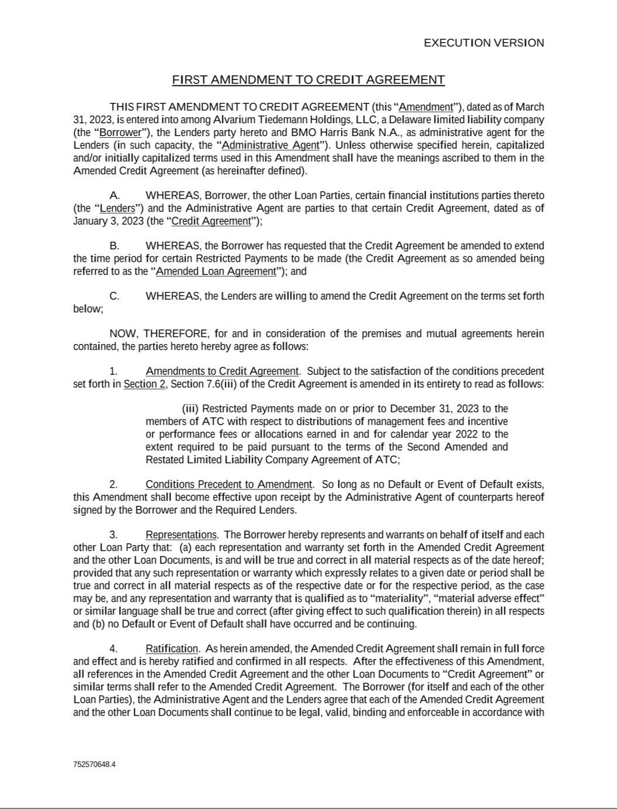

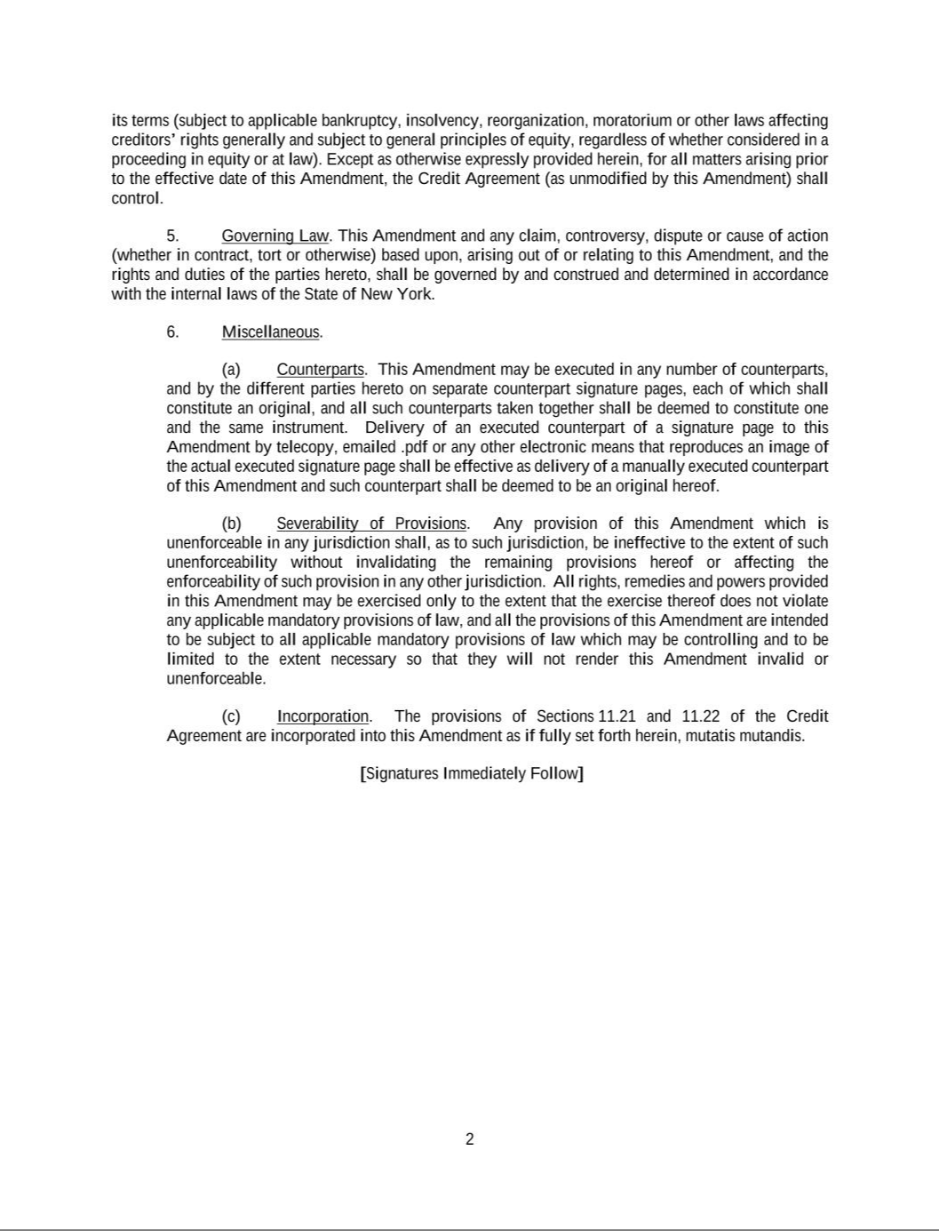

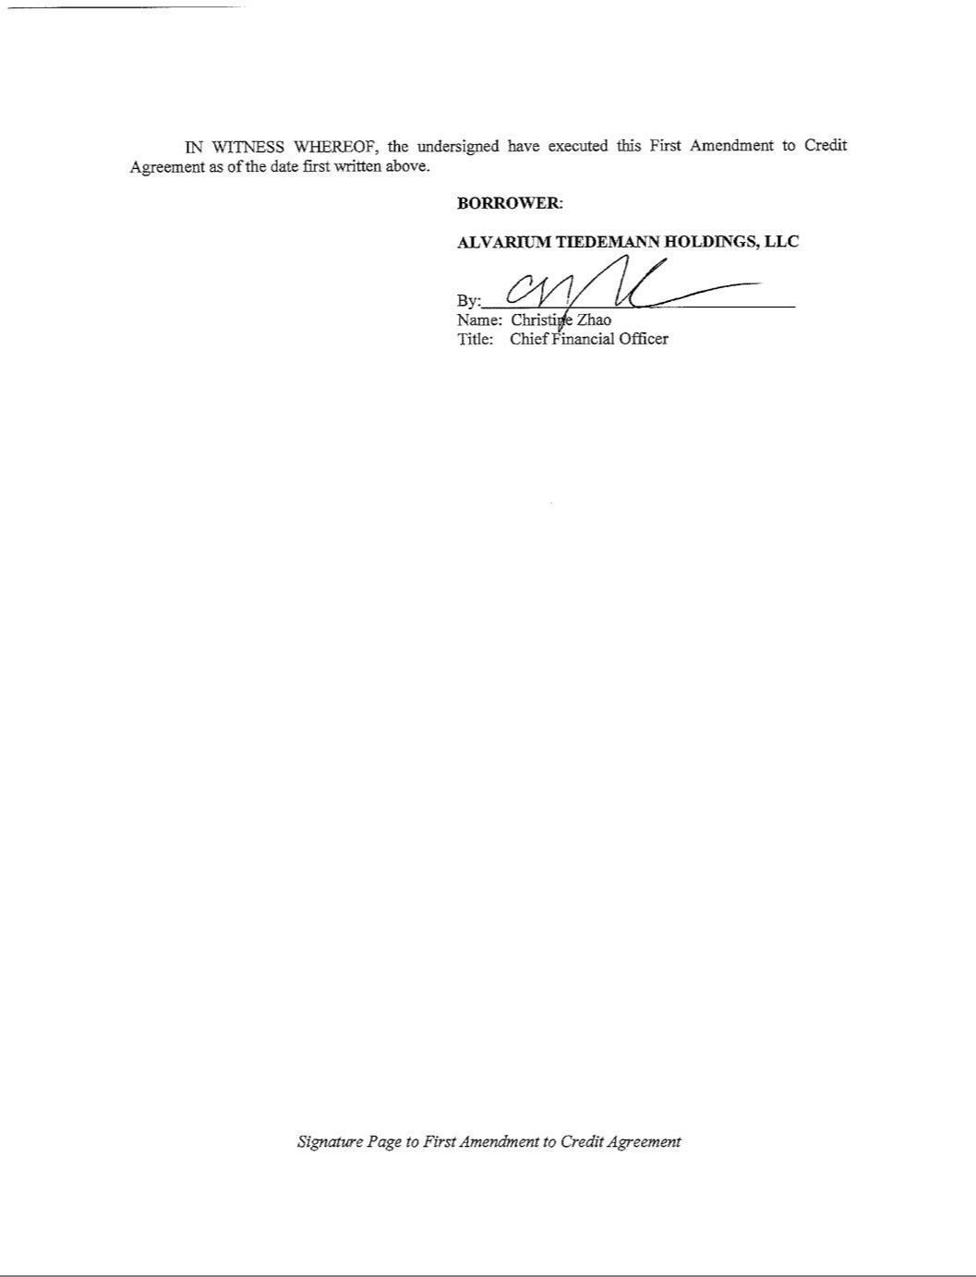



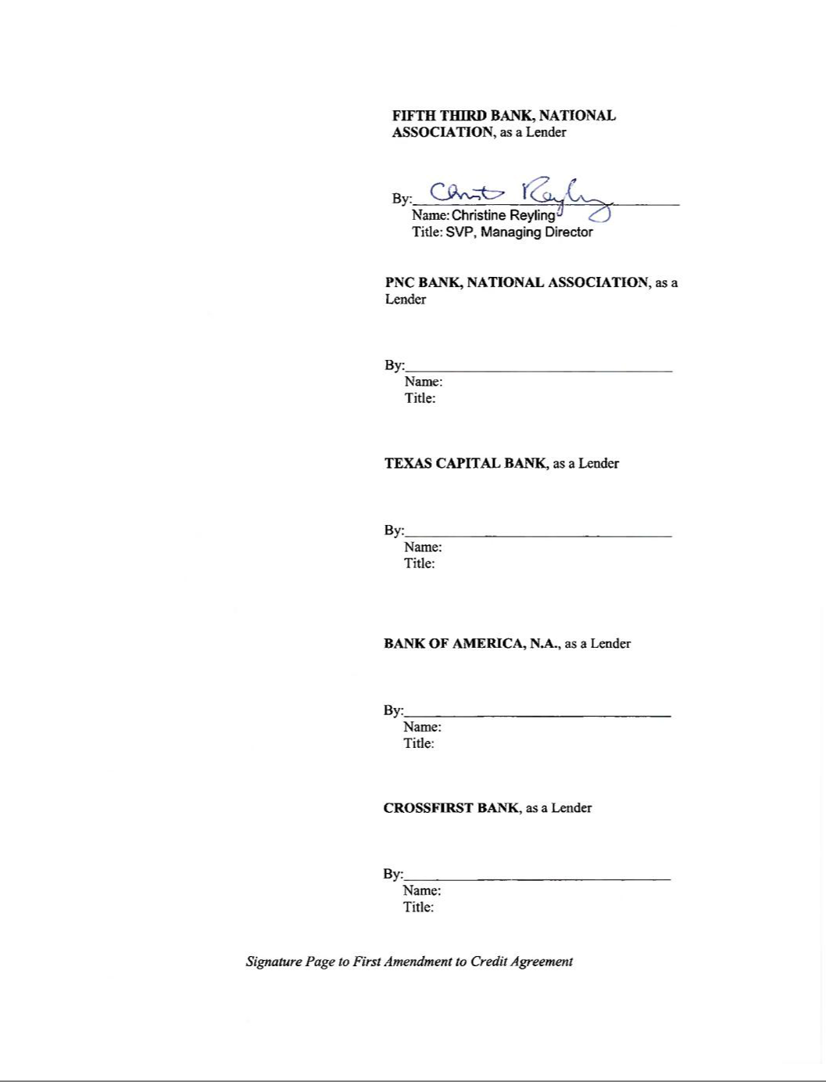

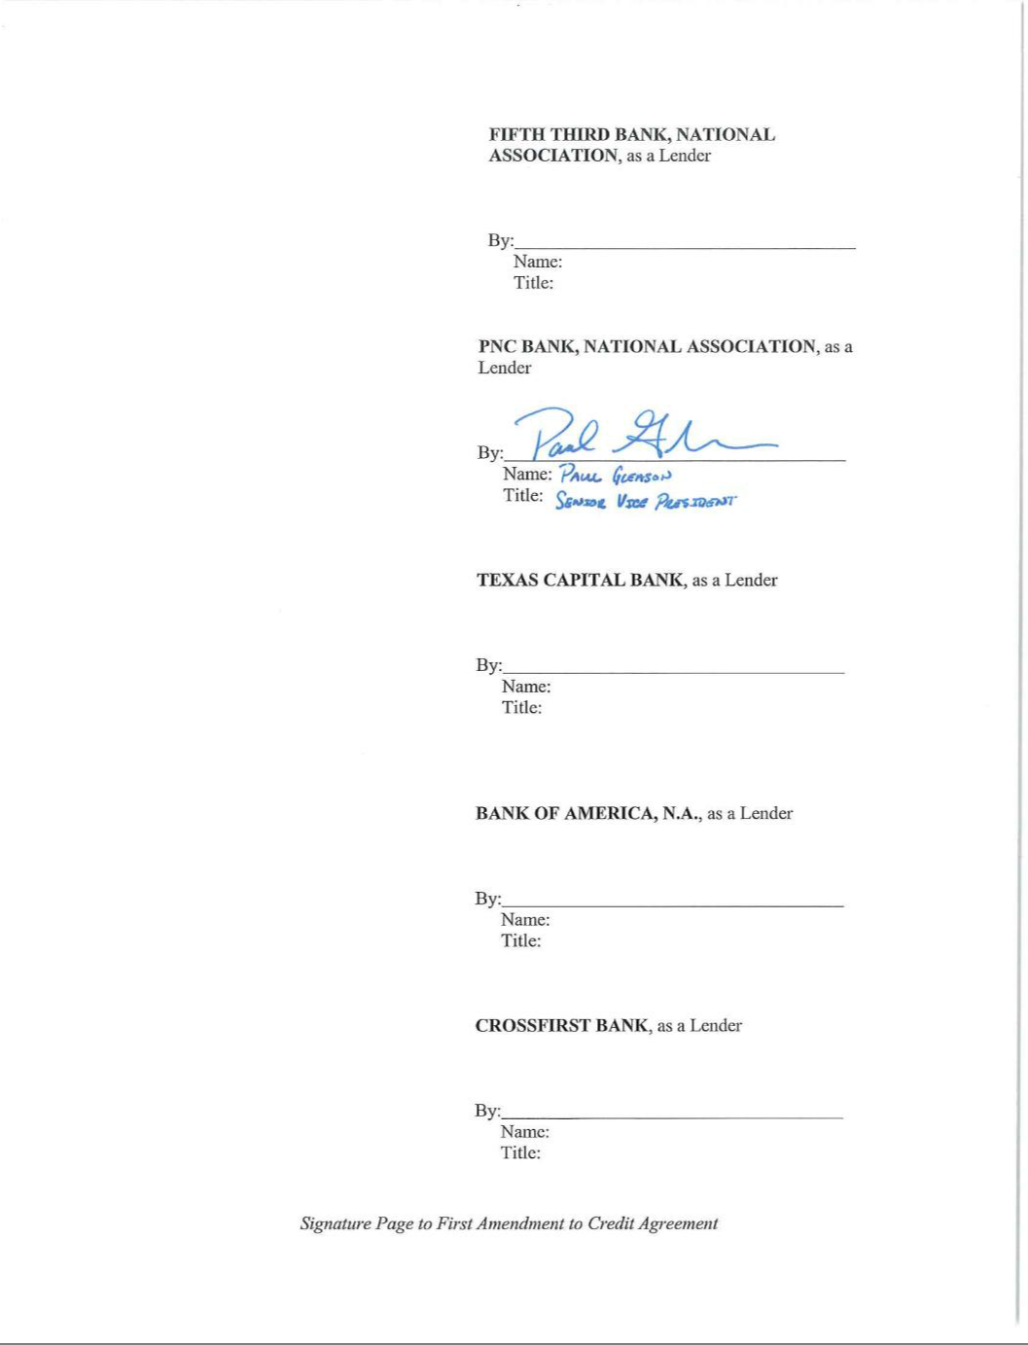

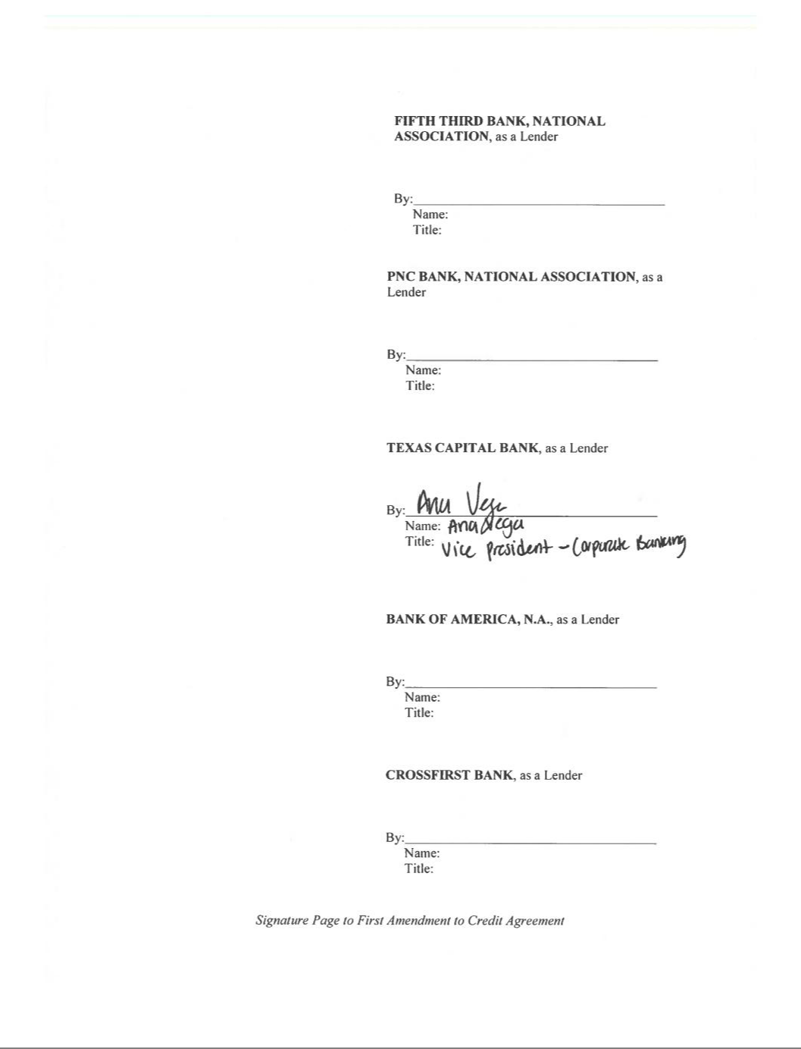

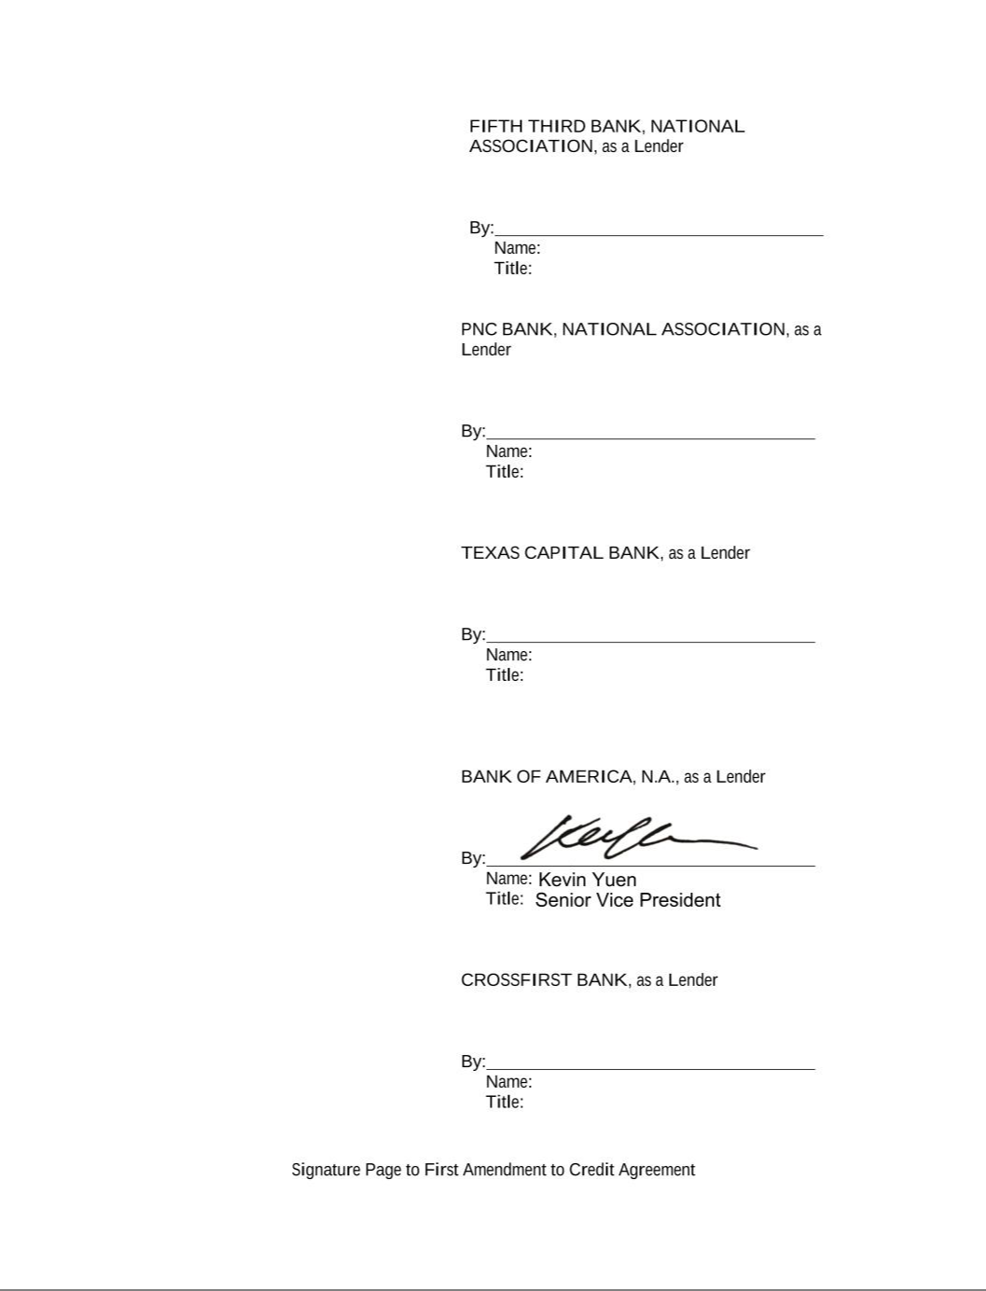

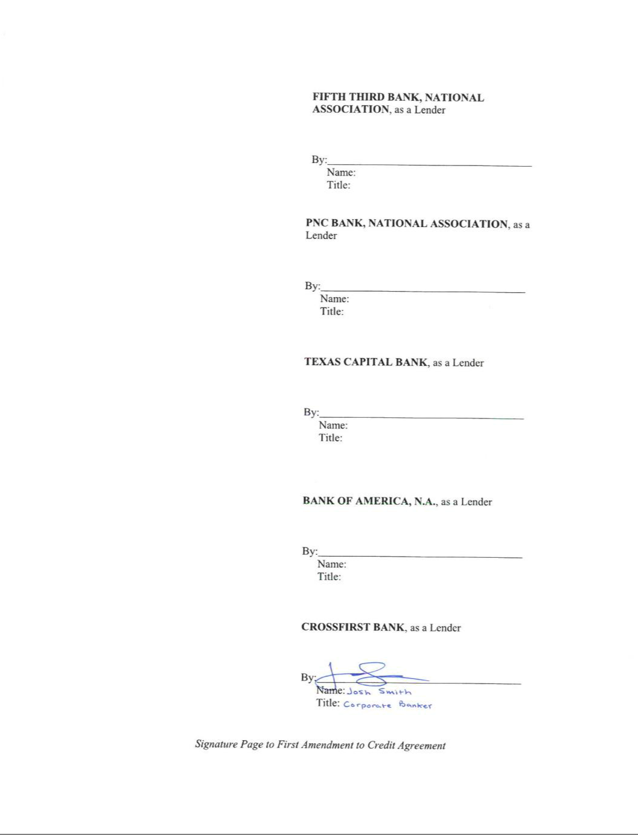

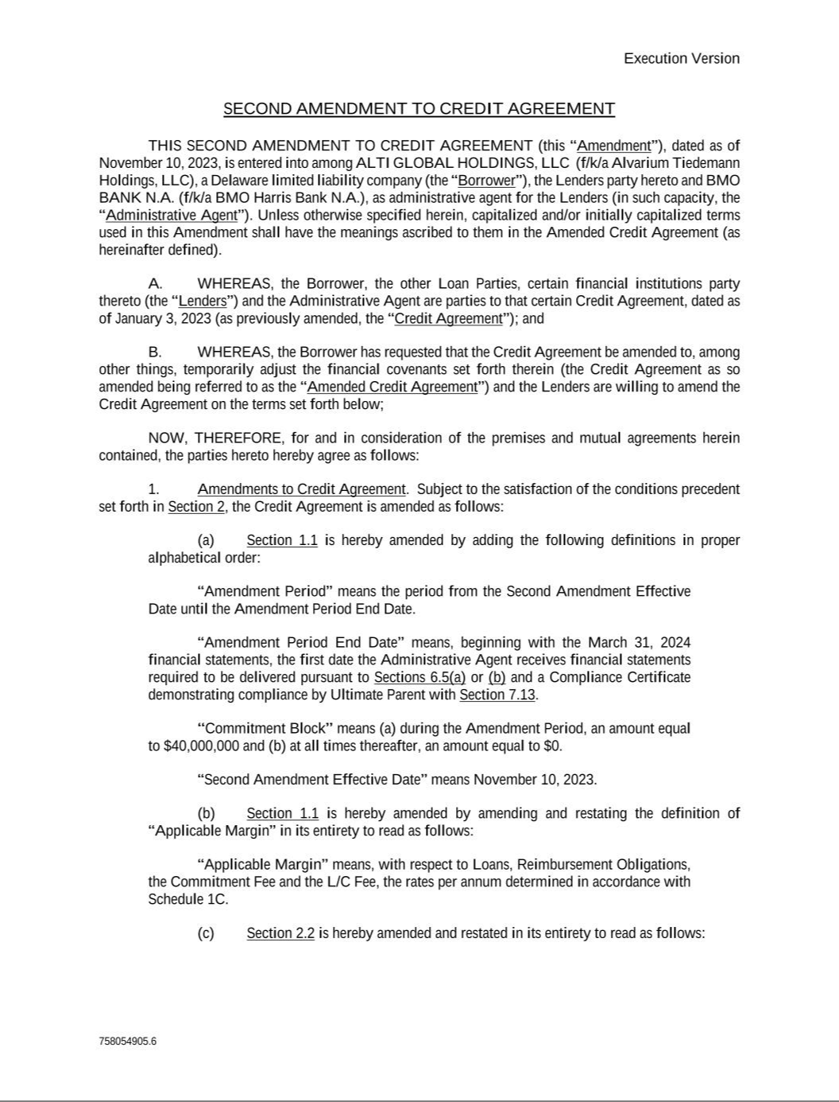

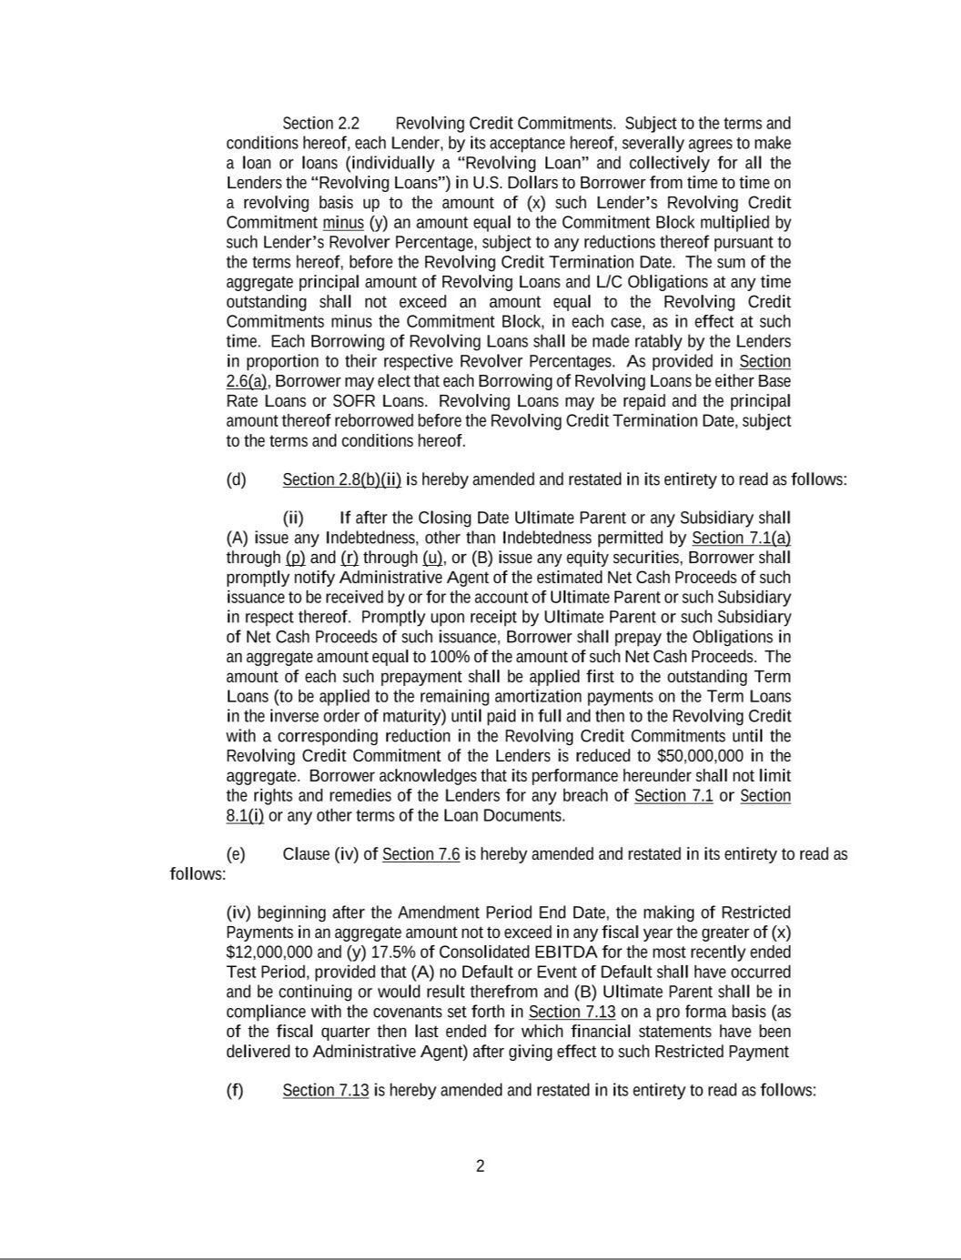

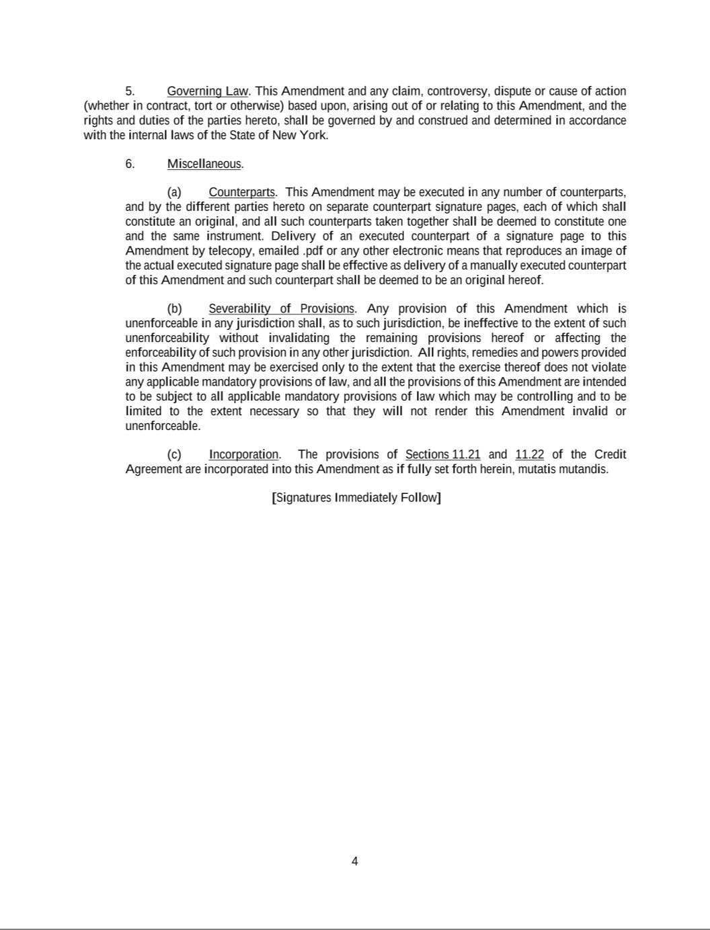

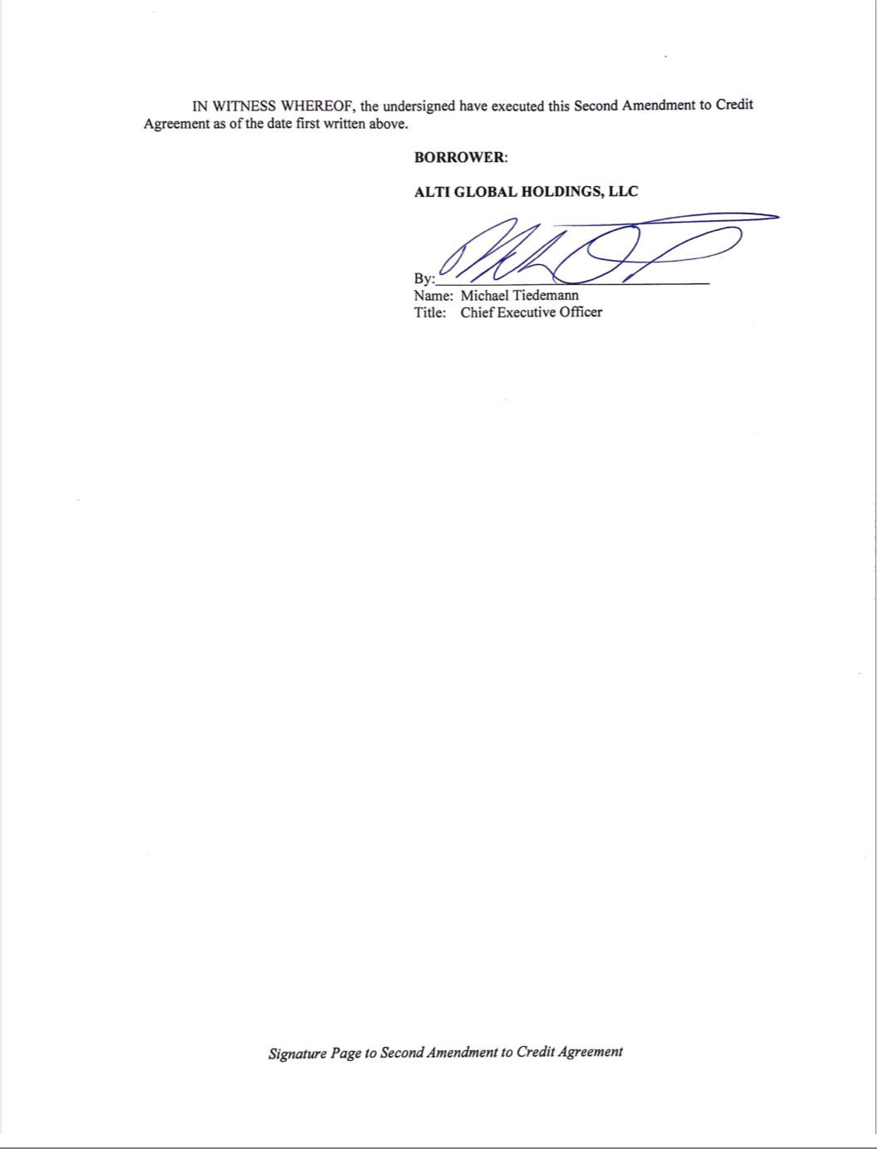



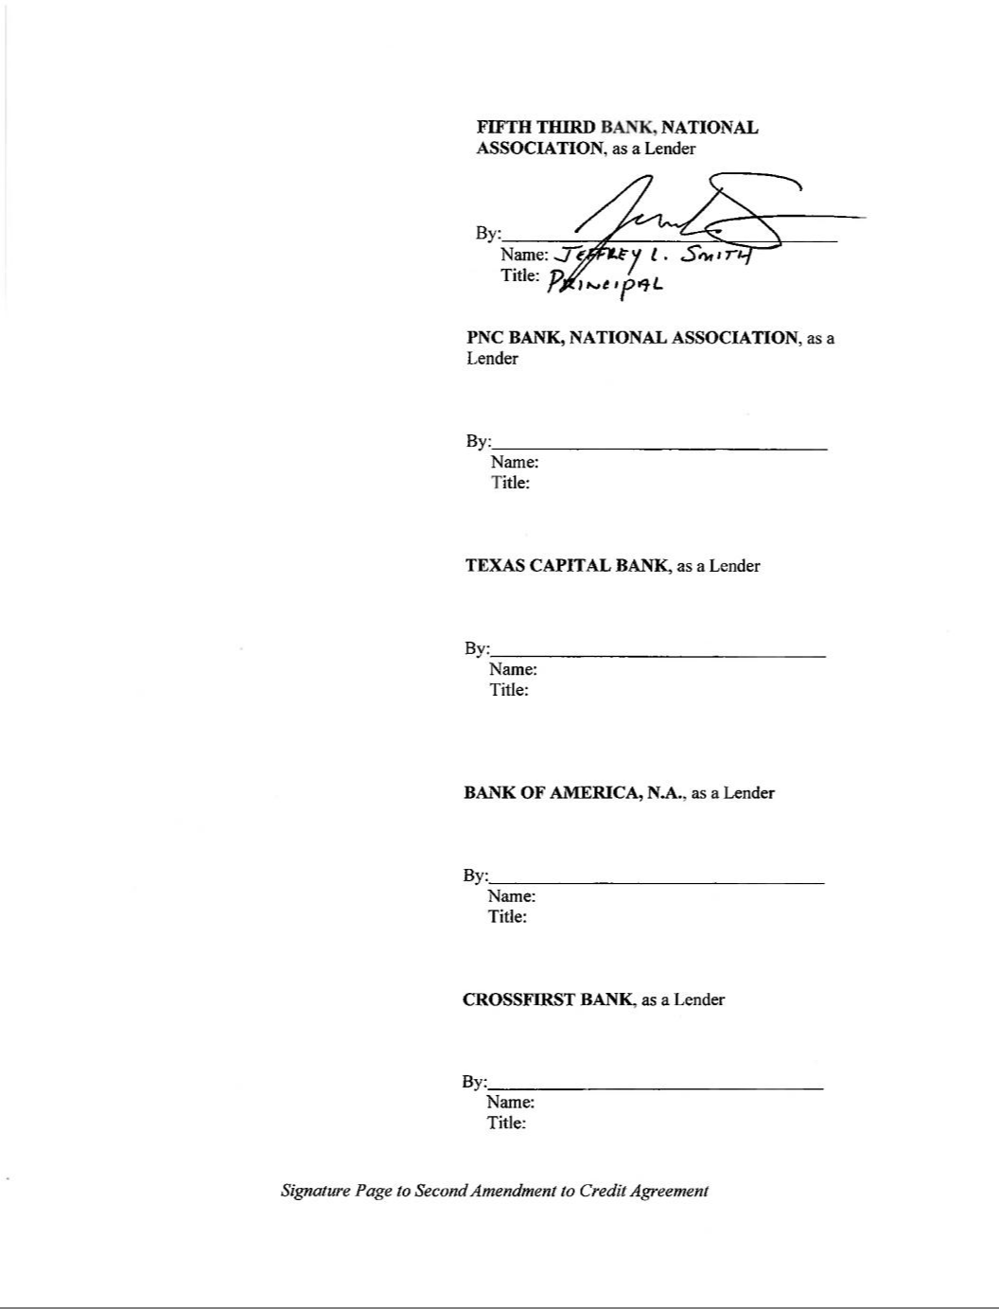



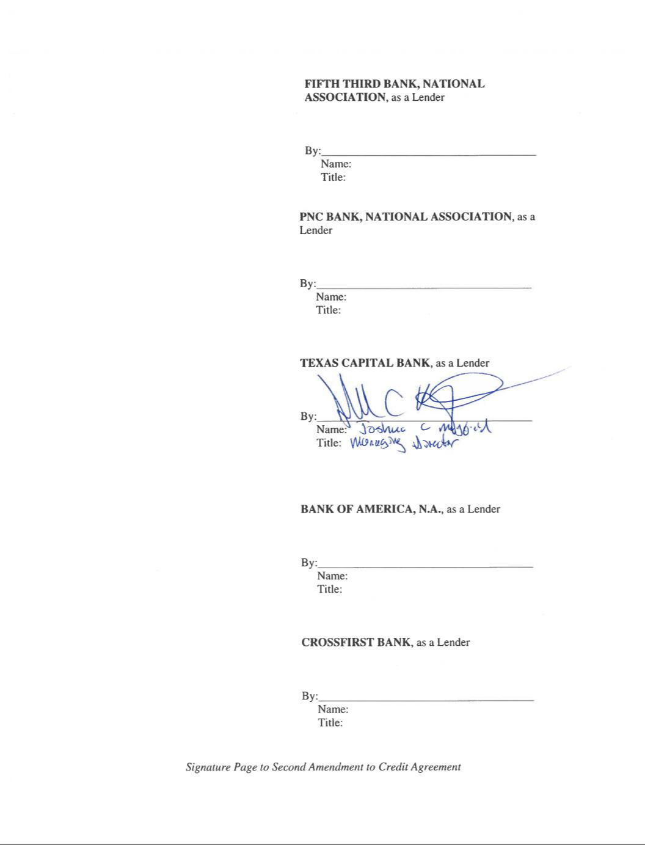

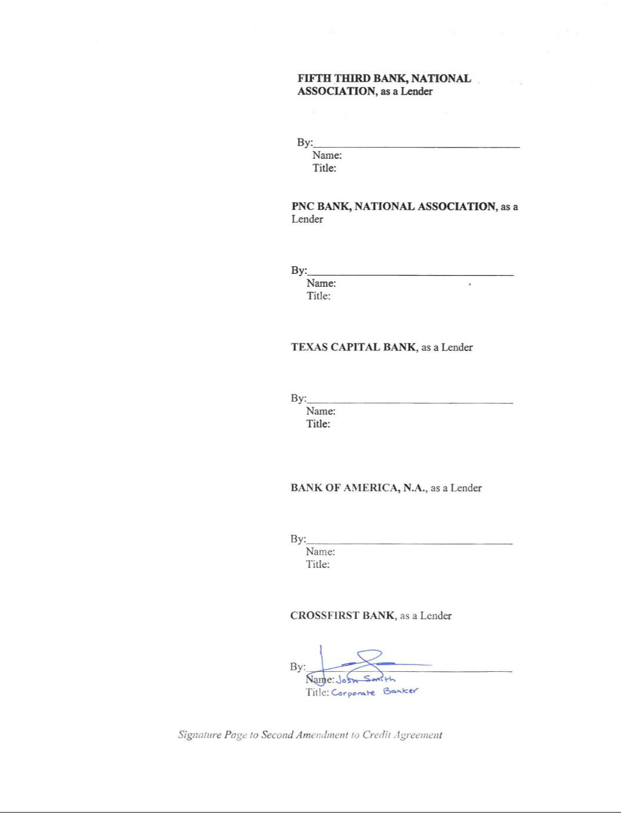

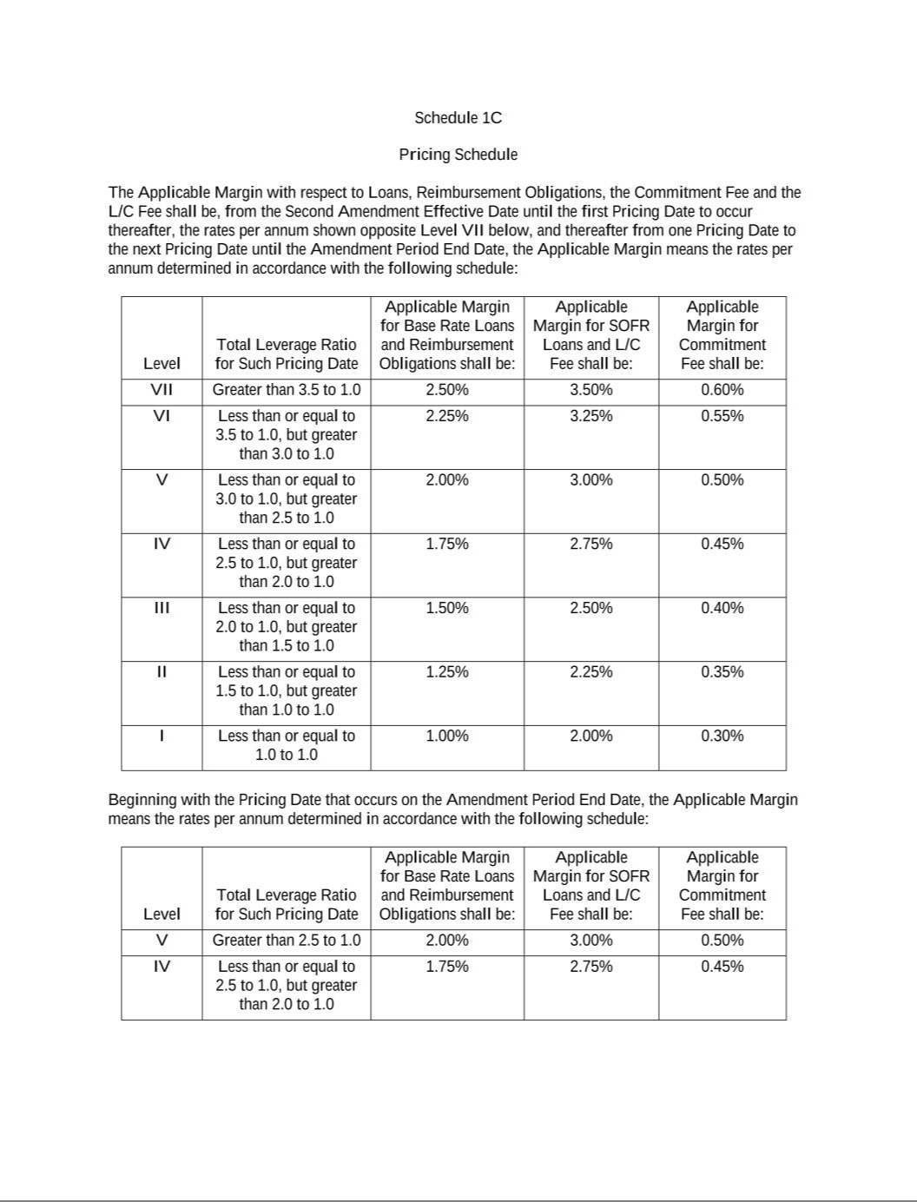

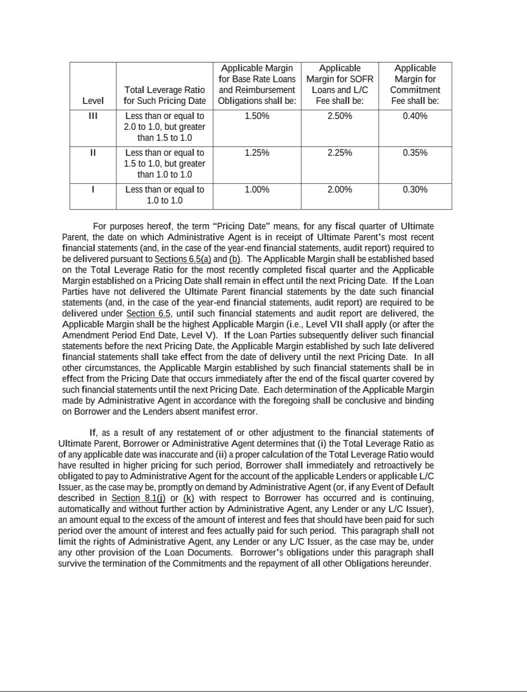

EXHIBIT 31.1

CERTIFICATION OF CHIEF EXECUTIVE OFFICER
PURSUANT TO RULES 13a-14(a) AND 15(d)-14(a) UNDER THE SECURITIES EXCHANGE ACT OF 1934,
AS ADOPTED PURSUANT TO SECTION 302 OF THE SARBANES-OXLEY ACT OF 2002

I, Michael Tiedemann, certify that:

- I have reviewed this quarterly report on Form 10-Q of AlTi Global, Inc.;

- Based on my knowledge, this report does not contain any untrue statement of a material fact or omit to state a material fact necessary to make the statements made, in light of the circumstances under which such statements were made, not misleading with respect to the period covered by this report;

- Based on my knowledge, the financial statements, and other financial information included in this report, fairly present in all material respects the financial condition, results of operations and cash flows of the registrant as of, and for, the periods presented in this report;

- The registrant’s other certifying officer and I are responsible for establishing and maintaining disclosure controls and procedures (as defined in Exchange Act Rules 13a-15(e) and 15d-15(e)) and internal control over financial reporting (as defined in Exchange Act Rules 13a-15(f) and 15d-15(f)) for the registrant and have:

  - Designed such disclosure controls and procedures, or caused such disclosure controls and procedures to be designed under our supervision, to ensure that material information relating to the registrant, including its consolidated subsidiaries, is made known to us by others within those entities, particularly during the period in which this report is being prepared;

  - Designed such internal control over financial reporting, or caused such internal control over financial reporting to be designed under our supervision, to provide reasonable assurance regarding the reliability of financial reporting and the preparation of financial statements for external purposes in accordance with generally accepted accounting principles;

  - Evaluated the effectiveness of the registrant’s disclosure controls and procedures and presented in this report our conclusions about the effectiveness of the disclosure controls and procedures, as of the end of the period covered by this report based on such evaluation; and

  - Disclosed in this report any change in the registrant’s internal control over financial reporting that occurred during the registrant’s most recent fiscal quarter (the registrant’s fourth fiscal quarter in the case of an annual report) that has materially affected, or is reasonably likely to materially affect, the registrant’s internal control over financial reporting; and

- The registrant’s other certifying officer and I have disclosed, based on our most recent evaluation of internal control over financial reporting, to the registrant’s auditors and the audit committee of the registrant’s board of directors (or persons performing the equivalent functions):

  - All significant deficiencies and material weaknesses in the design or operation of internal control over financial reporting which are reasonably likely to adversely affect the registrant’s ability to record, process, summarize and report financial information; and

  - Any fraud, whether or not material, that involves management or other employees who have a significant role in the registrant’s internal control over financial reporting.

Date: November 14, 2023

/s/ Michael Tiedemann

Michael Tiedemann
Chief Executive Officer
(Principal Executive Officer)

EXHIBIT 31.2

CERTIFICATION OF CHIEF FINANCIAL OFFICER
PURSUANT TO RULES 13a-14(a) AND 15(d)-14(a) UNDER THE SECURITIES EXCHANGE ACT OF 1934,
AS ADOPTED PURSUANT TO SECTION 302 OF THE SARBANES-OXLEY ACT OF 2002

I, Stephen Yarad, certify that:

- I have reviewed this quarterly report on Form 10-Q of AlTi Global, Inc.;

- Based on my knowledge, this report does not contain any untrue statement of a material fact or omit to state a material fact necessary to make the statements made, in light of the circumstances under which such statements were made, not misleading with respect to the period covered by this report;

- Based on my knowledge, the financial statements, and other financial information included in this report, fairly present in all material respects the financial condition, results of operations and cash flows of the registrant as of, and for, the periods presented in this report;

- The registrant’s other certifying officer and I are responsible for establishing and maintaining disclosure controls and procedures (as defined in Exchange Act Rules 13a-15(e) and 15d-15(e)) and internal control over financial reporting (as defined in Exchange Act Rules 13a-15(f) and 15d-15(f)) for the registrant and have:

  - Designed such disclosure controls and procedures, or caused such disclosure controls and procedures to be designed under our supervision, to ensure that material information relating to the registrant, including its consolidated subsidiaries, is made known to us by others within those entities, particularly during the period in which this report is being prepared;

  - Designed such internal control over financial reporting, or caused such internal control over financial reporting to be designed under our supervision, to provide reasonable assurance regarding the reliability of financial reporting and the preparation of financial statements for external purposes in accordance with generally accepted accounting principles;

  - Evaluated the effectiveness of the registrant’s disclosure controls and procedures and presented in this report our conclusions about the effectiveness of the disclosure controls and procedures, as of the end of the period covered by this report based on such evaluation; and

  - Disclosed in this report any change in the registrant’s internal control over financial reporting that occurred during the registrant’s most recent fiscal quarter (the registrant’s fourth fiscal quarter in the case of an annual report) that has materially affected, or is reasonably likely to materially affect, the registrant’s internal control over financial reporting; and

- The registrant’s other certifying officer and I have disclosed, based on our most recent evaluation of internal control over financial reporting, to the registrant’s auditors and the audit committee of the registrant’s board of directors (or persons performing the equivalent functions):

  - All significant deficiencies and material weaknesses in the design or operation of internal control over financial reporting which are reasonably likely to adversely affect the registrant’s ability to record, process, summarize and report financial information; and

  - Any fraud, whether or not material, that involves management or other employees who have a significant role in the registrant’s internal control over financial reporting.

Date: November 14, 2023

/s/ Stephen Yarad

Stephen Yarad
Chief Financial Officer
(Principal Financial Officer)

EXHIBIT 32.1

CERTIFICATION PURSUANT TO
18 U.S.C. SECTION 1350
AS ADOPTED PURSUANT TO
SECTION 906 OF THE SARBANES-OXLEY ACT OF 2002

In connection with the Quarterly Report of AlTi Global, Inc. (the “Company”) on Form 10-Q for the quarterly period ended September 30, 2023, as filed with the Securities and Exchange Commission (the “Report”), I, Michael Tiedemann, Chief Executive Officer of the Company, certify, pursuant to 18 U.S.C. §1350, as added by §906 of the Sarbanes-Oxley Act of 2002, that:
- The Report fully complies with the requirements of Section 13(a) or 15(d) of the Securities Exchange Act of 1934; and

- To my knowledge, the information contained in the Report fairly presents, in all material respects, the financial condition and results of operations of the Company as of and for the period covered by the Report.

Dated: November 14, 2023

/s/ Michael Tiedemann
Michael Tiedemann
Chief Executive Officer
(Principal Executive Officer)

EXHIBIT 32.2

CERTIFICATION PURSUANT TO
18 U.S.C. SECTION 1350
AS ADOPTED PURSUANT TO
SECTION 906 OF THE SARBANES-OXLEY ACT OF 2002

In connection with the Quarterly Report of AlTi Global, Inc. (the “Company”) on Form 10-Q for the quarterly period ended September 30, 2023, as filed with the Securities and Exchange Commission (the “Report”), I, Stephen Yarad, Chief Financial Officer of the Company, certify, pursuant to 18 U.S.C. §1350, as added by §906 of the Sarbanes-Oxley Act of 2002, that:
- The Report fully complies with the requirements of Section 13(a) or 15(d) of the Securities Exchange Act of 1934; and

- To my knowledge, the information contained in the Report fairly presents, in all material respects, the financial condition and results of operations of the Company as of and for the period covered by the Report.

Dated: November 14, 2023

/s/ Stephen Yarad

Stephen Yarad
Chief Financial Officer
(Principal Financial Officer)

