UNITED STATES
SECURITIES AND EXCHANGE COMMISSION
Washington, D.C. 20549
_________________________________________
FORM 8-K
_________________________________________
CURRENT REPORT
Pursuant to Section 13 or 15(d)
of the Securities Exchange Act of 1934
Date of report (Date of earliest event reported): August 10, 2026
_________________________________________
AlTi Global, Inc.
(Exact name of registrant as specified in its charter)
_________________________________________

Delaware |  |  |  |  |  | 001-40103 |  |  |  |  |  | 92-1552220
(State or other jurisdiction  of incorporation) |  |  |  |  |  | (Commission  File Number) |  |  |  |  |  | (I.R.S. Employer  Identification No.)
22 Vanderbilt Avenue, 27th Floor New York, New York |  |  | 10017
(Address of principal executive offices) |  |  | (Zip Code)
(212) 396-5900
(Registrant’s telephone number, including area code)

Not Applicable
(Former name or former address, if changed since last report)
_________________________________________

Check the appropriate box below if the Form 8-K is intended to simultaneously satisfy the filing obligation of the registrant under any of the following provisions:
☐ |  |  | Written communications pursuant to Rule 425 under the Securities Act (17 CFR 230.425)
☐ |  |  | Soliciting material pursuant to Rule 14a-12 under the Exchange Act (17 CFR 240.14a-12)
☐ |  |  | Pre-commencement communications pursuant to Rule 14d-2(b) under the Exchange Act (17 CFR 240.14d-2(b))
☐ |  |  | Pre-commencement communications pursuant to Rule 13e-4(c) under the Exchange Act (17 CFR 240.13e-4(c))

Securities registered pursuant to Section 12(b) of the Act:

Title of each class |  |  |  |  |  | Trading Symbol(s) |  |  |  |  |  | Name of each exchange  on which registered
Class A common stock, par value $0.0001 per share |  |  |  |  |  | ALTI |  |  |  |  |  | Nasdaq Capital Market
Indicate by check mark whether the registrant is an emerging growth company as defined in Rule 405 of the Securities Act of 1933 (§230.405 of this chapter) or Rule 12b-2 of the Securities Exchange Act of 1934 (§240.12b-2 of this chapter).
Emerging growth company ☒
If an emerging growth company, indicate by check mark if the registrant has elected not to use the extended transition period for complying with any new or revised financial accounting standards provided pursuant to Section 13(a) of the Exchange Act. ☐
________________________________________________________________________________________________________________________________________________________

Item 2.02 |  |  | Results of Operations and Financial Condition
AlTi Global, Inc. (the “Company”) is furnishing an updated form of investor presentation that is attached as Exhibit 99.1 to this Current Report on Form 8-K and incorporated by reference herein. A copy of the investor presentation is also available on the Company’s investor relations website at ir.alti-global.com.
Exhibit 99.1 and the information set forth therein shall not be deemed to be filed for purposes of Section 18 of the Securities Exchange Act of 1934, as amended (the “Exchange Act”), or otherwise be subject to the liabilities of that section, nor shall it be deemed to be incorporated by reference in any filing under the Securities Act of 1933, as amended, or the Exchange Act.

Item 7.01 |  |  | Regulation FD Disclosure.
The disclosure contained in Item 2.02 of this Current Report on Form 8-K, including the investor presentation furnished as Exhibit 99.1, is incorporated into this Item 7.01 by reference.
Exhibit 99.1 and the information set forth therein shall not be deemed to be filed for purposes of Section 18 of the Exchange Act, or otherwise be subject to the liabilities of that section, nor shall it be deemed to be incorporated by reference in any filing under the Securities Act of 1933, as amended, or the Exchange Act.

Item 9.01 |  |  | Financial Statements and Exhibits.
(d) Exhibits.

99.1 |  |  |  |  |  | Investor Presentation
104 |  |  |  |  |  | Cover Page Interactive Data File (embedded within the Inline XBRL document)

SIGNATURE

Pursuant to the requirements of the Securities Exchange Act of 1934, the registrant has duly caused this report to be signed on its behalf by the undersigned hereunto duly authorized.
ALTI GLOBAL, INC.
By: |  |  |  |  |  | /s/ Nancy Curtin
Name: |  |  |  |  |  | Nancy Curtin
Title: |  |  |  |  |  | Interim Chief Executive Officer

Date: August 10, 2026


AlTi Color Palette Background color Primary Accent Color Secondary colors Tertiary colors 1AlTi Global Second Quarter 2026 Earnings | August 10, 2026

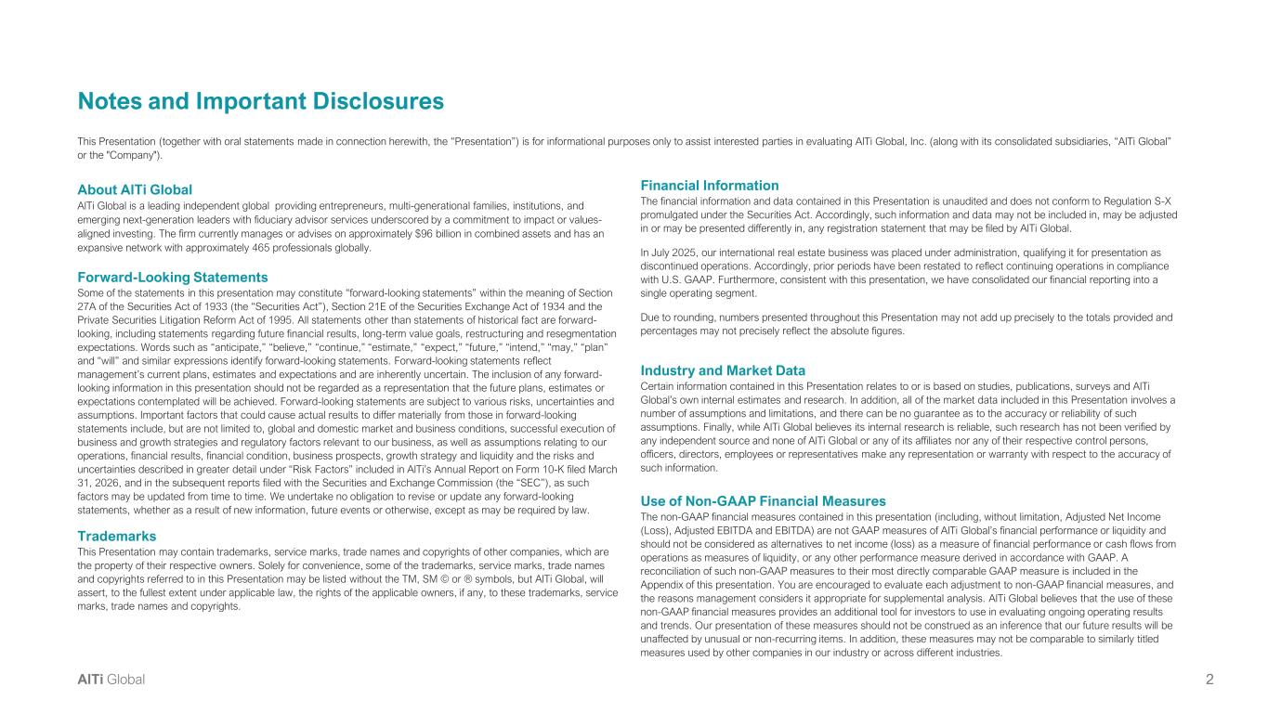
AlTi Color Palette Background color Primary Accent Color Secondary colors Tertiary colors 2AlTi Global Notes and Important Disclosures About AlTi Global AlTi Global is a leading independent global providing entrepreneurs, multi-generational families, institutions, and emerging next-generation leaders with fiduciary advisor services underscored by a commitment to impact or values- aligned investing. The firm currently manages or advises on approximately $96 billion in combined assets and has an expansive network with approximately 465 professionals globally. Forward-Looking Statements Some of the statements in this presentation may constitute “forward-looking statements” within the meaning of Section 27A of the Securities Act of 1933 (the “Securities Act”), Section 21E of the Securities Exchange Act of 1934 and the Private Securities Litigation Reform Act of 1995. All statements other than statements of historical fact are forward- looking, including statements regarding future financial results, long-term value goals, restructuring and resegmentation expectations. Words such as “anticipate,” “believe,” “continue,” “estimate,” “expect,” “future,” “intend,” “may,” “plan” and “will” and similar expressions identify forward-looking statements. Forward-looking statements reflect management’s current plans, estimates and expectations and are inherently uncertain. The inclusion of any forward- looking information in this presentation should not be regarded as a representation that the future plans, estimates or expectations contemplated will be achieved. Forward-looking statements are subject to various risks, uncertainties and assumptions. Important factors that could cause actual results to differ materially from those in forward-looking statements include, but are not limited to, global and domestic market and business conditions, successful execution of business and growth strategies and regulatory factors relevant to our business, as well as assumptions relating to our operations, financial results, financial condition, business prospects, growth strategy and liquidity and the risks and uncertainties described in greater detail under “Risk Factors” included in AlTi’s Annual Report on Form 10-K filed March 31, 2026, and in the subsequent reports filed with the Securities and Exchange Commission (the “SEC”), as such factors may be updated from time to time. We undertake no obligation to revise or update any forward-looking statements, whether as a result of new information, future events or otherwise, except as may be required by law. Trademarks This Presentation may contain trademarks, service marks, trade names and copyrights of other companies, which are the property of their respective owners. Solely for convenience, some of the trademarks, service marks, trade names and copyrights referred to in this Presentation may be listed without the TM, SM © or ® symbols, but AlTi Global, will assert, to the fullest extent under applicable law, the rights of the applicable owners, if any, to these trademarks, service marks, trade names and copyrights. This Presentation (together with oral statements made in connection herewith, the “Presentation”) is for informational purposes only to assist interested parties in evaluating AlTi Global, Inc. (along with its consolidated subsidiaries, “AlTi Global” or the "Company"). Financial Information The financial information and data contained in this Presentation is unaudited and does not conform to Regulation S-X promulgated under the Securities Act. Accordingly, such information and data may not be included in, may be adjusted in or may be presented differently in, any registration statement that may be filed by AlTi Global. In July 2025, our international real estate business was placed under administration, qualifying it for presentation as discontinued operations. Accordingly, prior periods have been restated to reflect continuing operations in compliance with U.S. GAAP. Furthermore, consistent with this presentation, we have consolidated our financial reporting into a single operating segment. Due to rounding, numbers presented throughout this Presentation may not add up precisely to the totals provided and percentages may not precisely reflect the absolute figures. Industry and Market Data Certain information contained in this Presentation relates to or is based on studies, publications, surveys and AlTi Global’s own internal estimates and research. In addition, all of the market data included in this Presentation involves a number of assumptions and limitations, and there can be no guarantee as to the accuracy or reliability of such assumptions. Finally, while AlTi Global believes its internal research is reliable, such research has not been verified by any independent source and none of AlTi Global or any of its affiliates nor any of their respective control persons, officers, directors, employees or representatives make any representation or warranty with respect to the accuracy of such information. Use of Non-GAAP Financial Measures The non-GAAP financial measures contained in this presentation (including, without limitation, Adjusted Net Income (Loss), Adjusted EBITDA and EBITDA) are not GAAP measures of AlTi Global’s financial performance or liquidity and should not be considered as alternatives to net income (loss) as a measure of financial performance or cash flows from operations as measures of liquidity, or any other performance measure derived in accordance with GAAP. A reconciliation of such non-GAAP measures to their most directly comparable GAAP measure is included in the Appendix of this presentation. You are encouraged to evaluate each adjustment to non-GAAP financial measures, and the reasons management considers it appropriate for supplemental analysis. AlTi Global believes that the use of these non-GAAP financial measures provides an additional tool for investors to use in evaluating ongoing operating results and trends. Our presentation of these measures should not be construed as an inference that our future results will be unaffected by unusual or non-recurring items. In addition, these measures may not be comparable to similarly titled measures used by other companies in our industry or across different industries.

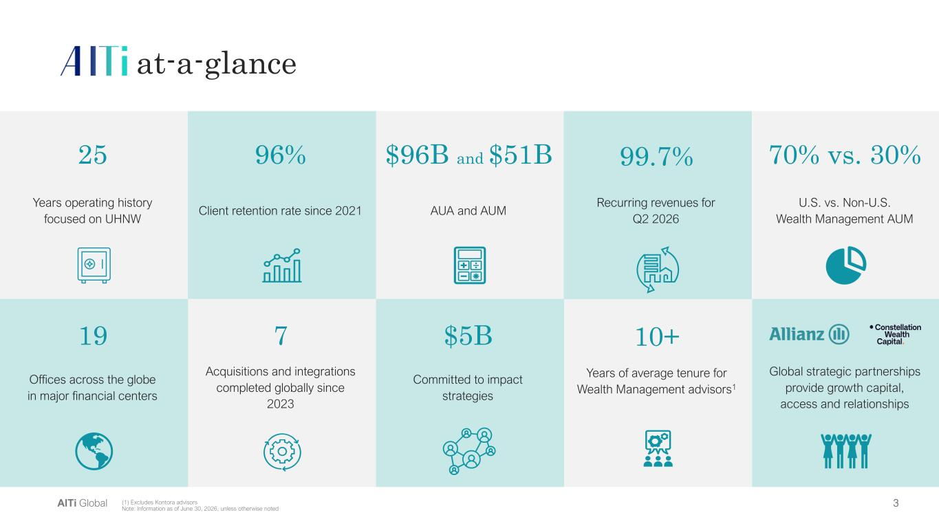
AlTi Color Palette Background color Primary Accent Color Secondary colors Tertiary colors 3AlTi Global at-a-glance U.S. vs. Non-U.S. Wealth Management AUM 70% vs. 30%$96B and $51B 7 Acquisitions and integrations completed globally since 2023 Client retention rate since 2021 96% 19 Offices across the globe in major financial centers Global strategic partnerships provide growth capital, access and relationships Years operating history focused on UHNW 25 (1) Excludes Kontora advisors Note: Information as of June 30, 2026, unless otherwise noted Committed to impact strategies $5B 10+ Years of average tenure for Wealth Management advisors1 99.7% Recurring revenues for Q2 2026 AUA and AUM

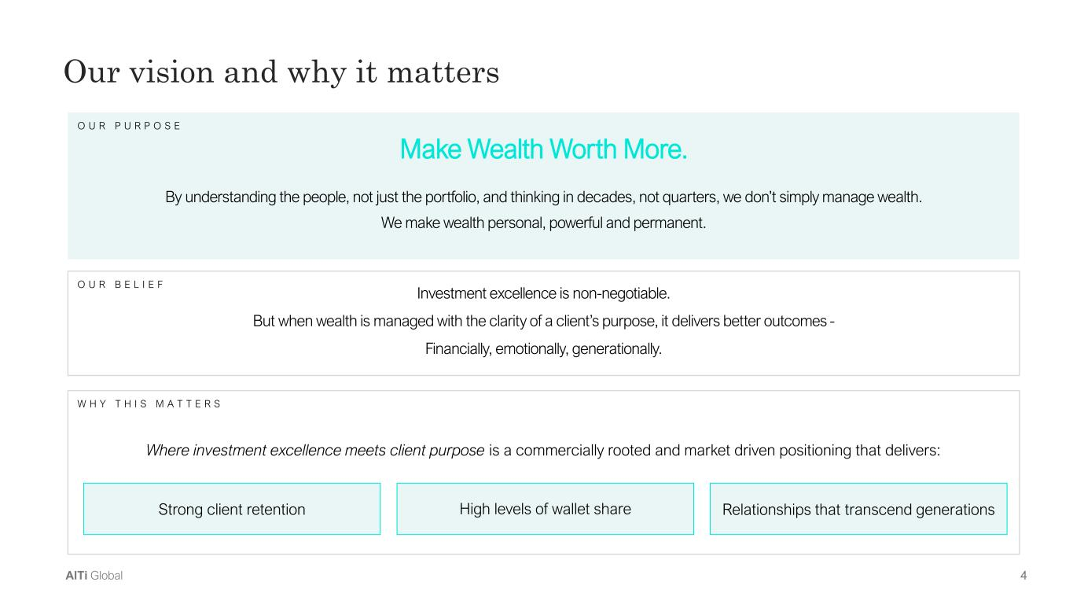
AlTi Color Palette Background color Primary Accent Color Secondary colors Tertiary colors 4AlTi Global By understanding the people, not just the portfolio, and thinking in decades, not quarters, we don’t simply manage wealth. We make wealth personal, powerful and permanent. Make Wealth Worth More. Our vision and why it matters O U R B E L I E F Investment excellence is non-negotiable. But when wealth is managed with the clarity of a client’s purpose, it delivers better outcomes - Financially, emotionally, generationally. O U R P U R P O S E W H Y T H I S M A T T E R S Where investment excellence meets client purpose is a commercially rooted and market driven positioning that delivers: Strong client retention High levels of wallet share Relationships that transcend generations

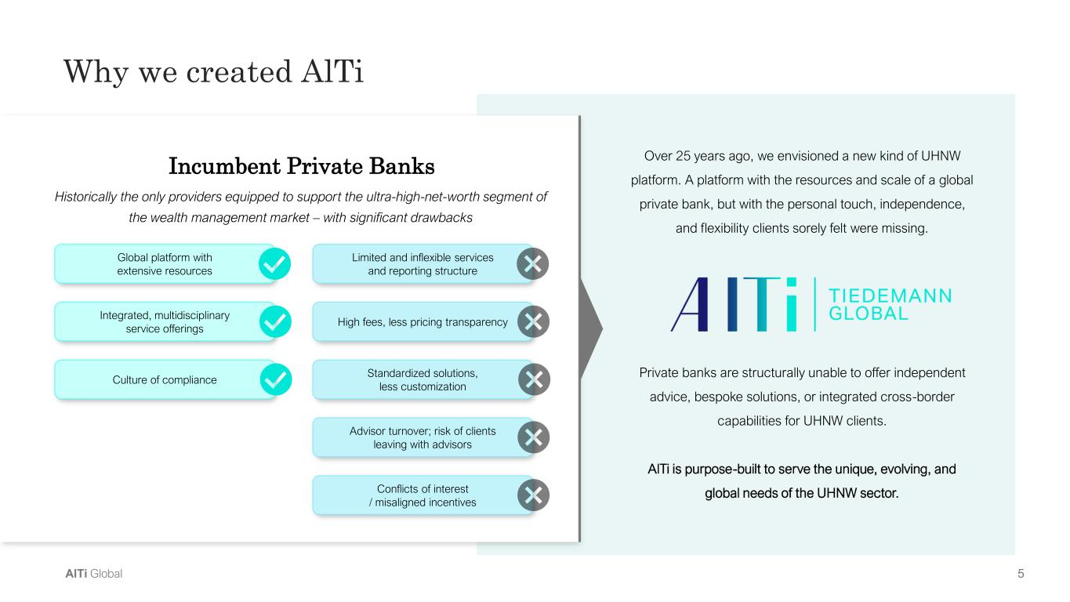
AlTi Color Palette Background color Primary Accent Color Secondary colors Tertiary colors 5AlTi Global Over 25 years ago, we envisioned a new kind of UHNW platform. A platform with the resources and scale of a global private bank, but with the personal touch, independence, and flexibility clients sorely felt were missing. Private banks are structurally unable to offer independent advice, bespoke solutions, or integrated cross-border capabilities for UHNW clients. AlTi is purpose-built to serve the unique, evolving, and global needs of the UHNW sector. Why we created AlTi Incumbent Private Banks Global platform with extensive resources Integrated, multidisciplinary service offerings Culture of compliance Limited and inflexible services and reporting structure High fees, less pricing transparency Standardized solutions, less customization Advisor turnover; risk of clients leaving with advisors Conflicts of interest / misaligned incentives Historically the only providers equipped to support the ultra-high-net-worth segment of the wealth management market – with significant drawbacks

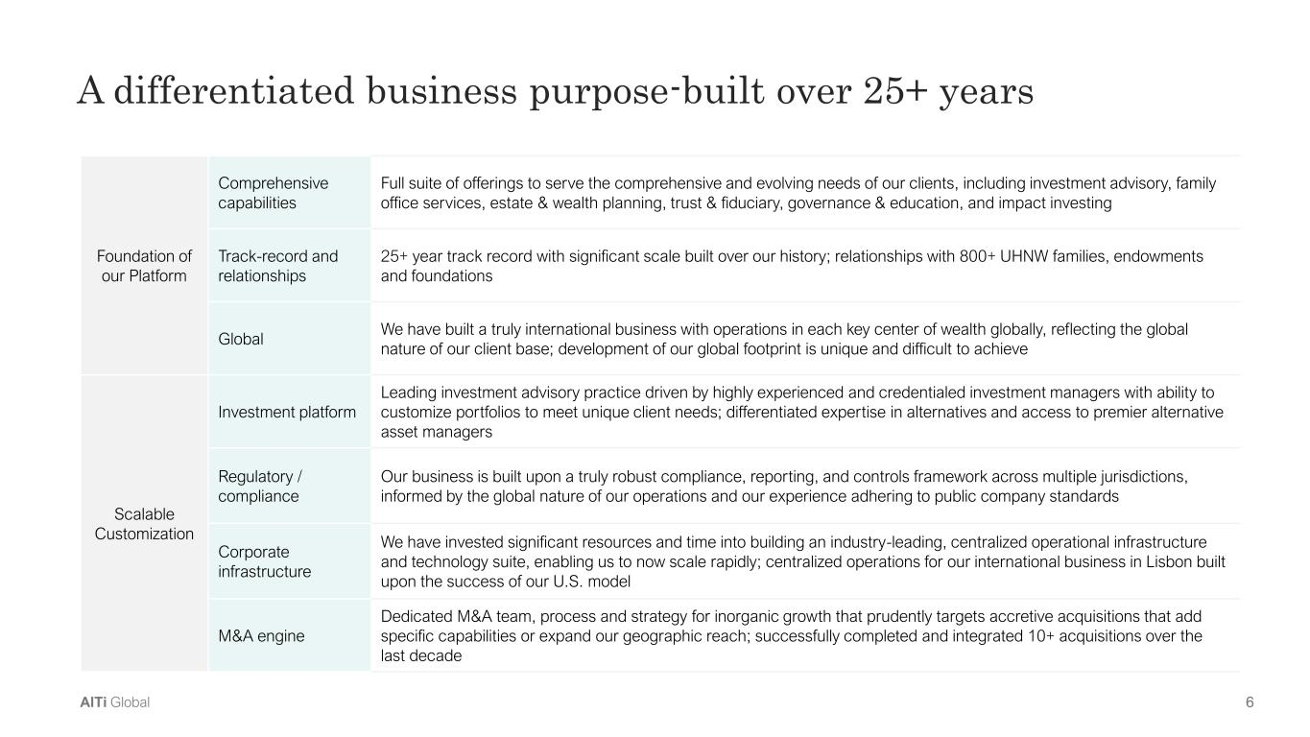
AlTi Color Palette Background color Primary Accent Color Secondary colors Tertiary colors 6AlTi Global A differentiated business purpose-built over 25+ years Foundation of our Platform Comprehensive capabilities Full suite of offerings to serve the comprehensive and evolving needs of our clients, including investment advisory, family office services, estate & wealth planning, trust & fiduciary, governance & education, and impact investing Track-record and relationships 25+ year track record with significant scale built over our history; relationships with 800+ UHNW families, endowments and foundations Global We have built a truly international business with operations in each key center of wealth globally, reflecting the global nature of our client base; development of our global footprint is unique and difficult to achieve Scalable Customization Investment platform Leading investment advisory practice driven by highly experienced and credentialed investment managers with ability to customize portfolios to meet unique client needs; differentiated expertise in alternatives and access to premier alternative asset managers Regulatory / compliance Our business is built upon a truly robust compliance, reporting, and controls framework across multiple jurisdictions, informed by the global nature of our operations and our experience adhering to public company standards Corporate infrastructure We have invested significant resources and time into building an industry-leading, centralized operational infrastructure and technology suite, enabling us to now scale rapidly; centralized operations for our international business in Lisbon built upon the success of our U.S. model M&A engine Dedicated M&A team, process and strategy for inorganic growth that prudently targets accretive acquisitions that add specific capabilities or expand our geographic reach; successfully completed and integrated 10+ acquisitions over the last decade

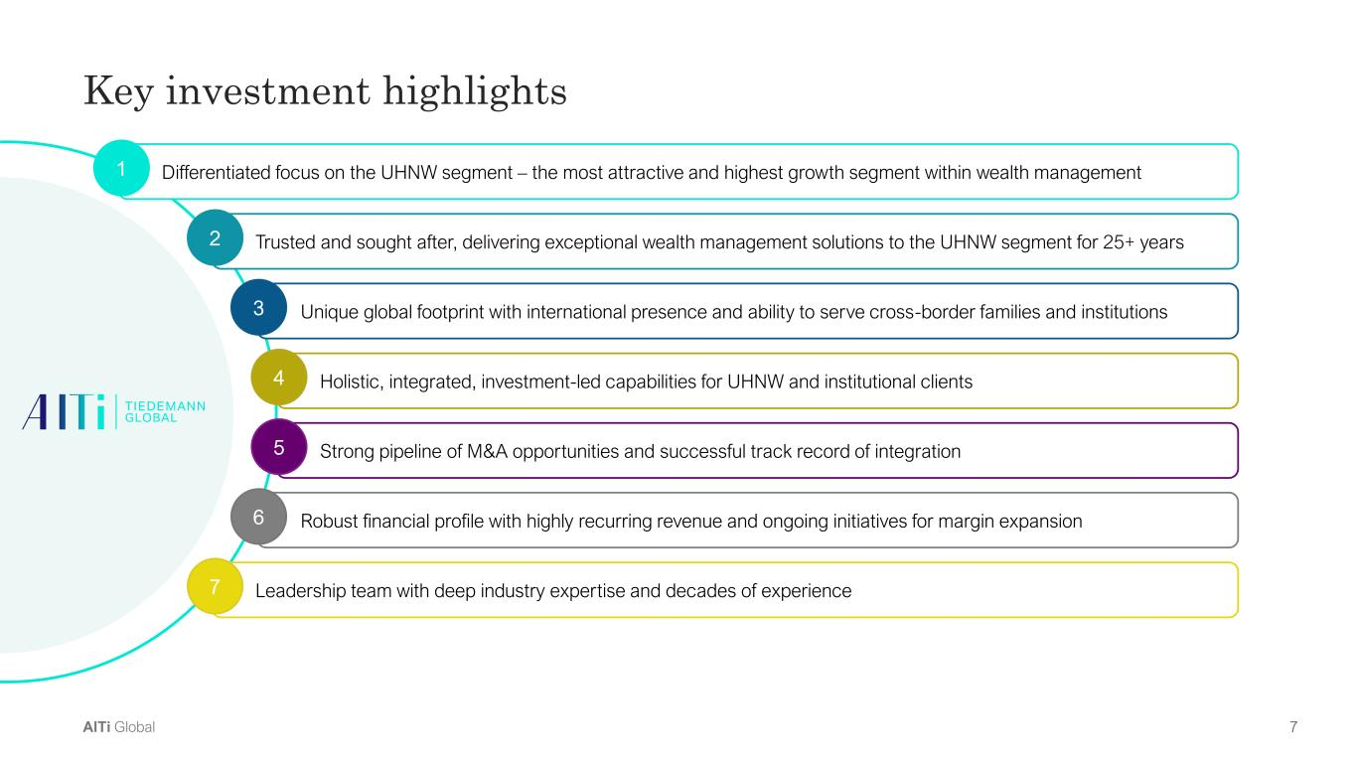
AlTi Color Palette Background color Primary Accent Color Secondary colors Tertiary colors 7AlTi Global Key investment highlights Differentiated focus on the UHNW segment – the most attractive and highest growth segment within wealth management Trusted and sought after, delivering exceptional wealth management solutions to the UHNW segment for 25+ years Unique global footprint with international presence and ability to serve cross-border families and institutions Holistic, integrated, investment-led capabilities for UHNW and institutional clients Robust financial profile with highly recurring revenue and ongoing initiatives for margin expansion Strong pipeline of M&A opportunities and successful track record of integration Leadership team with deep industry expertise and decades of experience 2 3 4 6 5 7 1

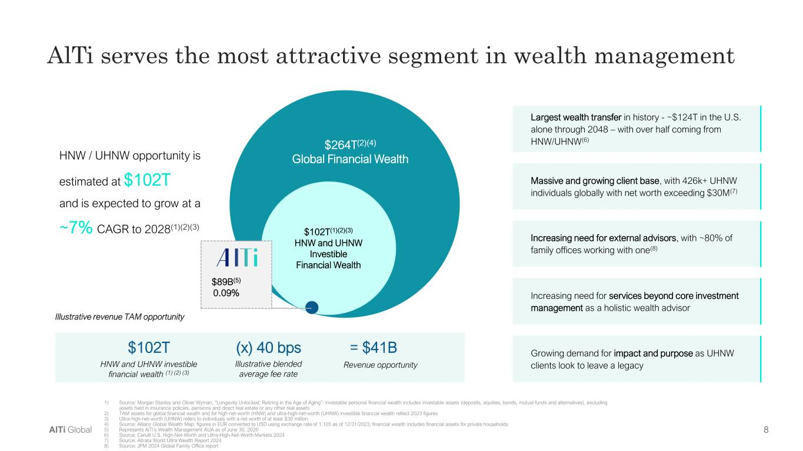
AlTi Color Palette Background color Primary Accent Color Secondary colors Tertiary colors 8AlTi Global HNW / UHNW opportunity is estimated at $102T and is expected to grow at a ~7% CAGR to 2028(1)(2)(3) Illustrative revenue TAM opportunity $102T HNW and UHNW investible financial wealth (1) (2) (3) (x) 40 bps Illustrative blended average fee rate = $41B Revenue opportunity $102T(1)(2)(3) HNW and UHNW Investible Financial Wealth $264T(2)(4) Global Financial Wealth $89B(5) 0.09% Largest wealth transfer in history - ~$124T in the U.S. alone through 2048 – with over half coming from HNW/UHNW(6) Massive and growing client base, with 426k+ UHNW individuals globally with net worth exceeding $30M(7) Increasing need for external advisors, with ~80% of family offices working with one(8) Increasing need for services beyond core investment management as a holistic wealth advisor Growing demand for impact and purpose as UHNW clients look to leave a legacy AlTi serves the most attractive segment in wealth management 1) Source: Morgan Stanley and Oliver Wyman, “Longevity Unlocked: Retiring in the Age of Aging”: investable personal financial wealth includes investable assets (deposits, equities, bonds, mutual funds and alternatives), excluding assets held in insurance policies, pensions and direct real estate or any other real assets 2) TAM assets for global financial wealth and for high-net-worth (HNW) and ultra-high-net-worth (UHNW) investible financial wealth reflect 2023 figures 3) Ultra-high-net-worth (UHNW) refers to individuals with a net worth of at least $30 million 4) Source: Allianz Global Wealth Map; figures in EUR converted to USD using exchange rate of 1.105 as of 12/31/2023; financial wealth includes financial assets for private households 5) Represents AlTi’s Wealth Management AUA as of June 30, 2026 6) Source: Cerulli U.S. High-Net-Worth and Ultra-High-Net-Worth Markets 2024 7) Source: Altrata World Ultra Wealth Report 2024 8) Source: JPM 2024 Global Family Office report

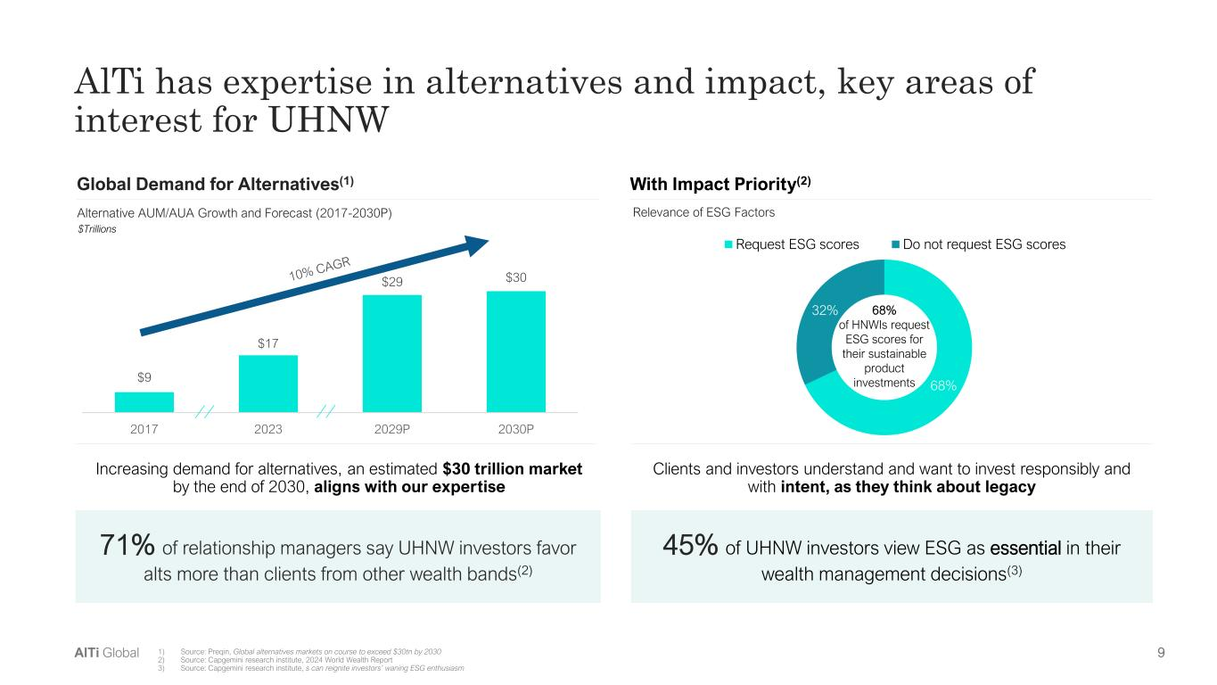
AlTi Color Palette Background color Primary Accent Color Secondary colors Tertiary colors 9AlTi Global $9 $17 $29 $30 2017 2023 2029P 2030P 1) Source: Preqin, Global alternatives markets on course to exceed $30tn by 2030 2) Source: Capgemini research institute, 2024 World Wealth Report 3) Source: Capgemini research institute, s can reignite investors’ waning ESG enthusiasm AlTi has expertise in alternatives and impact, key areas of interest for UHNW 71% of relationship managers say UHNW investors favor alts more than clients from other wealth bands(2) Alternative AUM/AUA Growth and Forecast (2017-2030P) Relevance of ESG Factors $Trillions Global Demand for Alternatives(1) Increasing demand for alternatives, an estimated $30 trillion market by the end of 2030, aligns with our expertise Clients and investors understand and want to invest responsibly and with intent, as they think about legacy 68% 32% Request ESG scores Do not request ESG scores 68% of HNWIs request ESG scores for their sustainable product investments 45% of UHNW investors view ESG as essential in their wealth management decisions(3) With Impact Priority(2)

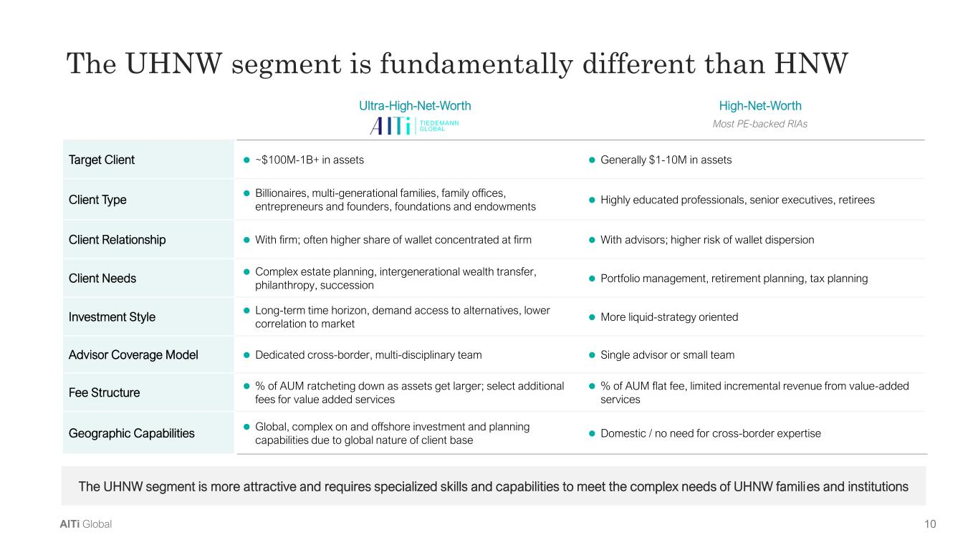
AlTi Color Palette Background color Primary Accent Color Secondary colors Tertiary colors 10AlTi Global The UHNW segment is fundamentally different than HNW The UHNW segment is more attractive and requires specialized skills and capabilities to meet the complex needs of UHNW families and institutions Ultra-High-Net-Worth High-Net-Worth Most PE-backed RIAs Target Client ⚫ ~$100M-1B+ in assets ⚫ Generally $1-10M in assets Client Type ⚫ Billionaires, multi-generational families, family offices, entrepreneurs and founders, foundations and endowments ⚫ Highly educated professionals, senior executives, retirees Client Relationship ⚫ With firm; often higher share of wallet concentrated at firm ⚫ With advisors; higher risk of wallet dispersion Client Needs ⚫ Complex estate planning, intergenerational wealth transfer, philanthropy, succession ⚫ Portfolio management, retirement planning, tax planning Investment Style ⚫ Long-term time horizon, demand access to alternatives, lower correlation to market ⚫ More liquid-strategy oriented Advisor Coverage Model ⚫ Dedicated cross-border, multi-disciplinary team ⚫ Single advisor or small team Fee Structure ⚫ % of AUM ratcheting down as assets get larger; select additional fees for value added services ⚫ % of AUM flat fee, limited incremental revenue from value-added services Geographic Capabilities ⚫ Global, complex on and offshore investment and planning capabilities due to global nature of client base ⚫ Domestic / no need for cross-border expertise

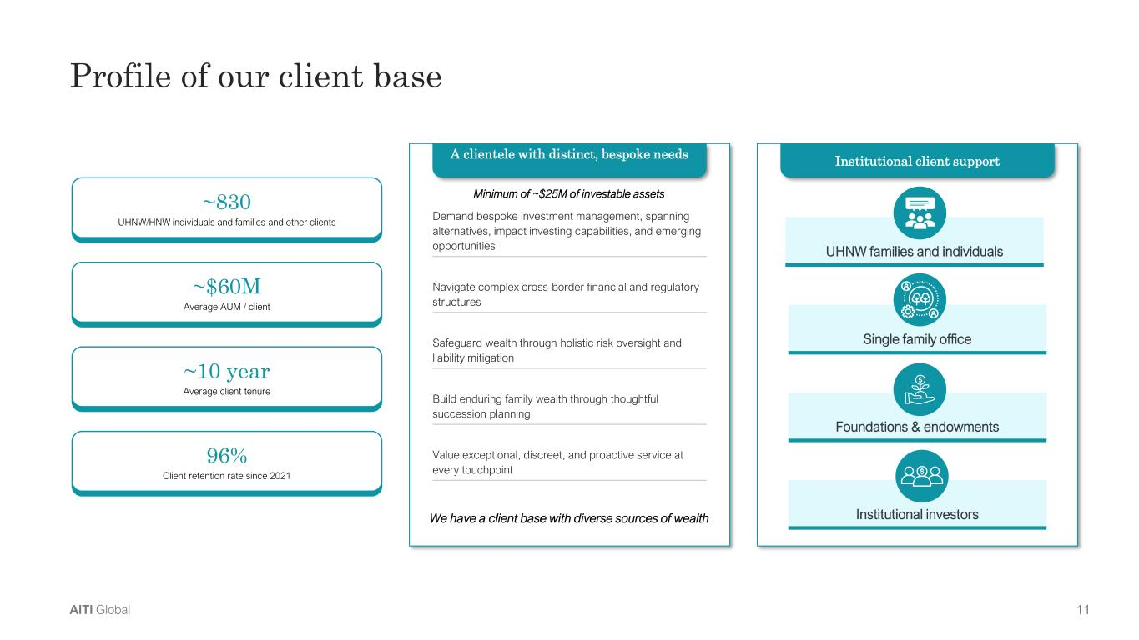
AlTi Color Palette Background color Primary Accent Color Secondary colors Tertiary colors 11AlTi Global Profile of our client base Institutional client support Foundations & endowments Single family office Institutional investors UHNW families and individuals ~830 UHNW/HNW individuals and families and other clients ~$60M Average AUM / client 96% Client retention rate since 2021 ~10 year Average client tenure A clientele with distinct, bespoke needs Demand bespoke investment management, spanning alternatives, impact investing capabilities, and emerging opportunities Navigate complex cross-border financial and regulatory structures Safeguard wealth through holistic risk oversight and liability mitigation Build enduring family wealth through thoughtful succession planning Value exceptional, discreet, and proactive service at every touchpoint We have a client base with diverse sources of wealth Minimum of ~$25M of investable assets

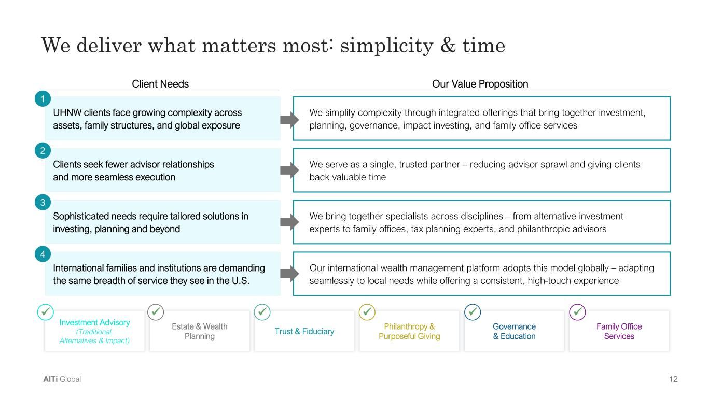
AlTi Color Palette Background color Primary Accent Color Secondary colors Tertiary colors 12AlTi Global We deliver what matters most: simplicity & time Investment Advisory (Traditional, Alternatives & Impact) Trust & Fiduciary Governance & Education Estate & Wealth Planning Philanthropy & Purposeful Giving Family Office Services Client Needs Our Value Proposition ✓ ✓ ✓ ✓ ✓ ✓ We bring together specialists across disciplines – from alternative investment experts to family offices, tax planning experts, and philanthropic advisors We simplify complexity through integrated offerings that bring together investment, planning, governance, impact investing, and family office services We serve as a single, trusted partner – reducing advisor sprawl and giving clients back valuable time UHNW clients face growing complexity across assets, family structures, and global exposure 1 Clients seek fewer advisor relationships and more seamless execution 2 Sophisticated needs require tailored solutions in investing, planning and beyond 3 International families and institutions are demanding the same breadth of service they see in the U.S. 4 Our international wealth management platform adopts this model globally – adapting seamlessly to local needs while offering a consistent, high-touch experience

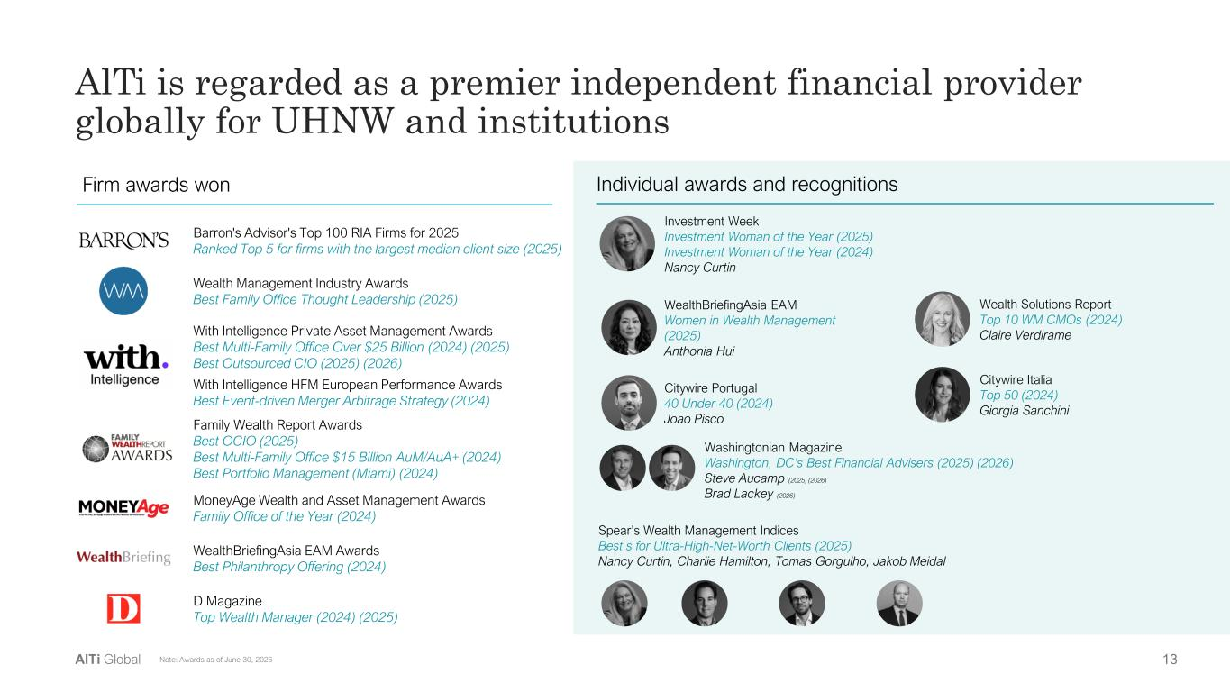
AlTi Color Palette Background color Primary Accent Color Secondary colors Tertiary colors 13AlTi Global AlTi is regarded as a premier independent financial provider globally for UHNW and institutions Firm awards won Individual awards and recognitions With Intelligence Private Asset Management Awards Best Multi-Family Office Over $25 Billion (2024) (2025) Best Outsourced CIO (2025) (2026) With Intelligence HFM European Performance Awards Best Event-driven Merger Arbitrage Strategy (2024) Family Wealth Report Awards Best OCIO (2025) Best Multi-Family Office $15 Billion AuM/AuA+ (2024) Best Portfolio Management (Miami) (2024) MoneyAge Wealth and Asset Management Awards Family Office of the Year (2024) WealthBriefingAsia EAM Awards Best Philanthropy Offering (2024) D Magazine Top Wealth Manager (2024) (2025) Spear’s Wealth Management Indices Best s for Ultra-High-Net-Worth Clients (2025) Nancy Curtin, Charlie Hamilton, Tomas Gorgulho, Jakob Meidal Investment Week Investment Woman of the Year (2025) Investment Woman of the Year (2024) Nancy Curtin Wealth Solutions Report Top 10 WM CMOs (2024) Claire Verdirame WealthBriefingAsia EAM Women in Wealth Management (2025) Anthonia Hui Citywire Italia Top 50 (2024) Giorgia Sanchini Citywire Portugal 40 Under 40 (2024) Joao Pisco Washingtonian Magazine Washington, DC’s Best Financial Advisers (2025) (2026) Steve Aucamp (2025) (2026) Brad Lackey (2026) Wealth Management Industry Awards Best Family Office Thought Leadership (2025) Barron's Advisor's Top 100 RIA Firms for 2025 Ranked Top 5 for firms with the largest median client size (2025) Note: Awards as of June 30, 2026

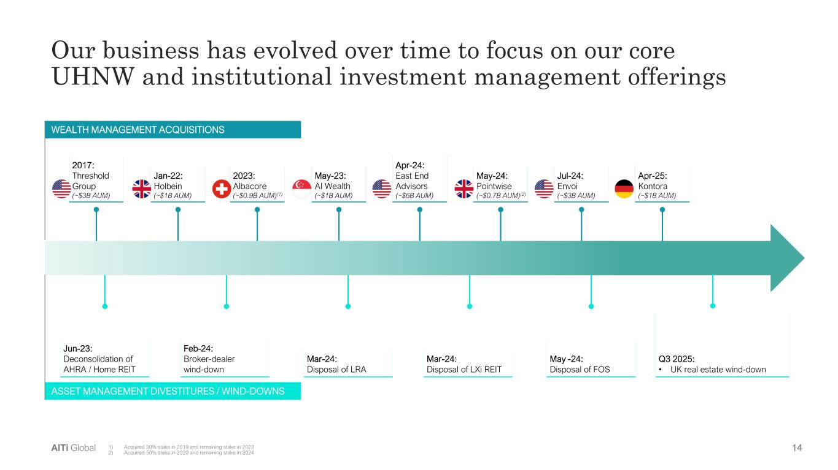
AlTi Color Palette Background color Primary Accent Color Secondary colors Tertiary colors 14AlTi Global Our business has evolved over time to focus on our core UHNW and institutional investment management offerings ASSET MANAGEMENT DIVESTITURES / WIND-DOWNS WEALTH MANAGEMENT ACQUISITIONS Jun-23: Deconsolidation of AHRA / Home REIT Feb-24: Broker-dealer wind-down Mar-24: Disposal of LRA Mar-24: Disposal of LXi REIT May -24: Disposal of FOS Q3 2025: • UK real estate wind-down May-23: AI Wealth (~$1B AUM) 2017: Threshold Group (~$3B AUM) Apr-24: East End Advisors (~$6B AUM) May-24: Pointwise (~$0.7B AUM)(2) Apr-25: Kontora (~$1B AUM) Jul-24: Envoi (~$3B AUM) Jan-22: Holbein (~$1B AUM) 2023: Albacore (~$0.9B AUM)(1) 1) Acquired 30% stake in 2019 and remaining stake in 2023 2) Acquired 50% stake in 2020 and remaining stake in 2024

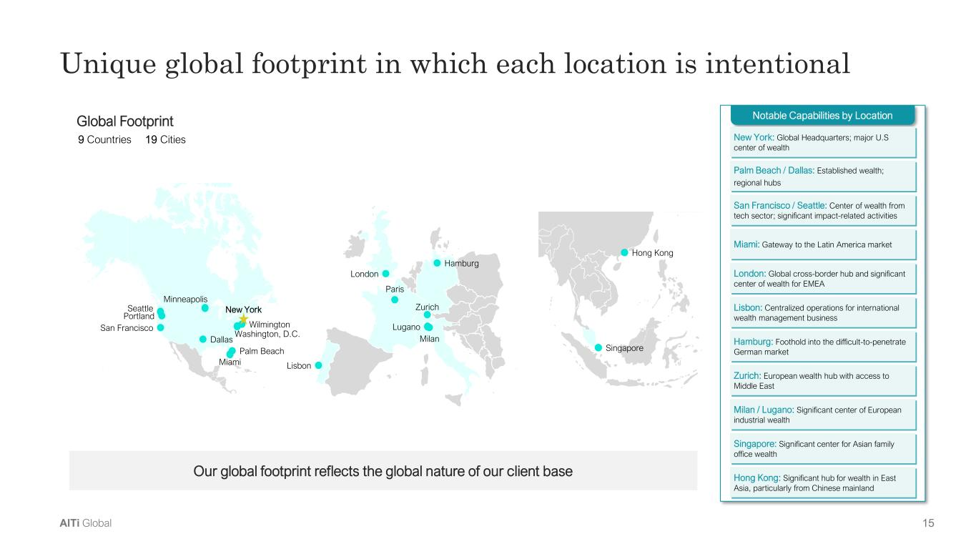
AlTi Color Palette Background color Primary Accent Color Secondary colors Tertiary colors 15AlTi Global Notable Capabilities by Location Global Footprint 9 Countries 19 Cities Our global footprint reflects the global nature of our client base London: Global cross-border hub and significant center of wealth for EMEA Zurich: European wealth hub with access to Middle East San Francisco / Seattle: Center of wealth from tech sector; significant impact-related activities Palm Beach / Dallas: Established wealth; regional hubs Miami: Gateway to the Latin America market Hamburg: Foothold into the difficult-to-penetrate German market New York: Global Headquarters; major U.S center of wealth Lisbon: Centralized operations for international wealth management business Milan / Lugano: Significant center of European industrial wealth Singapore: Significant center for Asian family office wealth Hong Kong: Significant hub for wealth in East Asia, particularly from Chinese mainland Singapore Hong Kong Wilmington Seattle Portland San Francisco Dallas Miami Minneapolis Washington, D.C. Palm Beach New York Lisbon Lugano Zurich Milan London Paris Hamburg Unique global footprint in which each location is intentional

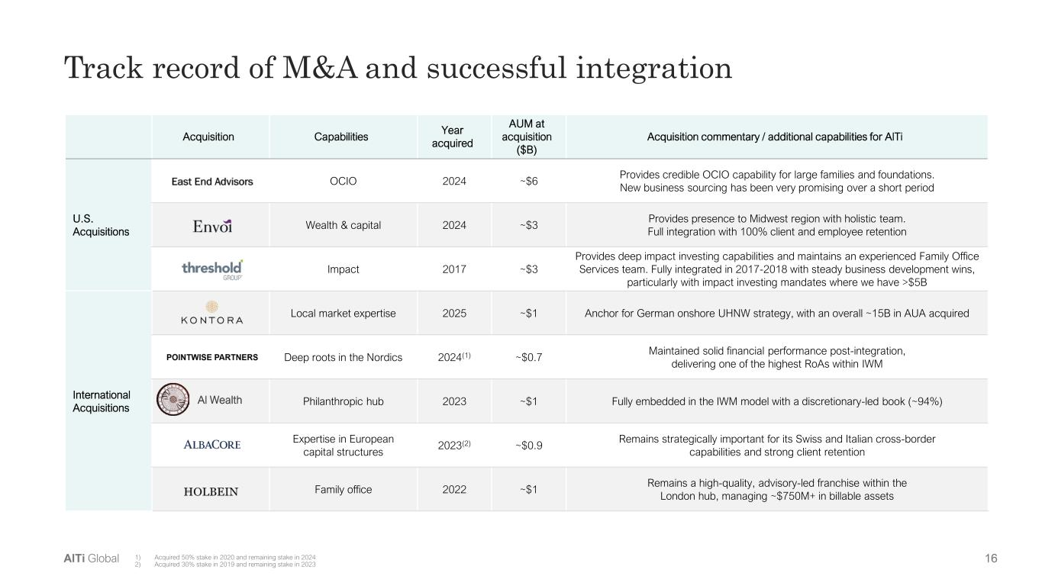
AlTi Color Palette Background color Primary Accent Color Secondary colors Tertiary colors 16AlTi Global Track record of M&A and successful integration Acquisition Capabilities Year acquired AUM at acquisition ($B) Acquisition commentary / additional capabilities for AlTi U.S. Acquisitions OCIO 2024 ~$6 Provides credible OCIO capability for large families and foundations. New business sourcing has been very promising over a short period Wealth & capital 2024 ~$3 Provides presence to Midwest region with holistic team. Full integration with 100% client and employee retention Impact 2017 ~$3 Provides deep impact investing capabilities and maintains an experienced Family Office Services team. Fully integrated in 2017-2018 with steady business development wins, particularly with impact investing mandates where we have >$5B International Acquisitions Local market expertise 2025 ~$1 Anchor for German onshore UHNW strategy, with an overall ~15B in AUA acquired Deep roots in the Nordics 2024(1) ~$0.7 Maintained solid financial performance post-integration, delivering one of the highest RoAs within IWM Philanthropic hub 2023 ~$1 Fully embedded in the IWM model with a discretionary-led book (~94%) Expertise in European capital structures 2023(2) ~$0.9 Remains strategically important for its Swiss and Italian cross-border capabilities and strong client retention Family office 2022 ~$1 Remains a high-quality, advisory-led franchise within the London hub, managing ~$750M+ in billable assets Al Wealth 1) Acquired 50% stake in 2020 and remaining stake in 2024 2) Acquired 30% stake in 2019 and remaining stake in 2023

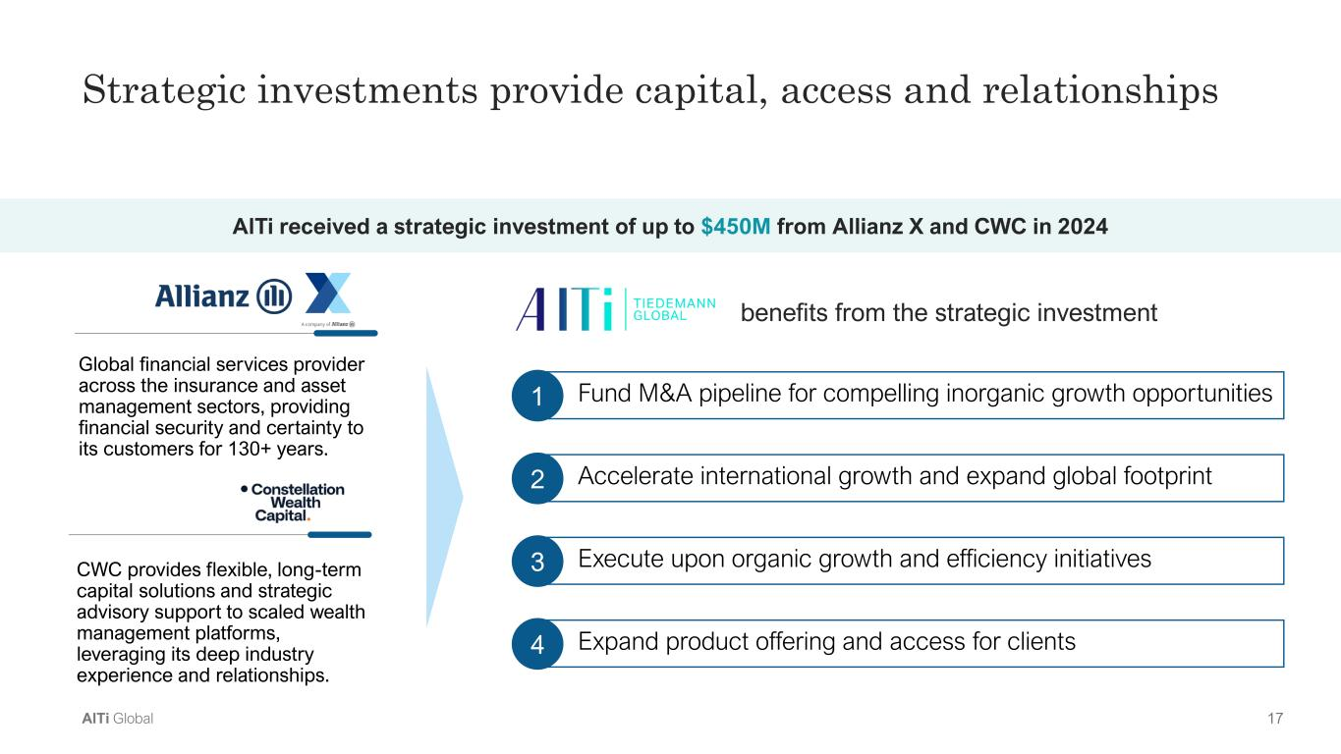
AlTi Color Palette Background color Primary Accent Color Secondary colors Tertiary colors 17AlTi Global Strategic investments provide capital, access and relationships Global financial services provider across the insurance and asset management sectors, providing financial security and certainty to its customers for 130+ years. CWC provides flexible, long-term capital solutions and strategic advisory support to scaled wealth management platforms, leveraging its deep industry experience and relationships. AlTi received a strategic investment of up to $450M from Allianz X and CWC in 2024 Fund M&A pipeline for compelling inorganic growth opportunities1 benefits from the strategic investment Accelerate international growth and expand global footprint2 Execute upon organic growth and efficiency initiatives3 Expand product offering and access for clients4

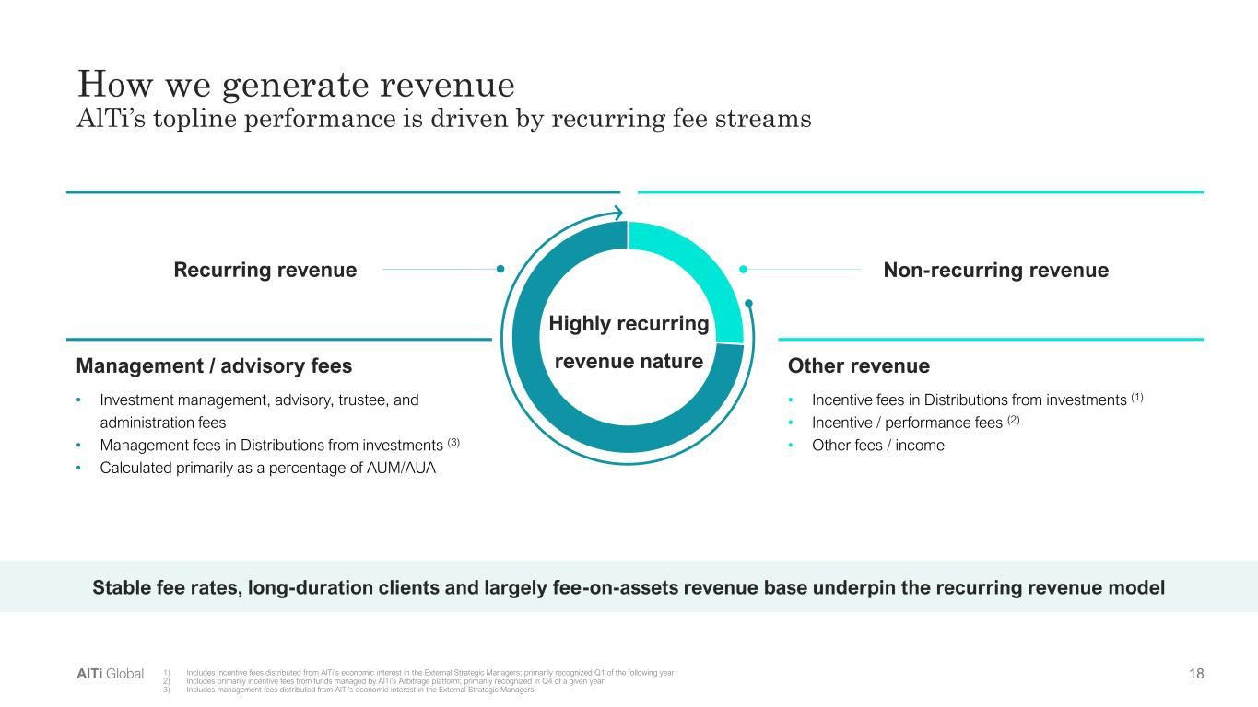
AlTi Color Palette Background color Primary Accent Color Secondary colors Tertiary colors 18AlTi Global How we generate revenue AlTi’s topline performance is driven by recurring fee streams Recurring revenue Non-recurring revenue Management / advisory fees • Investment management, advisory, trustee, and administration fees • Management fees in Distributions from investments (3) • Calculated primarily as a percentage of AUM/AUA Other revenue • Incentive fees in Distributions from investments (1) • Incentive / performance fees (2) • Other fees / income 1) Includes incentive fees distributed from AlTi’s economic interest in the External Strategic Managers; primarily recognized Q1 of the following year 2) Includes primarily incentive fees from funds managed by AlTi’s Arbitrage platform; primarily recognized in Q4 of a given year 3) Includes management fees distributed from AlTi’s economic interest in the External Strategic Managers Stable fee rates, long-duration clients and largely fee-on-assets revenue base underpin the recurring revenue model Highly recurring revenue nature

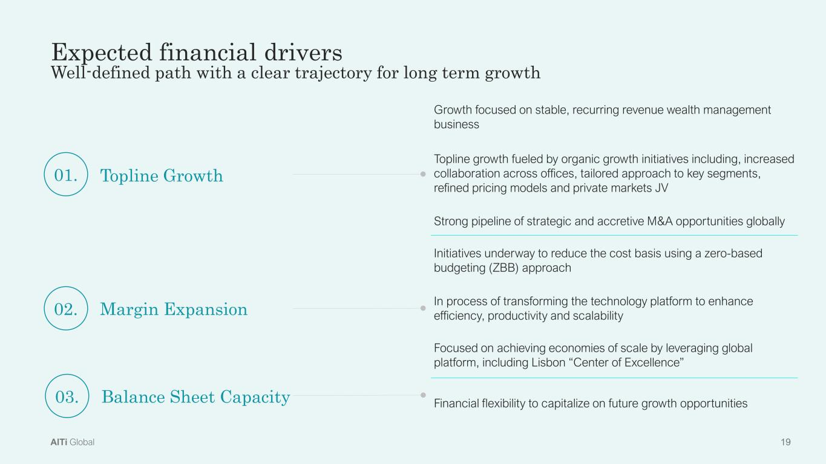
AlTi Color Palette Background color Primary Accent Color Secondary colors Tertiary colors 19AlTi Global Growth focused on stable, recurring revenue wealth management business Topline growth fueled by organic growth initiatives including, increased collaboration across offices, tailored approach to key segments, refined pricing models and private markets JV Strong pipeline of strategic and accretive M&A opportunities globally Initiatives underway to reduce the cost basis using a zero-based budgeting (ZBB) approach In process of transforming the technology platform to enhance efficiency, productivity and scalability Focused on achieving economies of scale by leveraging global platform, including Lisbon “Center of Excellence” Financial flexibility to capitalize on future growth opportunities 01. Topline Growth 02. Margin Expansion 03. Balance Sheet Capacity Expected financial drivers Well-defined path with a clear trajectory for long term growth

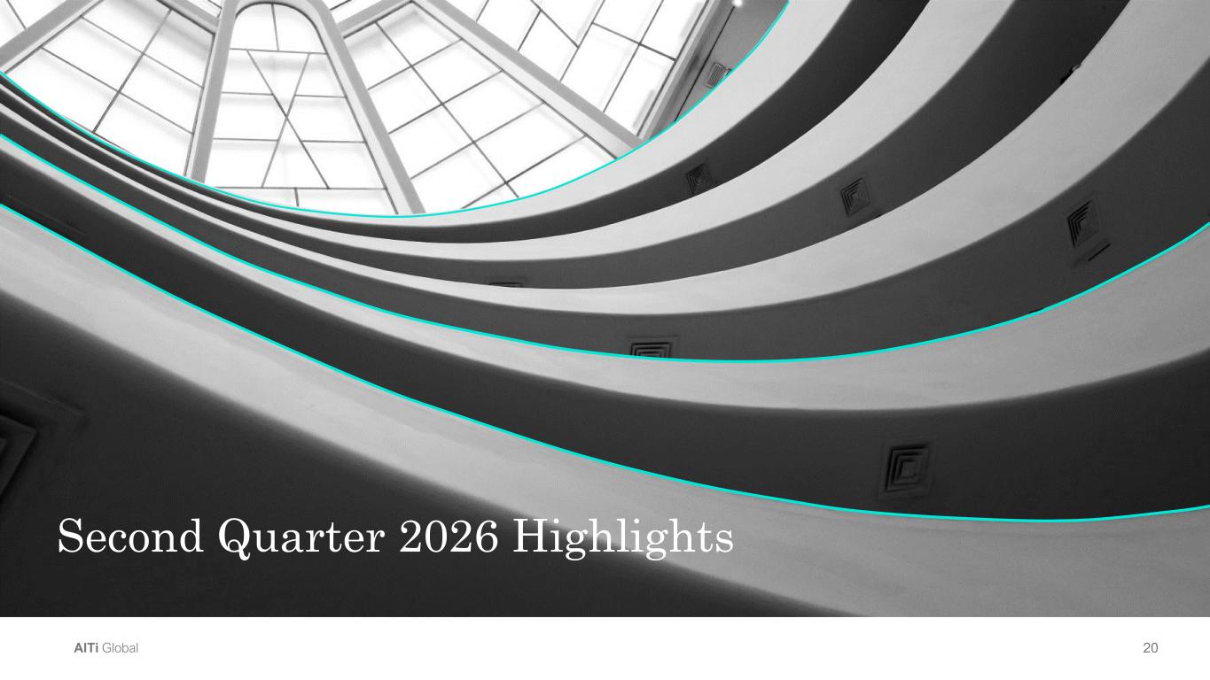
AlTi Color Palette Background color Primary Accent Color Secondary colors Tertiary colors 20AlTi Global Second Quarter 2026 Highlights

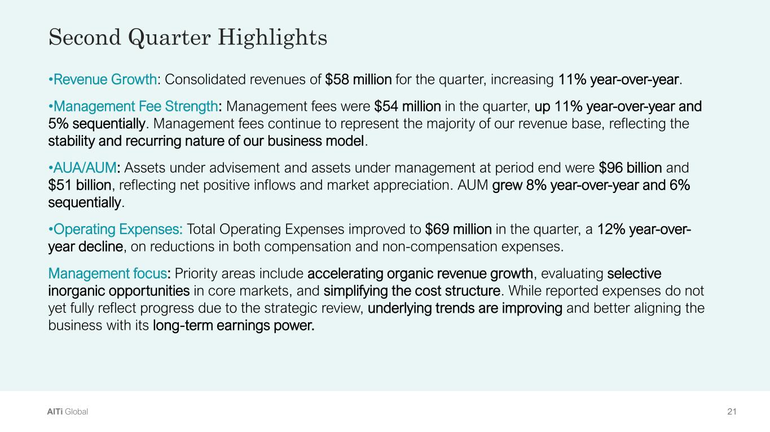
AlTi Color Palette Background color Primary Accent Color Secondary colors Tertiary colors 21AlTi Global •Revenue Growth: Consolidated revenues of $58 million for the quarter, increasing 11% year-over-year. •Management Fee Strength: Management fees were $54 million in the quarter, up 11% year-over-year and 5% sequentially. Management fees continue to represent the majority of our revenue base, reflecting the stability and recurring nature of our business model. •AUA/AUM: Assets under advisement and assets under management at period end were $96 billion and $51 billion, reflecting net positive inflows and market appreciation. AUM grew 8% year-over-year and 6% sequentially. •Operating Expenses: Total Operating Expenses improved to $69 million in the quarter, a 12% year-over- year decline, on reductions in both compensation and non-compensation expenses. Management focus: Priority areas include accelerating organic revenue growth, evaluating selective inorganic opportunities in core markets, and simplifying the cost structure. While reported expenses do not yet fully reflect progress due to the strategic review, underlying trends are improving and better aligning the business with its long-term earnings power. Second Quarter Highlights

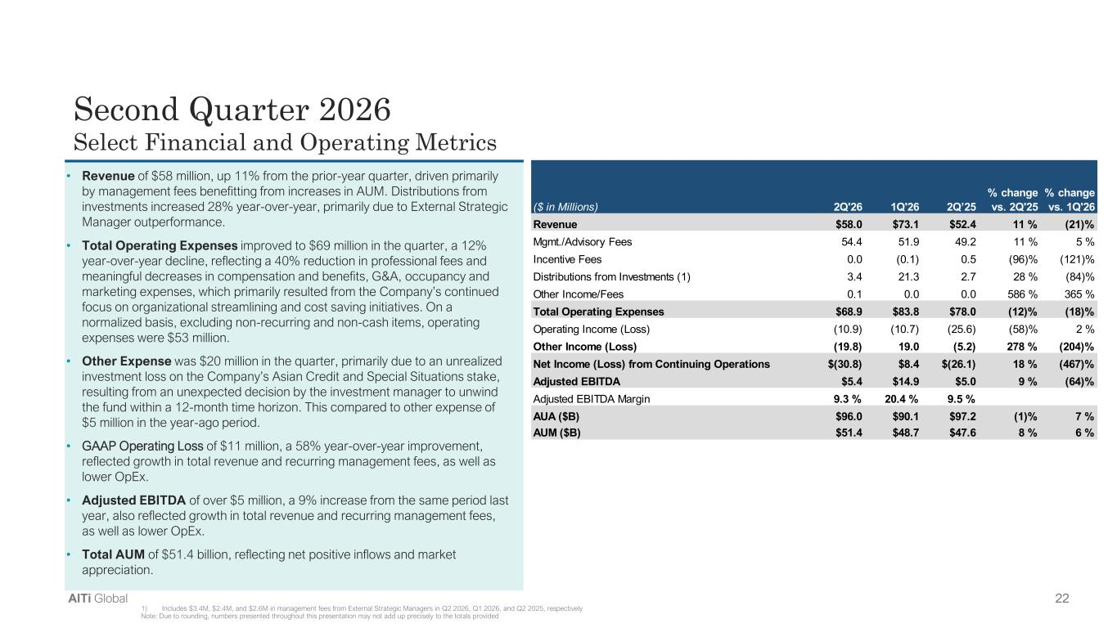
AlTi Color Palette Background color Primary Accent Color Secondary colors Tertiary colors 22AlTi Global Second Quarter 2026 Select Financial and Operating Metrics • Revenue of $58 million, up 11% from the prior-year quarter, driven primarily by management fees benefitting from increases in AUM. Distributions from investments increased 28% year-over-year, primarily due to External Strategic Manager outperformance. • Total Operating Expenses improved to $69 million in the quarter, a 12% year-over-year decline, reflecting a 40% reduction in professional fees and meaningful decreases in compensation and benefits, G&A, occupancy and marketing expenses, which primarily resulted from the Company’s continued focus on organizational streamlining and cost saving initiatives. On a normalized basis, excluding non-recurring and non-cash items, operating expenses were $53 million. • Other Expense was $20 million in the quarter, primarily due to an unrealized investment loss on the Company’s Asian Credit and Special Situations stake, resulting from an unexpected decision by the investment manager to unwind the fund within a 12-month time horizon. This compared to other expense of $5 million in the year-ago period. • GAAP Operating Loss of $11 million, a 58% year-over-year improvement, reflected growth in total revenue and recurring management fees, as well as lower OpEx. • Adjusted EBITDA of over $5 million, a 9% increase from the same period last year, also reflected growth in total revenue and recurring management fees, as well as lower OpEx. • Total AUM of $51.4 billion, reflecting net positive inflows and market appreciation. 1) Includes $3.4M, $2.4M, and $2.6M in management fees from External Strategic Managers in Q2 2026, Q1 2026, and Q2 2025, respectively Note: Due to rounding, numbers presented throughout this presentation may not add up precisely to the totals provided ($ in Millions) 2Q'26 1Q'26 2Q’25 % change vs. 2Q'25 % change vs. 1Q'26 Revenue $58.0 $73.1 $52.4 11 % (21)% Mgmt./Advisory Fees 54.4 51.9 49.2 11 % 5 % Incentive Fees 0.0 (0.1) 0.5 (96)% (121)% Distributions from Investments (1) 3.4 21.3 2.7 28 % (84)% Other Income/Fees 0.1 0.0 0.0 586 % 365 % Total Operating Expenses $68.9 $83.8 $78.0 (12)% (18)% Operating Income (Loss) (10.9) (10.7) (25.6) (58)% 2 % Other Income (Loss) (19.8) 19.0 (5.2) 278 % (204)% Net Income (Loss) from Continuing Operations $(30.8) $8.4 $(26.1) 18 % (467)% Adjusted EBITDA $5.4 $14.9 $5.0 9 % (64)% Adjusted EBITDA Margin 9.3 % 20.4 % 9.5 % AUA ($B) $96.0 $90.1 $97.2 (1)% 7 % AUM ($B) $51.4 $48.7 $47.6 8 % 6 %

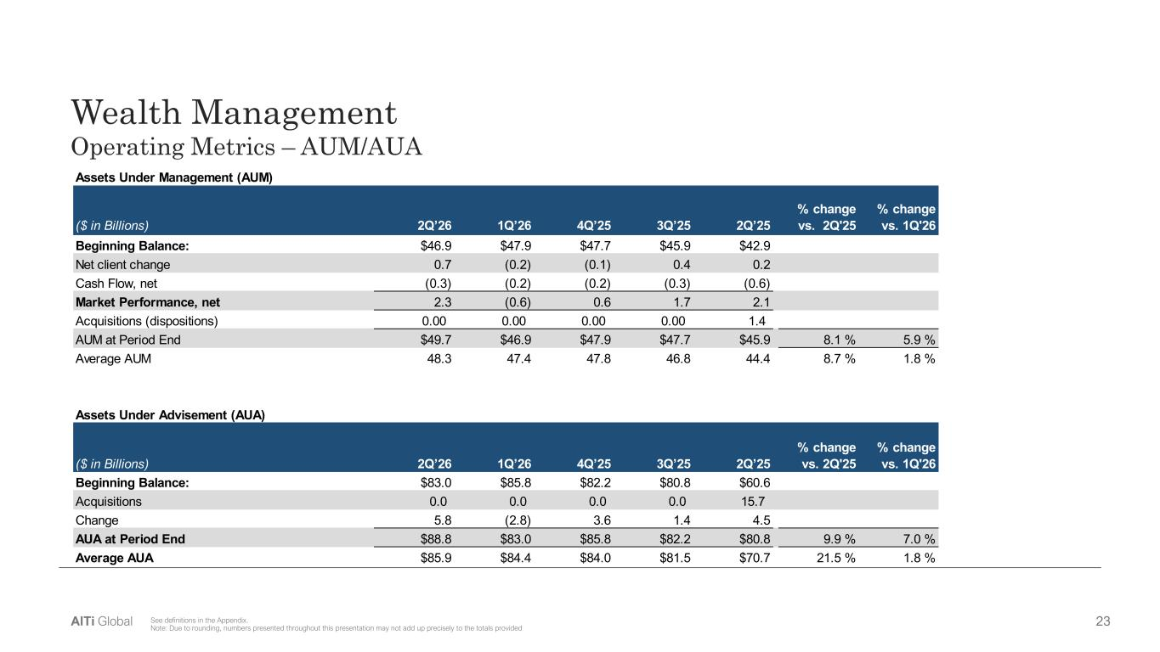
AlTi Color Palette Background color Primary Accent Color Secondary colors Tertiary colors 23AlTi Global Wealth Management Operating Metrics – AUM/AUA See definitions in the Appendix. Note: Due to rounding, numbers presented throughout this presentation may not add up precisely to the totals provided ($ in Billions) 2Q’26 1Q’26 4Q’25 3Q’25 2Q’25 % change vs. 2Q'25 % change vs. 1Q'26 Beginning Balance: $46.9 $47.9 $47.7 $45.9 $42.9 Net client change 0.7 (0.2) (0.1) 0.4 0.2 Cash Flow, net (0.3) (0.2) (0.2) (0.3) (0.6) Market Performance, net 2.3 (0.6) 0.6 1.7 2.1 Acquisitions (dispositions) 0.00 0.00 0.00 0.00 1.4 AUM at Period End $49.7 $46.9 $47.9 $47.7 $45.9 8.1 % 5.9 % Average AUM 48.3 47.4 47.8 46.8 44.4 8.7 % 1.8 % ($ in Billions) 2Q’26 1Q’26 4Q’25 3Q’25 2Q’25 % change vs. 2Q'25 % change vs. 1Q'26 Beginning Balance: $83.0 $85.8 $82.2 $80.8 $60.6 Acquisitions 0.0 0.0 0.0 0.0 15.7 Change 5.8 (2.8) 3.6 1.4 4.5 AUA at Period End $88.8 $83.0 $85.8 $82.2 $80.8 9.9 % 7.0 % Average AUA $85.9 $84.4 $84.0 $81.5 $70.7 21.5 % 1.8 % Assets Under Management (AUM) Assets Under Advisement (AUA)

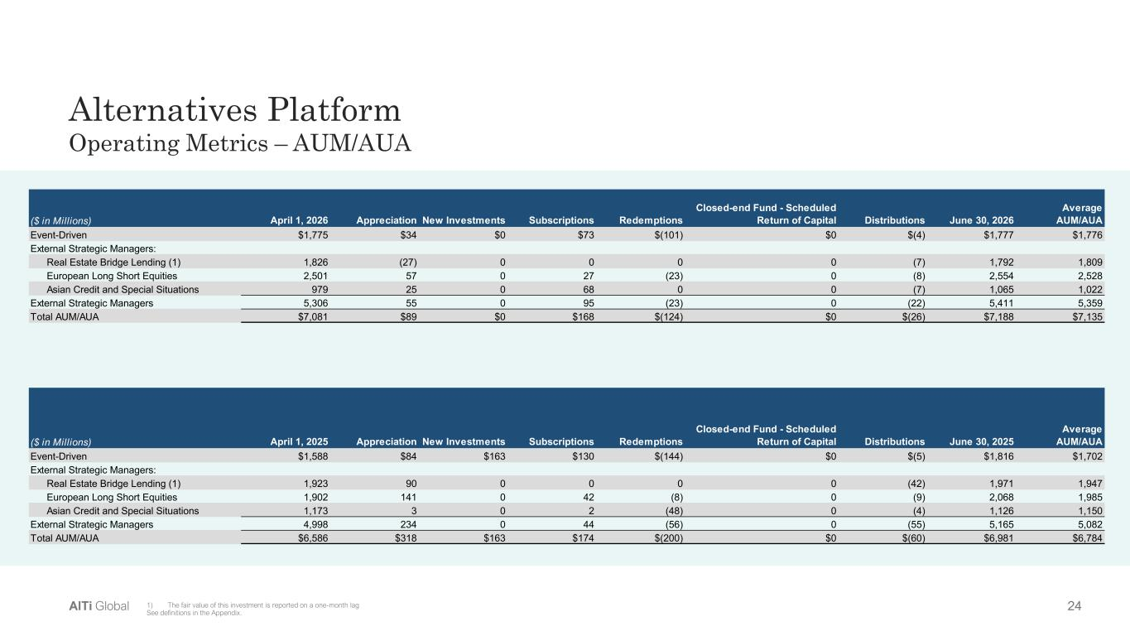
AlTi Color Palette Background color Primary Accent Color Secondary colors Tertiary colors 24AlTi Global Alternatives Platform Operating Metrics – AUM/AUA 1) The fair value of this investment is reported on a one-month lag See definitions in the Appendix. ($ in Millions) April 1, 2026 Appreciation New Investments Subscriptions Redemptions Closed-end Fund - Scheduled Return of Capital Distributions June 30, 2026 Average AUM/AUA Event-Driven $1,775 $34 $0 $73 $(101) $0 $(4) $1,777 $1,776 External Strategic Managers: Real Estate Bridge Lending (1) 1,826 (27) 0 0 0 0 (7) 1,792 1,809 European Long Short Equities 2,501 57 0 27 (23) 0 (8) 2,554 2,528 Asian Credit and Special Situations 979 25 0 68 0 0 (7) 1,065 1,022 External Strategic Managers 5,306 55 0 95 (23) 0 (22) 5,411 5,359 Total AUM/AUA $7,081 $89 $0 $168 $(124) $0 $(26) $7,188 $7,135 ($ in Millions) April 1, 2025 Appreciation New Investments Subscriptions Redemptions Closed-end Fund - Scheduled Return of Capital Distributions June 30, 2025 Average AUM/AUA Event-Driven $1,588 $84 $163 $130 $(144) $0 $(5) $1,816 $1,702 External Strategic Managers: Real Estate Bridge Lending (1) 1,923 90 0 0 0 0 (42) 1,971 1,947 European Long Short Equities 1,902 141 0 42 (8) 0 (9) 2,068 1,985 Asian Credit and Special Situations 1,173 3 0 2 (48) 0 (4) 1,126 1,150 External Strategic Managers 4,998 234 0 44 (56) 0 (55) 5,165 5,082 Total AUM/AUA $6,586 $318 $163 $174 $(200) $0 $(60) $6,981 $6,784

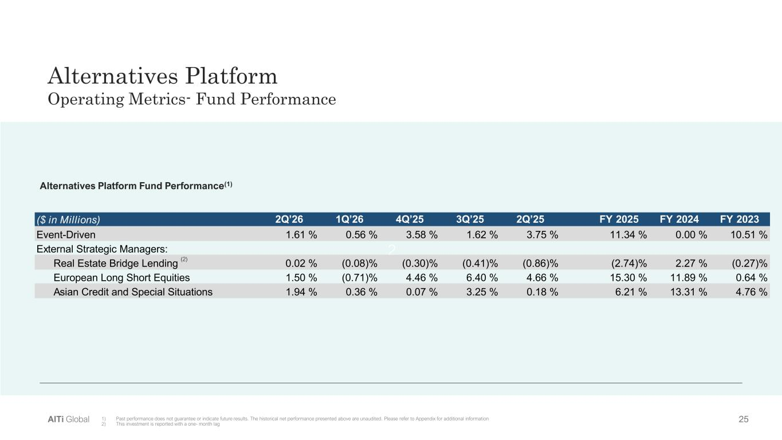
AlTi Color Palette Background color Primary Accent Color Secondary colors Tertiary colors 25AlTi Global 2 Alternatives Platform Fund Performance(1) 1) Past performance does not guarantee or indicate future results. The historical net performance presented above are unaudited. Please refer to Appendix for additional information 2) This investment is reported with a one- month lag Alternatives Platform Operating Metrics- Fund Performance ($ in Millions) 2Q’26 1Q’26 4Q’25 3Q’25 2Q’25 FY 2025 FY 2024 FY 2023 Event-Driven 1.61 % 0.56 % 3.58 % 1.62 % 3.75 % 11.34 % 0.00 % 10.51 % External Strategic Managers: Real Estate Bridge Lending 0.02 % (0.08)% (0.30)% (0.41)% (0.86)% (2.74)% 2.27 % (0.27)% European Long Short Equities 1.50 % (0.71)% 4.46 % 6.40 % 4.66 % 15.30 % 11.89 % 0.64 % Asian Credit and Special Situations 1.94 % 0.36 % 0.07 % 3.25 % 0.18 % 6.21 % 13.31 % 4.76 % (2)

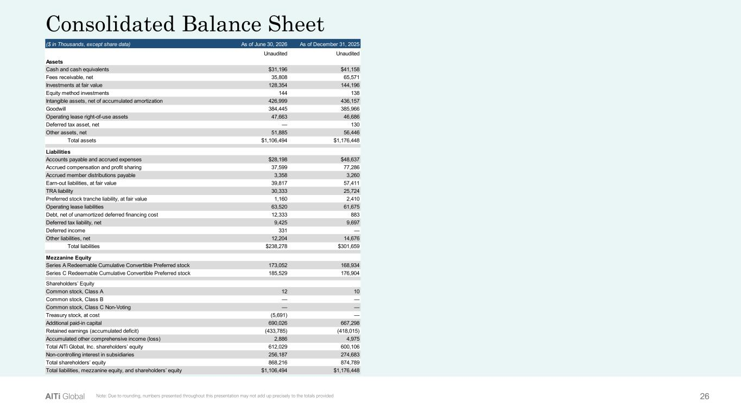
AlTi Color Palette Background color Primary Accent Color Secondary colors Tertiary colors 26AlTi Global Consolidated Balance Sheet Note: Due to rounding, numbers presented throughout this presentation may not add up precisely to the totals provided ($ in Thousands, except share data) As of June 30, 2026 As of December 31, 2025 Unaudited Unaudited Assets Cash and cash equivalents $31,196 $41,158 Fees receivable, net 35,808 65,571 Investments at fair value 128,354 144,196 Equity method investments 144 138 Intangible assets, net of accumulated amortization 426,999 436,157 Goodwill 384,445 385,966 Operating lease right-of-use assets 47,663 46,686 Deferred tax asset, net — 130 Other assets, net 51,885 56,446 Total assets $1,106,494 $1,176,448 Liabilities Accounts payable and accrued expenses $28,198 $48,637 Accrued compensation and profit sharing 37,599 77,286 Accrued member distributions payable 3,358 3,260 Earn-out liabilities, at fair value 39,817 57,411 TRA liability 30,333 25,724 Preferred stock tranche liability, at fair value 1,160 2,410 Operating lease liabilities 63,520 61,675 Debt, net of unamortized deferred financing cost 12,333 883 Deferred tax liability, net 9,425 9,697 Deferred income 331 — Other liabilities, net 12,204 14,676 Total liabilities $238,278 $301,659 Mezzanine Equity Series A Redeemable Cumulative Convertible Preferred stock 173,052 168,934 Series C Redeemable Cumulative Convertible Preferred stock 185,529 176,904 Shareholders’ Equity Common stock, Class A 12 10 Common stock, Class B — — Common stock, Class C Non-Voting — — Treasury stock, at cost (5,691) — Additional paid-in capital 690,026 667,298 Retained earnings (accumulated deficit) (433,785) (418,015) Accumulated other comprehensive income (loss) 2,886 4,975 Total AlTi Global, Inc. shareholders’ equity 612,029 600,106 Non-controlling interest in subsidiaries 256,187 274,683 Total shareholders’ equity 868,216 874,789 Total liabilities, mezzanine equity, and shareholders’ equity $1,106,494 $1,176,448

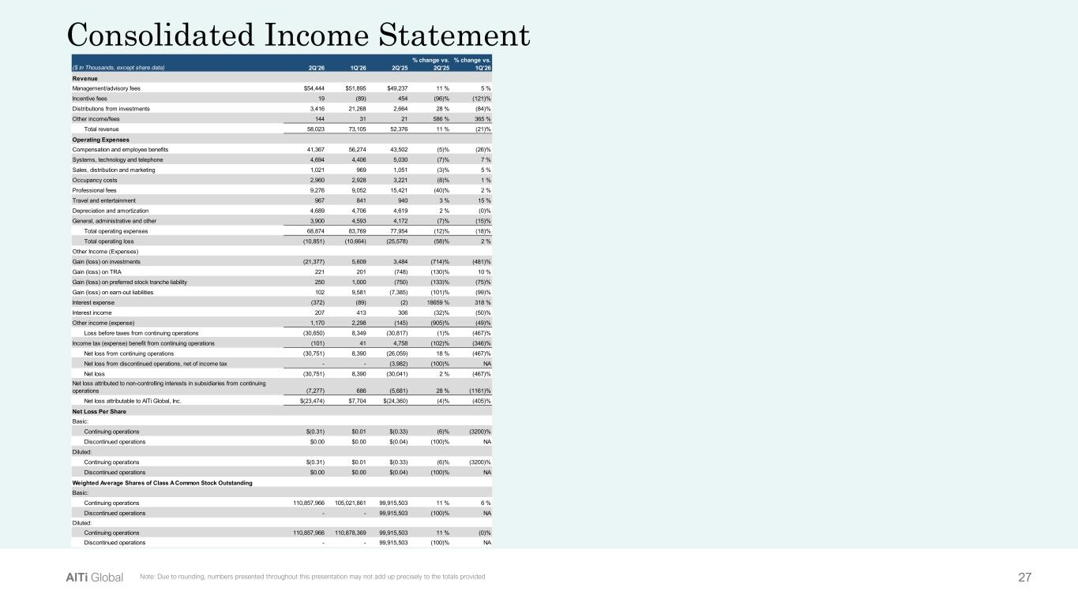
AlTi Color Palette Background color Primary Accent Color Secondary colors Tertiary colors 27AlTi Global Consolidated Income Statement Note: Due to rounding, numbers presented throughout this presentation may not add up precisely to the totals provided ($ in Thousands, except share data) 2Q’26 1Q’26 2Q’25 % change vs. 2Q'25 % change vs. 1Q'26 Revenue Management/advisory fees $54,444 $51,895 $49,237 11 % 5 % Incentive fees 19 (89) 454 (96)% (121)% Distributions from investments 3,416 21,268 2,664 28 % (84)% Other income/fees 144 31 21 586 % 365 % Total revenue 58,023 73,105 52,376 11 % (21)% Operating Expenses Compensation and employee benefits 41,367 56,274 43,502 (5)% (26)% Systems, technology and telephone 4,694 4,406 5,030 (7)% 7 % Sales, distribution and marketing 1,021 969 1,051 (3)% 5 % Occupancy costs 2,960 2,928 3,221 (8)% 1 % Professional fees 9,276 9,052 15,421 (40)% 2 % Travel and entertainment 967 841 940 3 % 15 % Depreciation and amortization 4,689 4,706 4,619 2 % (0)% General, administrative and other 3,900 4,593 4,172 (7)% (15)% Total operating expenses 68,874 83,769 77,954 (12)% (18)% Total operating loss (10,851) (10,664) (25,578) (58)% 2 % Other Income (Expenses) Gain (loss) on investments (21,377) 5,609 3,484 (714)% (481)% Gain (loss) on TRA 221 201 (748) (130)% 10 % Gain (loss) on preferred stock tranche liability 250 1,000 (750) (133)% (75)% Gain (loss) on earn-out liabilities 102 9,581 (7,385) (101)% (99)% Interest expense (372) (89) (2) 18659 % 318 % Interest income 207 413 306 (32)% (50)% Other income (expense) 1,170 2,298 (145) (905)% (49)% Loss before taxes from continuing operations (30,650) 8,349 (30,817) (1)% (467)% Income tax (expense) benefit from continuing operations (101) 41 4,758 (102)% (346)% Net loss from continuing operations (30,751) 8,390 (26,059) 18 % (467)% Net loss from discontinued operations, net of income tax - - (3,982) (100)% NA Net loss (30,751) 8,390 (30,041) 2 % (467)% Net loss attributed to non-controlling interests in subsidiaries from continuing operations (7,277) 686 (5,681) 28 % (1161)% Net loss attributable to AlTi Global, Inc. $(23,474) $7,704 $(24,360) (4)% (405)% Net Loss Per Share Basic: Continuing operations $(0.31) $0.01 $(0.33) (6)% (3200)% Discontinued operations $0.00 $0.00 $(0.04) (100)% NA Diluted: Continuing operations $(0.31) $0.01 $(0.33) (6)% (3200)% Discontinued operations $0.00 $0.00 $(0.04) (100)% NA Weighted Average Shares of Class A Common Stock Outstanding Basic: Continuing operations 110,857,966 105,021,861 99,915,503 11 % 6 % Discontinued operations - - 99,915,503 (100)% NA Diluted: Continuing operations 110,857,966 110,878,369 99,915,503 11 % (0)% Discontinued operations - - 99,915,503 (100)% NA

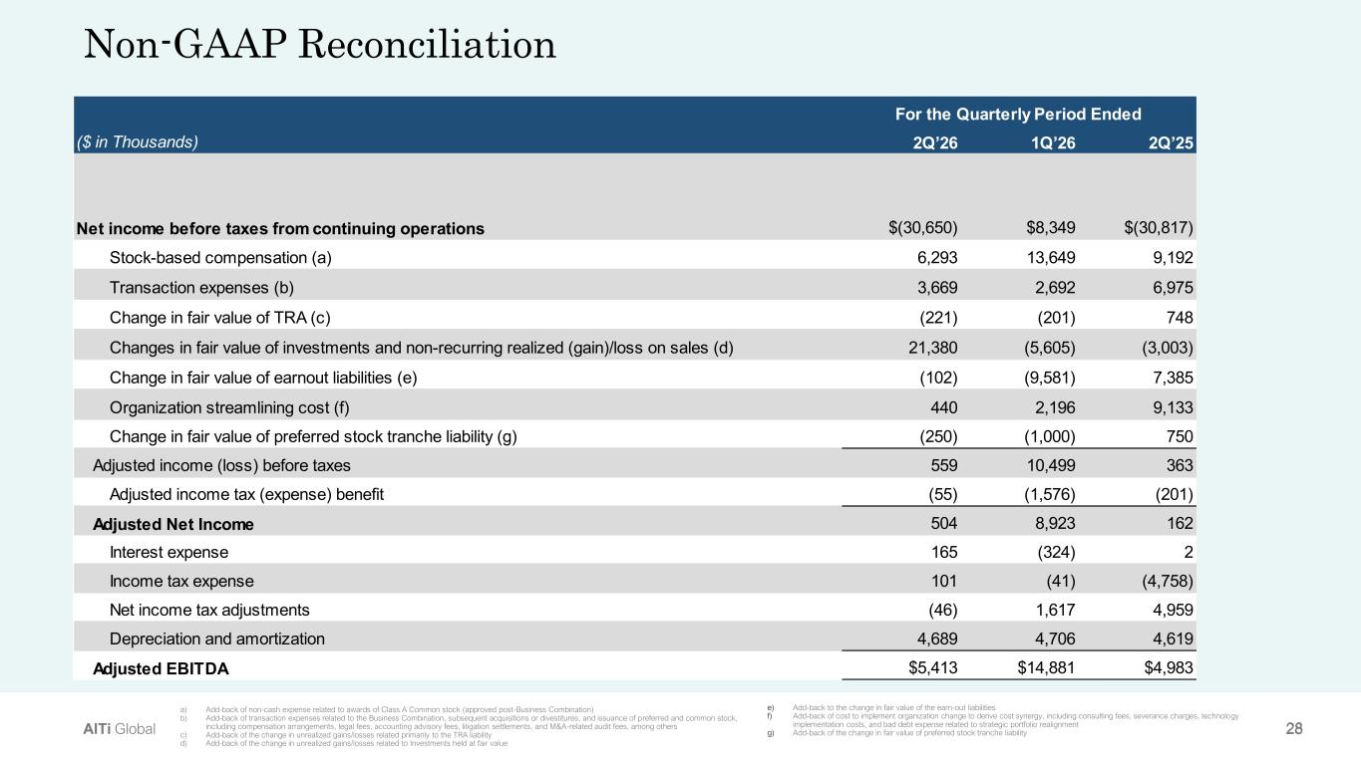
AlTi Color Palette Background color Primary Accent Color Secondary colors Tertiary colors 28AlTi Global e) Add-back to the change in fair value of the earn-out liabilities f) Add-back of cost to implement organization change to derive cost synergy, including consulting fees, severance charges, technology implementation costs, and bad debt expense related to strategic portfolio realignment g) Add-back of the change in fair value of preferred stock tranche liability Non-GAAP Reconciliation a) Add-back of non-cash expense related to awards of Class A Common stock (approved post-Business Combination) b) Add-back of transaction expenses related to the Business Combination, subsequent acquisitions or divestitures, and issuance of preferred and common stock, including compensation arrangements, legal fees, accounting advisory fees, litigation settlements, and M&A-related audit fees, among others c) Add-back of the change in unrealized gains/losses related primarily to the TRA liability d) Add-back of the change in unrealized gains/losses related to Investments held at fair value ($ in Thousands) 2Q’26 1Q’26 2Q’25 Net income before taxes from continuing operations $(30,650) $8,349 $(30,817) Stock-based compensation (a) 6,293 13,649 9,192 Transaction expenses (b) 3,669 2,692 6,975 Change in fair value of TRA (c) (221) (201) 748 Changes in fair value of investments and non-recurring realized (gain)/loss on sales (d) 21,380 (5,605) (3,003) Change in fair value of earnout liabilities (e) (102) (9,581) 7,385 Organization streamlining cost (f) 440 2,196 9,133 Change in fair value of preferred stock tranche liability (g) (250) (1,000) 750 Adjusted income (loss) before taxes 559 10,499 363 Adjusted income tax (expense) benefit (55) (1,576) (201) Adjusted Net Income 504 8,923 162 Interest expense 165 (324) 2 Income tax expense 101 (41) (4,758) Net income tax adjustments (46) 1,617 4,959 Depreciation and amortization 4,689 4,706 4,619 Adjusted EBITDA $5,413 $14,881 $4,983 For the Quarterly Period Ended

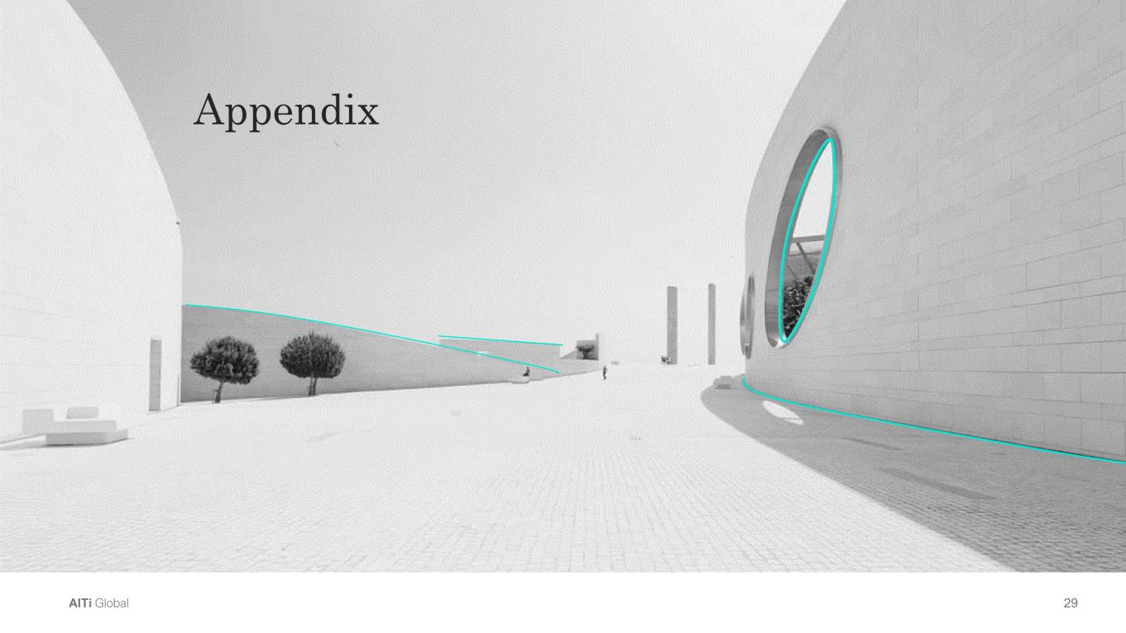
AlTi Color Palette Background color Primary Accent Color Secondary colors Tertiary colors 29AlTi Global Appendix

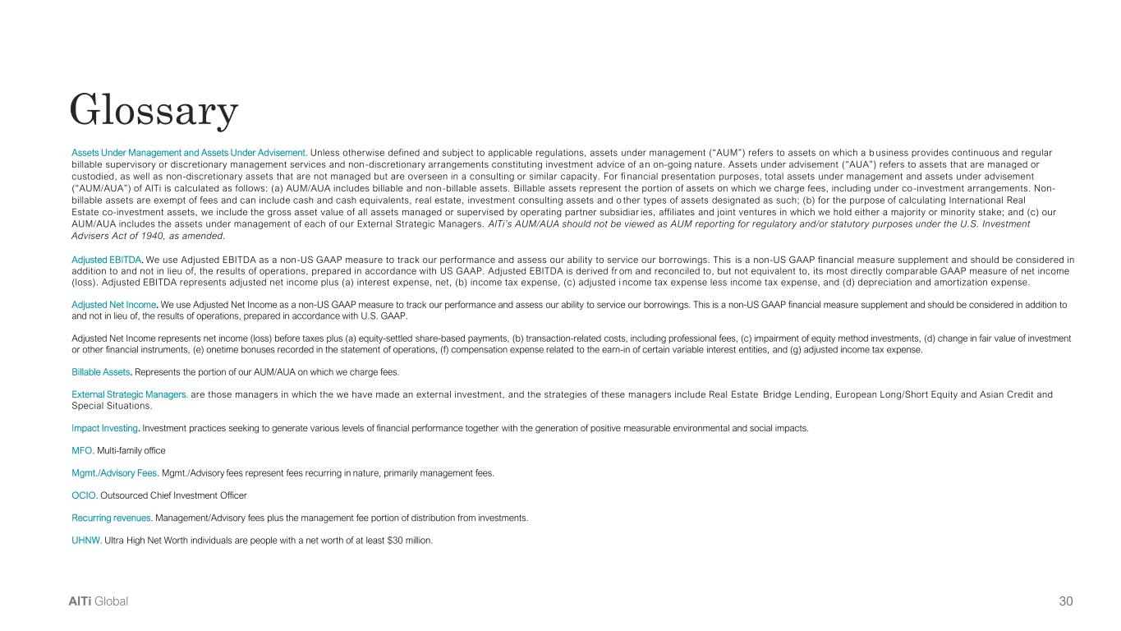
AlTi Color Palette Background color Primary Accent Color Secondary colors Tertiary colors 30AlTi Global Glossary Assets Under Management and Assets Under Advisement. Unless otherwise defined and subject to applicable regulations, assets under management (“AUM”) refers to assets on which a b usiness provides continuous and regular billable supervisory or discretionary management services and non-discretionary arrangements constituting investment advice of an on-going nature. Assets under advisement (“AUA”) refers to assets that are managed or custodied, as well as non-discretionary assets that are not managed but are overseen in a consulting or similar capacity. For fi nancial presentation purposes, total assets under management and assets under advisement (“AUM/AUA”) of AlTi is calculated as follows: (a) AUM/AUA includes billable and non -billable assets. Billable assets represent the portion of assets on which we charge fees, including under co-investment arrangements. Non- billable assets are exempt of fees and can include cash and cash equivalents, real estate, investment consulting assets and o ther types of assets designated as such; (b) for the purpose of calculating International Real Estate co-investment assets, we include the gross asset value of all assets managed or supervised by operating partner subsidiar ies, affiliates and joint ventures in which we hold either a majority or minority stake; and (c) our AUM/AUA includes the assets under management of each of our External Strategic Managers. AlTi’s AUM/AUA should not be viewed as AUM reporting for regulatory and/or statutory purposes under the U.S. Investment Advisers Act of 1940, as amended. Adjusted EBITDA. We use Adjusted EBITDA as a non-US GAAP measure to track our performance and assess our ability to service our borrowings. This is a non-US GAAP financial measure supplement and should be considered in addition to and not in lieu of, the results of operations, prepared in accordance with US GAAP. Adjusted EBITDA is derived fr om and reconciled to, but not equivalent to, its most directly comparable GAAP measure of net income (loss). Adjusted EBITDA represents adjusted net income plus (a) interest expense, net, (b) income tax expense, (c) adjusted i ncome tax expense less income tax expense, and (d) depreciation and amortization expense. Adjusted Net Income. We use Adjusted Net Income as a non-US GAAP measure to track our performance and assess our ability to service our borrowings. This is a non-US GAAP financial measure supplement and should be considered in addition to and not in lieu of, the results of operations, prepared in accordance with U.S. GAAP. Adjusted Net Income represents net income (loss) before taxes plus (a) equity-settled share-based payments, (b) transaction-related costs, including professional fees, (c) impairment of equity method investments, (d) change in fair value of investment or other financial instruments, (e) onetime bonuses recorded in the statement of operations, (f) compensation expense related to the earn-in of certain variable interest entities, and (g) adjusted income tax expense. Billable Assets. Represents the portion of our AUM/AUA on which we charge fees. External Strategic Managers. are those managers in which the we have made an external investment, and the strategies of these managers include Real Estate Bridge Lending, European Long/Short Equity and Asian Credit and Special Situations. Impact Investing. Investment practices seeking to generate various levels of financial performance together with the generation of positive measurable environmental and social impacts. MFO. Multi-family office Mgmt./Advisory Fees. Mgmt./Advisory fees represent fees recurring in nature, primarily management fees. OCIO. Outsourced Chief Investment Officer Recurring revenues. Management/Advisory fees plus the management fee portion of distribution from investments. UHNW. Ultra High Net Worth individuals are people with a net worth of at least $30 million.

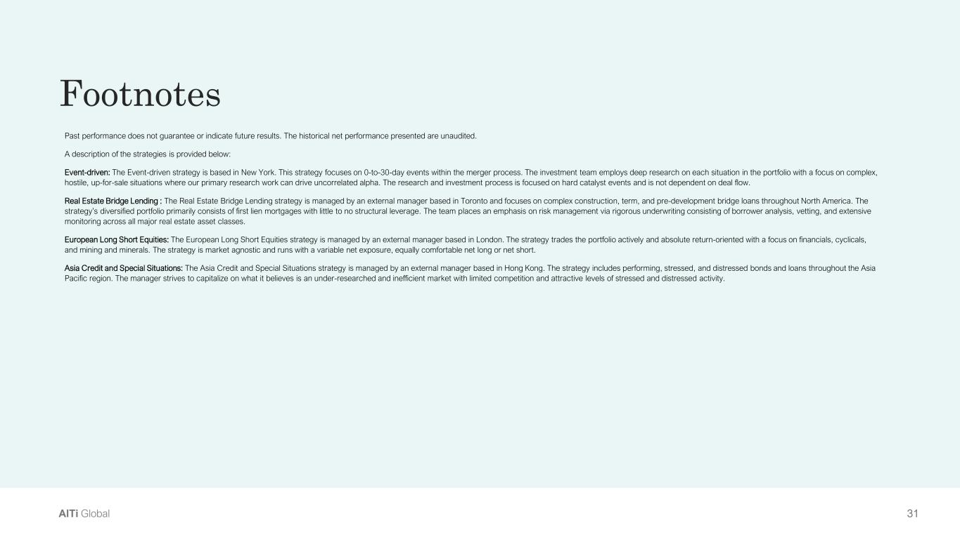
AlTi Color Palette Background color Primary Accent Color Secondary colors Tertiary colors 31AlTi Global Footnotes Past performance does not guarantee or indicate future results. The historical net performance presented are unaudited. A description of the strategies is provided below: Event-driven: The Event-driven strategy is based in New York. This strategy focuses on 0-to-30-day events within the merger process. The investment team employs deep research on each situation in the portfolio with a focus on complex, hostile, up-for-sale situations where our primary research work can drive uncorrelated alpha. The research and investment process is focused on hard catalyst events and is not dependent on deal flow. Real Estate Bridge Lending : The Real Estate Bridge Lending strategy is managed by an external manager based in Toronto and focuses on complex construction, term, and pre-development bridge loans throughout North America. The strategy’s diversified portfolio primarily consists of first lien mortgages with little to no structural leverage. The team places an emphasis on risk management via rigorous underwriting consisting of borrower analysis, vetting, and extensive monitoring across all major real estate asset classes. European Long Short Equities: The European Long Short Equities strategy is managed by an external manager based in London. The strategy trades the portfolio actively and absolute return-oriented with a focus on financials, cyclicals, and mining and minerals. The strategy is market agnostic and runs with a variable net exposure, equally comfortable net long or net short. Asia Credit and Special Situations: The Asia Credit and Special Situations strategy is managed by an external manager based in Hong Kong. The strategy includes performing, stressed, and distressed bonds and loans throughout the Asia Pacific region. The manager strives to capitalize on what it believes is an under-researched and inefficient market with limited competition and attractive levels of stressed and distressed activity.

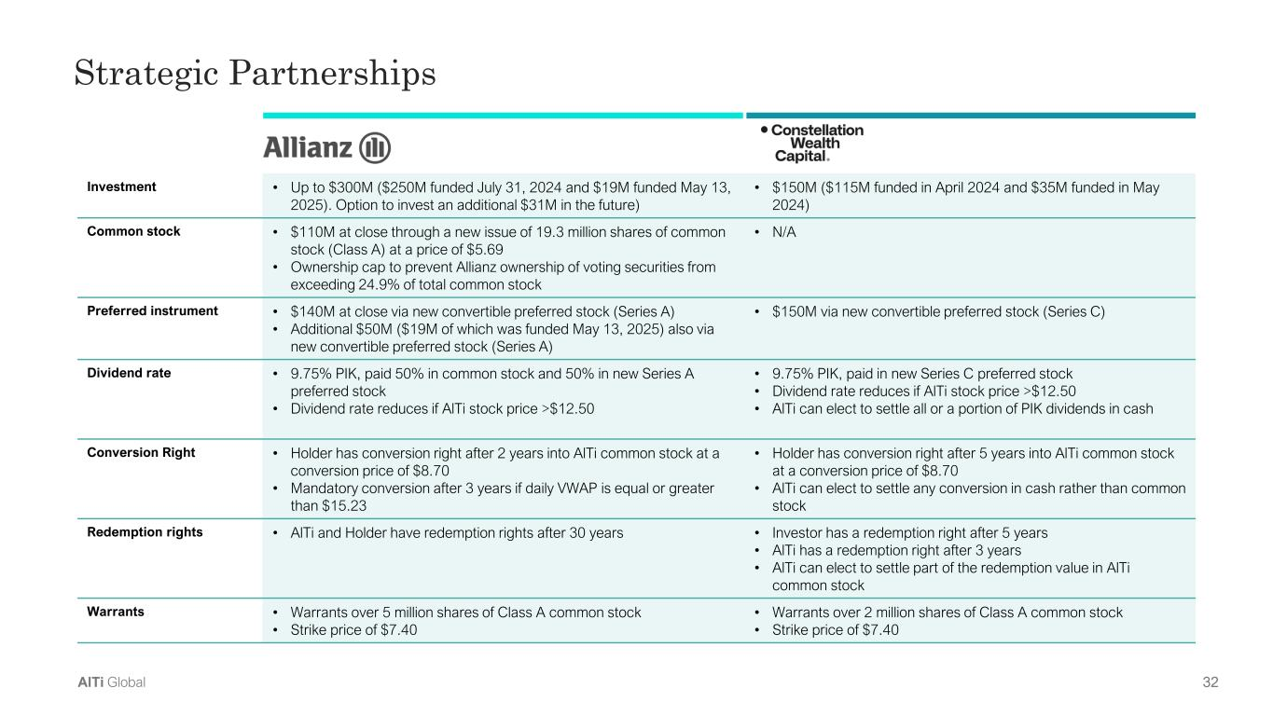
AlTi Color Palette Background color Primary Accent Color Secondary colors Tertiary colors 32AlTi Global Investment • Up to $300M ($250M funded July 31, 2024 and $19M funded May 13, 2025). Option to invest an additional $31M in the future) • $150M ($115M funded in April 2024 and $35M funded in May 2024) Common stock • $110M at close through a new issue of 19.3 million shares of common stock (Class A) at a price of $5.69 • Ownership cap to prevent Allianz ownership of voting securities from exceeding 24.9% of total common stock • N/A Preferred instrument • $140M at close via new convertible preferred stock (Series A) • Additional $50M ($19M of which was funded May 13, 2025) also via new convertible preferred stock (Series A) • $150M via new convertible preferred stock (Series C) Dividend rate • 9.75% PIK, paid 50% in common stock and 50% in new Series A preferred stock • Dividend rate reduces if AlTi stock price >$12.50 • 9.75% PIK, paid in new Series C preferred stock • Dividend rate reduces if AlTi stock price >$12.50 • AlTi can elect to settle all or a portion of PIK dividends in cash Conversion Right • Holder has conversion right after 2 years into AlTi common stock at a conversion price of $8.70 • Mandatory conversion after 3 years if daily VWAP is equal or greater than $15.23 • Holder has conversion right after 5 years into AlTi common stock at a conversion price of $8.70 • AlTi can elect to settle any conversion in cash rather than common stock Redemption rights • AlTi and Holder have redemption rights after 30 years • Investor has a redemption right after 5 years • AlTi has a redemption right after 3 years • AlTi can elect to settle part of the redemption value in AlTi common stock Warrants • Warrants over 5 million shares of Class A common stock • Strike price of $7.40 • Warrants over 2 million shares of Class A common stock • Strike price of $7.40 Strategic Partnerships


AlTi Color Palette Background color Primary Accent Color Secondary colors Tertiary colors 33AlTi Global Thank You

