Table of Contents

UNITED STATES

SECURITIES AND EXCHANGE COMMISSION

Washington, D.C. 20549

FORM 10-Q

(Mark One)

- QUARTERLY REPORT PURSUANT TO SECTION 13 OR 15(d) OF THE SECURITIES EXCHANGE ACT OF 1934

For the quarterly period ended June 30, 2024

OR

- TRANSITION REPORT PURSUANT TO SECTION 13 OR 15(d) OF THE SECURITIES EXCHANGE ACT OF 1934

For the transition period from _________ to _________

Commission file number 001-40103

AlTi Global, Inc.

(Exact name of registrant as specified in its charter)

Delaware

92-1552220

(State or other jurisdiction of incorporation or organization)

(I.R.S. Employer Identification No.)

520 Madison Avenue, 26th Floor New York, New York | 10022
(Address of Principal Executive Offices) | (Zip Code)
(212) 396-5900
(Registrant's telephone number, including area code)
Not Applicable

(Former name, former address and former fiscal year, if changed since last report)

Securities registered pursuant to Section 12(b) of the Act:

Title of each class | Trading Symbol(s) | Name of each exchange on which registered
Class A common stock, par value $0.0001 per share | ALTI | Nasdaq Capital Market

Indicate by check mark whether the registrant: (1) has filed all reports required to be filed by Section 13 or 15(d) of the Securities Exchange Act of 1934 during the preceding 12 months (or for such shorter period that the registrant was required to file such reports); and (2) has been subject to such filing requirements for the past 90 days. Yes ☒ No ☐

Indicate by check mark whether the registrant has submitted electronically every Interactive Data File required to be submitted pursuant to Rule 405 of Regulation S-T (§232.405 of this chapter) during the preceding 12 months (or for such shorter period that the registrant was required to submit such files). Yes ☒ No ☐

Indicate by check mark whether the registrant is a large accelerated filer, an accelerated filer, a non-accelerated filer, a smaller reporting company, or an emerging growth company. See the definitions of “large accelerated filer,” “accelerated filer,” “smaller reporting company” and “emerging growth company” in Rule 12b-2 of the Exchange Act.

Large accelerated filer | ☐ | Accelerated filer | ☒
Non-accelerated filer | ☐ | Smaller reporting company | ☐
 |  | Emerging growth company | ☒

If an emerging growth company, indicate by check mark if the registrant has elected not to use the extended transition period for complying with any new or revised financial accounting standards provided pursuant to Section 13(a) of the Exchange Act. ☐

Indicate by check mark whether the registrant is a shell company (as defined in Rule 12b-2 of the Act). Yes ☐ No ☒

The registrant had outstanding 91,846,903 shares of Class A Common Stock (as defined herein) and 47,978,953 shares of Class B Common Stock (as defined herein) as of August 8, 2024.

Table of Contents
Table of Contents
Part I Financial Information |  | 8
Item 1. Financial Statements (Unaudited) |  | 8
Condensed Consolidated Statement of Financial Position (Unaudited) |  | 8
Condensed Consolidated Statement of Operations (Unaudited) |  | 9
Condensed Consolidated Statement of Comprehensive Income (Loss) (Unaudited) |  | 10
Condensed Consolidated Statement of Changes in Mezzanine Equity and Shareholders’ Equity (Unaudited) |  | 11
Condensed Consolidated Statement of Cash Flows (Unaudited) |  | 14
Notes to Condensed Consolidated Financial Statements (Unaudited) |  | 16
Item 2. Management’s Discussion and Analysis of Financial Condition and Results of Operations |  | 83
Item 3. Quantitative and Qualitative Disclosures about Market Risk |  | 107
Item 4. Controls and Procedures |  | 108
Part II Other Information |  | 110
Item 1. Legal Proceedings |  | 110
Item 1A. Risk Factors |  | 110
Item 2. Unregistered Sales of Equity Securities and Use of Proceeds |  | 111
Item 3. Defaults Upon Senior Securities |  | 111
Item 4. Mine Safety Disclosures |  | 111
Item 5. Other Information |  | 111
Item 6. Exhibits |  | 112
Signatures |  | 114
2

Table of Contents

Defined Terms

Capitalized terms used herein but not otherwise defined herein shall have the respective meanings ascribed to them in the Amended and Restated Business Combination Agreement, a copy of which is attached as Exhibit 2.1 to our Current Report on Form 8-K filed October 26, 2022.

- “AFM UK” means Alvarium Fund Managers (UK) Limited, an English private limited company.

- “AHRA” means “Alvarium Home REIT Advisors Limited,” an English private limited company.

- “Alvarium” means AlTi Asset Management Holdings 2 Limited, formerly known as Alvarium Investments Limited, an English private limited company.

- “AlTi” means AlTi Global, Inc., together with its consolidated subsidiaries.

- “Alvarium Shareholders” means the shareholders of Alvarium.

- “Alvarium Tiedemann” means the Company, prior to being renamed “AlTi Global, Inc.”

- “AlTi Global Topco” means AlTi Global Topco Limited, formerly known as Alvarium Topco, an Isle of Man entity which was established by Alvarium and owned by the Alvarium Shareholders.

- “ARE” means AlTi RE Limited, formerly known as Alvarium RE Limited, an English private limited company.

- “AUA” means assets under advisement.

- “AUM” means assets under management.

- “Business Combination” means the transactions contemplated by the Business Combination Agreement.

- “Business Combination Agreement” means the Amended and Restated Business Combination Agreement, dated as of October 25, 2022, by and among Cartesian, Umbrella Merger Sub, TWMH, TIG GP, TIG MGMT, Alvarium and Umbrella.

- “Business Combination Earn-out” means the Sponsor and the selling shareholders of TWMH, TIG, and Alvarium became entitled to receive earn-out shares contingent on various share price milestones for up to five years following the Closing under the terms of the Business Combination.

- “Business Combination Earn-out Securities” means the earn-out shares of Class A Common Stock in the Company and Class B Common Units that may be issued or become tradeable upon the achievement of certain stock price-based vesting conditions in accordance with the terms of the Business Combination Agreement.

- “Cartesian” means Cartesian Growth Corporation, a Cayman Islands exempted company, prior to the Business Combination.

- “Cayman Islands Companies Act” means the Cayman Islands Companies Act (as revised) of the Cayman Islands, as the same may be amended from time to time.

- “Class A Common Stock” means the Class A Common Stock, par value $0.0001 per share, of the Company, including any shares of such Class A Common Stock issuable upon the exercise of any warrant or other right to acquire shares of such Class A Common Stock.

3

Table of Contents

- “Class B Common Stock” means the Class B Common Stock, par value $0.0001 per share, of the Company, including any shares of such Class B Common Stock issuable upon the exercise of any warrant or other right to acquire shares of such Class B Common Stock.

- “Class B Paired Interest” means a Class B Unit together with a share of Class B Common Stock.

- “Class B Units” means the limited liability company interests in Umbrella designated as Class B Common Units in the Umbrella LLC Agreement.

- “Closing” means the closing of the Business Combination.

- “Closing Date” means January 3, 2023, the date on which the Closing occurred.

- “Common Stock” refers to shares of the Class A Common Stock and the Class B Common Stock, collectively.

- “Company,” “our,” “we” or “us” means, prior to the Business Combination, Cartesian, as the context suggests, and, following the Business Combination, AlTi.

- “Condensed Consolidated Statement of Financial Position” refers to the consolidated balance sheet of AlTi Global, Inc.

- “Condensed Consolidated Statement of Operations” refers to the consolidated income statement of AlTi Global, Inc.

- “DGCL” refers to the Delaware General Corporation Law, as amended.

- “dollars” or “$” refers to U.S. dollars.

- “Domestication” means the continuation of Cartesian by way of domestication into a Delaware corporation, with the ordinary shares of Cartesian becoming shares of common stock of the Delaware corporation under the applicable provisions of the Cayman Islands Companies Act and the DGCL; the term includes all matters and necessary or ancillary changes in order to effect such Domestication, including the adoption of the Company’s certificate of incorporation consistent with the DGCL and changing the name and registered office of Cartesian.

- “Exchange Act” means the U.S. Securities Exchange Act of 1934, as amended.

- “External Strategic Managers” means global alternative asset managers with whom we partner by making strategic investments in which we actively participate in seeking to leverage the collective resources and synergies of the businesses to facilitate their growth.

- “FOS” means the European-based trust and private office service businesses, or European Family Office Services business.

- “HLIF” means “Home Long Income Fund,” a private fund regulated by the UK FCA.

- “HNWI” means-high-net-worth individual, being an individual having investable assets of $1 million or more, excluding primary residence, collectibles, consumables, and consumer durables.

- “Holbein” means Holbein Partners, LLP.

- “Home REIT” means “Home REIT plc,” a real estate investment trust listed on the London Stock Exchange.

4

Table of Contents

- “Impact Investing” means investment practices seeking to generate various levels of financial performance together with the generation of positive measurable environmental and social impacts.

- “Nasdaq” means the Nasdaq Capital Market.

- “NAV” means net asset value.

- “PIPE Investors” means the subscribers that agreed to purchase shares of Class A Common Stock at the Closing pursuant to the private placements, including without limitation, as reflected in the subscription agreements between Cartesian and each of the PIPE Investors.

- “SEC” means the United States Securities and Exchange Commission.

- “SHIA” means Social Housing Income Advisors Limited, an English private limited company.

- “Sponsor” means CGC Sponsor LLC, a Cayman Islands limited liability company.

- “Strategic Alternatives” means the segment that includes the Company’s alternatives platform, public and private real estate, and co-investment business, formerly known as Asset Management.

- “Target Companies” means, collectively, TWMH, TIG GP, TIG MGMT, and Alvarium.

- “Tax Receivable Agreement” or “TRA” means that certain Tax Receivable Agreement, dated as of January 3, 2023, by and among the Company and the TWMH Members, the TIG GP Members, and the TIG MGMT Members.

- “TIG” means, collectively, the TIG Entities and their subsidiaries and their predecessor entities where applicable.

- “TIG Entities” means, collectively, TIG GP and TIG MGMT and their predecessor entities where applicable.

- “TIG GP” means TIG Trinity GP, LLC, a Delaware limited liability company.

- “TIG GP Members” means the former members of TIG GP.

- “TIG MGMT” means TIG Trinity Management, LLC, a Delaware limited liability company.

- “TIG MGMT Members” means the former members of TIG MGMT.

- “TIH” means Tiedemann International Holdings, AG.

- “TRA Exchange” means the series of transactions in which certain holders of Class B Units and Class B Common Stock have exchanged, or may in the future exchange, a portion of such interests to the Company, in exchange for Class A Common Stock.

- “TWMH” means, collectively, Tiedemann Wealth Management Holdings, LLC, a Delaware limited liability company, and its subsidiaries, and their predecessor entities where applicable.

- “TWMH Members” means the former members of TWMH.

- “UHNW” means ultra high net worth individual, being an individual having investable assets of $30 million or more, excluding primary residence, collectibles, consumables, and consumer durables.

- “UK FCA” means the United Kingdom’s Financial Conduct Authority.

5

Table of Contents

- “Umbrella” means AlTi Global Capital, LLC (formerly known as Alvarium Tiedemann Capital, LLC), a Delaware limited liability company.

- “Umbrella LLC Agreement” means the Fourth Amended and Restated Limited Liability Company Agreement of AlTi Global Capital, LLC, effective as of July 31, 2024.

- “Umbrella Merger Sub” means Rook MS, LLC, a Delaware limited liability company.

- “US GAAP” means United States generally accepted accounting principles, consistently applied.

- “Warrants” means the warrants, which were initially issued in Cartesian’s initial public offering of its units pursuant to its registration statement on Form S-1 declared effective by the SEC on February 23, 2021, entitling the holder thereof to purchase one of Cartesian’s Class A ordinary shares at an exercise price of $11.50, subject to adjustment.

- “Wealth Management” means the segment that consists of the Company’s investment management and advisory services, trusts and administrative services, and family office services.

6

Table of Contents

Available Information

We file annual, quarterly and current reports, proxy statements and other information required by the Exchange Act with the SEC. We make available free of charge on our website (www.alti-global.com) our annual reports on Form 10-K, quarterly reports on Form 10-Q, current reports on Form 8-K, proxy statements and other filings as soon as reasonably practicable after such material is electronically filed with or furnished to the SEC. We also use our website to distribute Company information, including assets under management and performance information, and such information as may be deemed material. Accordingly, investors should monitor our website, in addition to our press releases, SEC filings and public conference calls and webcasts.

Also posted on our website in the “Investor Relations” section are the charters for our Audit, Finance and Risk Committee, Environmental, Social, Governance and Nominating Committee, and Human Capital and Compensation Committee, as well as our Corporate Governance Guidelines and Code of Business Conduct governing our directors, officers, and employees. Information on or accessible through our website is not a part of or incorporated into this Quarterly Report on Form 10-Q for the period ended June 30, 2024 (the “Quarterly Report”) or any other SEC filing. Copies of our SEC filings or corporate governance materials are available without charge upon written request to the Company at its principal place of business. Any materials we file with the SEC are also publicly available through the SEC’s website (www.sec.gov).

No statements herein, available on our website, or in any of the materials we file with the SEC constitute or should be viewed as constituting an offer to sell, or a solicitation of an offer to buy, securities in any jurisdiction.

Cautionary Note Regarding Forward-Looking Statements

This Quarterly Report contains forward-looking statements within the meaning of Section 27A of the Securities Act of 1933, as amended (the “Securities Act”), and Section 21E of the Exchange Act, which reflect our current views with respect to, among other things, future events, operations and financial performance. You can identify these forward-looking statements by the use of forward-looking words such as “outlook,” “believes,” “expects,” “potential,” “continues,” “may,” “will,” “should,” “seeks,” “approximately,” “predicts,” “projects,” “intends,” “plans,” “estimates,” “anticipates,” “target” or the negative version of those words, other comparable words or other statements that do not relate to historical or factual matters. The forward-looking statements are based on our beliefs, assumptions and expectations of our future performance, taking into account all information currently available to us. Such forward-looking statements are subject to various risks, uncertainties (some of which are beyond our control) or other assumptions relating to our operations, financial results, financial condition, business prospects, growth strategy and liquidity that may cause actual results or performance to be materially different from those expressed or implied by these forward-looking statements. Some of these factors are described under the headings “Part II. Item 1A. Risk Factors” and “Part I. Item 2. Management’s Discussion and Analysis of Financial Condition and Results of Operations.” These factors should not be construed as exhaustive and should be read in conjunction with the risk factors and other cautionary statements that are included in this Quarterly Report and in our other periodic filings. If one or more of these or other risks or uncertainties materialize, or if our underlying assumptions prove to be incorrect, our actual results may vary materially from those indicated in these forward-looking statements. New risks and uncertainties arise over time, and it is not possible for us to predict those events or how they may affect us. Therefore, you should not place undue reliance on these forward-looking statements. Any forward-looking statement speaks only as of the date on which it is made. We do not undertake any obligation to publicly update or review any forward-looking statement, whether as a result of new information, future developments or otherwise, except as required by law.

7

Table of Contents

PART I – FINANCIAL INFORMATION

Item 1. Financial Statements (Unaudited)

AlTi Global, Inc.

Condensed Consolidated Statement of Financial Position (Unaudited)

 | As of June 30, |  |  |  | As of December 31,
(Dollars in Thousands, except share data) | 2024 |  |  |  | 2023
Assets
Cash and cash equivalents | $ | 59,984 |  | $ | 15,348
Fees receivable, net (includes $830 and $16,069 of related party receivables, respectively) |  | 32,381 |  |  | 70,421
Investments at fair value |  | 162,234 |  |  | 165,894
Equity method investments |  | 7,504 |  |  | 14,194
Intangible assets, net of accumulated amortization |  | 505,233 |  |  | 435,677
Goodwill |  | 440,997 |  |  | 411,634
Operating lease right-of-use assets |  | 53,854 |  |  | 48,313
Other assets, net |  | 58,709 |  |  | 48,182
Contingent consideration receivable |  | 1,834 |  |  | —
Assets held for sale |  | — |  |  | 56,634
Total assets | $ | 1,322,730 |  | $ | 1,266,297
Liabilities
Accounts payable and accrued expenses | $ | 25,350 |  | $ | 37,156
Accrued compensation and profit sharing |  | 30,087 |  |  | 61,768
Accrued member distributions payable |  | 3,348 |  |  | 7,271
Warrant liabilities, at fair value |  | 2,934 |  |  | —
Earn-out liability, at fair value |  | 49,124 |  |  | 63,444
TRA liability (includes $6,911 and $13,233 at fair value, respectively) |  | 24,911 |  |  | 17,607
Delayed share purchase agreement |  | — |  |  | 1,818
Earn-in consideration payable |  | 969 |  |  | 1,830
Operating lease liabilities |  | 64,281 |  |  | 56,123
Debt, net of unamortized deferred financing cost |  | 163,986 |  |  | 186,353
Deferred tax liability, net |  | 12,897 |  |  | 14,109
Deferred income |  | 221 |  |  | 66
Other liabilities, net |  | 21,101 |  |  | 22,467
Liabilities held for sale |  | — |  |  | 13,792
Total liabilities | $ | 399,209 |  | $ | 483,804
Commitments and contingencies (Note 19)
Mezzanine Equity
Series C Redeemable Cumulative Convertible Preferred stock, $0.0001 par value, 150,000 authorized, 150,000 shares issued and outstanding at June 30, 2024, and 0
shares authorized, 0 issued and outstanding at December 31, 2023 |  | 153,442 |  |  | —
Shareholders' Equity
Common stock, Class A, $0.0001 par value, 875,000,000 authorized, 72,167,195 and 65,110,875 issued and outstanding, respectively |  | 7 |  |  | 7
Common stock, Class B, $0.0001 par value, 150,000,000 authorized, 47,978,953 and 53,219,713 issued and outstanding, respectively |  | — |  |  | —
Additional paid-in capital |  | 549,998 |  |  | 536,509
Retained earnings (accumulated deficit) |  | (170,172) |  |  | (193,527)
Accumulated other comprehensive income (loss) |  | 6,942 |  |  | 9,155
Total AlTi Global, Inc. shareholders' equity |  | 540,217 |  |  | 352,144
Non-controlling interest in subsidiaries |  | 383,304 |  |  | 430,349
Total shareholders' equity |  | 923,521 |  |  | 782,493
Total liabilities, mezzanine equity, and shareholders' equity | $ | 1,322,730 |  | $ | 1,266,297

The accompanying notes are an integral part of these unaudited condensed consolidated financial statements.

8

Table of Contents

AlTi Global, Inc.

Condensed Consolidated Statement of Operations (Unaudited)

 |  | For the Three Months Ended |  |  |  |  |  | For the Six Months Ended
(Dollars in Thousands) |  | June 30, 2024 |  |  | June 30, 2023 |  |  | June 30, 2024 |  |  | June 30, 2023
Revenue
Management/advisory fees | $ | 47,029 |  | $ | 46,844 |  | $ | 93,253 |  | $ | 93,314
Incentive fees |  | 53 |  |  | 469 |  |  | 216 |  |  | 1,046
Distributions from investments |  | 2,240 |  |  | 2,203 |  |  | 6,410 |  |  | 12,233
Other income/fees |  | 131 |  |  | 1,769 |  |  | 386 |  |  | 2,739
Total income |  | 49,453 |  |  | 51,285 |  |  | 100,265 |  |  | 109,332
Operating Expenses
Compensation and employee benefits |  | 38,893 |  |  | 33,952 |  |  | 78,450 |  |  | 97,124
Systems, technology and telephone |  | 4,809 |  |  | 4,110 |  |  | 9,123 |  |  | 7,939
Sales, distribution and marketing |  | 1,202 |  |  | 568 |  |  | 1,967 |  |  | 1,094
Occupancy costs |  | 4,025 |  |  | 3,352 |  |  | 7,502 |  |  | 6,532
Professional fees |  | 7,602 |  |  | 14,863 |  |  | 18,972 |  |  | 37,747
Travel and entertainment |  | 1,326 |  |  | 1,306 |  |  | 2,737 |  |  | 3,252
Depreciation and amortization |  | 3,813 |  |  | 3,655 |  |  | 6,380 |  |  | 8,172
General, administrative and other |  | 2,738 |  |  | 2,538 |  |  | 4,757 |  |  | 3,971
Total operating expenses |  | 64,408 |  |  | 64,344 |  |  | 129,888 |  |  | 165,831
Total operating income (loss) |  | (14,955) |  |  | (13,059) |  |  | (29,623) |  |  | (56,499)
Other Income (Expenses)
Impairment loss on intangible assets |  | (695) |  |  | (29,393) |  |  | (695) |  |  | (29,393)
Gain (loss) on investments |  | 11,357 |  |  | (5,154) |  |  | 7,696 |  |  | (1,704)
Gain (loss) on TRA |  | 389 |  |  | (1,792) |  |  | 6,322 |  |  | (2,092)
Gain (loss) on warrant liability |  | 409 |  |  | 76 |  |  | 69 |  |  | (12,866)
Gain (loss) on earnout liability |  | (1,945) |  |  | 66,083 |  |  | 37,509 |  |  | 36,877
Interest expense |  | (4,851) |  |  | (3,371) |  |  | (9,691) |  |  | (6,632)
Interest income |  | 563 |  |  | — |  |  | 823 |  |  | —
Other income (expense) |  | 13 |  |  | (706) |  |  | (17) |  |  | (647)
Income (loss) before taxes |  | (9,715) |  |  | 12,684 |  |  | 12,393 |  |  | (72,956)
Income tax (expense) benefit |  | 756 |  |  | 15,446 |  |  | 393 |  |  | 10,796
Net income (loss) |  | (8,959) |  |  | 28,130 |  |  | 12,786 |  |  | (62,160)
Net loss (income) attributed to non-controlling interests in subsidiaries |  | (2,965) |  |  | (14,610) |  |  | (10,569) |  |  | (36,160)
Net income (loss) attributable to AlTi Global, Inc. | $ | (5,994) |  | $ | 42,740 |  | $ | 23,355 |  | $ | (26,000)
Net Income (Loss) Per Share
Basic | $ | (0.18) |  | $ | 0.72 |  | $ | 0.16 |  | $ | (0.45)
Diluted | $ | (0.18) |  | $ | 0.25 |  | $ | 0.00 |  | $ | (0.44)
Weighted Average Shares of Class A Common Stock Outstanding
Basic |  | 71,738,190 |  |  | 59,286,346 |  |  | 69,228,309 |  |  | 58,425,916
Diluted |  | 71,738,190 |  |  | 114,319,307 |  |  | 119,355,038 |  |  | 58,454,342

The accompanying notes are an integral part of these unaudited condensed consolidated financial statements.

9

AlTi Global, Inc.

Condensed Consolidated Statement of Comprehensive Income (Loss) (Unaudited)

 | For the Three Months Ended |  |  |  | For the Six Months Ended
(Dollars in Thousands) | June 30, 2024 |  | June 30, 2023 |  | June 30, 2024 |  | June 30, 2023
Net income (loss) | (8,959) |  | 28,130 |  | 12,786 |  | (62,160)
Other Comprehensive Income (Loss)
Foreign currency translation adjustments | 1,060 |  | 8,237 |  | (2,929) |  | 17,908
Other comprehensive income (loss) | 299 |  | (682) |  | 211 |  | (682)
Total comprehensive income (loss) | (7,600) |  | 35,685 |  | 10,068 |  | (44,934)
Other loss attributed to non-controlling interests in subsidiaries | (2,562) |  | (11,295) |  | (12,202) |  | (28,115)
Comprehensive income (loss) attributable to AlTi Global, Inc. | (5,038) |  | 46,980 |  | 22,270 |  | (16,819)

The accompanying notes are an integral part of these unaudited condensed consolidated financial statements.

10

Table of Contents

AlTi Global, Inc.

Condensed Consolidated Statement of Changes in Mezzanine Equity and Shareholders’ Equity (Unaudited)

 | Mezzanine Equity |  |  |  |  |  |  |  |  |  |  |  |  |  |  |  | Shareholders’ Equity
 |  |  |  |  |  |  |  |  |  |  |  |  |  |  |  |  | Additional |  | Retained earnings |  |  | Accumulated other |  |  | Non-controlling |  |  |  | Total
(Dollars in Thousands, except share data) | Preferred Stock |  |  |  |  | Class A Common Stock |  |  |  |  | Class B Common Stock |  |  |  |  |  | paid-in- |  |  | (accumulated |  |  | comprehensive |  |  | interest in |  |  | Shareholders'
 |  |  |  |  |  |  |  |  |  |  |  |  |  |  |  |  | capital |  |  | deficit) |  |  | income |  |  | subsidiaries |  |  | Equity
 | Shares |  |  | Amount |  | Shares |  | Amount |  |  | Shares |  |  | Amount
Balance at March 31, 2024 | 115,000 |  |  | 115,093 |  | 71,064,411 |  | $ | 7 |  | 48,265,195 |  | $ | — |  | $ | 553,717 |  | $ | (164,178) |  | $ | 6,299 |  | $ | 387,405 |  | $ | 898,343
Net income (loss) | — |  |  | — |  | — |  |  | — |  | — |  |  | — |  |  | — |  |  | (5,994) |  |  | — |  |  | (2,965) |  |  | (8,959)
Currency translation adjustment | — |  |  | — |  | — |  |  | — |  | — |  |  | — |  |  | — |  |  | — |  |  | 778 |  |  | 282 |  |  | 1,060
Other comprehensive income | — |  |  | — |  | — |  |  | — |  | — |  |  | — |  |  | — |  |  | — |  |  | 179 |  |  | 120 |  |  | 299
Payment for partner's tax | — |  |  | — |  | — |  |  | — |  | — |  |  | — |  |  | (1,853) |  |  | — |  |  | — |  |  | — |  |  | (1,853)
Issuance of preferred shares, net of
issuance costs | 35,000 |  |  | 31,642 |  | — |  |  | — |  | — |  |  | — |  |  | — |  |  | — |  |  | — |  |  | — |  |  | 31,642
Preferred share dividend |  |  |  | 6,707 |  | — |  |  | — |  | — |  |  | — |  |  | (6,707) |  |  | — |  |  | — |  |  | — |  |  | —
Issuance of shares for business
combination | — |  |  | — |  | — |  |  | — |  | — |  |  | — |  |  | 1,634 |  |  | — |  |  | — |  |  | — |  |  | 1,634
Share based compensation | — |  |  | — |  | — |  |  | — |  | — |  |  | — |  |  | 6,450 |  |  | — |  |  | — |  |  | — |  |  | 6,450
Shares issued to employees on vesting
of equity awards | — |  |  | — |  | 816,542 |  |  | — |  | — |  |  | — |  |  | — |  |  | — |  |  | — |  |  | — |  |  | —
TRA Exchange | — |  |  | — |  | 286,242 |  |  | — |  | (286,242) — |  |  | — |  |  | (3,243) |  |  | — |  |  | — |  |  | (1,343) |  |  | (4,586)
FOS deconsolidation | — |  |  | — |  | — |  |  | — |  | — |  |  | — |  |  | — |  |  | — |  |  | (306) |  |  | (203) |  |  | (509)
LXi deconsolidation | — |  |  | — |  | — |  |  | — |  | — |  |  | — |  |  | — |  |  | — |  |  | (8) |  |  | 8 |  |  | —
Balance at June 30, 2024 | 150,000 |  | $ | 153,442 |  | 72,167,195 |  | $ | 7 |  | 47,978,953 |  | $ | — |  | $ | 549,998 |  | $ | (170,172) |  | $ | 6,942 |  | $ | 383,304 |  | $ | 923,521

The accompanying notes are an integral part of these unaudited condensed consolidated financial statements.

11

Table of Contents

AlTi Global, Inc.

Condensed Consolidated Statement of Changes in Mezzanine Equity and Shareholders’ Equity (Unaudited)

 | Mezzanine Equity |  |  |  |  |  |  |  |  |  |  |  |  |  |  |  | Shareholders’ Equity
 |  |  |  |  |  |  |  |  |  |  |  |  |  |  |  |  | Additional |  | Retained earnings |  |  | Accumulated other |  |  | Non-controlling |  |  |  | Total
(Dollars in Thousands, except share data) | Preferred Stock |  |  |  |  | Class A Common Stock |  |  |  |  | Class B Common Stock |  |  |  |  |  | paid-in- |  |  | (accumulated |  |  | comprehensive |  |  | interest in |  |  | Shareholders'
 |  |  |  |  |  |  |  |  |  |  |  |  |  |  |  |  | capital |  |  | deficit) |  |  | income |  |  | subsidiaries |  |  | Equity
 | Shares |  |  | Amount |  | Shares |  | Amount |  |  | Shares |  |  | Amount
Balance at January 1, 2024 | — |  |  | — |  | 65,110,875 |  | $ | 7 |  | 53,219,713 |  | $ | — |  | $ | 536,509 |  | $ | (193,527) |  | $ | 9,155 |  | $ | 430,349 |  | $ | 782,493
Net income (loss) | — |  |  | — |  | — |  |  | — |  | — |  |  | — |  |  | — |  |  | 23,355 |  |  | — |  |  | (10,569) |  |  | 12,786
Currency translation adjustment | — |  |  | — |  | — |  |  | — |  | — |  |  | — |  |  | — |  |  | — |  |  | (1,211) |  |  | (1,718) |  |  | (2,929)
Other comprehensive income | — |  |  | — |  | — |  |  | — |  | — |  |  | — |  |  | — |  |  | — |  |  | 127 |  |  | 84 |  |  | 211
Payment for partner's tax | — |  |  | — |  | — |  |  | — |  | — |  |  | — |  |  | (1,882) |  |  | — |  |  | — |  |  | — |  |  | (1,882)
Issuance of preferred shares, net of
issuance costs | 150,000 |  |  | 142,800 |  | — |  |  | — |  | — |  |  | — |  |  | — |  |  | — |  |  | — |  |  | — |  |  | 142,800
Preferred share dividend |  |  |  | 10,642 |  |  |  |  |  |  |  |  |  |  |  |  | (10,642) |  |  | — |  |  | — |  |  | — |  |  | —
Issuance of shares for business
combination | — |  |  | — |  | — |  |  | — |  | — |  |  | — |  |  | 948 |  |  | — |  |  | — |  |  | — |  |  | 948
Share based compensation | — |  |  | — |  | — |  |  | — |  | — |  |  | — |  |  | 9,074 |  |  | — |  |  | — |  |  | — |  |  | 9,074
Shares issued to employees on vesting
of equity awards | — |  |  | — |  | 1,815,560 |  |  | — |  | — |  |  | — |  |  | (4,037) |  |  | — |  |  | — |  |  | — |  |  | (4,037)
TRA Exchange | — |  |  | — |  | 5,240,760 |  |  | — |  | (5,240,760) — |  |  | — |  |  | 20,028 |  |  | — |  |  | — |  |  | (34,092) |  |  | (14,064)
FOS deconsolidation | — |  |  | — |  | — |  |  | — |  | — |  |  | — |  |  | — |  |  | — |  |  | (306) |  |  | (203) |  |  | (509)
LXi deconsolidation | — |  |  | — |  | — |  |  | — |  | — |  |  | — |  |  | — |  |  | — |  |  | (823) |  |  | (547) |  |  | (1,370)
Balance at June 30, 2024 | 150,000 |  | $ | 153,442 |  | 72,167,195 |  | $ | 7 |  | 47,978,953 |  | $ | — |  | $ | 549,998 |  | $ | (170,172) |  | $ | 6,942 |  | $ | 383,304 |  | $ | 923,521

The accompanying notes are an integral part of these unaudited condensed consolidated financial statements.

12

Table of Contents

AlTi Global, Inc.

Condensed Consolidated Statement of Changes in Mezzanine Equity and Shareholders’ Equity (Unaudited)

 |  |  |  |  |  |  |  |  |  |  |  | Shareholders’ Equity
 |  |  |  |  |  |  |  |  |  |  |  |  |  |  | Retained
 |  |  |  |  |  |  |  |  |  |  |  |  |  |  | earnings |  | Accumulated other |  |  | Non-controlling |  |  |  | Total
(Dollars in Thousands, except share |  |  |  |  |  |  |  |  |  |  | Additional paid- |  |  |  | (accumulated |  |  | comprehensive |  |  | interest in |  |  | Shareholders'
data) | Class A Common Stock |  |  |  |  | Class B Common Stock |  |  |  |  |  | in-capital |  |  | deficit) |  |  | income |  |  | subsidiaries |  |  | Equity
 | Shares |  |  | Amount |  | Shares |  | Amount
Balance at March 31, 2023 | 57,916,649 |  | $ | 6 |  | 55,032,961 |  | $ | — |  | $ | 462,275 |  | $ | (96,686) |  | $ | 4,941 |  | $ | 590,169 |  | $ | 960,705
Net income (loss) | — |  |  | — |  | — |  |  | — |  |  | — |  |  | 42,740 |  |  | — |  |  | (14,610) |  |  | 28,130
Currency translation adjustment | — |  |  | — |  | — |  |  | — |  |  | — |  |  | — |  |  | 4,605 |  |  | 3,632 |  |  | 8,237
Cancellation of AHRA call option | — |  |  | — |  | — |  |  | — |  |  | — |  |  | — |  |  | — |  |  | 154 |  |  | 154
Other comprehensive income | — |  |  | — |  | — |  |  | — |  |  | — |  |  | — |  |  | (364) |  |  | (318) |  |  | (682)
Payment for partner’s tax | — |  |  | — |  | — |  |  | — |  |  | (998) |  |  | — |  |  | — |  |  | — |  |  | (998)
AHRA deconsolidation | — |  |  | — |  | — |  |  | — |  |  | 28,791 |  |  | — |  |  | — |  |  | (28,791) |  |  | —
Share based compensation | — |  |  | — |  | — |  |  | — |  |  | 2,131 |  |  | — |  |  | — |  |  | — |  |  | 2,131
Issuance of shares - exercise of
warrants | 5,041,022 |  |  | — |  | — |  |  | — |  |  | 24,063 |  |  | — |  |  | — |  |  | — |  |  | 24,063
Balance at June 30, 2023 | 62,957,671 |  | $ | 6 |  | 55,032,961 |  | $ | — |  | $ | 516,262 |  | $ | (53,946) |  | $ | 9,182 |  | $ | 550,236 |  | $ | 1,021,740
 |  |  |  |  |  |  |  |  |  |  |  | Shareholders’ Equity
 |  |  |  |  |  |  |  |  |  |  |  |  |  |  | Retained
 |  |  |  |  |  |  |  |  |  |  |  |  |  |  | earnings |  | Accumulated other |  |  | Non-controlling |  |  |  | Total
(Dollars in Thousands, except share |  |  |  |  |  |  |  |  |  |  | Additional paid- |  |  |  | (accumulated |  |  | comprehensive |  |  | interest in |  |  | Shareholders'
data) | Class A Common Stock |  |  |  |  | Class B Common Stock |  |  |  |  |  | in-capital |  |  | deficit) |  |  | income |  |  | subsidiaries |  |  | Equity
 | Shares |  |  | Amount |  | Shares |  | Amount
Balance at January 1, 2023 | 55,388,023 |  | $ | 6 |  | 55,032,961 |  | $ | — |  | $ | 435,859 |  | $ | (27,946) |  | $ | — |  | $ | 606,989 |  | $ | 1,014,908
Issuance of shares to Alvarium
Employee Benefit Trust | 2,100,000 |  |  | — |  | — |  |  | — |  |  | 21,000 |  |  | — |  |  | — |  |  | — |  |  | 21,000
Net income (loss) | — |  |  | — |  | — |  |  | — |  |  | — |  |  | (26,000) |  |  | — |  |  | (36,160) |  |  | (62,160)
Currency translation adjustment | — |  |  | — |  | — |  |  | — |  |  | — |  |  | — |  |  | 9,546 |  |  | 8,362 |  |  | 17,908
Cancellation of AHRA call option | — |  |  | — |  | — |  |  | — |  |  | — |  |  | — |  |  | — |  |  | 154 |  |  | 154
Other comprehensive income | — |  |  | — |  | — |  |  | — |  |  | — |  |  | — |  |  | (364) |  |  | (318) |  |  | (682)
Payment for partner's tax | — |  |  | — |  | — |  |  | — |  |  | (998) |  |  | — |  |  | — |  |  | — |  |  | (998)
AHRA Deconsolidation | — |  |  | — |  | — |  |  | — |  |  | 28,791 |  |  | — |  |  | — |  |  | (28,791) |  |  | —
Share based compensation | — |  |  | — |  | — |  |  | — |  |  | 2,131 |  |  | — |  |  | — |  |  | — |  |  | 2,131
Issuance of shares - exercise of
warrants | 5,469,648 |  |  | — |  | — |  |  | — |  |  | 29,479 |  |  | — |  |  | — |  |  | — |  |  | 29,479
Balance at June 30, 2023 | 62,957,671 |  | $ | 6 |  | 55,032,961 |  | $ | — |  | $ | 516,262 |  | $ | (53,946) |  | $ | 9,182 |  | $ | 550,236 |  | $ | 1,021,740

The accompanying notes are an integral part of these unaudited condensed consolidated financial statements.

13

Table of Contents

AlTi Global, Inc.

Condensed Consolidated Statement of Cash Flows (Unaudited)

 |  | For the Six Months Ended
(Dollars in Thousands)
(Dollars in Thousands) |  | June 30, 2024 |  |  | June 30, 2023
Cash Flows from Operating Activities
Net income (loss) | $ | 12,786 |  | $ | (62,160)
Adjustments to reconcile net income (loss) to net cash provided by (used in) operating activities:
Depreciation and amortization |  | 6,380 |  |  | 8,172
Amortization of debt discounts and deferred financing costs |  | 841 |  |  | (2,816)
Unrealized (gain) loss on investments |  | 2,923 |  |  | 170
Realized (gain) loss on investments |  | (10,619) |  |  | —
Impairment loss on goodwill and intangible assets |  | 695 |  |  | 29,393
Gain (loss) on TRA |  | (6,322) |  |  | 2,092
(Income) loss on equity method investments |  | 1,046 |  |  | 1,654
Fair value of warrant liability |  | (69) |  |  | 12,866
Fair value of earn-out liability |  | (37,509) |  |  | (36,877)
Deferred income tax (benefit) expense |  | (8,027) |  |  | (16,392)
Equity-settled share-based payments |  | 9,074 |  |  | 33,100
Unrealized foreign currency (gains)/losses |  | 16 |  |  | 1,189
(Gain) loss from retirement of debt |  | — |  |  | (73)
Forgiveness of debt shareholder loan |  | 106 |  |  | 117
Fair value of interest rate swap |  | — |  |  | 33
Cash flows due to changes in operating assets and liabilities
Fees receivable |  | 39,485 |  |  | 8,476
Other assets |  | (11,376) |  |  | (4,366)
Operating cash flow from operating leases |  | 2,052 |  |  | 555
Accounts payable and accrued expenses |  | (16,013) |  |  | (22,485)
Accrued compensation and profit sharing |  | (31,607) |  |  | (10,056)
Other liabilities |  | 468 |  |  | (9,090)
Other operating activities |  | 14 |  |  | (31)
Net cash provided by (used in) operating activities |  | (45,656) |  |  | (66,529)

(Continued on the following page)

14

Table of Contents

AlTi Global, Inc.

Condensed Consolidated Statement of Cash Flows (Unaudited)

(Continued from the previous page) |  | For the Six Months Ended
(Dollars in Thousands)
(Dollars in Thousands) |  | June 30, 2024 |  |  | June 30, 2023
Cash Flows from Investing Activities
Cash payment for acquisition of TWMH and TIG historical equity |  | — |  |  | (99,999)
Receipt of payments of notes receivable from members |  | 283 |  |  | 216
Cash receipts from the repayment of advances and loans |  | — |  |  | 302
Purchases of investments |  | (74) |  |  | (15,435)
Cash payment for delayed share purchase agreement |  | (1,818) |  |  | —
Payment of Payout Right |  | — |  |  | (760)
Acquisition of ALWP, net of cash acquired |  | — |  |  | (14,430)
Acquisition of East End Advisors, LLC, net of cash acquired |  | (69,014) |  |  | —
Acquisition of Pointwise Holdings Limited, net of cash acquired |  | (1,467) |  |  | —
Sales of investments |  | 825 |  |  | 1,812
Proceeds from sale of FOS |  | 16,683 |  |  | —
Proceeds from sale of LXi REIT Advisors |  | 32,202 |  |  | —
Purchases of fixed assets |  | (1,274) |  |  | (254)
Net cash provided by (used in) investing activities |  | (23,654) |  |  | (128,548)
Cash Flows from Financing Activities
Proceeds from issuance of preferred stock and warrants |  | 150,000 |  |  | —
Member contribution (distribution) |  | (5,534) |  |  | (5,305)
Payments on term notes and lines of credit |  | (53,612) |  |  | (141,950)
Borrowings on term notes and lines of credit |  | 32,258 |  |  | 188,660
Payments of debt issuance costs |  | (1,519) |  |  | —
Tax payments related to vesting of RSUs |  | (4,037) |  |  | —
Tax payments on behalf of umbrella partners |  | (270) |  |  | —
Increase (decrease) in distributions due to former TIG members |  | — |  |  | (13,355)
Cash payment for purchase of shares to be transferred as part of Alvarium share compensation |  | — |  |  | (4,215)
Cash receipts from exercise of Warrants |  | — |  |  | 5,836
Payment of preferred stock issuance costs |  | (4,307) |  |  | —
Cash payment of earn-in liability |  | (754) |  |  | —
Other financing activities |  | — |  |  | 1
Net cash provided by (used in) financing activities |  | 112,225 |  |  | 29,672
Effect of exchange rate changes on cash |  | (1,177) |  |  | (1,527)
Net increase (decrease) in cash |  | 41,738 |  |  | (166,932)
Cash and cash equivalents at beginning of the period |  | 18,246 |  |  | 194,037
Cash and cash equivalents at end of the period | $ | 59,984 |  | $ | 27,105
Reconciliation of balance sheet cash and cash equivalents to cash flows:
Cash and cash equivalents on balance sheet | $ | 59,984 |  | $ | 24,106
Cash and cash equivalents included in Assets held for sale (Note 3) |  | — |  | $ | 2,999
Cash and cash equivalents, including cash in Assets held for sale | $ | 59,984 |  | $ | 27,105
Supplemental Disclosure of Cash Flow Information
Cash Paid During the Period for:
Income taxes |  | 843 |  |  | 842
Interest payments on term notes and lines of credit |  | 8,703 |  |  | 4,086

The accompanying notes are an integral part of these unaudited condensed consolidated financial statements.

15

AlTi Global, Inc.

Notes to Condensed Consolidated Financial Statements (Unaudited)

- Description of the Business

AlTi Global, Inc. is a global wealth management firm, with a diverse array of investment, advisory, and administrative capabilities. The Company manages or advises approximately $71.9 billion in combined assets as of June 30, 2024. The Company provides holistic solutions for wealth management clients through a full spectrum of wealth management services, including discretionary investment management services, non-discretionary investment advisory services, trust services, administration services, and family office services. It also structures, arranges, and provides a network of investors with co-investment opportunities in a variety of alternative assets which are either managed intra-group or by carefully selected managers in the relevant asset class.

Business Combination

The Registrant was initially incorporated in the Cayman Islands as Cartesian Growth Capital, a special purpose acquisition company. In anticipation of the Business Combination:

- The holders of the equity of the TIG Entities contributed their TWMH and TIG equity to Umbrella making TWMH and the TIG wholly owned subsidiaries of Umbrella.

- Alvarium reorganized such that it became the wholly owned indirect subsidiary of AlTi Global Topco.

- Cartesian SPAC formed Umbrella Merger Sub.

Pursuant to the Business Combination on January 3, 2023:

- The Registrant was redomiciled as a Delaware corporation and changed its name to Alvarium Tiedemann Holdings, Inc. Effective April 19, 2023, Alvarium Tiedemann Holdings, Inc. changed its name to AlTi Global, Inc.

- The Registrant acquired all the outstanding share capital of AlTi Global Topco.

- Umbrella Merger Sub, LLC merged into Umbrella with AlTi Global Capital, LLC, formerly known as Alvarium Tiedemann Capital, LLC, as the surviving entity.

- The Company acquired 51% of the equity interests of Umbrella, while the existing TWMH and TIG rollover shareholders hold a 49% economic interest in Umbrella. Umbrella holds 100% of the equity interests of TWMH, TIG, and Alvarium.

16

AlTi Global, Inc.

Notes to Condensed Consolidated Financial Statements (Unaudited)

- Through a series of intercompany transactions, AlTi was restructured to reflect the below:
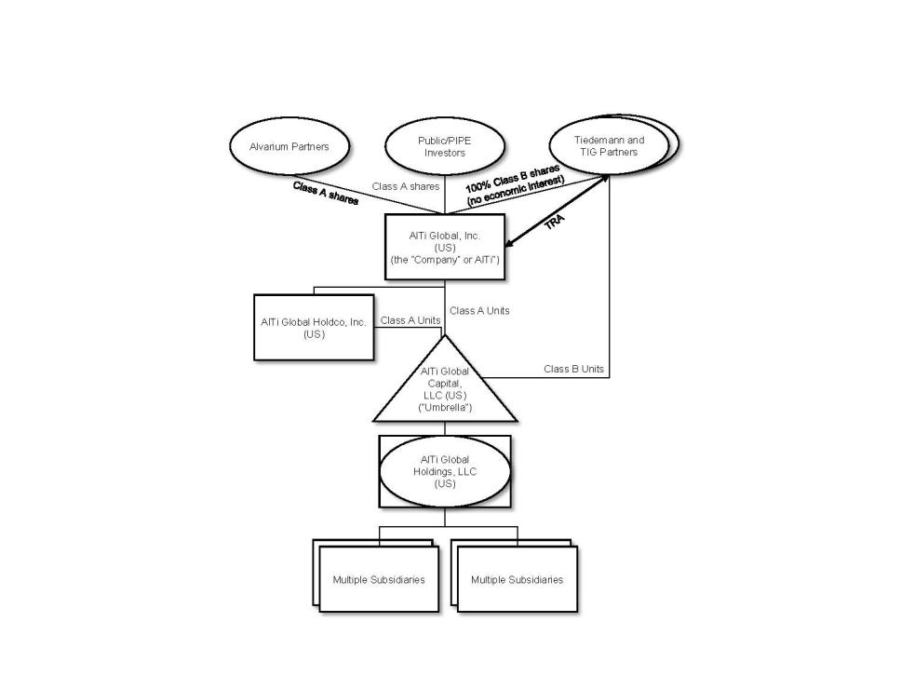

Capital Structure

The Registrant has the following classes of shares and other instruments outstanding:

- Class A Common Stock – Shares of Class A Common Stock that are publicly traded. Class A shareholders are entitled to dividends on shares of Class A Common Stock declared by the Company’s board of directors. As of June 30, 2024, the shares of Class A Common Stock represent 55.6% of the total voting power of all shares of Common Stock.

- Class B Common Stock – Shares of Class B Common Stock that are not publicly traded. Class B shareholders are entitled to distributions declared by the Company’s board of directors. The distributions are paid by Umbrella. As of June 30, 2024, the shares of Class B Common Stock represent 36.9% of the total voting power of all shares of Common Stock.

- Prior to the Business Combination, the Company issued Warrants to purchase shares of Class A Common Stock at a price of $11.50 per share. Throughout the period from January 1, 2023 to March 31, 2023, 428,626 Warrants were exercised. On April 3, 2023, 78,864 Warrants were exercised. On June 7, 2023, the Company closed an offer and consent solicitation and entered into a warrant amendment, pursuant to which the remaining 19,892,387 Warrants were exchanged for 4,962,147 shares of Class A Common Stock. The exercises and exchanges throughout the period from January 1,

17

AlTi Global, Inc.

Notes to Condensed Consolidated Financial Statements (Unaudited)

2023 to June 30, 2023 resulted in an increase in Additional paid-in-capital amount of $29.5 million. As of June 30, 2024, none of such Warrants were outstanding.

- Series C Cumulative Convertible Preferred Stock (the “Series C Preferred Stock”) – Shares of Series C Preferred Stock that are not publicly traded and issued in connection with the sale (the “Transaction”) to CWC AlTi Investor LLC, an affiliate of Constellation Wealth Capital, LLC (“Constellation”) (combined with the Transaction, the “Constellation Transaction”). The Series C Preferred Stock will receive cumulative, compounding dividends at a rate of 9.75% per year, subject to annual adjustments based on the stock price of the Class A Common Stock during the fourth quarter of each applicable year (subject to a maximum rate of 9.75%) on the sum of (i) $1,000 per share plus, (ii) once compounded, any compounded dividends thereon ($1,000 per share plus accumulated compounded dividends and accrued but unpaid dividends through any date of determination). Dividends will be paid (at the option of the Company) as a payment in kind increase in the stated value of the issued shares of Series C Preferred Stock or in cash. The Series C Preferred Stock will also participate with any dividends or distributions declared on the Class A Common Stock. As of June 30, 2024, the shares of Series C Preferred Stock represent 7.5% of the total voting power of all shares.

- In connection with the Constellation Transaction, the Company issued warrants (the “Constellation Warrants”) to purchase 2,000,000 shares of the Company’s Class A Common Stock at an exercise price of $7.40 per share. These warrants have been classified as a liability as of June 30, 2024. No Constellation Warrants were exercised during the current reporting period.

The following table presents the number of shares of the Registrant that were outstanding as of June 30, 2024 and December 31, 2023:

 | As of June 30, |  |  | As of December 31,
2024 |  |  |  | 2023
Class A Common Stock |  | 72,167,195 |  | 65,110,875
Class B Common Stock |  | 47,978,953 |  | 53,219,713
Series C Preferred Stock |  | 150,000 |  | —

Segments

Our business is organized into two operating segments: Wealth Management and Strategic Alternatives. Described below are the segments and the revenue generated by each, which broadly fall into three categories: recurring management, advisory, or administration fees; performance or incentive fees; and transaction fees. Subsequent to June 30, 2024, management has commenced a strategic review of certain businesses within the currently defined Strategic Alternatives segment. This review, which is expected to be completed by the end of the third quarter of 2024, will consider, among other things, potential changes to our legal entity structure as well as the components included within the operating segments outlined below. Refer to Note 21 (Subsequent Events) for further details.

Wealth Management

Within our Wealth Management segment, services provided principally consist of investment management and advisory services, trusts and administrative services, and family office services. The wealth management client base includes high-net-worth individuals, families, single family offices, foundations, and endowments globally. Investment management or advisory fees are the primary source of revenue in our Wealth Management segment. These fees are generally calculated based on a percentage of the value of each client’s billable AUM or AUA (as applicable). As of June 30, 2024 and December 31, 2023, this segment had $55.9 billion and $51.0 billion, respectively, in AUA.

18

AlTi Global, Inc.

Notes to Condensed Consolidated Financial Statements (Unaudited)

Investment Management and Advisory Services

In our investment management and advisory services teams, we diversify our clients’ portfolios across risk factors, geographies, traditional asset classes such as money markets, equities and fixed income, and alternative asset classes including private equity, private debt, hedge funds, real estate, and other assets through highly experienced third-party

managers.

Trusts and Administration Services

The trust and administration services that we provide include entity formation and management, creating or modifying trust instruments and/or administrative practices to meet beneficiary needs, full corporate, trustee-executor, and fiduciary services. We also offer a provision of directors and company secretarial services, administering entity ownership of intellectual property rights, advice and administration services in connection with investments in marine and aviation assets, and administering entity ownership of fine art and collectibles.

Family Office Services

Family office services are tailored outsourced family office solutions and administrative services which we provide primarily to our larger clients. These services include bookkeeping and back-office services, private foundation management and grantmaking, oversight of trust administration, financial tracking and reporting, cash flow management and bill pay, and other financial services.

Strategic Alternatives

Strategic alternatives services include the alternatives platform and public and private real estate (including co-investment) businesses.

Alternatives Platform

The alternatives platform embodies our legacy TIG business, which is an alternative asset manager and includes our TIG Arbitrage strategy and funds managed by our External Strategic Managers, predominantly for institutional investors. The TIG Arbitrage strategy is an event-driven strategy fund that earns management fees and incentive fees based on the performance of its underlying funds and accounts. The investment strategies of the External Strategic Managers include Real Estate Bridge Lending, European Equities and Asian Credit and Special Situations. Distributions are received from the External Strategic Managers through profit or revenue sharing arrangements that are generated through management and incentive fees based on the performance of the underlying investments. As of June 30, 2024 and December 31, 2023, this platform had $7.3 billion and $7.6 billion, respectively, in AUA.

Real Estate Co-Investment

Real estate co-investment oversees deal origination, documentation, and structuring from inception to exit for a variety of strategies, including development, income, value-add, and planning. Investors are typically HNWIs, single family offices, and institutional investors. Fees earned include private market, incentive fees, management and advisory fees, and placement and brokerage fees.

Real Estate Fund Management

Fees from our real estate fund management business are earned from management and advisory services. As of June 30, 2024 and December 31, 2023, this business had approximately $8.6 billion and $12.7 billion, respectively, in AUA.

Prior to the first quarter of 2024, our real estate fund management business managed two funds based in the United Kingdom, LXi, a publicly traded real estate investment trust, and HLIF, a private fund. As described

19

AlTi Global, Inc.

Notes to Condensed Consolidated Financial Statements (Unaudited)

further below, during 2024 we exited the management of the publicly traded real estate fund and we are in the process of exiting the management of the private real estate fund.

On January 9, 2024, AlTi RE Public Markets Limited entered into heads of terms to sell 100% of the equity of LXi REIT Advisors Limited (“LRA”), the advisor to the publicly-traded fund LXi REIT plc (“LXi”), to LondonMetric Property Plc (“LondonMetric”) for fixed consideration of approximately $33.1 million and up to an estimated $5.1 million of

contingent consideration based on the exchange rate as of the balance sheet date, as applicable. The contingent consideration meets the definition of a derivative and is recorded as Contingent consideration receivable on the Condensed Consolidated Statement of Financial Position as of June 30, 2024. This contingent consideration will be remeasured at fair
value at each reporting date in accordance with ASC 820, Fair Value Measurement, with changes in fair value recognized in the Condensed Consolidated Statement of Operations in the period of change.

This disposal was completed on March 6, 2024. As a result, the Company recognized an intangible asset impairment charge of $23.5 million, which is recorded in Impairment loss on goodwill and intangible assets in the Consolidated Statement of Operations during the year ended December 31, 2023. In addition, as of December 31, 2023, the major classes of

assets and liabilities of LRA were presented as held for sale in the Consolidated Statement of Financial Position. As of the six months ended June 30, 2024, there was no gain on

disposal recognized in Gain (loss) on investments in the Condensed Consolidated Statement of Operations. See Note 3 (Business Combinations and Divestitures) for further information.

On February 26, 2024, AFM UK and SHIA served notice to terminate their contracts with HLIF. We are in discussions with a third-party manager to take over the management of HLIF and termination of these contracts will become effective once the transition process has been completed.

Subsequent to the end of the second quarter of 2024, management has commenced a strategic review of the business plan for Real Estate Co-investment and Fund Management activities. This review will consider, among other things, potential changes to our legal entity structure as well as the components included within our operating segments. Refer to Note 21 (Subsequent Events) for further details.

Alvarium Home REIT Advisors Limited

Prior to the Business Combination, ARE, an indirect wholly owned subsidiary of Alvarium, entered into an agreement to sell 100% of the equity of AHRA, the investment advisor to the publicly-traded fund Home REIT, to a newly formed entity (“NewCo”) owned by the management of AHRA, for aggregate consideration approximately equal to $29 million. Consequently, AHRA has never been part of AlTi. The consideration was comprised of a promissory note that matured on December 31, 2023. Additionally, ARE was granted a call option pursuant to which ARE had the right to repurchase AHRA prior to the repayment of the note for a purchase price equal to the note balance then outstanding thereunder.

Subsidiaries are companies over which a company has the power indirectly and/or directly to control the financial and operating policies so as to obtain benefits. In assessing control for accounting purposes, potential voting rights that are presently exercisable or convertible (including rights that may arise on the exercise of an option) are taken into account. With respect to the AHRA, the above arrangements resulted in AHRA continuing to be consolidated by AlTi after its legal disposal to NewCo. Due to this consolidation, after the Business Combination, an intangible asset was recognized related to the investment advisory agreement between AHRA and Home REIT.

AlTi was formed on January 3, 2023, through a business combination transaction that included certain legacy Alvarium companies. While the sale of AHRA occurred prior to the Business Combination, under GAAP, its results were required to be consolidated in our financial statements until June 30, 2023, when it was deconsolidated. On June 30, 2023, the Company entered into a series of agreements that resulted in the deconsolidation of AHRA from the Strategic Alternatives segment with immediate effect. The agreements removed ARE’s potential controlling voting rights in AHRA (previously ascertainable on the exercise of the

20

AlTi Global, Inc.

Notes to Condensed Consolidated Financial Statements (Unaudited)

option) and terminated other residual contractual relationships between AHRA and ARE. As a result, these agreements removed AlTi’s control of AHRA from an accounting perspective. AHRA’s results are included in the Company’s Condensed Consolidated Statement of Operations for the period from January 1, 2023 to June 30, 2023, and it was removed from the Consolidated Statement of Financial Position as of June 30, 2023. The deconsolidation resulted in an intangible asset impairment charge of $29.4 million, which was recorded in Impairment loss on goodwill and intangible assets in the Condensed Consolidated Statement of Operations during the year ended December 31, 2023. Assets managed by AHRA, however, have been excluded from the Company’s AUM/AUA metrics since January 1, 2023.

- Summary of Significant Accounting Policies

  - Basis of Presentation

The accompanying unaudited condensed consolidated financial statements comprise the financial statements of the Company and its subsidiaries. These condensed consolidated financial statements have been prepared under the accrual basis of accounting in accordance with U.S. GAAP and conform to prevailing practices within the financial services industry, as applicable to the Company, and should be read in conjunction with the annual financial statements included in the Annual Report on Form 10-K filed by the Company on March 22, 2024 (as amended by the Company on Form 10-K/A filed with the SEC on April 5, 2024, the “Annual Report”). The notes are an integral part of the Company’s condensed consolidated financial statements. In the opinion of management, all adjustments necessary for a fair presentation of the Company’s condensed consolidated financial statements have been included and are of a normal and recurring nature.

The condensed consolidated financial statements include the accounts of the Company and its subsidiaries. All significant intercompany balances and transactions have been eliminated in consolidation. Certain prior period presentations and disclosures, while not required to be recast, may be reclassified to ensure comparability with current period classifications.

- Prior Period Immaterial Corrections

Following an analysis of quantitative and qualitative factors in accordance with SEC Staff Accounting Bulletin 99, Materiality, the Company concluded that the errors below were immaterial to the previously issued consolidated financial statements, and thus, no restatement of any of the Company’s previously issued financial statements is necessary. The Company revised the reported balances to correct for the immaterial errors accordingly.

During the first quarter of 2024, the Company identified and corrected immaterial errors impacting the December 31, 2023 balances previously reported related to Accrued compensation and profit sharing, Goodwill, Accounts payable and accrued expenses and certain other balances reported within Other liabilities. These revisions resulted in an adjustment to the opening retained earnings balance for the current reporting period of $(3.0) million, a $4.2 million increase in Accrued compensation and profit sharing, a $0.3 million decrease in Goodwill, a $0.6 million increase in Other liabilities, and a $0.3 million increase in Accounts payable and accrued expenses. In conjunction with the prior period immaterial error correction, certain reclassifications have been made to prior period amounts between our Non-controlling interest in subsidiaries and Additional paid-in capital which relate to the TRA Exchange of our Class B Units for shares of Class A Common Stock. These reclassifications resulted in an adjustment of $13.3 million and are reflected in our Condensed Consolidated Statement of Changes in Mezzanine Equity and Shareholders’ Equity. These prior period reclassifications have no impact on the Company’s cash flows, net income, or total shareholders’ equity.

21

AlTi Global, Inc.

Notes to Condensed Consolidated Financial Statements (Unaudited)

Additionally, in the current reporting period, the Company reclassified the balances in its Condensed Consolidated Statement of Operations as of June 30, 2023 of the previously reported amounts for the line items Management/advisory fees and Professional fees, decreasing both balances by $0.6 million.

- Reclassifications

Certain amounts as of June 30, 2024 have been reclassified in our Condensed Consolidated Financial Position due to presentation changes that occurred during the current period and are not comparable to the year ended December 31, 2023. The impact of these reclassifications includes a $4.8 million reclass from Accounts payable and accrued expenses to Accrued compensation and profit sharing and a $3.2 million reclass from Other liabilities to Accrued compensation and profit sharing.

- Use of Estimates

The preparation of financial statements in conformity with US GAAP requires management to make assumptions and estimates that affect the amounts reported in the condensed consolidated financial statements of the Company. The most critical of these estimates are related to (i) the fair value of the investments included in the Billable Assets within AUM/AUA, as this impacts the amount of revenues the Company recognizes each period; (ii) the fair values of the Company’s investments and liabilities with respect to the TRA, and Earn-out Securities, as changes in these fair values have a direct impact on the Company’s consolidated net income (loss); (iii) the estimate of future taxable income, which impacts the realizability and carrying amount of the Company’s deferred income tax assets; (iv) the qualitative and quantitative assessments of whether impairments of equity method investments, carried interest vehicles, acquired intangible assets, and goodwill exist; and (v) the determination of whether to consolidate a variable interest entity (“VIE”); and (vi) fair value of assets acquired and liabilities assumed in business combinations, including assumptions with respect to future cash inflows and outflows, discount rates, assets’ useful lives, market multiples, the allocation of purchase price consideration in the business combination valuation of acquired assets and liabilities, the estimated useful lives of intangible assets, goodwill impairment testing, assumptions used to calculate equity-based compensation, and the realization of deferred tax assets. Inherent in such estimates are judgments relating to future cash flows, which include the Company’s interpretation of current economic indicators and market valuations, and assumptions about the Company’s strategic plans with regard to its operations. While management believes that the estimates utilized in preparing the condensed consolidated financial statements are reasonable and prudent, actual results could differ materially from those estimates.

- Consolidation

The Company consolidates those entities in which it has a direct or indirect controlling financial interest based on either a variable interest model or voting interest model. The Company determines whether an entity should be consolidated by first evaluating whether it holds a variable interest in the entity. Entities that are not VIEs are further evaluated for consolidation under the voting interest model (“VOE” model).

An entity is considered to be a VIE if any of the following conditions exist: (a) the total equity investment at risk is not sufficient to permit the entity to finance its activities without additional subordinated financial support, (b) the holders of equity investment at risk, as a group, lack either the direct or indirect ability through voting rights or similar rights to make decisions that have a significant effect on the success of the entity or the obligation to absorb the expected losses or right to receive the expected residual returns, or (c) the voting rights of some equity investors are disproportionate to their obligation to absorb losses of the entity, their rights to receive returns from an entity, or both and substantially all of the entity’s activities either involve or are conducted on behalf of an investor with disproportionately few voting rights.

Fees that are customary and commensurate with the level of services provided by the Company, and where the Company does not hold other economic interests in the entity that would absorb more than an

22

AlTi Global, Inc.

Notes to Condensed Consolidated Financial Statements (Unaudited)

insignificant amount of the expected losses or returns of the entity, are not considered a variable interest. The Company factors in all economic interests, including proportionate interests through related parties, to determine if fees are considered a variable interest. Where the Company’s interests in funds are primarily management fees and insignificant direct or indirect equity interests through related parties, the Company is not considered to have a variable interest in such entities.

The Company consolidates all VIEs for which it is the primary beneficiary. An entity is determined to be the primary beneficiary if it holds a controlling financial interest, which is defined as having (a) the power to direct the activities of the VIE that most significantly impact the entity’s economic performance and (b) the obligation to absorb losses of the entity or the right to receive benefits from the entity that could potentially be significant to the VIE. The Company does not consolidate any of the products it manages as it does not hold any direct or indirect interests in such entities that could expose the Company to an obligation to absorb losses of an entity or the right to receive benefits from an entity that could potentially be significant to such entities.

The Company determines whether it is the primary beneficiary of a VIE at the time it becomes involved with a VIE and continuously reconsiders that conclusion. In evaluating whether the Company is the primary beneficiary, the Company evaluates its direct and indirect economic interests in the entity. The consolidation analysis is generally performed qualitatively, however, if the primary beneficiary is not readily determinable, a quantitative analysis may also be performed. This analysis requires judgment, including: (1) determining whether the equity investment at risk is sufficient to permit the entity to finance its activities without additional subordinated financial support, (2) evaluating whether the equity holders, as a group, can make decisions that have a significant effect on the success of the entity, (3) determining whether two or more parties’ equity interests should be aggregated, (4) determining whether the equity investors have proportionate voting rights to their obligations to absorb losses or rights to receive returns from an entity and (5) evaluating the nature of relationships and activities of the parties involved in determining which party within a related-party group is most closely associated with a VIE and therefore would be deemed the primary beneficiary.

Under the voting interest model, the Company consolidates those entities it controls through a majority voting interest. The Company will generally not consolidate those voting interest entities where a single investor or simple majority of third-party investors with equity have the ability to exercise substantive kick-out or participation rights.

- Revenue Recognition

Revenue is recognized when the Company transfers promised goods or services to customers in an amount that reflects the consideration to which the Company expects to be entitled in exchange for those goods or services. A five-step framework is utilized that requires an entity to: (i) identify the contract(s) with a customer, which includes assessing the collectability of the consideration to which it will be entitled in exchange for the goods or services transferred to the customer, (ii) identify the performance obligation in the contract, (iii) determine the transaction price, (iv) allocate the transaction price to the performance obligation in the contract, and (v) recognize revenue when the entity satisfies a performance obligation.

Management/Advisory Fees

Revenues from contracts with customers consist of investment management, trustee, and custody fees. The Company recognizes revenue at the time of transfer of promised goods or services to customers in an amount that reflects the consideration to which the Company expects to be entitled in exchange for those goods or services. Revenue recognized is calculated based on contractual terms, including the transaction price, whether a distinct performance obligation has been satisfied

23

AlTi Global, Inc.

Notes to Condensed Consolidated Financial Statements (Unaudited)

and control is transferred to the customer, and when collection of the revenue is assessed as probable.

Investment management, trustee and custody fees are recognized over the period in which the investment management services are performed, using a time-based output method to measure progress. The amount of revenue varies from one reporting period to another as levels of AUA change (from inflows, outflows, and market movements) and the number of days in the reporting period change.

For services provided to each client account, the Company charges an investment management fee, inclusive of custody and/or trustee fees, based on the fair value of the AUA of such account representing a single performance obligation. For assets for which valuations are not available on a daily basis, the most recent valuation provided to the Company is used as the fair value for the purpose of calculating the quarterly fee. In certain circumstances, fixed fees are charged to customers on a monthly basis. The nature of the Company’s performance obligation is to provide a series of distinct services in which the customer receives the benefits of the services over time. The Company’s performance obligation is satisfied at the end of each month or quarter, as applicable to the contract with the customer.

Fees are charged on a mixture of methodologies that include quarterly in arrears based upon the market value at the end of the quarter, quarterly based on the average daily balance, or monthly. Receivable balances from contracts with customers are included in the fees receivable line in the Condensed Consolidated Statement of Financial Position.

Our family office services business is also included in the Management/advisory fees line item. Family office services fees are generally structured to reflect an annual agreed upon fee or they can be structured on a project/time-based fee. Family office services fees are typically billed quarterly in arrears. We also generate family office services project/time-based fees arising from accounting, administration fees, set up, the Foreign Account Tax Compliance Act (“FATCA”), and other non-investment advisory services.

Incentive Fees

The Company is entitled to incentive fees if targeted returns have been achieved in accordance with customer contracts. Incentive fees are calculated using a percentage of net profit from the amount the customers earn. Incentive fees are variable consideration that is generally calculated as applicable to the contract with the customer. We recognize our incentive fees when it is no longer probable that a significant reversal of revenue will occur. Our incentive fees are not subject to clawback provisions.

Other Fees/Income

The Company generates arrangement fees in its co-investment division by arranging private debt or equity financing, generally in connection with an acquisition or an investment. Arrangement fees are typically 50 to 100 basis points of equity value contributed to a transaction, and are payable upon closing of the transaction. Acquisition fees are typically payable where there are no agency fees or where there is an off-market transaction sourced by the team. Such acquisition fees are usually in the range of 50 to 100 basis points of the purchase price of the relevant acquisition. The equity structures are long-term (five to ten years) closed-ended structures with fees normally ranging between 50 and 175 basis points of the equity value committed or drawn. The debt structure terms are generally between 12 and 36 months. The investment adviser, general partner or

24

AlTi Global, Inc.

Notes to Condensed Consolidated Financial Statements (Unaudited)

other entity entitled to fees in respect of each of our co-investments receives such fees either monthly, quarterly or annually.

- Distributions from Investments

The Company has equity interests in three entities pursuant to which it is entitled to distributions based on the terms of the respective arrangements. Distributions from each investment will be recorded upon receipt of the distribution. These distributions are recurring under investment agreements and are structured as either a profit or revenue share of the investment’s management and incentive fees.

- Cash and Cash Equivalents

Cash and cash equivalents primarily consist of cash and money market funds. Cash balances maintained by consolidated VIEs are not considered legally restricted and are included in cash and cash equivalents on the Condensed Consolidated Statement of Financial Position.

Cash was held across our U.S. and international markets. A majority of cash in the U.S. was held in checking accounts within the credit facility bank group, including at a major global financial institution which management believes is creditworthy.

- Restricted Cash and Cash Equivalents

Restricted cash and cash equivalents consist of balances that are restricted as to withdrawal or usage.

As of June 30, 2024 and December 31, 2023, restricted cash and cash equivalents amounted to $6.8 million and $5.4 million, respectively, and are included in the line item Cash and cash equivalents on the Condensed Consolidated Statement of Financial Position and Consolidated Statement of Financial Position, respectively. These amounts represent the level of liquidity to be maintained by the Company’s certain subsidiaries to meet regulatory requirements. Failing to meet the requirement could lead to censure, fines and ultimately a loss of license.

- Compensation and Employee Benefits

Cash-Based Compensation

Compensation and benefits consist of salaries, bonuses, commissions, benefits and payroll taxes. Compensation is accrued over the related service period.

Equity-Based Compensation

Equity-based compensation awards are reviewed to determine whether such awards are equity-classified or liability-classified. Compensation expense related to equity-classified awards is equal to their grant-date fair value and generally recognized on a straight-line basis over the awards’ requisite service period for time-based awards or recognized over a graded-vesting period for awards with both a service and market condition, as applicable. When certain settlement features require an award to be liability-classified, compensation expense is recognized over the service period, and such amount is adjusted at each statement of financial position date through the settlement date to the then current fair value of such award.

The Company recognizes equity-based award forfeitures in the period they occur as a reversal of previously recognized compensation expense. The reduction in compensation expense is determined based on the specific awards forfeited during that period. Furthermore, the Company recognizes all excess tax benefits and deficiencies as income tax benefits or expenses in the Condensed Consolidated Statement of Operations.

25

AlTi Global, Inc.

Notes to Condensed Consolidated Financial Statements (Unaudited)

- Foreign Currency and Transactions

The Company has multiple functional currencies across various consolidated entities. All functional currencies that are not the U.S. dollar are converted upon consolidation at the reporting date. Monetary assets and liabilities denominated in foreign currency are remeasured into U.S. dollars at the closing rates of exchange on the date of the Condensed Consolidated Statement of Financial Position. Non-monetary assets and liabilities denominated in foreign currencies are remeasured into U.S. dollars using the historical exchange rate. The profit or loss arising from foreign currency transactions is remeasured using the rate in effect on the date of the relevant transaction. Gains and losses on transactions denominated in foreign currencies due to changes in exchange rates are recorded within Foreign currency translation adjustments. Gains and losses on certain financing transactions that the Company intends to repay in the foreseeable future are recorded in net income.

- Income Taxes

The Company accounts for income taxes under the asset and liability method in accordance with ASC 740. Under this method, deferred tax assets and liabilities are determined based on differences between the condensed consolidated financial statement carrying amounts and tax bases of assets and liabilities and operating loss and tax credit carryforwards and are measured using the enacted tax rates that are expected to be in effect when the differences reverse. The effect on deferred tax assets and liabilities of a change in tax rates is recognized in the Condensed Consolidated Statement of Operations in the period that includes the enactment date. Valuation allowances are established when necessary to reduce deferred tax assets to an amount that, in the opinion of management, is more likely than not to be realized, meaning the likelihood of realization is greater than 50%.

The Company accounts for uncertain tax positions by reporting a liability for unrecognizable tax benefits resulting from uncertain tax positions taken or expected to be taken in a tax return. The Company recognizes interest and penalties, if any, related to unrecognized tax benefits in income tax expense.

(m) Other Assets, Net and Other Liabilities, Net

Other assets, net include prepaid expenses, miscellaneous receivables, current income taxes receivable, fixed assets, and software licenses. The Company amortizes assets over their respective useful lives, as applicable.

Other liabilities, net include the AlTi Wealth Management (Switzerland) SA, formerly known as Alvarium Investment Managers (Suisse) SA, (“AWMS”) deferred cash consideration (see Note 3 (Business Combinations and Divestitures)), accrued payroll and payroll related taxes, accrued legal fees, and corporate taxes payable, among other miscellaneous payables.

- Investments

Investments in Debt Securities. The Company classifies debt investments as held-to-maturity or trading based on the Company’s intent and ability to hold the debt security to maturity or its intent to sell the security. The Company does not have any held-to-maturity debt investments.

Trading securities are those investments that are purchased principally for the purpose of selling them in the near term. Trading securities are carried at fair value on the Condensed Consolidated Statement of Financial Position with changes in fair value recorded in Loss on investments on the Condensed Consolidated Statement of Operations.

26

AlTi Global, Inc.

Notes to Condensed Consolidated Financial Statements (Unaudited)

Investments in Equity Securities. Equity securities are generally carried at fair value on the Condensed Consolidated Statement of Financial Position in accordance with ASC 321, Investments – Equity Securities. Changes in fair value are recorded in Loss on investments on the Condensed Consolidated Statement of Operations.

Equity Method. The Company applies the equity method of accounting for equity investments where the Company does not consolidate the investee but can exert significant influence over the financial and operating policies of the investee. The evaluation of whether the Company exerts control or significant influence over the financial and operational policies of its investees is based on the facts and circumstances surrounding each individual investment. The Company’s share of the investee’s underlying net income or loss is recorded as Loss on investments within current period earnings. The Company’s share of net income of the investee is recorded based upon the most current information available at the time, which may precede the date of the Condensed Consolidated Statement of Financial Position. Due to the nature and size of its investees, the Company has adopted a lag in reporting for certain equity method investees for which the Company cannot reliably obtain financial information on a regular basis. Distributions received reduce the Company’s carrying value of the investee and the cost basis if deemed to be a return of capital. For certain investments, the Company may apply the alternative fair value option to the investment at initial measurement. The fair value measurement of investments in which the fair value option is elected will be measured in accordance with ASC 825.

For equity method investments and nonmarketable investments, impairment evaluation considers qualitative factors, including the financial conditions and specific events related to an investee, which may indicate the fair value of the investment is less than the carrying value. For held-to-maturity investments, impairment is evaluated using market values, when available, or the expected cash flows of the investment. These losses in value may be considered other than temporary impairment losses.

- Leases

The Company determines if an arrangement is a lease at inception of the arrangement and primarily enters into operating leases, as the lessee, for office space. The Company accounts for its leases in accordance with ASC 842, Leases, and recognizes a lease liability and right-of-use asset in the Condensed Consolidated Statement of Financial Position for contracts that it determines are leases or contain a lease. The Company evaluates leases at their inception to determine if they are to be accounted for as an operating lease or a finance lease. A lease is accounted for as a finance lease if it meets one of the following five criteria: (i) the lease has a purchase option that is reasonably certain of being exercised, (ii) the present value of the future cash flows is substantially all of the fair market value of the underlying asset, (iii) the lease term is for a significant portion of the remaining economic life of the underlying asset, (iv) the title to the underlying asset transfers at the end of the lease term, or (v) if the underlying asset is of such a specialized nature that it is expected to have no alternative uses to the lessor at the end of the term. Leases that do not meet the finance lease criteria are accounted for as an operating lease. At the inception of a finance lease, an asset and finance lease obligation are recorded at an amount equal to the lesser of the present value of the minimum lease payments and the property’s fair market value. Finance lease obligations are classified as either current or long-term based on the due dates of future lease payments, net of interest. The Company’s lease portfolio primarily consists of operating leases for office space in various countries around the world. The Company also has operating leases for office equipment and vehicles, which are not significant. The Company does not separate non-lease components from lease components for its office space and equipment operating leases and instead accounts for each separate lease component and its associated non-lease component as a single lease component. Right-of-use assets represent the Company’s right to use an underlying asset for the lease term and lease liabilities represent the Company’s obligation to make lease payments arising from the leases. The Company’s right-of-use assets and lease liabilities are recognized at lease commencement based on the present value of lease payments over the lease term. Lease right-of-use assets include initial direct costs incurred by the Company and are presented net of deferred rent and lease incentives. Absent an implicit interest rate in

27

AlTi Global, Inc.

Notes to Condensed Consolidated Financial Statements (Unaudited)

the lease, the Company uses its incremental borrowing rate, adjusted for the effects of collateralization, based on the information available at commencement in determining the present value of lease payments. The Company’s lease terms may include options to extend or terminate the lease when it is reasonably certain that the Company will exercise those options. Lease expense for lease payments is recognized on a straight-line basis over the lease term. Lease right-of-use assets are reviewed for impairment whenever events or changes in circumstances indicate that the carrying amount of the asset may not be recoverable.

The Company does not recognize a lease liability or right-of-use asset on the balance for short-term leases. Instead, the Company recognizes short-term lease payments as an expense on a straight-line basis over the lease term. A short-term lease is defined as a lease that, at the commencement date, has a lease term of 12 months or less and does not include an option to purchase the underlying asset that the lessee is reasonably certain to exercise. When determining whether a lease qualifies as a short-term lease, the Company evaluates the lease term and the purchase option in the same manner as all other leases.

- Intangible Assets Other Than Goodwill, Net

The Company recognized certain finite-lived intangible assets as a result of the Business Combination. The Company’s finite-lived intangible assets consist of Trade Names, Customer Relationships, Investment Management Agreements, and Backlog. Finite-lived intangible assets are amortized on a straight-line basis over their estimated useful lives.

The Company tests finite-lived intangible assets for impairment if certain events occur or circumstances change indicating that the carrying amount of the intangible asset may not be recoverable. The Company evaluates impairment by comparing the estimated fair value attributable to the intangible asset with its carrying amount. If an impairment exists, the Company adjusts the carrying value to equal the fair value by taking a charge through earnings.

The Company also recognized certain indefinite-lived intangible assets as a result of the Business Combination consisting of certain investment management agreements. These indefinite-lived intangibles are not subject to amortization, but are evaluated for impairment at least annually. In assessing its indefinite-lived intangible assets for impairment, the Company has the option to first perform a qualitative assessment to determine whether events or circumstances exist that lead to a determination that it is unlikely that the fair value of the indefinite-lived intangible asset is less than its carrying amount. If the Company determines that it is unlikely that the fair value of an indefinite-lived intangible asset is less than its carrying amount, the Company is not required to perform any additional tests in assessing the asset for impairment. However, if the Company concludes otherwise or elects not to perform the qualitative assessment, then it is required to perform a quantitative analysis to determine if the fair value of an indefinite-lived intangible asset is less than its carrying value. If through this quantitative analysis the Company determines the fair value of an indefinite-lived intangible asset exceeds its carrying amount, the indefinite-lived intangible asset is considered not to be impaired. If the Company concludes that the fair value of an indefinite-lived intangible asset is less than its carrying value, an impairment loss will be recognized for the amount by which the carrying amount exceeds the indefinite-lived intangible asset’s fair value.

During the three and six months ended June 30, 2024, the Company recognized intangible asset impairment charges of $0.7 million. As of December 31, 2023, the Company recognized intangible asset impairment charges of $52.9 million. See Note 10 (Intangible assets, net) for further detail.

- Goodwill

Goodwill represents the excess of the purchase price in a business combination over the fair value of the tangible and intangible assets acquired and the liabilities assumed.

Under ASC 350, Intangibles—Goodwill and Other, goodwill is not amortized, but rather is subject to an annual impairment test.

28

AlTi Global, Inc.

Notes to Condensed Consolidated Financial Statements (Unaudited)

Goodwill represents the excess of consideration over identifiable net assets of an acquired business. Goodwill is allocated at a reporting unit level. The Company has two reporting units, Strategic Alternatives and Wealth Management, and tests goodwill annually for impairment at each reporting unit. If, after assessing qualitative factors, the Company believes that it is more likely than not that the fair value of the reporting unit inclusive of goodwill is less than its carrying amount, the Company will perform a quantitative assessment to determine whether an impairment exists. If an impairment exists, the Company adjusts the carrying value of goodwill so that the carrying value of the reporting unit is equal to its fair value by taking a charge through earnings. The Company also tests goodwill for impairment in other periods if an event occurs or circumstances change such that it is more-likely-than-not to reduce the fair value of the reporting unit below its carrying amount. The Company concluded that the estimated fair value of the Strategic Alternatives and Wealth Management reporting units were greater than their carrying values, and as such, no impairment charges were required for the three and six months ended June 30, 2024. As of December 31, 2023, the Company recognized goodwill impairment charges of $153.9 million for the Strategic Alternatives segment and no goodwill impairment charges for the Wealth Management segment. See Note 13 (Goodwill, net).

- Fixed Assets, Net

Fixed assets are recorded at cost, less accumulated depreciation and amortization, and are included in the “Other assets” line item in the Company’s Condensed Consolidated Statement of Financial Position. Fixed assets are depreciated or amortized on a straight-line basis, with the corresponding depreciation and amortization expense included within general, administrative and other expenses in the Company’s Condensed Consolidated Statement of Operations. The estimated useful life for leasehold improvements is the lesser of the remaining lease term and the life of the asset, while other fixed assets are generally depreciated over a period of two to seven years. Fixed assets are reviewed for impairment whenever events or changes in circumstances indicate that the carrying amount of an asset may not be recoverable.

- Debt Obligations, Net

The Company’s debt obligations are recorded at amortized cost, net of any debt issuance costs, discounts and premiums. Debt issuances costs are deferred and along with discounts and premiums are amortized to interest expense in the Condensed Consolidated Statement of Operations over the life of the related debt instrument using the effective interest method. Unamortized debt issuance costs, discounts and premiums are written off to net losses on retirement of debt in the Condensed Consolidated Statement of Operations when the Company prepays borrowings prior to maturity.

- Tax Receivable Agreement

The TRA liability represents amounts payable to certain pre-Business Combination equity holders of the Company. The portion of the TRA liability related to the Business Combination is deemed contingent consideration payable to the previous owners and is carried at fair value, with changes in fair value reported within Gain (loss) on TRA in the Condensed Consolidated Statement of Operations. Future exchanges of Class B Units for shares of Class A Common Stock may increase the TRA liability. Those increases will be carried at a value equal to the expected future payments due under the TRA. On August 31, 2023, holders of shares of Class B Common Stock exchanged 1,813,248 Class B Paired Interests with the Company, for shares of Class A Common Stock on a 1:1 basis totaling an amount equal to $7.31 multiplied by the total number of shares of Class A Common Stock received at the time of the transaction. On March 11, 2024, holders of Class B Common Stock exchanged 4,954,518 Class B Paired Interests with the Company, for shares of Class A Common Stock on a 1:1 basis totaling an amount equal to $6.61 multiplied by the total number of shares of Class B Common Stock exchanged at the time of the transaction. On May 14, 2024, holders of Class B Common Stock exchanged 286,242 Class B Paired Interests with the Company, for shares of Class A Common Stock on a 1:1 basis totaling an amount equal to $4.69 multiplied by the total number of shares of Class B Common Stock exchanged at the time of the

29

AlTi Global, Inc.

Notes to Condensed Consolidated Financial Statements (Unaudited)

transaction. For future changes in the TRA balance due to exchanges, the Company will record an initial estimate of future payments under the TRA portion as an adjustment to Additional paid-in capital in the Condensed Consolidated Statement of Financial Position. Subsequent adjustments to the liability for future payments under the TRA related to changes in estimated future tax rates or state income tax apportionment are recognized through current period earnings in the Condensed Consolidated Statement of Operations.

- Warrant Liabilities

The Company evaluated the Warrants issued in connection with the Business Combination in accordance with ASC 815-40 and concluded that a provision in the warrant agreement related to certain tender or exchange offers precludes the Warrants from being accounted for as components of equity. As the Warrants meet the definition of a derivative, the Warrants are recorded as derivative liabilities on the balance sheet and measured at fair value at each reporting date in accordance with ASC 820, Fair Value Measurement, with changes in fair value recognized in Loss on warrant liability in the Condensed Consolidated Statement of Operations in the period of change. Prior to the Business Combination the Sponsor held private warrants that were contributed to the Company and legally cancelled. The contribution and cancellation of these warrants resulted in derecognition of the private warrants and accounted for in Additional paid-in capital as of January 1, 2023. The Company subsequently issued new warrants with terms identical to those of the public warrants to the Target Companies’ selling shareholders classified as derivative liabilities. On June 7, 2023, the Company closed an offer and consent solicitation and entered into a warrant amendment, pursuant to which the remaining Warrants were exchanged. In total, the Warrants were exchanged for 4,962,221 shares of Class A Common Stock. See Note 1 (Description of the Business). Following the exchange, none of the Warrants remained outstanding as of December 31, 2023.

On March 27, 2024 and May 15, 2024, the Company completed the initial and additional issuances of Constellation Warrants to purchase 1,533,333 shares and 466,667 shares, respectively, of the Company’s Class A Common Stock. The Company evaluated the Constellation Warrants in accordance with ASC 815-40 and determined that a provision in the agreement related to a change of control adjustment would preclude equity classification as the Constellation Warrants would no longer be a fixed-for-fixed option. The Constellation Warrants meet the definition of a derivative and are recorded as a derivative liability on the balance sheet and measured at fair value at each reporting date in accordance with ASC 820, Fair Value Measurement, with any changes in fair value to be recognized in the Consolidated Statement of Operations in the period of change. As of June 30, 2024, none of the Constellation Warrants have been exercised.

- Business Combination Earn-out Liability

The Business Combination Earn-out Securities, comprised of 3.3 million Class A Shares, 7.1 million shares of Class B Common Stock, and 7.1 million Class B Units (one Class B share and one Class B Unit comprising a Paired Interest, as described in Note 3 (Business Combinations and Divestitures)), are payable to the Sponsor and the selling shareholders of TWMH, TIG, and Alvarium upon the achievement of certain vesting conditions in accordance with the terms of the Business Combination Agreement. Upon the Company’s Class A Share price meeting a volume-weighted average price threshold of $12.50 for 20 out of 30 trading days within five years of the Closing, fifty percent of the Business Combination Earn-out Securities will vest and be issued in settlement of the Business Combination Earn-out Liability (or, in the case of the Sponsor, which shares have already been issued, will no longer be subject to forfeiture). Upon the Company’s Class A Share price meeting a volume-weighted average price threshold of $15.00 for 20 out of 30 trading days within five years of the Closing, the remaining fifty percent of the Business Combination Earn-out Securities will vest and be issued. If, within five years of the Closing, a change of control event occurs (as defined in the Business Combination Agreement), any Business Combination Earn-out Securities not previously issued will be deemed to have vested and will be issued (or, in the case of the Sponsor, which shares have already been issued, will no longer be subject to forfeiture). The

30

AlTi Global, Inc.

Notes to Condensed Consolidated Financial Statements (Unaudited)

Company evaluated the terms of the Business Combination earn-out agreement in accordance with ASC 815-40 and concluded that the Business Combination Earn-out Securities are precluded from being accounted for as a component of equity. Since the Business Combination earn-out agreement meets the definition of a derivative, the Business Combination Earn-out Securities are recorded in Earn-out liability, at fair value, as a derivative liability on the Condensed Consolidated Statement of Financial Position and measured at fair value at each reporting date in accordance with ASC 820, Fair Value Measurement, with changes in fair value recognized in Gain (loss) on earn-out liability in the Condensed Consolidated Statement of Operations and in Fair value of earn-out liability in the Condensed Consolidated Statement of Cash Flows in the period of change.

- AWMS Earn-out Liability

On August 2, 2023, (the “AWMS Acquisition Date”), the Company acquired the remaining 70% of the issued and outstanding ownership and membership interests of AWMS, increasing its interest from 30% to 100% (the “AWMS Acquisition”). The AWMS Acquisition was accounted for using the acquisition method of accounting and the fair

value of the total purchase consideration transferred was $16.8 million. The total purchase consideration transferred includes cash consideration, equity consideration, deferred cash consideration, earn-out consideration (“AWMS earn-out liability”), and the payment of assumed liabilities. As of June 30, 2024 and December 31, 2023, the AWMS
earn-out liability of $1.1 million and $1.1 million, is reported in Earn-out liability, at fair value, in the Condensed Consolidated Statement of Financial Position and

Consolidated Statement of Financial Position, respectively. Since the AWMS earn-out liability meets the definition of a derivative, it is recorded at fair value as a derivative liability on the Condensed Consolidated Statement of Financial Position and measured at fair value at each reporting date in accordance with ASC 820, Fair Value
Measurement, with changes in fair value to be recognized in Gain (loss) on earn-out liability in the Condensed Consolidated Statement of Operations and in Fair value of earn-out liability in the Condensed Consolidated Statement of Cash Flows in the period of change. See Note 3 (Business Combinations and Divestitures) for further information.

- East End Advisors Earn-out Liability

On April 1, 2024 (the “EEA Acquisition Date”), the Company acquired all of the issued and outstanding ownership and membership interests of East End Advisors, LLC

(“EEA”) pursuant to the terms of the purchase agreement between the Company and EEA Holding Company, LLC (the “EEA Acquisition”). The EEA Acquisition was accounted for using the acquisition method of accounting and the fair value of the total purchase consideration transferred was $93.1 million. The total purchase consideration
transferred includes estimated contingent consideration of $23.3 million (“EEA earn-out liability”), for which the Company may be required to make additional cash payments

contingent on the future EBITDA performance targets between the closing date and the fifth anniversary of the closing date. As of June 30, 2024, the EEA earn-out liability’s fair value of $24.0 million is reported in the Earn-out liability line item in the Condensed Consolidated Statement of Financial Position. The fair value will be remeasured at
each reporting date in accordance with ASC 820, Fair Value Measurement, with changes in fair value recognized in Gain (loss) on earn-out liability in the Condensed

Consolidated Statement of Operations and in Fair value of earn-out liability in the Condensed Consolidated Statement of Cash Flows in the period of change. See Note 3 (Business Combinations and Divestitures) for further information.

- Delayed Share Purchase Agreement

Prior to the Business Combination, TWMH entered into an agreement to purchase a remaining non-controlling interest in its consolidated subsidiary representing 51.1% of shares in TIH. This arrangement was agreed upon for consideration of $2.1 million in cash and $1.2 million in Class A Common Stock. On March 25, 2024, the TIH SPA was fully paid. As of December 31, 2023, the Delayed share purchase agreement liability was $1.8 million and the portion of the Delayed share purchase agreement reported in Accrued compensation and profit sharing was $0.3 million. The stock purchase price was recognized in the Consolidated Statement of Financial Condition as Additional paid-in capital. As of December 31,

31

AlTi Global, Inc.

Notes to Condensed Consolidated Financial Statements (Unaudited)

2023, the portion of the delayed share purchase agreement reported in Additional paid-in capital was $1.2 million.

- Non-controlling Interests

Non-controlling interests in the net assets of consolidated subsidiaries are identified separately from the Company’s equity. Non-controlling interests consist of the amount of those interests at the date of the original Business Combination and the minority’s share of changes in equity since the date of the Business Combination. The proportions of profit and loss and changes in equity allocated to the owners of the parent and to the non-controlling interests are determined on the basis of existing ownership interests.

(aa) Derivative Financial Instruments

The Company accounts for derivative financial instruments in accordance with ASC 815, Derivatives and Hedging, which requires the Company to recognize all derivative instruments on the Condensed Consolidated Statement of Financial Position as either assets or liabilities and to measure them at fair value each reporting period unless they qualify for normal purchases and normal sales exception. Normal purchases and normal sales contracts are those that provide for the purchase or sale of something other than a financial instrument or derivative instrument that will be delivered in quantities expected to be used or sold by a reporting entity over a reasonable period in the normal course of business.

In connection with the LXi disposal, the Company determined the contingent consideration meets the definition of a derivative and is recorded as Contingent consideration receivable on the Condensed Consolidated Statement of Financial Position as of June 30, 2024. The Contingent consideration receivable will be remeasured at fair value at each reporting date in accordance with ASC 820, Fair Value Measurement, with changes in fair value recognized in the Condensed Consolidated Statement of Operations in the period of change.

(ab) Segment Reporting

Our business is organized into two operating segments: Wealth Management and Strategic Alternatives. Segment information is utilized by the Company’s chief operating decision maker, which is our Chief Executive Officer, to assess performance and to allocate resources. Described below are the segments and the revenue generated by each, which broadly fall into three categories: recurring management, advisory, or administration fees; performance or incentive fees; and transaction fees.

Wealth Management

Our Wealth Management services principally consist of investment management and advisory services, trusts and administrative services, and family office services. Our wealth management client base includes HNWIs, families, single family offices, foundations, and endowments globally. Investment management or advisory fees are the primary source of revenue in our Wealth Management segment. These fees are generally calculated based on a percentage of the value of each client’s AUM or AUA (as applicable). As of June 30, 2024 and December 31, 2023, this segment had $55.9 billion and $51.0 billion, respectively, in AUA.

Investment Management and Advisory Services

In our investment management and advisory services teams, we diversify our clients’ portfolios across risk factors, geographies, and asset classes including private equity, private debt, hedge funds, real estate, and other assets through highly experienced third-party managers, who may be hard to access.

32

AlTi Global, Inc.

Notes to Condensed Consolidated Financial Statements (Unaudited)

Trusts and Administration Services

The trusts and administration services that we provide include entity formation and management, creating or modifying trust instruments and/or administrative practices to meet beneficiary needs, full corporate, trustee-executor, and fiduciary services. We also offer provision of directors and company secretarial services, administering entity ownership of intellectual property rights, advice and administration services in connection with investments in marine and aviation assets, and administering entity ownership of fine art and collectibles.

Family Office Services

Our family office services are tailored outsourced family office solutions and administrative services which we provide primarily to our larger clients. These services include bookkeeping and back-office services, private foundation management and grantmaking, oversight of trust administration, financial tracking and reporting, cash flow management and bill pay, and other financial services.

Strategic Alternatives

Our strategic alternatives services include alternatives platform and public and private real estate (including co-investment) businesses.

Alternatives Platform

Our alternatives platform represents our legacy TIG business which is an alternative asset manager. This platform includes our TIG Arbitrage strategy and funds managed by our External Strategic Managers. Our alternatives platform client base is predominantly comprised of institutional investors. The TIG Arbitrage strategy is our event-driven
strategy through which management fees and incentive fees based on performance are received from the underlying funds and accounts. The strategies of our External
Strategic Managers include Real Estate Bridge Lending, European Equities and Asian Credit and Special Situations. We receive distributions from our External Strategic Managers through our profit or revenue sharing arrangements that are generated through their management and incentive fees based on performance of the underlying

investments. As of June 30, 2024 and December 31, 2023, this platform had $7.3 billion and $7.6 billion, respectively, in AUA.

Real Estate Co-Investment

Real estate co-investment oversees deal origination, documentation, and structuring from inception to exit for a variety of strategies, including development, income, value-add, and planning. Investors are typically HNWIs, single family offices, and institutional investors. Fees earned include private market, incentive fees, management and advisory fees, and placement and brokerage fees.

Real Estate Fund Management

Fees from our real estate fund management business are earned from management and advisory services. As of June 30, 2024 and December 31, 2023, this business had approximately $8.6 billion and $12.7 billion, respectively, in AUA.

(ac) Interest Income

Interest income is earned on the Company’s cash balances, money market accounts, or through its investments in exchange-traded notes. These generally include debt securities held on a short- or medium-

33

AlTi Global, Inc.

Notes to Condensed Consolidated Financial Statements (Unaudited)

term basis when the Company has excess cash. The Company recognizes and records interest income in Interest income in the Condensed Consolidated Statement of Operations.

Dividend income is earned through investments in common stock, mutual funds, and exchange-traded funds. Dividend income is recorded on the date received and is included in Interest income in the Condensed Consolidated Statement of Operations.

(ad) Interest Expense

Interest is related to the Company’s debt as well as investments in exchange-traded notes. These generally include debt securities held on a short- or medium-term basis when the Company has excess cash. The Company recognizes and records interest expense in Interest expense in the Condensed Consolidated Statement of Operations.

(ae) Other Income and Expenses

Other than Interest income and Interest expense discussed above, other income and expenses include unrealized gains (losses) on investments, income from equity method investees, and other items.

The Company holds investments in common stock, mutual funds, exchange-traded funds, and exchange-traded notes, which represent investments in equity and debt securities. The Company earns realized and unrealized gains and losses which depend on investment performance. Changes in fair value of these investments are recorded in Loss on investments in the Condensed Consolidated Statement of Operations.

The Company holds interests in various affiliated limited partnerships and limited liability companies, whose purpose is to achieve capital appreciation through investments in financial instruments and investment vehicles. The Company accounts for investments in which it has significant influence but not a controlling financial interest using the equity method of accounting and may earn income related to its equity in income of equity method investees. The equity method investments are in various fund complexes, including funds focused on infrastructure and utilities, high income yields, and multi-strategy, among others. Changes in fair value of these investments are recorded in Loss on investments in the Condensed Consolidated Statement of Operations.

(af) Held for Sale Accounting

In circumstances when the Company is evaluating its components, we may establish plans that require us to evaluate whether a component qualifies for held-for-sale accounting under ASC 360, Property, Plant, and Equipment. If a sale is deemed probable within a twelve-month period, the component is classified to either the assets held for sale or liabilities held for sale line items on the Consolidated Statement of Financial Position. The disposal group will be measured at the lower of its carrying amount or fair value less the cost to sell. Any long-lived assets shall not be depreciated or amortized while classified as held for sale. On November 6, 2023, the Company entered into an agreement to sell FOS for a cash consideration of approximately $20.1 million. Subsequently, an adjustment to the cash consideration of $(0.6) million was made, resulting in a final cash consideration of approximately $19.5 million. The agreement to sell was subject to regulatory approval that was granted in April 2024, following which, on May 8, 2024, the transaction was completed. On March 6, 2024, the Company completed the sale of LRA, for fixed consideration of approximately $33.1 million and up to an estimated $5.1 million of contingent consideration. Assets and liabilities of FOS and LRA are presented as held for sale on our Consolidated Statement of Financial Position as of December 31, 2023.

34

AlTi Global, Inc.

Notes to Condensed Consolidated Financial Statements (Unaudited)

(ag) Recent Accounting Pronouncements

In November 2023, the Financial Accounting Standards Board (“FASB”) issued ASU 2023-07, Segment Reporting (Topic 280) - Improvements to Reportable Segment Disclosures. The amendments in this update improve reportable segment disclosure requirements, primarily through enhanced disclosures about significant segment expenses. The amendments are effective for fiscal years beginning after December 15, 2023, and interim periods within fiscal years beginning after December 15, 2024, with early adoption permitted. The Company does not expect the impact of this guidance to be material to its consolidated financial statements.

In December 2023, the FASB issued ASU 2023-09, Income Taxes (Topic 740) - Improvements to Income Tax Disclosures. The amendments in this update related to the rate reconciliation and income taxes paid disclosures improve the transparency of income tax disclosures by requiring (1) consistent categories and greater disaggregation of information in the rate reconciliation and (2) income taxes paid disaggregated by jurisdiction. The amendments are effective for annual periods beginning after December 15, 2024, with early adoption permitted. The Company does not expect the impact of this guidance to be material to its consolidated financial statements.

In January 2024, the FASB issued ASU 2024-01, Compensation—Stock Compensation (Topic 718) - Scope Application of Profits Interest and Similar Awards. The amendments in this update improve US GAAP by adding an illustrative example that demonstrates how an entity should apply the scope guidance in paragraph 718-10-15-3 to determine whether a profits interest award should be accounted for in accordance with Topic 718. The amendments in paragraph 718-10-15-3 improve its overall clarity and operability without changing the guidance. The amendments are effective for annual periods beginning after December 15, 2024, and interim periods within annual periods beginning after December 15, 2025, with early adoption permitted. The Company does not expect the impact of this guidance to be material to its consolidated financial statements.

The Company has considered all newly issued accounting guidance that is applicable to its operations and the preparation of its unaudited condensed consolidated statements, including those it has not yet adopted. ASUs not listed above were assessed and either determined to be not applicable or expected to have minimal impact on the Company's condensed consolidated financial statements.

- Business Combinations and Divestitures

AlTi Global Business Combination

On January 3, 2023, the Company entered into the Business Combination described in Note 1 (Description of the Business). The primary purpose of the Business Combination was to combine established high-growth companies that can benefit from access to capital and public markets and continue value-creation by management.

The Business Combination is a forward merger and is accounted for using the acquisition method of accounting. The Company is the accounting acquirer and Umbrella, including the Target Companies, is the accounting acquiree. The Company has been determined to be the accounting acquirer because Umbrella meets the definition of a VIE, and the Company is the primary beneficiary of Umbrella. ASC 805 requires the primary beneficiary of a VIE to be identified as the accounting acquirer. The Company is the primary beneficiary because it controls all activities of Umbrella, and the non-managing members of Umbrella do not have substantive kick-out or participating rights.

The Business Combination met the requirements to be considered a business combination under ASC 805. The assets and liabilities acquired from the Target Companies, affected for adjustments to reflect fair market values assigned to assets purchased and liabilities assumed, and results of operations, are included in the Company’s

35

AlTi Global, Inc.

Notes to Condensed Consolidated Financial Statements (Unaudited)

condensed consolidated financial statements from the date of acquisition. The Company has allocated the purchase price to the tangible and identifiable intangible assets based on their estimated fair market values at the acquisition date as required under ASC 805. The excess of the purchase price over the fair value of the net identifiable tangible and intangible assets was recorded as goodwill and is deductible for tax purposes.

The Business Combination resulted in the Company acquiring 51% of the equity interests of Umbrella which holds 100% of the equity interests of Alvarium, TWMH, and TIG. The remainder of Umbrella is held by the historical equity holders of TWMH and TIG through their ownership of Class B Units, which are presented as non-controlling interest on the Company’s Condensed Consolidated Statement of Financial Position.

As a result of the Business Combination, Umbrella, which represents substantially all of the economic activity of the Company, became a subsidiary of the Company. Since the Company is the sole managing member of Umbrella following the Business Combination, the Class B Units held by the former equity holders of TWMH and TIG are classified as non-controlling interests in the Company’s financial statements. An allocation of net income or loss representing the percentage of ownership of Umbrella not controlled by the Company will be attributed to the non-controlling interests in the Company’s Condensed Consolidated Statement of Operations.

Each Class B Unit of Umbrella is paired with a share of Class B Common Stock (collectively, the “Paired Interests”). Pursuant to the Umbrella LLC Agreement, a Paired Interest is exchangeable at any time after the lock-up period for a share of Class A Common Stock on a one-for-one basis, subject to equitable adjustments for stock splits, stock dividends and reclassifications. As the holder exchanges the Paired Interests pursuant to the Umbrella LLC Agreement, the shares of Class B Common Stock included in the Paired Interests will automatically be canceled and the Class B Common Units included in the Paired Interests shall be automatically transferred to the Company and converted into and become an equal number of Class A Common Units in Umbrella. Alternatively, if approved by the disinterested members of the board of directors of the Company, such Class B Common Stock can be settled in cash funded from the proceeds of a private sale or a public offering of Class A Common Stock.

The Sponsor, in connection with the initial public offering prior to the Business Combination, purchased 8,625,000 shares of Class B Common Stock (the “Founder Shares”) for $25,000 (approximately $0.03 per share). These shares had no value until the Business Combination completed. At this point, the Founder Shares automatically converted into Class A Common Stock. This conversion was solely contingent upon the completion of the Business Combination and did not include any future service requirements. As such, this cost of 8,625,000 shares at $10.33 per share for $89.1 million will be presented “on the line” and is not reflected in the financial statements presented. “On the line” describes those expenses triggered by the consummation of a business combination that are not recognized in the Condensed Consolidated Statement of Operations as they are not directly attributable to either period but instead were contingent on the Business Combination.

As part of the Business Combination, the Company incurred $17.8 million of acquisition-related costs which are included predominantly in the “Professional fees” line in the Condensed Consolidated Statement of Operations. In addition, the Company incurred $4.6 million of debt issuance costs related to debt issued to finance the Business Combination. Of the total debt issuance costs, $1.8 million is related to the Term Loan and drawn amount of the Revolver and is recorded as an offset to the “Debt, net of unamortized deferred financing cost” line item of the Condensed Consolidated Statement of Financial Position. $2.8 million of the debt issuance costs related to the undrawn amount of the Revolver were recorded in the “Other assets” line item of the Condensed Consolidated Statement of Financial Position.

The Business Combination was accounted for using the acquisition method of accounting, and the fair value of the total purchase consideration transferred was $1,071.1 million. Included in total purchase consideration is contingent consideration of $85.1 million, which is payable to the selling shareholders upon achievement of certain volume-weighted average price targets for the shares of Class A Common Stock or upon a change of control of the Company occurring between the Closing Date and the fifth anniversary of the Closing Date. The

36

AlTi Global, Inc.

Notes to Condensed Consolidated Financial Statements (Unaudited)

contingent consideration was measured at fair value at the acquisition date and recorded as a liability in the Earn-out liability line of the Condensed Consolidated Statement of Financial Position. See Note 2 (Summary of Significant Accounting Policies) for additional information.

(Dollars in Thousands) |  | Amount
Cash consideration | $ | 99,999
Equity consideration:
Class A | $ | 294,159
Class B | $ | 573,205
Warrants | $ | 4,896
Earn-out consideration | $ | 85,097
Tax Receivable Agreement | $ | 13,000
Payment of assumed liabilities | $ | 760
Total purchase consideration transferred | $ | 1,071,116

37

AlTi Global, Inc.

Notes to Condensed Consolidated Financial Statements (Unaudited)

The following table sets forth the fair values of the assets acquired and liabilities assumed in connection with the Business Combination:

 |  | Business
 |  | Combination
(Dollars in Thousands) |  | Date Fair Value
Cash and cash equivalents | $ | 24,023
Management/advisory fees receivable |  | 42,381
Investments at fair value |  | 148,674
Equity method investments |  | 42,185
Property, plant and equipment |  | 3,996
Intangible assets |  | 520,161
Goodwill |  | 530,546
Operating lease right-of-use assets |  | 28,487
Other assets |  | 47,251
Total Assets Acquired | $ | 1,387,704
Accounts payable and accrued expenses |  | 72,022
Accrued compensation and profit sharing |  | 25,051
Accrued member distributions payable |  | 12,803
Delayed share purchase agreement |  | 1,818
Earn-in consideration payable |  | 1,519
Operating lease liabilities |  | 29,047
Debt |  | 124,533
Deferred tax liability, net |  | 34,640
Other liabilities |  | 15,149
Total Liabilities Assumed | $ | 316,582
Total Assets Acquired and Liabilities Assumed |  | 1,071,122
Non-controlling interest in subsidiaries |  | (6)
 | $ | 1,071,116

Fair Value of Net Assets Acquired and Intangibles

With the exception of operating right-of-use assets and operating lease liabilities accounted for under Topic 842, in accordance with Accounting Standards Codification, or ASC 805, the assets and liabilities were recorded at their respective fair values as of January 1, 2023. The Company developed the fair value of intangible assets, which include trade names, customer relationships, investment management agreements, developed technology and backlog, using various techniques including discounted cash flow, relief from royalty, multi-period excess earnings, and a Monte Carlo simulation approach. The Company developed the fair value of equity method investments using various techniques including discounted cash flow and a guideline public company approach. The investments at fair value and earn-in consideration are carried at fair value and no adjustment was made. For all other major assets and liabilities acquired, the Company determined that book value approximated fair value.

Goodwill is comprised of expected synergies for the combined operations and the assembled workforce acquired in the Business Combination, which does not qualify as a separately recognized intangible asset. Goodwill is allocated between the two reporting segments: Wealth Management and Strategic Alternatives. The

38

AlTi Global, Inc.

Notes to Condensed Consolidated Financial Statements (Unaudited)

goodwill allocation between wealth management and strategic alternatives is $298.1 million and $232.4 million, respectively.
Below is a summary of the intangible assets acquired in the Business Combination (in thousands):
 |  | Acquisition Date |  | Estimated Life
(Dollars in Thousands) |  | Fair Value |  | (Years)
Trade Names | $ | 14,695 | 9.9
Customer Relationships |  | 163,392 | 27.1
Investment Management Agreements (definite life) |  | 94,575 | 18.4
Investment Management Agreements (indefinite life) |  | 245,900 |  | Indefinite
Developed Technology |  | 1,000 | 5
Backlog |  | 599 | 0.5
Total intangible assets acquired | $ | 520,161

The intangible assets acquired and subject to amortization have a weighted average useful life of 23.0 years.

Acquisition of AlTi Wealth Management (Singapore) Pte Limited

On April 6, 2023, (the “ALWP Acquisition Date”), the Company acquired all of the issued and outstanding ownership and membership interests of AlTi Wealth Management (Singapore) Pte Limited (“ALWP”) pursuant to the terms of the share purchase agreement between the Company and ALWP (the “ALWP Acquisition”). The primary purpose of the ALWP Acquisition is to acquire ALWP’s extensive business within Southeast Asia to further expand the Company’s global operations.

The ALWP Acquisition met the requirements to be considered a business combination under ASC 805. The assets and liabilities acquired from ALWP, affected for preliminary adjustments to reflect the fair market values assigned to assets purchased and liabilities assumed, and results of operations, are included in the Company’s condensed consolidated financial statements from the ALWP Acquisition Date. The Company has allocated the purchase price to the tangible and identifiable intangible assets and liabilities assumed based on their estimated fair market values at the ALWP Acquisition Date as required under ASC 805.

The ALWP Acquisition was accounted for using the acquisition method of accounting and the fair value of the total purchase consideration transferred was $15.5 million, with the total amount paid in cash. The Company will make second and third payments to the sellers of ALWP on the third and fifth anniversary of the ALWP Acquisition Date, respectively. Management has determined that these payments will be treated as future compensation expense in the Company’s Condensed Consolidated Statement of Operations. There is no contingent consideration as part of the ALWP Acquisition.

During the year ended December 31, 2023, the Company incurred $0.4 million of direct acquisition-related expenses, which are recognized in the Professional fees line item of the Condensed Consolidated Statement of Operations.

39

AlTi Global, Inc.
Notes to Condensed Consolidated Financial Statements (Unaudited)
The following table sets forth the fair values of the assets acquired and liabilities assumed in connection with the ALWP Acquisition:
 |  | ALWP Acquisition Date Fair
(Dollars in Thousands) |  | Value
Cash and cash equivalents | $ | 1,092
Management/advisory fees receivable |  | 1,952
Property, plant and equipment |  | 644
Intangible assets |  | 12,300
Goodwill |  | 3,836
Operating lease right-of-use assets |  | 1,048
Other assets |  | 474
Total Assets Acquired |  | 21,346
Accounts payable and accrued expenses |  | 368
Operating lease liabilities |  | 1,048
Other liabilities |  | 4,400
Total Liabilities Assumed | $ | 5,816
Total Assets Acquired and Liabilities Assumed | $ | 15,530

Fair Value of Net Assets Acquired and Intangibles

Goodwill is comprised of expected synergies for the combined operations, including employees acquired in a business combination. The total amount of goodwill arising in the transaction was allocated to the Company’s Wealth Management segment. The components of goodwill do not qualify as a separately recognized intangible asset. The Company will test for impairment annually to determine changes in goodwill at the Wealth Management reporting unit.

Below is a summary of the intangible assets acquired in the ALWP Acquisition:
(Dollars in Thousands) | ALWP Acquisition Date Fair |  |  | Estimated Life (Years)
(Dollars in Thousands) | Value |  |  | Estimated Life (Years)
Customer Relationships | $ | 12,300 | 10
Total Intangible Assets | $ | 12,300

The fair value for customer relationships was determined using the multi-period excess earnings method. The intangible assets are subject to amortization over a useful life of 10 years.

The results of operations for the ALWP Acquisition have been included in the Company’s condensed consolidated financial statements from the date of ALWP Acquisition.

Acquisition of AlTi Wealth Management (Switzerland) SA

The AWMS Acquisition met the requirements to be considered a business combination under ASC 805. The assets and liabilities acquired from AWMS, affected for preliminary adjustments to reflect the fair market values assigned to assets purchased and liabilities assumed, and results of operations, are included in the Company’s condensed consolidated

financial statements from the AWMS Acquisition Date. The Company has allocated the purchase price to the tangible and identifiable intangible assets and liabilities assumed based on their estimated fair market values at the AWMS Acquisition Date as required under ASC 805.

40

AlTi Global, Inc.

Notes to Condensed Consolidated Financial Statements (Unaudited)

The AWMS Acquisition was accounted for using the acquisition method of accounting and the fair value of the total purchase consideration transferred was $16.8 million. The total

purchase consideration transferred includes cash consideration, equity consideration, deferred cash consideration, earn-out consideration, and the payment of assumed liabilities. The total purchase consideration includes the following amounts:

(Dollars in Thousands) |  | AWMS Amount
Initial Cash consideration | $ | 5,711
Equity consideration |  | 1,459
Deferred cash consideration |  | 6,695
Earn-out consideration |  | 2,721
Payment of assumed liabilities |  | 168
Total purchase consideration transferred | $ | 16,754

The deferred cash consideration is payable no later than September 30, 2024 and the earn-out consideration is payable no later than December 31, 2024.

At the AWMS Acquisition Date, as required by ASC 805, the Company’s existing 30% equity interest in AWMS, which was previously recognized as an equity method investment, was revalued to reflect the fair value at this date. The fair value of this existing equity method investment was $7.4 million, which was calculated as 30% of the fair value of AWMS total equity value (determined using the discounted cash flow method of the income approach, less debt), excluding the impact of any synergies or control premium that would be realized by a controlling interest. This change in fair value resulted in a gain of $1.9 million, which was recognized during the year ended December 31, 2023 in the Gain (loss) on investments line of the Consolidated Statement of Operations.

The Company incurred $0.01 million of direct acquisition-related expenses, which are recognized in the Professional fees line item of the Condensed Consolidated Statement of Operations.

The following table sets forth the fair values of the assets acquired and liabilities assumed in connection with the AWMS business combination:

(Dollars in Thousands) |  | AWMS Acquisition Date Fair
(Dollars in Thousands) |  | Value
Cash and cash equivalents | $ | 1,401
Management/advisory fees receivable |  | 1,057
Equity method investments |  | 57
Intangible assets |  | 9,679
Goodwill |  | 15,146
Operating lease right-of-use assets |  | 298
Other assets |  | 323
Total Assets Acquired |  | 27,961
Accounts payable and accrued expenses |  | 784
Operating lease liabilities |  | 298
Other liabilities |  | 2,944
Total Liabilities Assumed | $ | 4,026
Total Assets Acquired and Liabilities Assumed | $ | 23,935

The purchase price allocation is preliminary and subject to change during the measurement period, which is not to exceed one year from the AWMS Acquisition Date. At this time, the Company does not expect any material

41

AlTi Global, Inc.

Notes to Condensed Consolidated Financial Statements (Unaudited)

adjustments to the above allocations. When the valuation is final, changes to the valuation of acquired assets and liabilities could result in adjustments to identified intangibles and goodwill.

Fair Value of Net Assets Acquired and Intangibles

Goodwill is comprised of expected synergies for the combined operations, including employees acquired in a business combination. The total amount of goodwill arising in the transaction was allocated to the Company’s Wealth Management segment. The components of goodwill do not qualify as a separately recognized intangible asset. The Company will test for impairment annually to determine changes in goodwill at the Wealth Management reporting unit. The Company will also test goodwill for impairment in other periods if an event occurs or circumstances change that may indicate impairment.

Below is a summary of the intangible assets acquired in the AIMS business combination:
 | AWMS Acquisition Date Fair
(Dollars in Thousands) | Value |  |  | Estimated Life (Years)
Customer Relationships | $ | 9,679 | 14
Total Intangible Assets | $ | 9,679

The fair value for customer relationships was determined using the multi-period excess earnings method. The intangible assets are subject to amortization over a useful life of 14 years.

The results of operations for the AWMS Acquisition have been included in the Company’s condensed consolidated financial statements from the AWMS Acquisition Date. Prior to the AWMS Acquisition Date, the results of AWMS were included as a 30% held equity method investment.

Acquisition of East End Advisors, LLC

The Company completed the EEA Acquisition on April 3, 2024.

The EEA Acquisition met the requirements to be considered a business combination under ASC 805. The assets and liabilities acquired from EEA, affected for preliminary adjustments to reflect the fair market values assigned to assets purchased and liabilities assumed, and results of operations, are included in the Company’s condensed consolidated

financial statements from the EEA Acquisition Date. The Company has allocated the purchase price to the tangible and identifiable intangible assets and liabilities assumed based on their estimated fair market values at the EEA Acquisition Date as required under ASC 805.

The EEA Acquisition was accounted for using the acquisition method of accounting and the fair value of the total purchase consideration transferred was $93.1 million. Included in

the total purchase consideration is estimated contingent consideration of $23.3 million, for which the Company may be required to make additional cash payments contingent on the future EBITDA performance targets between the closing date and the fifth anniversary of the closing date. The contingent consideration was measured at fair value at the acquisition
date and recorded within the Earn-out liability line item in the Condensed Consolidated Statement of Financial Position.

(Dollars in Thousands) |  |  | Amount
Cash consideration | $ |  | 69,013
Contingent consideration installments |  |  | 23,308
Payment of assumed liabilities |  |  | 793
Total purchase consideration transferred |  | $ | 93,114
 | 42

AlTi Global, Inc.

Notes to Condensed Consolidated Financial Statements (Unaudited)

The Company incurred $1.3 million of direct acquisition-related expenses, which are recognized in the Professional fees line item of the Condensed Consolidated Statement of Operations.

The following table sets forth the fair values of the assets acquired and liabilities assumed in connection with the EEA Acquisition:
(Dollars in Thousands) | EEA Acquisition Date Fair Value
Cash and cash equivalents | $ | 218
Management/advisory fees receivable |  | 12
Intangible assets |  | 67,300
Goodwill |  | 25,494
Operating lease right-of-use assets |  | 2,326
Other assets |  | 1,181
Total Assets Acquired |  | 96,531
Accounts payable and accrued expenses |  | 79
Operating lease liabilities |  | 2,326
Other liabilities |  | 1,012
Total Liabilities Assumed | $ | 3,417
Total Assets Acquired and Liabilities Assumed | $ | 93,114

The purchase price allocation is preliminary and subject to change during the measurement period, which is not to exceed one year from the EEA Acquisition Date. When the valuation is final, changes to the valuation of acquired assets and liabilities could result in adjustments to identified intangibles and goodwill.

Fair Value of Net Assets Acquired and Intangibles

With the exception of operating right-of-use assets and operating lease liabilities accounted for under ASC 842, in accordance with ASC 805, the assets and liabilities were recorded at their respective fair values as of April 1, 2024. The Company developed the fair value of intangible assets, which includes trade names, customer relationships and developed technology, using various techniques including relief of royalty, excess earnings method, and a discounted cash flow approach. For all other major assets and liabilities acquired, the
Company determined that book value approximated fair value. Goodwill is comprised of expected synergies for the combined operations and the assembled workforce acquired in the Business Combination, which does not qualify as a separately recognized intangible asset.

Below is a summary of the intangible assets acquired in the EEA Acquisition:
(Dollars in Thousands) | EEA Acquisition Date Fair Value |  |  | Estimated Life (Years)
Trade Name | $ | 1,400 | 5
Customer Relationships | $ | 65,600 | 17
Developed Technology | $ | 300 | 5
Total Intangible Assets | $ | 67,300

The results of operations for EEA have been included in the Company’s condensed consolidated financial statements from the EEA Acquisition Date.

43

AlTi Global, Inc.

Notes to Condensed Consolidated Financial Statements (Unaudited)

Acquisition of Pointwise Partners Limited

On May 9, 2024 (the “PW Acquisition Date”), the Company acquired the remaining 50% of the issued and outstanding ownership and membership interest of Pointwise Partners Limited (“PW”), increasing its interest from 50% to 100% (the “PW Acquisition”).

The PW Acquisition met the requirements to be considered a business combination under ASC 805. The assets and liabilities acquired from PW, affected for preliminary adjustments to reflect the fair market values assigned to assets purchased and liabilities assumed, and results of operations, are included in the Company’s condensed consolidated financial statements from the PW Acquisition Date. The Company has allocated the purchase price to the tangible and identifiable intangible assets and liabilities assumed based on their estimated fair market values at the PW Acquisition Date as required under ASC 805.

The PW Acquisition was accounted for using the acquisition method of accounting and the fair value of the total purchase consideration was $8.0 million. The total purchase consideration transferred includes cash consideration, equity consideration, estimated deferred consideration, and the settlement of pre-existing relationships as summarized below:

(Dollars in Thousands) |  | PW Amount
Initial Cash consideration | $ | 1,735
Equity consideration |  | 1,705
Deferred consideration |  | 3,328
Settlement of pre-existing relationships |  | 1,186
Total purchase consideration transferred | $ | 7,954

The estimated deferred consideration is payable in cash and equity and is due for payment no later than March 1, 2025.

At the PW Acquisition Date, as required by ASC 805, the Company’s existing 50% equity in PW, which was previously recognized as an equity method investment, was revalued to reflect the fair value at this date. The fair value of this existing equity method investment was $6.2 million, which was calculated as 50% of the fair value of PW total equity value, excluding the impact of any synergies or control premium that would be realized by a controlling interest. The change in fair value has resulted in a gain of $4.4 million being recognized. This gain has been recognized in the Gain (loss) on investments line of the Condensed Consolidated Statement of Operations.

44

AlTi Global, Inc.
Notes to Condensed Consolidated Financial Statements (Unaudited)
The following table sets forth the fair values of the assets acquired, and liabilities assumed in connection with the PW business combination:
(Dollars in Thousands) |  | PW Acquisition Date
(Dollars in Thousands) |  | Fair Value
Cash and cash equivalents | $ | 269
Intangible assets |  | 9,700
Goodwill |  | 6,747
Other assets |  | 20
Total Assets Acquired |  | 16,736
Accounts payable and accrued expenses |  | 589
Other liabilities |  | 292
Deferred tax liability |  | 1,749
Total Liabilities Assumed | $ | 2,630
Total Assets Acquired and Liabilities Assumed | $ | 14,106

The purchase price allocation is preliminary and subject to change during the measurement period, which is not to exceed one year from the PW Acquisition Date. When the valuation is final, changes to the valuation of acquired assets and liabilities could result in adjustments to identified intangibles and goodwill.

Fair Value of Net Assets Acquired and Intangibles

Goodwill is comprised of expected synergies of the combined operations, including employees acquired in a business combination. The total amount of goodwill arising in the transaction was allocated to the Company’s Wealth Management segment. The components of goodwill do not qualify as a separately recognized intangible asset. The Company will test for impairment in other periods if an event occurs or circumstances change that may indicate impairment.

Below is a summary of the intangible assets acquired in the PW business combination:
(Dollars in Thousands) |  | PW Acquisition Date Fair Value | Estimated Life (Years)
Customer Relationships | $ | 9,700 | 14
Total Intangible Assets | $ | 9,700

The fair value of customer relationships was determined using the multi-period excess earnings method. The intangible assets are subject to amortization over a useful life of 14 years.

The results of the PW Acquisition have been included in the Company’s condensed consolidated financial statements from the PW Acquisition Date. Prior to the PW Acquisition Date, the results of PW were included as a 50% held equity method investment.

Supplemental Pro Forma Financial Information (Unaudited)

The results of operations for the AWMS acquisition for the three and six months ended June 30, 2024, the EEA and PW acquisitions for the three months ended June 30, 2024,

along with the ALWP acquisition for the three and six months ended June 30, 2024 and for the three months ended June 30, 2023, respectively, do not require pro forma disclosure as the results have been included in our unaudited condensed consolidated statement of operations.

45

AlTi Global, Inc.

Notes to Condensed Consolidated Financial Statements (Unaudited)

The following selected unaudited supplemental pro forma financial information is a summary of our combined results for the six months ended June 30, 2024 and three and six months ended June 30, 2023 with EEA and PW, for the three and six months ended June 30, 2023 with AWMS, and for the six months ended June 30, 2023 with ALWP, respectively. The unaudited supplemental pro forma financial information gives effect to the acquisitions as if they had occurred on January 1, 2023.

The unaudited pro forma financial information presented below is for informational purposes only, and is not necessarily indicative of the results that would have been achieved if the AWMS, ALWP, EEA, and PW acquisitions had taken place on January 1, 2023, nor is it indicative of future results.

 |  | For the Three Months Ended |  |  |  |  |  | For the Six Months Ended
(Dollars in Thousands)
(Dollars in Thousands) |  | June 30, 2024 |  |  | June 30, 2023 |  |  | June 30, 2024 |  |  | June 30, 2023
Total revenue | $ | 49,453 |  | $ | 57,194 |  | $ | 105,160 |  | $ | 119,194
Net income (loss) | $ | (8,959) |  | $ | 28,160 |  | $ | 12,319 |  | $ | (62,747)

Deconsolidation of Alvarium Home REIT Advisors Ltd

AlTi was formed on January 3, 2023, through a business combination transaction that included certain legacy Alvarium companies. While the sale of AHRA occurred prior to the Business Combination, under GAAP, its results were required to be consolidated in our financial statements until June 30, 2023, when it was deconsolidated. On June 30, 2023, the Company entered into a series of agreements that resulted in the deconsolidation of AHRA from the Strategic Alternatives segment with immediate effect. The agreements removed ARE’s potential controlling voting rights in AHRA (previously ascertainable on the exercise of the option), and terminated other residual contractual relationships between AHRA and ARE. As a result, these agreements removed AlTi’s control of AHRA from an accounting perspective. AHRA’s results are included in the Company’s Condensed Consolidated Statement of Operations for the period from January 3, 2023 to June 30, 2023, and its accounts were removed from the Condensed Consolidated Statement of Financial Position as of June 30, 2023. The deconsolidation resulted in an intangible asset impairment charge of $29.4 million, which was recorded in Impairment loss on goodwill and intangible assets in the Condensed Consolidated Statement of Operations during the year ended December 31, 2023. Assets managed by AHRA, however, have been excluded from the Company’s AUM/AUA metrics since January 1, 2023.

Disposal of LRA

On January 9, 2024, AlTi RE Public Markets Limited entered into heads of terms to sell 100% of the equity of LRA, the advisor to the publicly-traded fund LXi, to LondonMetric for fixed consideration of approximately $33.1 million and up to an estimated $5.1 million of contingent consideration based on the exchange rate as of the balance sheet date, as applicable. The contingent consideration meets the definition of a derivative and is recorded as Contingent consideration receivable on the Condensed Consolidated Statement of Financial Position as of June 30, 2024. This contingent consideration will be remeasured at fair value at each reporting date in accordance with ASC 820, Fair Value Measurement, with changes in fair value recognized in the Condensed Consolidated Statement of Operations in the period of change.

The disposal was completed on March 6, 2024. As a result, the Company has recognized an intangible asset impairment charge of $23.5 million, which is recorded in Impairment loss on goodwill and intangible assets in the Consolidated Statement of Operations during the year ended December 31, 2023. In addition, as of December 31, 2023, the major classes of assets and liabilities of LRA were presented as held for sale in the Consolidated Statement of Financial Position. As of the six months ended June 30, 2024, there was no gain on disposal recognized in Gain (loss) on investments in the Condensed Consolidated Statement of Operations.

Disposal of FOS

On November 6, 2023, the Company entered into an agreement to sell FOS, the European-based trust and private office service which was part of the Company’s Wealth Management segment, for a cash consideration

46

AlTi Global, Inc.

Notes to Condensed Consolidated Financial Statements (Unaudited)

of approximately $20.1 million. The transaction was completed on May 8, 2024. This disposal does not represent a strategic shift that will have a major impact on the Company’s operations, and as such, is not classified as a discontinued operation. As of December 31, 2023, the major classes of assets and liabilities of FOS were presented as held for sale in the Consolidated Statement of Financial Position. During the quarter ended June 30, 2024, a gain on disposal of $9.4 million was recognized in Gain (loss) on investments in the Condensed Consolidated Statement of Operations.

Assets Held for Sale

The carrying amounts of the major classes of assets and liabilities of FOS and LRA were presented as held for sale in the Consolidated Statement of Financial Position at December 31, 2023. As of the six months ended June 30, 2024, no assets or liabilities were classified as held for sale. The following table represents amounts presented as held for sale for the periods presented:

 |  | As of
(in thousands) |  | December 31, 2023
Assets
Cash and cash equivalents | $ | 2,897
Fees receivable, net |  | 4,792
Intangible assets, net of accumulated amortization |  | 46,658
Operating lease right-of-use assets |  | 434
Deferred tax asset, net |  | 41
Other assets |  | 1,812
Total assets held for sale | $ | 56,634
Liabilities
Accounts payable and accrued expenses | $ | (1,007)
Operating lease liabilities |  | (381)
Deferred tax liability, net |  | (10,852)
Deferred income |  | (781)
Other liabilities |  | (772)
Total liabilities held for sale | $ | (13,792)

- Revenue

The following table represents the Company’s revenue disaggregated by fee type for the periods presented below:

 |  | For the Three Months Ended |  |  |  |  |  | For the Six Months Ended
(Dollars in Thousands) |  | June 30, 2024 |  |  | June 30, 2023 |  |  | June 30, 2024 |  |  | June 30, 2023
Management/advisory fees | $ | 47,029 |  | $ | 46,844 |  | $ | 93,253 |  | $ | 93,314
Incentive fees |  | 53 |  |  | 469 |  |  | 216 |  |  | 1,046
Distributions from investments |  | 2,240 |  |  | 2,203 |  |  | 6,410 |  |  | 12,233
Other fees/income |  | 131 |  |  | 1,769 |  |  | 386 |  |  | 2,739
Total Income | $ | 49,453 |  | $ | 51,285 |  | $ | 100,265 |  | $ | 109,332

47

AlTi Global, Inc.

Notes to Condensed Consolidated Financial Statements (Unaudited)

(Dollars in Thousands) |  | As of June 30, 2024 |  |  | As of December 31, 2023
Management/advisory fees receivable
Beginning balance | $ | 29,539 |  | $ | 30,698
Ending balance ⁽¹⁾ |  | 32,069 |  |  | 29,539
Incentive fees receivable
Beginning balance | $ | 40,356 |  | $ | 7,570
Ending balance ⁽²⁾ |  | 209 |  |  | 40,356
Other fees/income receivable
Beginning balance | $ | 526 |  | $ | 4,112
Ending balance |  | 103 |  |  | 526
Deferred management/advisory fees
Beginning balance | $ | (66) |  | $ | (945)
Ending balance |  | (221) |  |  | (66)
Deferred other fees/income
Beginning balance | $ | — |  | $ | (422)
Ending balance |  | — |  |  | —

- As of June 30, 2024 and December 31, 2023, this amount includes $0.8 million and $1.2 million, respectively, in Management/advisory fees receivable due from related parties. See Note 16 (Related Party Transactions) for further details.

- As of June 30, 2024 and December 31, 2023, this amount includes $0.0 million and $14.9 million, respectively, in Incentive fees receivable due from related parties. See Note 16 (Related Party Transactions) for further details.

- Equity-Based Compensation and Earn-in Expenses

The Company grants equity-based compensation awards in the form of restricted share units (“RSUs”) or performance restricted share units (“PRSUs”) for Class A Common Stock to its management, employees, consultants, and independent members of the board of directors under its 2023 Stock Incentive Plan (the “Plan”). The total number of shares of Class A Common Stock that may be issued under the Plan is 11,788,132, of which 735,147 remain available as of June 30, 2024. To the extent that an award expires or is canceled, forfeited, terminated, surrendered, exchanged or withheld to cover tax withholding obligations, the unissued awards will again be available for grant under the Plan.

The Company recognizes equity-based compensation expenses at the Company’s stock price as of the grant date. As of June 30, 2024, the Company has an unrecognized equity-based compensation expense of $30.4 million, which is expected to be recognized over a weighted average period of 2.32 years.

48

AlTi Global, Inc.

Notes to Condensed Consolidated Financial Statements (Unaudited)

The following table summarizes the equity-based compensation award activity for the six months ended June 30, 2024, and June 30, 2023:

 | June 30, 2024 |  |  |  |  | June 30, 2023
 |  |  | Weighted Average Grant |  |  |  |  | Weighted Average Grant
 | Number of Awards |  |  | Date Fair Value |  | Number of Awards |  |  | Date Fair Value
Restricted common stock
Restricted common stock awards outstanding at beginning of period | 4,797,464 |  | $ | 4.64 |  | — |  | $ | —
Restricted common stock granted | 4,078,237 |  |  | 5.20 |  | 7,395,306 |  |  | 6.40
Restricted common stock forfeited | (356,918) |  |  | 4.45 |  | (80,095) |  |  | 4.35
Restricted common stock vested | (1,823,811) |  |  | 4.99 |  | (2,534,202) |  |  | 9.99
Restricted common stock awards outstanding at end of period | 6,694,972 |  | $ | 4.90 |  | 4,781,009 |  | $ | 4.53

The following table summarizes the equity-based compensation recognized, which is included in Compensation and employee benefits in the Condensed Consolidated Statement of

Operations, during the three and six months ended June 30, 2024, and June 30, 2023:

 | For the Three Months Ended |  |  |  |  |  |  | For the Six Months Ended
(Dollars in Thousands)
(Dollars in Thousands) | June 30, 2024 |  |  | June 30, 2023 |  |  |  | June 30, 2024 |  |  | June 30, 2023
RSUs | $ | 2,136 |  | $ | 1,515 |  | $ | 5,093 |  | $ | 31,060
PRSUs |  | 466 |  |  | — |  |  | 466 |  |  | —
Earn-in expense |  | 1,079 |  |  | 1,061 |  |  | 3,045 |  |  | 2,074
Revenue share |  | 152 |  |  | — |  |  | 364 |  |  | —
Deferred compensation |  | 1,156 |  |  | — |  |  | 2,375 |  |  | —
Total | $ | 4,989 |  | $ | 2,576 |  | $ | 11,343 |  | $ | 33,134

RSUs

In connection with the Business Combination, certain of TWMH’s restricted units vested and the Company granted fully vested shares to Alvarium’s employees, resulting in compensation expense of $4.2 million and $24.6 million, respectively, during both the three and six months ended June 30, 2023. The $24.6 million consisted of $21.0 million related to the acceleration of 2.1 million of earn-out shares at closing and $3.6 million for 360,485 shares related to another transaction completed in contemplation of and for the benefit of the acquirer under Topic 805. None of these stock awards were outstanding after the Business Combination.

Upon completion of the Business Combination, the Company issued 60,800 shares of Class A Common Stock to employees of the Company. These awards vested in full immediately and had a fair value of $10.00 per share, resulting in compensation expense of $0.6 million for both the three and six months ended June 30, 2023.

On March 23, 2023, in connection with the Business Combination, the Company granted 65,554 RSUs to its board of directors, which vested over an approximate nine-month period and had a fair value of $12.56 per share. On March 1, 2024, the Company granted 138,564 RSUs to its board of directors, which vest over a four-month period and had a fair value of $5.87 per share. On June 26, 2024, the Company granted 123,732 RSUs to its board of directors, which vest over a twelve-month period and had a grant date fair value of $4.98 per share. These grants resulted in compensation expense of $0.6 million and $0.8 million for the three and six months ended June 30, 2024, respectively.

49

AlTi Global, Inc.

Notes to Condensed Consolidated Financial Statements (Unaudited)

On May 31, 2023, the Company granted 4,697,317 RSUs to its employees, which, vest over a three-year period and had a fair value of $4.35 per share. On June 5, 2024, the Company granted 2,219,661 RSUs to its employees, which vest over a three-year period and had a fair value of $4.78 per share. These grants resulted in compensation expense of $1.4 million and $1.5 million for the three months ended June 30, 2024 and June 30, 2023, respectively, and $3.4 million and $1.5 million for the six months ended June 30, 2024 and June 30, 2023, respectively. Since the initial grant date of these awards, 539,545 shares have been forfeited.

On various dates throughout 2023, the Company granted 111,148 and 118,987 RSUs to employees, representative of buy-out equity awards as restricted units, vesting generally over a one to three year period, with a fair value of $7.66 and $8.72, respectively, per share. On February 6, 2024, the Company granted 29,154 shares of Class A Common Stock to employees, representative of buy-out equity awards as restricted units, vesting over a two year period, with a fair value of $5.36 per share. The Company recognized compensation expense of $0.1 million and $0.9 million for the three and six months ended June 30, 2024, respectively, related to these buy-out equity awards.

PRSUs

The Company grants PRSUs to selected members of AlTi’s executive team. Vesting of the PRSUs is based on meeting certain market conditions and the requisite service period. The PRSUs are eligible to vest on a graded basis at the end of each of three annual periods, subject to the employee’s continued service with the Company through the applicable performance period, and are only earned upon achievement of total shareholder return of the Company’s Class A Common Stock exceeding certain thresholds.

On June 5, 2024, the Company granted 1,567,125 PRSUs to participants and used a Monte Carlo simulation model to determine the average grant date fair value of $5.76 per share. Compensation expense associated with the PRSUs will be recognized over the longer of the expected achievement period for the service or market condition. These grants resulted in compensation expense of $0.5 million for both the three and six months ended June 30, 2024.

Earn-Ins

In connection with TWMH’s historical acquisition of Holbein Partners, LLP (“Holbein”), certain employees of Holbein are entitled to receive a combination of cash and shares of the Company based on Holbein revenues in 2023 and 2024 (the “Holbein Earn-Ins”). The Holbein Earn-Ins were measured at fair value using estimates of future revenues as of the closing date. The earn-ins are expected to be paid in a combination of 50% cash and 50% in shares of the Company’s Class A Common Stock on the second and third anniversaries of the closing date of January 7, 2022. On July 14, 2023, the Company amended the Holbein purchase agreement related to the Holbein acquisition. The amendment crystallized the contingent earn-in consideration amount by replacing the valuation of the Holbein Earn-Ins consideration of an estimate of future revenue. Additionally, the first payment date and second payment date are agreed as April 1, 2024, and April 1, 2025, respectively, replacing the original share purchase agreement payment dates of ten business days after the second and third anniversary of the acquisition of Holbein. The agreed upon first and second date payments are $7.1 million and $8.9 million, respectively. The selling shareholders remain required to maintain certain service agreements to receive the compensatory Holbein Earn-ins. The amount of shares awarded will be calculated based on the twenty day average volume weighted average price of the Company's Class A Common Stock preceding the first and second payment dates. The Company recognized an expense for the earn-ins of $0.5 million and $1.1 million for the three months ended June 30, 2024, and June 30, 2023, respectively, and $2.5 million and $2.1 million for the six months ended June 30, 2024, and June 30, 2023, respectively.

Separate from the compensatory Holbein Earn-Ins, the Holbein acquisition consideration included contingent consideration that was measured at fair value using estimates of future revenues as of the closing date. The

50

AlTi Global, Inc.

Notes to Condensed Consolidated Financial Statements (Unaudited)

acquisition consideration was also amended to crystallize the non-compensatory earn-in amount and follows the same fact pattern as the above-described amendment for the compensatory earn-ins. As of June 30, 2024, and December 31, 2023, this contingent consideration is recorded as a liability of $1.0 million and $1.8 million in the Earn-in consideration payable line of the Condensed Consolidated Statement of Financial Condition and Consolidated Statement of Financial Condition, respectively.

In connection with the Company’s acquisition of EEA (see Note 3 Business Combinations and Divestitures), certain employees of EEA are entitled to receive a portion of the contingent consideration comprised of a combination of additional cash and shares of the Company (the “EEA Earn-Ins”) based on the future EBITDA performance targets between the closing date and the fifth anniversary of the closing date, which is April 1, 2024. The portion of the EEA Earn-Ins to be issued in shares was measured at fair value as of the closing date. The Company recognized compensation expense for the estimated shares in relation to the accrual of the EEA Earn-Ins of $0.3 million for both the three and six months ended June 30, 2024.

In connection with the Company’s acquisition of PW (see Note 3 Business Combinations and Divestitures), certain employees of PW are entitled to receive additional shares of the Company (the “PW Earn-Ins”). The PW Earn-Ins are payable in equity upon the achievement of certain integration milestones and are due for payment no later than March 1, 2025. The Company recognized compensation expense in relation to the accrual of the PW Earn-Ins of $0.2 million for both the three and six months ended June 30, 2024.

Revenue Share

During the three and six months ended June 30, 2024, the Company accrued $0.2 million and $0.4 million, respectively, in compensation expense related to various revenue share arrangements to its employees, which is included in Compensation and employee benefits in the Condensed Consolidated Statement of Operations and in Accrued compensation and profit sharing in the Condensed Consolidated Statement of Financial Position.

Deferred Compensation Liability

In connection with the ALWP Acquisition, during the three and six months ended June 30, 2024, the Company accrued $1.2 million and $2.4 million, respectively, in shares of Class A Common Stock which is included in Compensation and employee benefits in the Condensed Consolidated Statement of Operations and in Accrued compensation and profit sharing in the Condensed Consolidated Statement of Financial Position.

- Income Taxes

The computation of the effective tax rate and provision at each interim period requires the use of certain estimates and significant judgment including, but not limited to, the expected operating income for the year, projections of the proportion of income that is subject to tax, permanent differences between the Company’s GAAP earnings and taxable income, and the likelihood of recovering deferred tax assets existing as of the balance sheet date. The estimates used to compute the provision for income taxes may change throughout the year as new events occur, additional information is obtained or as tax laws and regulations change. Accordingly, the effective tax rate for future interim periods may vary materially.

The Company is a domestic corporation for U.S. federal income tax purposes and is subject to U.S. federal and state and local corporate-level income taxes on its share of taxable income from the Umbrella Partnership. The Umbrella Partnership is a partnership for U.S. federal income tax purposes and a taxable entity for certain state and local taxes, such as New York City and Connecticut unincorporated business tax (“UBT”). Further, the Company’s income tax provision and related income tax assets and liabilities are based on, among other things, an estimate of the tax implications to both the Company and Umbrella Partnership resulting from exchanges of Warrants and Class B Units for shares of Class A Common Stock. The Company’s estimate is based on the most recent information available. The tax basis and state impact of the Company’s controlling interest in

51

AlTi Global, Inc.

Notes to Condensed Consolidated Financial Statements (Unaudited)

Umbrella Partnership and its underlying assets and liabilities are based on estimates subject to finalization of the Company’s tax returns.

The Company had an effective tax rate of 7.8% and (121.8)% for the three months ended June 30, 2024, and June 30, 2023, respectively, and (3.2)% and 14.8% for the six months ended June 30, 2024, and June 30, 2023, respectively. The effective tax rates were calculated using an Annual Effective Tax Rate approach. The book income related to fair value changes to liabilities was excluded from forecasted earnings as these amounts are based on changes in stock price and are unable to be forecasted. The effective tax rates differ from the statutory rate primarily due to the portion of income allocated to noncontrolling interests, the portion of losses incurred primarily in the United Kingdom for which no tax benefit is recognized, and the impact of state and local and non-U.S. taxes.

The Company regularly evaluates the realizability of its deferred tax asset and may recognize or adjust any valuation allowance when it is more-likely-than-not that all or a portion of the deferred tax asset may not be realized. As of June 30, 2024, the Company has recorded valuation allowances against a portion of its deferred tax assets generated by its subsidiaries in the United Kingdom. The Company files its tax returns as prescribed by the tax laws of the jurisdictions in which it operates. In the normal course of business, the tax years that remain open under the statute of limitations may be subject to examinations by the appropriate tax authorities.

As of June 30, 2024, and June 30, 2023, the Company has evaluated its tax filing positions and has not recorded a reserve for unrecognized tax benefits.

- Fair Value Disclosures

The Company classifies its fair value measurements using a three-tiered fair value hierarchy. The basis of the tiers is dependent upon the various “inputs” used to determine the fair value of the Company’s assets and liabilities. Fair value is considered the value using the price that would be received to sell an asset or paid to transfer a liability in an orderly transaction between market participants at the measurement date.

Observable inputs are those that market participants would use in pricing the asset or liability based on market data obtained from sources independent of the Company. Unobservable inputs reflect the Company’s assumptions about the inputs market participants would use in pricing the asset or liability and are developed based on the best information available in the circumstances. The inputs are summarized in the three broad levels listed below:

- Level 1 – Valuations based on unadjusted quoted prices in active markets for identical assets or liabilities that the Company has the ability to access.

- Level 2 – Valuations based on quoted prices in markets that are not active or for which all significant inputs are observable, either directly or indirectly.

- Level 3 – Valuations based on inputs that are unobservable and significant to the overall fair value measurement.

Level 3 Valuation Techniques

In the absence of observable market prices, the Company values financial instruments using valuation methodologies applied on a consistent basis. For some investments little market activity may exist; management’s determination of fair value is then based on the best information available in the circumstances and may incorporate management’s own assumptions and involves a significant degree of judgment, taking into

52

AlTi Global, Inc.

Notes to Condensed Consolidated Financial Statements (Unaudited)

consideration a combination of internal and external factors. Financial instruments for which market prices are not observable include:

- Business Combination Earn-Out Liability - The Company’s valuation approach utilized a Monte Carlo simulation to estimate future share prices and the implied earn-out payment discounted using the risk-free rate.

- TRA Liability - The Company’s valuation approach utilized a Monte Carlo simulation to estimate future taxable income, share prices, and the implied TRA payments discounted using the liability discount rate which is estimated based on the Company’s credit rating.

- AWMS Earn-Out Liability - The Company’s valuation approach utilized a Monte Carlo simulation to estimate future revenue and the implied earn out payment discounted using the liability discount rate which is estimated based on the Company’s credit rating.

- EEA Earn-Out Liability - The Company’s valuation approach utilized a Discounted Cash Flow approach to determine the fair value using the liability discount rate which is estimated based on the Company’s credit quality.

- Earn-In Consideration Payable - The Company’s valuation approach utilized a Monte Carlo simulation to estimate future revenue and the implied earn in payment discounted using the liability discount rate which was estimated based on the credit rating of TWMH. On July 14, 2023, the Company amended the Holbein purchase agreement related to the Holbein acquisition discussed in Note 5 (Equity-Based Compensation and Earn-in Expenses), which crystallized the contingent earn-in consideration amount and discontinued the use of a Level 3 valuation technique.

- Investments in External Strategic Managers - The Company utilized a Discounted Cash Flow approach to determine the fair value of the External Strategic Managers. The discount rate selection for each investment was calibrated using the implied internal rate of return as of the original investment date, adjusted for certain market- and company-specific factors. The selected long-term growth rate for each investment was based on long-term GDP growth rates in the geographic locations of the underlying External Strategic Manager, with consideration for general growth in the asset management industry.

- Contingent Consideration Receivable - The Company utilized a Monte Carlo simulation to estimate the future share price of the acquirer of LXi, and the implied contingent consideration discounted using the risk-free rate and the acquirer’s estimated credit spread.

- Warrant Liabilities - The fair value of the Constellation Warrants is determined based on Level 3 inputs using a Black-Scholes-Merton option pricing model. As of June 30, 2024, the Constellation Warrants amounted to $2.9 million and is included in the line item Warrant liabilities, at fair value of the Condensed Consolidated Statement of Financial Condition.

Refer to the valuation methodologies table below for further analysis of Level 3 valuations.

53

AlTi Global, Inc.

Notes to Condensed Consolidated Financial Statements (Unaudited)

The following is a summary categorization, as of June 30, 2024, and December 31, 2023, of the Company’s financial instruments based on the inputs utilized in determining the value of such financial instruments. Investments at fair value as of June 30, 2024, and December 31, 2023 are presented below:

 |  |  |  | As of June 30, 2024
 | Level 1 |  |  | Level 2 |  |  |  | Level 3
(Dollars in Thousands) | Quoted Prices |  |  | Observable Inputs |  |  |  | Unobservable Inputs |  |  | Total
Assets:
Mutual funds | $ | 110 |  | $ | — |  | $ | — |  | $ | 110
Exchange-traded funds |  | 109 |  |  | — |  |  | — |  |  | 109
Investments – External Strategic Managers ⁽¹⁾ |  | 6 |  |  | — |  |  | 161,139 |  |  | 161,145
Investments – Affiliated Funds ⁽²⁾ |  | — |  |  | — |  |  | — |  |  | 870
Contingent consideration receivable |  | — |  |  | — |  |  | 1,834 |  |  | 1,834
Total | $ | 225 |  | $ | — |  | $ | 162,973 |  | $ | 164,068
Liabilities:
Warrant liability | $ | — |  | $ | — |  | $ | 2,934 |  | $ | 2,934
Earn-out liability |  | — |  |  | — |  |  | 49,124 |  |  | 49,124
TRA liability ⁽³⁾ |  | — |  |  | — |  |  | 6,911 |  |  | 6,911
Earn-in consideration payable |  | 969 |  |  | — |  |  | — |  |  | 969
Total | $ | 969 |  | $ | — |  | $ | 58,969 |  | $ | 59,938

- The fair value of certain investments within the Company’s Investments - External Strategic Managers are reported on a one-month lag from the fund financial statements due to timing of the information provided by the funds and third-party entities unless information is available on a more timely basis. As a result, any changes in the markets in which our managed funds operate, and the impact market conditions have on underlying asset valuations, may not yet be reflected in reported amounts.

- Investments in Affiliated Funds are measured at fair value using the net asset value (or its equivalent) practical expedient. The Company's investments in Affiliated Funds represent interests that do not trade in an active market and are valued using the NAV of each investment company as reported and without adjustment. The Company does not have any commitments to the Affiliated Funds and redemptions are permitted on a monthly basis and require 30 days’ notice. The strategies of the Affiliated Funds primarily focus on near-dated, hard catalyst events that typically involve hostile deals, proposals, minority interest buy-ins, leverage buyouts, activism, spin-offs, recapitalizations, and agreed upon deals. The investments held in the Affiliated Funds are primarily highly liquid and marketable securities. The fair value amounts presented in this table are intended to permit reconciliation of the fair value hierarchy to the amounts presented in the Consolidated Statement of Financial Position.

- The Company carries a portion of its TRA liability at fair value equal to the expected future payments under the TRA.

 |  |  |  | As of December 31, 2023
 | Level 1 |  |  | Level 2 |  |  |  | Level 3
(Dollars in Thousands) | Quoted Prices |  |  | Observable Inputs |  |  |  | Unobservable Inputs |  |  | Total
Assets:
Mutual funds | $ | 75 |  | $ | — |  | $ | — |  | $ | 75
Exchange-traded funds |  | 108 |  |  | — |  |  | — |  |  | 108
Investments – External Strategic Managers |  | 7 |  |  | — |  |  | 164,077 |  |  | 164,084
Investments – Affiliated Funds ⁽¹⁾ |  | — |  |  | — |  |  | — |  |  | 1,627
Total | $ | 190 |  | $ | — |  | $ | 164,077 |  | $ | 165,894
Liabilities:
Earn-out liability |  | — |  |  | — |  |  | 63,444 |  |  | 63,444
TRA liability ⁽³⁾ |  | — |  |  | — |  |  | 13,233 |  |  | 13,233
Earn-in consideration payable | $ | 1,830 |  | $ | — |  | $ | — |  | $ | 1,830
Total | $ | 1,830 |  | $ | — |  | $ | 76,677 |  | $ | 78,507

54

AlTi Global, Inc.

Notes to Condensed Consolidated Financial Statements (Unaudited)

- Investments in Affiliated Funds are measured at fair value using the net asset value (or its equivalent) practical expedient. The Company's investments in Affiliated Funds represent interests that do not trade in an active market and are valued using the NAV of each investment company as reported and without adjustment. The Company does not have any commitments to the Affiliated Funds and redemptions are permitted on a monthly basis and require 30 days’ notice. The strategies of the Affiliated Funds primarily focus on near-dated, hard catalyst events that typically involve hostile deals, proposals, minority interest buy-ins, leverage buyouts, activism, spin-offs, recapitalizations, and agreed upon deals. The investments held in the Affiliated Funds are primarily highly liquid and marketable securities. The fair value amounts presented in this table are intended to permit reconciliation of the fair value hierarchy to the amounts presented in the Consolidated Statement of Financial Position.

- The Company carries a portion of its TRA liability at fair value based on the expected future payments under the TRA.

Reconciliation of Fair Value Measurements Categorized within Level 3

Unrealized gains and losses on the Company’s assets and liabilities carried at fair value on a recurring basis are included within other loss in the Condensed Consolidated Statement of Operations. During the year ended December 31, 2023, there was one transfer from Level 3 to Level 1 of the earn-in consideration payable. The following table sets forth a summary of changes in the fair value of Level 3 measurements as of June 30, 2024 and December 31, 2023:

 |  |  |  |  |  |  | Level 3 Liabilities as of June 30, 2024
 |  |  |  |  | Earn-out |  | AWMS earn-out
(Dollars in Thousands) |  | TRA liability |  |  | liability |  | liability |  | EEA earn-out liability |  | Warrant liabilities |  |  | Total
Beginning balance | $ | 13,233 |  | $ | 62,380 |  | 1,064 |  | — |  | — |  | $ | 76,677
Issuances |  | — |  |  | — |  | — |  | 23,308 |  | 3,003 |  |  | 26,311
Settlements |  | — |  |  | — |  | — |  | — |  | — |  |  | —
Net gains/(losses) |  | (6,322) |  |  | (38,334) |  | 36 |  | 670 |  | (69) |  |  | (44,019)
Transfers out of Level 3 | $ | — |  | $ | — |  | — |  | — |  | — |  | $ | —
Ending balance | $ | 6,911 |  | $ | 24,046 |  | 1,100 |  | 23,978 |  | 2,934 |  | $ | 58,969

 |  |  |  |  | Level 3 Liabilities as of December 31, 2023
 |  |  |  | Earn-out |  |  | AWMS earn-out |  |  | Earn-in consideration
(Dollars in Thousands) | TRA Liability |  |  | Liability |  |  | liability |  |  | payable |  |  | Total
Beginning balance | $ | 13,000 |  | $ | 91,761 |  | — |  | $ | 1,519 |  | $ | 106,280
Issuances |  | — |  |  | — |  | 2,721 |  |  | — |  |  | 2,721
Settlements |  | — |  |  | — |  | — |  |  | — |  |  | —
Net (gains) losses |  | 233 |  |  | (29,381) |  | (1,657) |  |  | 311 |  |  | (30,494)
Transfers out of Level 3 | $ | — |  | $ | — |  | — |  | $ | (1,830) |  | $ | (1,830)
Ending balance | $ | 13,233 |  | $ | 62,380 |  | 1,064 |  | $ | — |  | $ | 76,677

 |  |  |  | Level 3 Assets as of June 30, 2024
 | Investments – External Strategic |  |  |  | Contingent Consideration
(Dollars in Thousands) |  | Managers |  |  | Receivable |  |  | Total
Beginning balance | $ | 164,077 |  | $ | — |  | $ | 164,077
Realized and Unrealized Gains (Losses) |  | (2,938) |  |  | (101) |  |  | (3,039)
Purchases |  | — |  |  | 1,935 |  |  | 1,935
Ending balance | $ | 161,139 |  | $ | 1,834 |  | $ | 162,973

55

AlTi Global, Inc.

Notes to Condensed Consolidated Financial Statements (Unaudited)

Level 3 Assets as of December 31, 2023

 | Investments – External Strategic
(Dollars in Thousands) |  | Managers |  |  | Total
Beginning balance | $ | 146,130 |  | $ | 146,130
Realized and Unrealized Gains (Losses) | $ | 2,580 |  | $ | 2,580
Purchases | $ | 15,367 |  | $ | 15,367
Ending balance | $ | 164,077 |  | $ | 164,077

Valuation Methodologies for Fair Value Measurements Categorized within Level 3 as of June 30, 2024

 |  | Fair |  | Valuation |  | Unobservable |  |  |  | Impact to Valuation
 |  |  |  |  |  |  |  |  |  | from an Increase in
(Dollars in Thousands) |  | Value |  | Techniques |  | Inputs |  | Ranges |  | Input
Level 3 Assets:
Investments – External Strategic Managers | $ | 161,139 |  | Discounted Cash Flow |  | Discount rate |  | 19.0% -29% |  | Lower
 |  |  |  |  |  | Long-term growth rate |  | 4.0 % |  | Higher
Contingent consideration receivable | $ | 1,834 |  | Monte Carlo |  | Risk-free rate |  | 4.1 % |  | Higher
 |  |  |  |  |  | Volatility |  | 26.2 % |  | Lower
 |  |  |  |  |  | Credit spread |  | 0.8 % |  | Lower
Level 3 Liabilities:
TRA liability | $ | 6,911 |  | Monte Carlo |  | Volatility |  | 50.0 % |  | Lower
 |  |  |  |  |  | Correlation |  | 22.5 % |  | Higher
 |  |  |  |  |  | Cost of debt range |  | 14.2% - 15.0% |  | Lower
 |  |  |  |  |  | Equity risk premium |  | 6.8% - 14.3% |  | Lower
Earn-out liability | $ | 24,046 |  | Monte Carlo |  | Volatility |  | 50.0 % |  | Higher
 |  |  |  |  |  | Risk-free rate |  | 4.5 % |  | Higher
AWMS earn-out liability | $ | 1,100 |  | Monte Carlo |  | Volatility |  | 7.0 % |  | Higher
 |  |  |  |  |  | Risk-free rate |  | 0.8 % |  | Higher
 |  |  |  |  |  | Revenue Discount Rate |  | 2.5 % |  | Lower
 |  |  |  |  |  | Liability Discount Rate |  | 13.6 % |  | Lower
EEA earn-out liability | $ | 23,978 |  | Discounted Cash Flow |  | EBITDA Discount Rate |  | 16.6 % |  | Lower
 |  |  |  |  |  | Risk-free rate |  | 4.4 % |  | Lower
 |  |  |  |  |  | Credit spread |  | 12.8 % |  | Lower
Warrant liabilities | $ | 2,934 |  | Black-Scholes-Merton model |  | Volatility |  | 39.0 % |  | Higher
 |  |  |  |  |  | Risk-free rate |  | 4.4 % |  | Higher

56

AlTi Global, Inc.

Notes to Condensed Consolidated Financial Statements (Unaudited)

Valuation Methodologies for Fair Value Measurements Categorized within Level 3 as of December 31, 2023

 | Fair |  |  | Valuation |  | Unobservable |  |  |  | Impact to Valuation
 | Fair |  |  |  |  |  |  |  |  | from an Increase in
(Dollars in Thousands) | Value |  |  | Techniques |  | Inputs |  | Ranges |  | Input
Level 3 Assets:
Investments – External Strategic Managers | $ | 164,077 |  | Discounted Cash Flow |  | Discount rate |  | 21.5% -29.0% |  | Lower
 |  |  |  |  |  | Long-term growth rate |  | 4.0 % |  | Higher
Level 3 Liabilities:
TRA liability | $ | 13,233 |  | Monte Carlo |  | Volatility |  | 40.0 % |  | Lower
 |  |  |  |  |  | Correlation |  | 20.0 % |  | Higher
 |  |  |  |  |  | Cost of debt range |  | 4.1% - 5.1% |  | Lower
 |  |  |  |  |  | Equity risk premium |  | 7.4% - 13.1% |  | Lower
Earn-out liability | $ | 62,380 |  | Monte Carlo |  | Volatility |  | 40.0 % |  | Higher
 |  |  |  |  |  | Risk-free rate |  | 3.9 % |  | Higher
AWMS earn-out liability | $ | 1,064 |  | Monte Carlo |  | Revenue Volatility |  | 14.0 % |  | Higher
 |  |  |  |  |  | Risk-free rate |  | 1.1 % |  | Higher
 |  |  |  |  |  | Revenue Discount Rate |  | 3.5 % |  | Lower
 |  |  |  |  |  | Liability Discount Rate |  | 5.6 % |  | Lower
 |  |  |  |  |  | Deferred Payment
 |  |  |  |  |  | Liability Discount Rate |  | 5.3 % |  | Lower

- Equity Method Investments

As of June 30, 2024 and December 31, 2023, the Company had $7.5 million and $14.2 million, of equity method investments recorded within equity method investments on the Condensed Consolidated Statement of Financial Position and Consolidated Statement of Financial Position, respectively. In accordance with US GAAP, certain equity method investees do not account for both their financial assets and liabilities under fair value measures; therefore, the Company’s investment in such equity method investees may not represent fair value.

For the three months ended June 30, 2024 and June 30, 2023, the Company recognized $4.0 million and $— million, respectively, and for the six months ended June 30, 2024 and June 30, 2023, the Company recognized $4.0 million and $0.3 million, respectively, of impairment on its equity method investments within gain (loss) on investments in the Condensed Consolidated Statement of Operations. Additionally, as part of the Business Combination, AlTi acquired the right to carried interest on several projects. These are held as assets at cost less impairment. The Company assesses for indicators of impairment every quarter utilizing a number of factors, including market conditions. For the three months ended June 30, 2024 and June 30, 2023, the Company recognized $28.2 thousand and $1.8 million, respectively, and for the six months ended June 30, 2024 and June 30, 2023, the Company recognized $68.3 thousand and $1.8 million, respectively, of impairment to these assets.

57

AlTi Global, Inc.

Notes to Condensed Consolidated Financial Statements (Unaudited)

- Investments

The Company’s investments include Investments at fair value and Equity method investments.

Investments at fair value consist of investments for which the fair value option has been elected. The primary reasons for electing the fair value option are to:

- reflect economic events in earnings on a timely basis;

- mitigate volatility in earnings from using different measurement attributes; and

- address simplification and cost-benefit considerations

Such election is irrevocable and is applied on an investment-by-investment basis at initial recognition or at other eligible election dates. Changes in the fair value of such instruments are recognized in Loss on investments in the Condensed Consolidated Statement of Operations.

The Cost and Fair Value of Investments as of June 30, 2024 and December 31, 2023 are presented below:

 |  | As of June 30, 2024 |  |  |  |  |  | As of December 31, 2023
(Dollars in Thousands) |  | Cost |  |  | Fair Value |  |  | Cost |  |  | Fair Value
Investments at Fair Value:
Mutual funds | $ | 124 |  | $ | 110 |  | $ | 93 |  | $ | 75
Exchange-traded funds |  | 100 |  |  | 109 |  |  | 105 |  |  | 108
TIG Arbitrage Associates Master Fund |  | 489 |  |  | 513 |  |  | 482 |  |  | 500
TIG Arbitrage Enhanced Master Fund |  | 179 |  |  | 227 |  |  | 179 |  |  | 231
TIG Arbitrage Enhanced |  | — |  |  | — |  |  | 682 |  |  | 776
Arkkan Opportunities Feeder Fund |  | 111 |  |  | 129 |  |  | 111 |  |  | 119
Arkkan Capital Management Limited |  | 20,062 |  |  | 25,352 |  |  | 20,062 |  |  | 24,822
Zebedee Asset Management |  | 68,913 |  |  | 72,280 |  |  | 68,913 |  |  | 69,454
Romspen Investment Corporation ⁽¹⁾ |  | 72,523 |  |  | 63,508 |  |  | 72,523 |  |  | 69,802
Other |  | 6 |  |  | 6 |  |  | 7 |  |  | 7
Total Investments at fair value | $ | 162,507 |  | $ | 162,234 |  | $ | 163,157 |  | $ | 165,894
Equity method investments:
Real estate equity method investments | $ | 5,628 |  | $ | 5,628 |  | $ | 9,311 |  | $ | 9,311
Wealth management - investment advisory | $ | 99 |  | $ | 99 |  | $ | 2,505 |  | $ | 2,505
Carried interest vehicles | $ | 1,777 |  | $ | 1,777 |  | $ | 2,378 |  | $ | 2,378
Total Equity method investments |  | 7,504 |  |  | 7,504 |  |  | 14,194 |  |  | 14,194
Total | $ | 170,011 |  | $ | 169,738 |  | $ | 177,351 |  | $ | 180,088

- The fair value of this investment is reported on a one-month lag from the fund financial statements due to timing of the information provided by the fund and third-party entity unless information is available on a more timely basis. As a result, any changes in the markets in which our managed funds operate, and the impact market conditions have on underlying asset valuations, may not yet be reflected in reported amounts.

The Company’s Investments at fair value include unrealized gains (losses) and realized gains (losses) in the Condensed Consolidated Statement of Financial Position.

58

AlTi Global, Inc.

Notes to Condensed Consolidated Financial Statements (Unaudited)

The breakdown of unrealized gains (losses) and realized gains (losses) on Investments at fair value for the relevant periods are as follows:

 |  | For the Three Months Ended |  |  |  |  |  | For the Six Months Ended
(Dollars in Thousands) |  | June 30, 2024 |  |  | June 30, 2023 |  |  | June 30, 2024 |  |  | June 30, 2023
Gains (Losses) on Investments at FV:
Realized gains (losses) | $ | 4 |  | $ | 5,685 |  | $ | 7 |  | $ | —
Unrealized gains (losses) |  | 1,734 |  |  | (1,915) |  |  | (2,923) |  |  | 1,864
Total gains (losses) on Investments at fair value | $ | 1,738 |  | $ | 3,770 |  | $ | (2,916) |  | $ | 1,864

(10) Intangible Assets, net

The following table provides a reconciliation of Intangible assets, net reported on the Condensed Consolidated Statement of Financial Position.

 |  |  |  |  |  | As of June 30, 2024
 | Weighted
 | Average |  |  | Gross
 | Amortization |  |  | Carrying |  |  |  |  |  | Accumulated |  |  | Net Carrying
(Dollars in Thousands) | Period (in years) |  |  | Amount ⁽²⁾ |  |  | Impairment |  |  | Amortization |  |  | Amount
Intangible assets
Amortizing intangible assets
Customer relationships | 22.8 |  | $ | 258,765 |  | $ | — |  | $ | (12,139) |  | $ | 246,626
Investment management agreements | 20.6 |  |  | 6,673 |  |  | (695) |  |  | (4,619) |  |  | 1,359
Trade names | 9.4 |  |  | 12,478 |  |  | — |  |  | (2,115) |  |  | 10,363
Acquired internally developed software | 5.0 |  |  | 1,300 |  |  | — |  |  | (315) |  |  | 985
Other intangible asset | 0.0 |  |  | 622 |  |  | — |  |  | (622) |  |  | —
Total amortized intangible assets |  |  |  | 279,838 |  |  | (695) |  |  | (19,810) |  |  | 259,333
Non-amortized intangible assets ⁽¹⁾
Investment management agreements |  |  |  | 245,900 |  |  | — |  |  | — |  |  | 245,900
Total intangible assets |  |  | $ | 525,738 |  | $ | (695) |  | $ | (19,810) |  | $ | 505,233

- The Company’s non-amortized intangible assets consist of management contracts for open-ended fund products, in which there is no contractual termination date.

- As of June 30, 2024, gross carrying amounts related to the Company’s intangible assets include additions to intangibles of $77.1 million related to the PW and EEA Acquisitions (see Note 3 Business Combinations and Divestitures) and foreign currency translation differences of $(1.0) million.

59

AlTi Global, Inc.

Notes to Condensed Consolidated Financial Statements (Unaudited)

 |  |  |  |  |  |  | As of December 31, 2023
 | Weighted |  |  | Gross
 | Average
 | Amortization |  |  | Carrying |  |  |  |  |  |  |  |  |  |  |  | Accumulated |  |  | Net Carrying
(Dollars in Thousands) | Period (in years) |  |  | Amount ⁽³⁾ |  |  | Impairment |  |  | Disposal |  |  | Held for Sale |  |  | Amortization |  |  | Amount
Intangible assets
Amortizing intangible assets
Customer relationships | 25.3 |  | $ | 186,832 |  | $ | — |  | $ | (254) |  | $ | (2,128) |  | $ | (7,180) |  | $ | 177,270
Investment management agreements ⁽¹⁾ | 19.6 |  |  | 100,269 |  |  | (50,283) |  |  | — |  |  | (43,299) |  |  | (4,545) |  |  | 2,142
Trade names | 10 |  |  | 14,945 |  |  | (2,635) |  |  | — |  |  | (1,231) |  |  | (1,514) |  |  | 9,565
Acquired internally developed software | 5 |  |  | 1,000 |  |  | — |  |  | — |  |  | — |  |  | (200) |  |  | 800
Other intangible asset | 0 |  |  | 622 |  |  | — |  |  | — |  |  | — |  |  | (622) |  |  | —
Total amortized intangible assets |  |  |  | 303,668 |  |  | (52,918) |  |  | (254) |  |  | (46,658) |  |  | (14,061) |  |  | 189,777
Non-amortized intangible assets ⁽²⁾
Investment management agreements |  |  |  | 245,900 |  |  | — |  |  | — |  |  | — |  |  | — |  |  | 245,900
Total intangible assets |  |  | $ | 549,568 |  | $ | (52,918) |  | $ | (254) |  | $ | (46,658) |  | $ | (14,061) |  | $ | 435,677

- During the year ended December 31, 2023, the Company deconsolidated AHRA (See Note 3 Business Combinations and Divestitures) and as a result, recorded an impairment charge of $29.4 million to the carrying value of AHRA’s investment advisory agreement with Home REIT, which is recorded in the line item Impairment loss on goodwill and intangible assets in the Consolidated Statement of Operations. On January 9th, 2024, AlTi RE Public Markets Limited entered into heads of terms to sell 100% of the equity of LRA, the advisor to the publicly-traded fund LXi, to LondonMetric for fixed consideration of approximately $33.1 million and up to an estimated $5.1 million of contingent consideration based on the exchange rate as of the balance sheet date, as applicable. The contingent consideration meets the definition of a derivative and is recorded as Contingent consideration receivable on the Condensed Consolidated Statement of Financial Position as of June 30, 2024. This contingent consideration will be remeasured at fair value at each reporting date in accordance with ASC 820, Fair Value Measurement, with changes in fair value recognized in the Condensed Consolidated Statement of Operations in the period of change. The disposal completed on March 6, 2024. As a result, during the year ended December 31, 2023, AlTi recognized an intangible asset impairment charge of $23.5 million in Impairment loss on goodwill and intangible assets in the Consolidated Statement of Operations. In addition, as of December 31, 2023, the major classes of assets and liabilities of LRA were presented as held for sale in the Consolidated Statement of Financial Position. As of the six months ended June 30, 2024, there was no gain on disposal recognized in Gain (loss) on investments in the Condensed Consolidated Statement of Operations.

- The Company’s non-amortized intangible assets consist of management contracts for open-ended fund products, in which there is no contractual termination date.

- Gross carrying amounts related to the Company’s intangible assets include foreign currency translation differences of $7.4 million as of December 31, 2023.

Amortization expense of approximately $3.4 million and $3.3 million for the three months ended June 30, 2024 and June 30, 2023, respectively, and approximately $5.8 million and $7.6 million for the six months ended June 30, 2024 and June 30, 2023, respectively, were recognized.

The estimated future amortization for finite-lived intangible assets for each of the next five years and thereafter are as follows:

(Dollars in Thousands) |  | As of June 30, 2024
2024 | $ | 6,901
2025 |  | 13,801
2026 |  | 13,801
2027 |  | 13,801
2028 and beyond |  | 211,029
Total | $ | 259,333

60

AlTi Global, Inc.

Notes to Condensed Consolidated Financial Statements (Unaudited)

(11) Other assets, net and Other liabilities, net

The following table provides a breakdown of Other assets, net reported on the Condensed Consolidated Statement of Financial Position.

(Dollars in Thousands) |  | As of June 30, 2024 |  |  | As of December 31, 2023
Fixed assets, net:
Leasehold improvements | $ | 7,462 |  | $ | 4,978
Office equipment and furniture |  | 3,382 |  |  | 3,489
Foreign currency translation difference |  | (479) |  |  | (270)
Accumulated depreciation and amortization |  | (6,227) |  |  | (5,665)
Fixed assets, net |  | 4,138 |  |  | 2,532
Accrued income |  | 12,252 |  |  | 17,124
Prepaid expenses |  | 19,697 |  |  | 8,045
Sundry receivables |  | 6,097 |  |  | 5,664
Other receivables |  | 13,355 |  |  | 12,204
Other assets |  | 3,170 |  |  | 2,613
Other assets, net ⁽¹⁾ | $ | 58,709 |  | $ | 48,182

- As of June 30, 2024 and December 31, 2023, these amounts include $4.6 million and $6.7 million, respectively, in receivables due from related parties. See Note 16 (Related Party Transactions) for further details.

The following table provides a breakdown of Other liabilities, net reported on the Condensed Consolidated Statement of Financial Position.

(Dollars in Thousands) | As of June 30, 2024 |  | As of December 31, 2023
AWMS deferred cash consideration | 6,857 |  | 7,135
PW deferred consideration | 3,365 |  | —
Payroll | — |  | 5,202
Corporation tax payable | 2,826 |  | —
Sundry | 3,593 |  | 3,422
Other | 4,460 |  | 6,709
Other Liabilities, net ⁽¹⁾ | 21,101 |  | 22,467

- As of June 30, 2024 and December 31, 2023, these amounts include $11.0 million and $8.4 million, respectively, in liabilities due to related parties. Additionally, certain reclassifications have been made during the current period and are no longer comparable to the year ended December 31, 2023. See Note 16 (Related Party Transactions) and Note 2 (Summary of Significant Accounting Policies), respectively, for further details.

(12) Leases

The Company adopted ASC 842 as of January 1, 2022, on a modified retrospective basis with no cumulative adjustment to equity as of the adoption date. The Company has presented financial results and applied its accounting policies for the period beginning January 1, 2022 under ASC 842. The Company elected to take the practical expedient to not separate lease and non-lease components as part of the adoption. Lease agreements entered into after the adoption of ASC 842 that include lease and non-lease components are accounted for as a single lease component. Since January 1, 2022, the Company’s operating leases, excluding those with terms less than 12 months, have been discounted and recorded as assets and liabilities on the Company’s Condensed Consolidated Statement of Financial Position. The Company primarily has non-cancellable operating leases for

61

AlTi Global, Inc.

Notes to Condensed Consolidated Financial Statements (Unaudited)

office spaces across various countries. We categorize leases as either operating or finance leases at the commencement date of the respective lease.

The components of lease costs are as follows:

 | For the Three Months Ended |  |  |  |  |  | For the Six Months Ended
(Dollars in Thousands) | June 30, 2024 |  |  | June 30, 2023 |  |  | June 30, 2024 |  |  | June 30, 2023
Operating lease expense | $ | 2,675 |  | $ | 2,135 |  | $ | 5,543 |  | $ | 4,061
Variable lease expense |  | 607 |  |  | 1,166 |  |  | 1,162 |  |  | 1,603
Short-term lease expense |  | 53 |  |  | 207 |  |  | 126 |  |  | 412
Total lease expense | $ | 3,335 |  | $ | 3,508 |  | $ | 6,831 |  | $ | 6,076

Supplemental cash flow information and non-cash activity related to our operating leases are as follows:

 |  | For the Six Months Ended
(Dollars in Thousands) |  | June 30, 2024 |  |  | June 30, 2023
Operating cash flow information:
Operating cash flow from operating leases | $ | 3,327 |  | $ | 3,464
Non-cash activity:
Right-of-use assets obtained in exchange for lease obligations |  | 4,103 |  |  | 2,055

Weighted-average remaining lease term and discount rate for our operating leases are as follows:

 | As of June 30, 2024 |  |  | As of December 31, 2023
Weighted-average remaining lease term |  | 11.60 |  | 11.94
Weighted-average discount rate |  | 6.22 % |  | 6.22 %

Future minimum lease payments for the Company’s operating leases as of June 30, 2024, are as follows:

 |  | Future Minimum Rental
 |  | Operating Leases
(Dollars in Thousands)
Rest of 2024 | $ | 3,986
2025 |  | 9,077
2026 |  | 8,372
2027 |  | 7,833
2028 |  | 6,957
2029 and beyond |  | 60,012
Total lease payments |  | 96,237
Less: Imputed interest |  | 31,956
Present value of lease liabilities | $ | 64,281

62

AlTi Global, Inc.

Notes to Condensed Consolidated Financial Statements (Unaudited)

(13) Goodwill, net

The following tables provide a reconciliation of Goodwill, net reported on the Condensed Consolidated Statement of Financial Position and Consolidated Statement of Financial Position as of June 30, 2024 and December 31, 2023, respectively.

 | Strategic Alternatives |  |  | Wealth Management
(Dollars in Thousands) | As of June 30, 2024 |  |  | As of June 30, 2024 |  |  |  | Total
Beginning Balance
Gross goodwill | $ | 90,480 |  | $ | 321,154 |  | $ | 411,634
Net goodwill: | $ | 90,480 |  | $ | 321,154 |  | $ | 411,634
Goodwill acquired during the period | $ | — |  | $ | 32,317 |  | $ | 32,317
Currency translation and other adjustments |  | (1,454) |  |  | (1,500) |  |  | (2,954)
 | $ | (1,454) |  | $ | 30,817 |  | $ | 29,363
Ending Balance
Gross goodwill | $ | 89,026 |  | $ | 351,971 |  | $ | 440,997
Net goodwill | $ | 89,026 |  | $ | 351,971 |  | $ | 440,997

 |  | Strategic Alternatives |  |  | Wealth Management
(Dollars in Thousands) |  | As of December 31, 2023 |  |  | As of December 31, 2023 |  |  | Total
Beginning Balance
Gross goodwill | $ | 232,429 | $— $ |  | 298,118 |  | $ | 530,547
Net goodwill: | $ | 232,429 | $ |  | 298,118 |  | $ | 530,547
Goodwill acquired during the period | $ | — | $ |  | 18,972 |  | $ | 18,972
Impairment charges |  | (153,859) |  |  | — |  |  | (153,859)
Currency translation and other adjustments |  | 11,910 | — |  | 4,064 |  |  | 15,974
 | $ | (141,949) |  | $ | 23,036 |  | $ | (118,913)
Ending Balance
Gross goodwill | $ | 90,480 | $ |  | 321,154 |  | $ | 411,634
Net goodwill | $ | 90,480 | $ |  | 321,154 |  | $ | 411,634

During the three and six months ended June 30, 2024, no triggering events were identified, and no impairment charge was recognized on goodwill from acquisitions.

During the year ended December 31, 2023, the Company evaluated as of September 30, 2023 whether circumstances existed, indicating that the fair value of its reporting units may have declined to an amount lower than the carrying value of goodwill recorded on its Consolidated Statement of Position as of that date. The Company considered a variety of factors, including the impact of prevailing market conditions, persistently high interest rates and uncertainties caused by inflation and certain world events as well as the recent actions taken by the Company to restructure and reposition certain of the businesses within its reporting units. Based on the evaluation of these factors, the Company concluded that triggering events had occurred during the period that required the Company to assess whether the goodwill allocated to its Strategic Alternatives segment was impaired. Accordingly, the Company performed a goodwill impairment test, which compared the estimated fair value of the Strategic Alternatives reporting unit to its carrying value. The Company utilized the discounted cash flow method under the income approach and the Guideline Public Company Method (“GPCM”) under the market approach, in equal
weightings, in determining a fair value for the reporting unit. The results of the impairment test performed at September 30, 2023 indicated that the carrying value of the Strategic Alternatives

63

AlTi Global, Inc.

Notes to Condensed Consolidated Financial Statements (Unaudited)

reporting unit exceeded its estimated fair value by $153.6 million. Consequently, the Company recognized a goodwill impairment charge for this amount.

The assumptions used in the discounted cash flow analyses require significant judgment, including judgment about appropriate growth rates and the amount and timing of expected future cash flows. The Company’s forecasted cash flows were based on its current assessment of the markets and on assumed growth rates expected as of the measurement date. The key assumptions used in the cash flows were revenue growth rates, operating expenses, gross margins, and discount rates that appropriately reflect the risks inherent in the cash flow streams. Under the GPCM approach, the significant assumptions include the consideration of stock price and financial metrics from guideline companies.

The Company believes that its procedures for estimating the fair value of the reporting units are reasonable and consistent with assumptions that would be used by other marketplace participants. However, such assumptions are inherently uncertain, and a change in assumptions could change the estimated fair value of our reporting units. Future impairments of our reporting units could be required, which could be material to the consolidated financial statements.

(14) Debt, net of unamortized deferred financing cost

The following table summarizes outstanding debt obligations of the Company as of June 30, 2024 and December 31, 2023:

 |  |  |  | As of June 30, 2024 |  |  |  |  |  |  |  | As of December 31, 2023
 |  |  |  |  | Net Carrying |  |  | Fair |  |  |  |  |  | Net Carrying |  |  | Fair
(Dollars in Thousands) |  | Debt Outstanding |  |  | Value ⁽¹⁾ |  |  | Value ⁽²⁾ |  |  | Debt Outstanding |  |  | Value⁽¹⁾ |  |  | Value ⁽²⁾
Credit Agreement
Term Loans | $ | 41,442 |  | $ | 37,978 |  | $ | 41,442 |  |  | 95,000 |  |  | 92,603 |  |  | 95,000
Revolving Credit Facility |  | 126,008 |  |  | 126,008 |  |  | 126,008 |  |  | 93,750 |  |  | 93,750 |  |  | 93,750
Total Debt | $ | 167,450 |  | $ | 163,986 |  | $ | 167,450 |  | $ | 188,750 |  | $ | 186,353 |  | $ | 188,750

- Represents debt outstanding net of unamortized debt issuance costs.

⁽²⁾ The fair value of the Term Loans and Revolving Credit Facility approximates carrying value as of June 30, 2024 and December 31, 2023. The fair value is categorized as Level 3 under ASC 820.

Credit Agreement

On January 3, 2023, the Company entered into a credit agreement (the “Credit Agreement”) with BMO Harris Bank N.A., as administrative agent, for a senior secured credit facility (the “BMO Credit Facility”) in an aggregate principal amount of $250.0 million, consisting of term loan commitments for an aggregate principal amount of $100.0 million (the “Term Loans”) and a revolving credit facility with commitments for an aggregate commitment amount of $150.0 million (the “Revolving Credit Facility”), with an accordion option to increase the revolving commitments an additional $75.0 million to $225.0 million total. Upon the Closing, the Company had initially acquired legacy debt obligations from its subsidiaries in the amount of $124.4 million. Subsequently, after the Closing, the Company obtained additional financing through the BMO Credit Facility from which proceeds from borrowings were used to repay outstanding debt obligations acquired through the transaction, and also for working capital and general corporate purposes, including, without limitation, permitted acquisitions.

The Term Loans and Revolving Credit Facility bear interest at a rate per annum equal to, at the Company’s option, either (i) SOFR plus a margin based on the Company’s Total Leverage Ratio (as defined in the Credit Agreement) or (ii) the Base Rate (as defined in the Credit Agreement) plus a margin based on the Company’s Total Leverage Ratio. The margin ranges between 1.0% and 2.0% for base rate loans and between 2.0% and 3.0% for SOFR loans. The Company will pay a commitment fee based on the average daily unused portion

64

AlTi Global, Inc.

Notes to Condensed Consolidated Financial Statements (Unaudited)

of the commitments under the Revolving Credit Facility, a letter of credit fee equal to the margin then in effect with respect to the SOFR loans under the Revolving Credit Facility, a fronting fee and any customary documentary and processing charges for any letter of credit issued under the Credit Agreement. The Term Loan is subject to quarterly amortization payments and will mature on January 3, 2028. The Revolving Credit Facility will terminate on January 3, 2028. As of June 30, 2024, unfunded commitments on the Revolving Credit Facility amounted to $14.0 million, and the weighted-average interest rate on the outstanding borrowings of this facility was 9.5%. As of December 31, 2023, unfunded commitments on the Revolving Credit Facility amounted to $16.3 million, and the weighted-average interest rate on the outstanding borrowings of this facility was 9.0%. As security for the Term Loans and Revolving Credit Facility, the borrower and the guarantors thereunder have pledged substantially all of their assets, subject to agreed-upon exclusions. The guarantor group consists of the Company’s U.S. and non-U.S. subsidiaries, subject to an agreed-upon materiality threshold. As of June 30, 2024 and December 31, 2023, total outstanding debt, net of unamortized deferred financing costs amounted to $164.0 million and $186.4 million, respectively.

First Amendment to Credit Agreement

On March 31, 2023 the Company executed the First Amendment to the Credit Agreement (the “First Amendment”). The First Amendment permits the Company to extend the time period for certain payments to be made that would have otherwise been restricted by the Credit Agreement.

Second Amendment to Credit Agreement

On November 10, 2023, the Company entered into the Second Amendment to the Credit Agreement (“the Second Amendment”). The Second Amendment, among other things, temporarily amends, from the date of the amendment until effectively April 1, 2024, the following provisions of the Credit Agreement:

- The aggregate commitment amount under the Revolving Credit Facility is reduced from $150.0 million to $110.0 million;

- The financial covenants in the Credit Agreement are adjusted to allow for a higher Total Leverage Ratio and Modified Leverage Ratio as well as a lower Interest Coverage Ratio;
- During the amendment period, cash proceeds from the issuance of any debt, (other than certain debt permitted under the Credit Agreement) and any equity securities issued by the Company are required to be used to repay amounts outstanding under the facility, first under the Term Loans until such Term Loans are repaid in full and then under the Revolving Credit Facility, until the Revolving Credit Facility is reduced to $50.0 million in the aggregate; and

- Beginning after the end of the amendment period, certain clauses in the Credit Agreement that pertain to restricted payments are amended.

Third Amendment to Credit Agreement

On February 22, 2024, the Company entered into a Third Amendment to the Credit Agreement (the “Third Amendment”). The Third Amendment amends and restates the Credit Agreement in its entirety to, among other things:

- provide for and permit that the investments in the Company being made by Allianz Strategic Investments S.à.r.l., a Luxembourg private limited liability company (“Allianz”) and Constellation are not required to reduce amounts outstanding under the facility;

- amend the financial covenants applicable to the Company, including permanently removing the Modified Leverage Ratio, and a waiver of the Leverage Ratio and Interest Coverage Ratio for the quarters ending March 31, 2024, and June 30, 2024. For these periods, covenants will include a Minimum EBITDA and Minimum Liquidity level. In addition, starting in the quarter ending September 30, 2024 and subsequent

65

AlTi Global, Inc.

Notes to Condensed Consolidated Financial Statements (Unaudited)

periods, certain cash balances will permitted to be netted against debt outstanding when calculating the Company’s Leverage Ratio;

- amend the pricing grid setting forth the Applicable Margin to, among other things, increase the Applicable Margin by 0.50% while the leverage ratio and interest coverage ratio are temporarily waived, and provide for additional pricing levels based on the Company’s Total Leverage Ratio after the waiver period;

- limit the Company’s use of proceeds relating to the Revolving Credit Facility solely to general working capital; and

- provide for the sale of certain assets of the Company, the proceeds of which will be required to pay down the term loan and may reduce the $40,000,000 revolving facility commitment block in place while the leverage ratio and interest coverage ratio are temporarily waived.

Fourth Amendment to Credit Agreement

On August 5, 2024, the Company entered into a Fourth Amendment to the Credit Agreement (the “Fourth Amendment”). The Fourth Amendment amends the Credit Agreement to permit the Company to utilize proceeds from any drawdowns on the revolving credit facility on certain “Permitted Acquisitions,” as defined in the Credit Agreement.

As required by accounting standards, the Company has performed an assessment based on its current operations and capital structure of its ability to generate sufficient cash flows to meet its financial obligations for one year subsequent to the financial statement issuance date, based on conditions known and reasonably knowable as of the financial statement issuance date. Management has performed this required assessment as of August 9, 2024, and believes there are sufficient funds available to support its ongoing business operations and continue as a going concern for at least the next 12 months.

Management’s assessment is subject to known and unknown risks, uncertainties, assumptions, and changes in circumstances, many of which are beyond our control including the impact of the macroeconomic environment, and that are difficult to predict as to timing, extent, likelihood, and degree of occurrence, and that could cause actual results to differ from estimates and forecasts, potentially materially. Based upon the results of Management’s assessment, these interim unaudited condensed consolidated financial statements have been prepared on a going concern basis. The interim unaudited condensed consolidated financial statements do not include any adjustments that could result from the outcome of the aforementioned risks and uncertainties.

Contractual maturities of the Term Loans as of June 30, 2024, are set out in the table below:

(Dollars in Thousands) | Aggregate Maturities
Rest of 2024 | $ | 2,500
2025 | $ | 7,500
2026 | $ | 10,000
2027 | $ | 10,000
2028 | $ | 11,442
Total | $ | 41,442

Debt is prepayable without penalty prior to maturity. Borrowings under the Revolving Credit Facility are due and payable on the termination date or an earlier date at the Company’s discretion.

66

AlTi Global, Inc.

Notes to Condensed Consolidated Financial Statements (Unaudited)

Constellation Transaction

In connection with the Constellation Transaction, the Company evaluated the Constellation Warrants in accordance with ASC 815-40 and concluded that a provision in the warrant agreement related to a change of control adjustment which would preclude equity classification as the Constellation Warrants would no longer be a fixed-for-fixed option.

The Constellation Warrants meet the definition of a derivative and are recorded as derivative liabilities on the balance sheet and measured at fair value at each reporting date in accordance with ASC 820, Fair Value Measurement. As of June 30, 2024, the Constellation Warrants of $2.9 million are recorded in the line item Warrant liabilities at fair value on the Company’s Condensed Consolidated Statement of Financial Position. For the three and six months ended June 30, 2024, the change in fair value of the Constellation Warrants are $0.4 million and $0.1 million, respectively, and are recorded in the line item Loss on warrant liability in the Condensed Consolidated Statement of Operations.

(15) Retirement Plans

The Company sponsors a defined–contribution 401(k) plan for the benefit of its employees. The plan allows employees to contribute a percentage of their salary subject to certain limitations, set forth by the Internal Revenue Service, on a pretax basis. At its discretion, the Company can make profit sharing plan contributions to the participants’ accounts. The Company’s contributions are summarized in the following table:

(Dollars in Thousands) | For the Three Months Ended |  |  |  |  |  |  | For the Six Months Ended
 | June 30, 2024 |  |  | June 30, 2023 |  |  |  | June 30, 2024 |  |  | June 30, 2023
Plan Contributions | $ | 717 |  | $ | 858 |  | $ | 1,732 |  | $ | 1,672

As of June 30, 2024, $1.4 million in contributions was payable, which is included in Accounts payable and accrued expenses on the Condensed Consolidated Statement of Financial Position.

67

AlTi Global, Inc.

Notes to Condensed Consolidated Financial Statements (Unaudited)

(16) Related Party Transactions

Related party transactions include the below:

(Dollars in Thousands)

Related Party Receivables

Due from Certain TWMH Members, TIG GP Members and TIG MGMT Members Due from Equity Method Investees
Due from Alvarium related fee arrangements Due from TIG related fee arrangements

Related Party Payables

Due to Certain TWMH Members, TIG GP Members and TIG MGMT Members

Due to Certain Non-Controlling Interest Holders in Connection with the Tax Receivable Agreements

Delayed share purchase agreement

Delayed share purchase agreement

Due to Certain TWMH Members, TIG GP Members, TIG MGMT Members and Alvarium Shareholders in connection with the Business Combination Earn-out

AWMS earn-out liability

AWMS deferred cash contribution

Due to Equity Method Investees

EEA earn-out liability

PW deferred consideration

Shareholders' Equity

Delayed share purchase agreement

Consolidated Balance Sheet Line Item |  | As of June 30, |  | As of December 31,
Consolidated Balance Sheet Line Item |  | 2024 |  | 2023
Other assets | $ | 541 | $ | 712
Other assets | $ | 4,107 | $ | 5,948
Fees receivable, net | $ | 9 | $ | 247
Fees receivable, net | $ | 822 | $ | 15,822
Other Liabilities | $ | (517) | $ | —
TRA liability | $ | (24,911) | $ | (17,607)
Delayed share purchase agreement | $ | — $ |  | (1,818)
Accrued compensation and profit sharing | $ | — | $ | (282)
Earn-out liability, at fair value | $ | (24,046) | $ | (62,380)
Earn-out liability, at fair value | $ | (1,100) | $ | (1,064)
Other liabilities | $ | (6,857) | $ | (7,135)
Other liabilities | $ | (232) | $ | (1,277)
Earn-out liability, at fair value | $ | (23,978) | $ | —
Other liabilities | $ | (3,365) | $ | —
Additional paid-in capital | $ | 40 | $ | (1,178)

Due from TWMH Members

Certain TWMH Members were offered promissory notes to pay their estimated federal, state and local withholding taxes owed by such members, which constitute loans to members. Promissory notes totaling $1.5 million were issued by the Company in 2020, 2021 and 2022, and bear interest at an annual rate of three and one quarter percent (3.25%). Of these, certain promissory notes totaling $1.1 million included a forgiveness of debt provision. If at each of the first five one-year anniversaries of February 15, 2023, the members’ employment relationship has not been terminated for any reason, an amount equal to twenty percent (20%) of the principal and accrued interest, shall be forgiven. Upon termination of employment, any outstanding amount of loan not forgiven becomes due within 30 days. The additional notes totaling $0.4 million were paid back in full to the Company as of December 31, 2022. On March 14, 2024, a certain member repaid their note totaling $0.7 million.

For the three months ended June 30, 2024 and June 30, 2023, the Company recognized $58 thousand and $65 thousand, respectively, and for the six months ended June 30, 2024 and June 30, 2023, the Company recognized

68

AlTi Global, Inc.

Notes to Condensed Consolidated Financial Statements (Unaudited)

$116 thousand and $131 thousand, respectively, of forgiveness of principal debt and accrued interest within Compensation and employee benefits expense on the Consolidated Statement of Operations.

The promissory notes are full legal recourse and have applicable default provisions, which allow the Company to enforce collection against all assets of the note holder, including Class B Units which have been pledged as collateral. These loans are presented in Other assets on the Condensed Consolidated Statement of Financial Condition. As of June 30, 2024 and December 31, 2023, the balance of loans to members were $0.5 million and $0.7 million, respectively.

Delayed Share Purchase Agreement

On July 28, 2023, the Company amended the delayed shared purchase agreement for the shares of Tiedemann International Holdings, AG, which are owned by an executive and shareholder of the Company. The amendment adjusted the purchase price from $2.2 million in cash to $2.1 million in cash and $1.2 million in the Company’s Class A Common Stock. The cash purchase price has been recognized in the Condensed Consolidated Statement of Financial Condition as Delayed share purchase agreement and Accrued compensation and profit sharing. On March 25, 2024, the TIH SPA was fully paid. As of December 31, 2023, the delayed share purchase agreement liability was reported as $1.8 million and the portion of the Delayed share purchase agreement reported in Accrued compensation and profit sharing was $0.3 million. The stock purchase price was recognized in the Consolidated Statement of Financial Condition as Additional paid-in capital. As of December 31, 2023, the portion of the delayed share purchase agreement reported in Additional paid-in capital was $1.2 million.

For the three and six months ended June 30, 2024, the Company recognized $0.0 thousand and $40.0 thousand, respectively, of stock and cash compensation associated with the delayed share purchase agreement within Compensation and employee benefits expense on the Condensed Consolidated Statement of Operations.

Equity Method Investees

The Company’s transactions with Equity Method Investees include receivables related to loans, fees, and expenses, which are presented in Other assets on the Condensed Consolidated Statement of Financial Condition, and payables related to loans, fees and expenses, which are presented in Accounts payable and accrued expenses and Other Liabilities on the Condensed Consolidated Statement of Financial Condition.

The Company recognized Management/advisory fees, Compensation and employee benefits, Other income/fees and Interest and dividend income (expense) from its equity method investees on the Condensed Consolidated Statement of Operations, as summarized in the following table:

(Dollars in Thousands) | For the Three Months Ended |  |  |  |  |  |  | For the Six Months Ended
 | June 30, 2024 |  |  | June 30, 2023 |  |  |  | June 30, 2024 |  |  | June 30, 2023
Management/advisory fees | $ | 140 |  | $ | 200 |  | $ | 309 |  | $ | 1,000
Compensation and employee benefits | $ | — |  | $ | — |  | $ | — |  | $ | 800
Other income/fees | $ | (322) |  | $ | (800) |  | $ | (1,359) |  | $ | (700)
Interest and dividend income (expense) | $ | 10 |  | $ | (43) |  | $ | 16 |  | $ | (21)

Tax Receivable Agreements

On the Closing Date, the Company entered into the Tax Receivable Agreement. The TRA generally provides for certain payments and makes certain arrangements with respect to certain tax benefits to be derived by the Company and its subsidiaries as the result of the Business Combination and future exchanges by such TWMH Members, TIG GP Members and TIG MGMT Members of their Paired Interests for Class A Common Stock in accordance with the Umbrella LLC Agreement and the making of payments under the TRA.

69

AlTi Global, Inc.

Notes to Condensed Consolidated Financial Statements (Unaudited)

Pursuant to the terms of the TRA, the Company generally will pay an amount equal to 85% of the net tax benefit that it receives from such exchanges to the TWMH Members, the TIG GP Members and the TIG MGMT Members. The costs and expenses of administering the TRA will be borne 15% by the Company and 85% by the TWMH Members, the TIG GP Members and the TIG MGMT Members, or in certain instances, all or a portion of such 85% amount may be borne by Umbrella.

The TRA is recognized on the Consolidated Statement of Financial Condition as the TRA Liability. The value of the TRA Liability as of June 30, 2024 and December 31, 2023 was $24.9 million and $17.6 million, respectively. As of June 30, 2024 and December 31, 2023, the Company carried $6.9 million and $13.2 million, respectively, of its TRA Liability at fair value, as it is contingent consideration from the Business Combination. The remaining portion related to the TRA Exchange of $18.0 million and $4.4 million as of June 30, 2024 and December 31, 2023, respectively, is recorded at its carrying value. For the three months ended June 30, 2024 and June 30, 2023, the Company recognized a loss of $0.4 million and $(1.8) million, respectively, and for the six months ended June 30, 2024 and June 30, 2023, the Company recognized a loss of $6.3 million and $(2.1) million, respectively, which is recorded in Gain (loss) on TRA in the Condensed Consolidated Statement of Operations.

On August 31, 2023, holders of Class B Common Stock exchanged a portion of such Class B Units with the Company, in exchange for shares of Class A Common Stock on a 1:1 basis totaling an amount equal to $7.31 multiplied by the total number of shares of Class B Common Stock exchanged at the time of the transaction. On March 11, 2024, holders of Class B Common Stock exchanged a portion of such Class B Units with the Company, in exchange for shares of Class A Common Stock on a 1:1 basis totaling an amount equal to $6.61 multiplied by the total number of shares of Class B Common Stock exchanged at the time of the transaction. On May 14, 2024, holders of Class B Common Stock exchanged 286,242 Class B Units with the Company, in exchange for shares of Class A Common Stock on a 1:1 basis totaling an amount equal to $4.69 multiplied by the total number of shares of Class B Common Stock exchanged at the time of the transaction.

For the six months ended June 30, 2024, the Company made tax distributions to Class B Units holders of $1.5 million.

Business Combination Earn-out Liability

Under the terms of the Business Combination, upon closing, the selling shareholders of TWMH, TIG, and Alvarium became entitled to receive earn-out shares contingent on various share price milestones and in the event of a change in control. The earn-out shares are precluded from being considered indexed to the Company's own stock and are recognized as a liability at fair value with changes in fair value recognized in earnings. As of June 30, 2024 and December 31, 2023, the fair value of the Business Combination Earn-out Liability was $24.0 million and $62.4 million, and is reported in Earn-out liability, at fair value, in the Condensed Consolidated Statement of Financial Position. The Company recognized the change in fair value of $1.2 million and $(66.1) million for the three months ended June 30, 2024 and June 30, 2023, respectively, and $(38.3) million and $(36.9) million for the six months ended June 30, 2024 and June 30, 2023, respectively, which is recorded in Gain (loss) on earnout liability in the Condensed Consolidated Statement of Operations and in Fair value of earn-out liability in the Condensed Consolidated Statement of Cash Flows in the period of change.

AWMS Earn-out Liability

On August 2, 2023, the Company acquired the remaining 70% of the issued and outstanding ownership and membership interests of AWMS, increasing its interest from 30% to 100%. The AWMS Acquisition was accounted for using the acquisition method of accounting and the fair value of the total purchase consideration transferred was $16.8 million. The total purchase consideration transferred includes cash consideration, equity consideration, deferred cash consideration, earn-out consideration, (or AWMS earn-out liability), and the

70

AlTi Global, Inc.

Notes to Condensed Consolidated Financial Statements (Unaudited)

payment of assumed liabilities. As of June 30, 2024 and December 31, 2023, the AWMS earn-out liability of $1.1 million and $1.1 million, respectively, is reported in Earn-out liability, at fair value, in the Condensed Consolidated Statement of Financial Position. Since the AWMS earn-out liability meets the definition of a derivative, it is recorded at fair value as a derivative liability on the Condensed Consolidated Statement of Financial Position and measured at fair value at each reporting date in accordance with ASC 820, Fair Value Measurement. The Company recognized the change in fair value of $39.0 thousand and $36.0 thousand for the three and six months ended June 30, 2024, respectively, which is recorded in Gain (loss) on earn-out liability in the Condensed Consolidated Statement of Operations and in Fair value of earn-out liability in the Condensed Consolidated Statement of Cash Flows in the period of change.

EEA Earn-out Liability

On April 1, 2024, the Company acquired all of the issued and outstanding ownership and membership interests of EEA. The EEA Acquisition was accounted for using the acquisition method of accounting and the fair value of the total purchase consideration transferred was $93.1 million. Included in the total purchase consideration is estimated contingent consideration of $23.3 million, for which the Company may be required to make additional cash payments contingent on the future EBITDA performance targets between the closing date and the fifth anniversary of the closing date (or EEA earn-out liability). As of June 30, 2024, the EEA earn-out liability of $24.0 million is reported in Earn-out liability, at fair value, in the Condensed Consolidated Statement of Financial Position. The fair value will be remeasured at each reporting date in accordance with ASC 820, Fair Value Measurement. The Company recognized the change in fair value of $0.7 million for both the three and six months ended June 30, 2024, which is recorded in Gain (loss) on earn-out liability in the Condensed Consolidated Statement of Operations and in Fair value of earn-out liability in the Condensed Consolidated Statement of Cash Flows in the period of change.

Pointwise Deferred Consideration

On May 9, 2024, AlTi acquired the remaining 50% of the issued and outstanding ownership and membership interest of PW, increasing its interest from 50% to 100%. The PW Acquisition was accounted for using the acquisition method of accounting and the fair value of the total purchase consideration was $8.0 million. The total purchase consideration transferred includes cash consideration, equity consideration and estimated deferred consideration of $3.3 million. The deferred consideration was measured at fair value at the acquisition date. As of June 30, 2024, the deferred consideration of $3.4 million is recorded within the Other liabilities line item in the Condensed Consolidated Statement of Financial Position.

Fees Receivable, net

The Company recognizes fees at the time of transfer of promised goods or services to customers in an amount that reflects the consideration to which the Company expects to be entitled in exchange for those goods or services. Fees recognized are calculated based on contractual terms, including the transaction price, whether a distinct performance obligation has been satisfied and control is transferred to the customer, and when collection of the revenue is assessed as probable. Such fees are recognized in the Consolidated Statement of Financial Condition as Fees Receivable, net. As of June 30, 2024 and December 31, 2023, fees due from Alvarium related fee arrangements were $8.9 thousand and $0.2 million, respectively. Additionally, as of June 30, 2024 and December 31, 2023, management and incentive fees receivable due from TIG related fee agreements were $0.8 million and $15.8 million, respectively.

71

AlTi Global, Inc.

Notes to Condensed Consolidated Financial Statements (Unaudited)

(17) Segment Reporting

The Company operates within two business segments: Strategic Alternatives and Wealth Management. See Note 1 (Description of the Business). Segment information is utilized by the Company’s chief operating decision maker, which is our Chief Executive Officer, to assess performance and to allocate resources.

The Company’s business segment information was prepared using the following methodologies and generally represents the information that is relied upon by management in its decision-making process.

- Revenues and expenses directly associated with each business segment are included in determining net income/(loss) by segment.

- Indirect expenses (such as general and administrative expenses including executive and indirect overhead costs) not directly associated with specific business segments are allocated to the business segments’ statement of operations.

Accordingly, the Company presents segment information consistent with internal management reporting. See Note 1 (Description of the Business) and the table below for more detail on unallocated items. The following table presents the financial information for the Company’s segments for the periods indicated.

Subsequent to June 30, 2024, management has commenced a strategic review of certain businesses within the currently defined Strategic Alternatives segment. This review, which is expected to be completed by the end of the third quarter of 2024, will consider, among other things, potential changes to our legal entity structure as well as the components included within the operating segments outlined below. Refer to Note 21 (Subsequent Events) for further details.

72

AlTi Global, Inc.

Notes to Condensed Consolidated Financial Statements (Unaudited)

 |  |  |  |  |  |  |  | For the Three Months Ended
(Dollars in Thousands) |  |  |  |  | June 30, 2024 |  |  |  |  |  |  |  |  | June 30, 2023
 |  |  |  |  | Wealth |  |  |  |  |  |  |  |  | Wealth
Net Income by Segment | Strategic Alternatives |  |  |  | Management |  |  |  |  | Strategic Alternatives |  |  |  | Management
 |  | Segment |  |  | Segment |  |  | Total |  |  | Segment |  |  | Segment |  |  | Total
Revenue: |  |  |  |  |  |  |  |  |  |  |  |  |  |  |  | $
Management/advisory fees | $ | 6,041 |  | $ | 40,988 |  | $ | 47,029 |  | $ | 12,952 |  | $ | 33,892 |  | $ | 46,844
Incentive fees |  | 52 |  |  | 1 |  |  | 53 |  |  | 469 |  |  | — |  |  | 469
Distributions from investments |  | 2,240 |  |  | — |  |  | 2,240 |  |  | 2,203 |  |  | — |  |  | 2,203
Other income/fees |  | 220 |  |  | (89) |  |  | 131 |  |  | 1,697 |  |  | 72 |  |  | 1,769
Total income | $ | 8,553 |  | $ | 40,900 |  | $ | 49,453 |  | $ | 17,321 |  | $ | 33,964 |  | $ | 51,285
Operating Expenses:
Compensation and employee benefits |  | 9,900 |  |  | 28,993 |  |  | 38,893 |  |  | 12,306 |  |  | 21,646 |  |  | 33,952
Systems, technology, and telephone |  | 1,165 |  |  | 3,644 |  |  | 4,809 |  |  | 1,388 |  |  | 2,722 |  |  | 4,110
Sales, distribution, and marketing |  | 508 |  |  | 694 |  |  | 1,202 |  |  | 213 |  |  | 355 |  |  | 568
Occupancy costs |  | 1,176 |  |  | 2,849 |  |  | 4,025 |  |  | 975 |  |  | 2,377 |  |  | 3,352
Professional fees |  | 3,784 |  |  | 3,818 |  |  | 7,602 |  |  | 6,757 |  |  | 8,106 |  |  | 14,863
Travel and entertainment |  | 518 |  |  | 808 |  |  | 1,326 |  |  | 510 |  |  | 796 |  |  | 1,306
Depreciation and amortization |  | 406 |  |  | 3,407 |  |  | 3,813 |  |  | 1,518 |  |  | 2,137 |  |  | 3,655
General, administrative, and other |  | 951 |  |  | 1,787 |  |  | 2,738 |  |  | 2,010 |  |  | 528 |  |  | 2,538
Total operating expenses | $ | 18,408 |  | $ | 46,000 |  | $ | 64,408 |  | $ | 25,677 |  | $ | 38,667 |  | $ | 64,344
Operating income (loss) |  | (9,855) |  |  | (5,100) |  |  | (14,955) |  |  | (8,356) |  |  | (4,703) |  |  | (13,059)
Other income (expenses):
Impairment loss on goodwill and intangible assets |  | (695) |  |  | — |  |  | (695) |  |  | (29,393) |  |  | — |  |  | (29,393)
Gain (loss) on investments |  | (721) |  |  | 12,078 |  |  | 11,357 |  |  | (5,585) |  |  | 431 |  |  | (5,154)
Gain (loss) on derivative |  | — |  |  | — |  |  | — |  |  | — |  |  | — |  |  | —
Gain (loss) on warrant liability |  | 205 |  |  | 204 |  |  | 409 |  |  | 38 |  |  | 38 |  |  | 76
Gain (loss) on earn-out liability |  | (593) |  |  | (1,352) |  |  | (1,945) |  |  | 33,042 |  |  | 33,041 |  |  | 66,083
Gain (loss) on TRA |  | 194 |  |  | 195 |  |  | 389 |  |  | (896) |  |  | (896) |  |  | (1,792)
Interest expense |  | (2,390) |  |  | (2,461) |  |  | (4,851) |  |  | (1,634) |  |  | (1,737) |  |  | (3,371)
Interest income |  | 241 |  |  | 322 |  |  | 563 |  |  | — |  |  | — |  |  | —
Other income |  | 2 |  |  | 11 |  |  | 13 |  |  | (367) |  |  | (339) |  |  | (706)
Income (loss) before taxes |  | (13,612) |  |  | 3,897 |  |  | (9,715) |  |  | (13,151) |  |  | 25,835 |  |  | 12,684
Income tax (expenses) benefit |  | 836 |  |  | (80) |  |  | 756 |  |  | 7,723 |  |  | 7,723 |  |  | 15,446
Net income (loss) | $ | (12,776) |  | $ | 3,817 |  | $ | (8,959) |  | $ | (5,428) |  | $ | 33,558 |  | $ | 28,130

73

AlTi Global, Inc.

Notes to Condensed Consolidated Financial Statements (Unaudited)

 |  |  |  |  |  |  |  | For the Six Months Ended
(Dollars in Thousands) |  |  |  |  | June 30, 2024 |  |  |  |  |  |  |  |  | June 30, 2023
Net Income by Segment | Strategic Alternatives |  |  |  | Wealth |  |  |  |  | Strategic Alternatives |  |  |  | Wealth
Net Income by Segment |  |  |  |  | Management |  |  |  |  |  |  |  |  | Management
 |  | Segment |  |  | Segment |  |  | Total |  |  | Segment |  |  | Segment |  |  | Total
Revenue: |  |  |  |  |  |  |  |  |  |  |  |  |  |  |  | $
Management/advisory fees | $ | 15,619 |  | $ | 77,634 |  | $ | 93,253 |  | $ | 27,928 |  | $ | 65,386 |  | $ | 93,314
Incentive fees |  | 216 |  |  | — |  |  | 216 |  |  | 1,046 |  |  | — |  |  | 1,046
Distributions from investments |  | 6,410 |  |  | — |  |  | 6,410 |  |  | 12,233 |  |  | — |  |  | 12,233
Other income/fees |  | 289 |  |  | 97 |  |  | 386 |  |  | 2,629 |  |  | 110 |  |  | 2,739
Total income | $ | 22,534 |  | $ | 77,731 |  | $ | 100,265 |  | $ | 43,836 |  | $ | 65,496 |  | $ | 109,332
Operating Expenses:
Compensation and employee benefits |  | 22,603 |  |  | 55,847 |  |  | 78,450 |  |  | 39,568 |  |  | 57,556 |  |  | 97,124
Systems, technology, and telephone |  | 2,443 |  |  | 6,680 |  |  | 9,123 |  |  | 2,582 |  |  | 5,357 |  |  | 7,939
Sales, distribution, and marketing |  | 877 |  |  | 1,090 |  |  | 1,967 |  |  | 463 |  |  | 631 |  |  | 1,094
Occupancy costs |  | 2,311 |  |  | 5,191 |  |  | 7,502 |  |  | 2,180 |  |  | 4,352 |  |  | 6,532
Professional fees |  | 8,635 |  |  | 10,337 |  |  | 18,972 |  |  | 19,014 |  |  | 18,733 |  |  | 37,747
Travel and entertainment |  | 1,099 |  |  | 1,638 |  |  | 2,737 |  |  | 1,500 |  |  | 1,752 |  |  | 3,252
Depreciation and amortization |  | 758 |  |  | 5,622 |  |  | 6,380 |  |  | 4,257 |  |  | 3,915 |  |  | 8,172
General, administrative, and other |  | 2,118 |  |  | 2,639 |  |  | 4,757 |  |  | 2,465 |  |  | 1,506 |  |  | 3,971
Total operating expenses | $ | 40,844 |  | $ | 89,044 |  | $ | 129,888 |  | $ | 72,029 |  | $ | 93,802 |  | $ | 165,831
Operating income (loss) |  | (18,310) |  |  | (11,313) |  |  | (29,623) |  |  | (28,193) |  |  | (28,306) |  |  | (56,499)
Other income (expenses):
Impairment loss on goodwill and intangible assets |  | (695) |  |  | — |  |  | (695) |  |  | (29,393) |  |  | — |  |  | (29,393)
Gain (loss) on investments |  | (4,875) |  |  | 12,571 |  |  | 7,696 |  |  | (1,312) |  |  | (392) |  |  | (1,704)
Gain (loss) on derivative |  | — |  |  | — |  |  | — |  |  | — |  |  | — |  |  | —
Gain (loss) on warrant liability |  | 35 |  |  | 34 |  |  | 69 |  |  | (6,433) |  |  | (6,433) |  |  | (12,866)
Gain (loss) on earn-out liability |  | 19,167 |  |  | 18,342 |  |  | 37,509 |  |  | 18,439 |  |  | 18,438 |  |  | 36,877
Gain (loss) on TRA |  | 3,161 |  |  | 3,161 |  |  | 6,322 |  |  | (1,046) |  |  | (1,046) |  |  | (2,092)
Interest expense |  | (4,768) |  |  | (4,923) |  |  | (9,691) |  |  | (3,387) |  |  | (3,245) |  |  | (6,632)
Interest income |  | 364 |  |  | 459 |  |  | 823 |  |  | — |  |  | — |  |  | —
Other income |  | 30 |  |  | (47) |  |  | (17) |  |  | (366) |  |  | (281) |  |  | (647)
Income (loss) before taxes |  | (5,891) |  |  | 18,284 |  |  | 12,393 |  |  | (51,691) |  |  | (21,265) |  |  | (72,956)
Income tax (expenses) benefit |  | 508 |  |  | (115) |  |  | 393 |  |  | 5,398 |  |  | 5,398 |  |  | 10,796
Net income (loss) | $ | (5,383) |  | $ | 18,169 |  | $ | 12,786 |  | $ | (46,293) |  | $ | (15,867) |  | $ | (62,160)

(Dollars in Thousands)
Assets by segment |  | As of June 30, 2024 |  |  | As of December 31, 2023
Strategic Alternatives | $ | 606,708 |  | $ | 675,926
Wealth Management | $ | 716,022 |  | $ | 590,371
Total Assets | $ | 1,322,730 |  | $ | 1,266,297

74

AlTi Global, Inc.

Notes to Condensed Consolidated Financial Statements (Unaudited)

(18) Earnings Per Share

The table below presents the Company’s treatment for basic and diluted earnings (loss) per share for instruments outstanding of the Company. Potentially dilutive instruments are only considered in the calculation to the extent they would be dilutive.

For the Three Months Ended

 |  | June 30, 2024 |  |  |  |  |  | June 30, 2023
 | Basic |  |  | Diluted |  |  | Basic |  |  | Diluted
Class A Shares | Included |  |  | Included |  |  | Included |  |  | Included
Class B Shares ⁽¹⁾ | Excluded |  |  | If-converted method |  |  | Excluded |  |  | If-converted method
 |  |  |  | More dilutive of two-class
Series C Preferred Shares ⁽²⁾ | Two-class method |  |  | method or if-converted method |  |  | — |  |  | —
Warrants ⁽³⁾ | Excluded |  |  | Treasury stock method |  |  | Excluded |  |  | Treasury stock method
Earn-Out Shares⁽⁴⁾ | Excluded |  |  | Treasury stock method |  |  | Excluded |  |  | Excluded
Unvested RSUs | Excluded |  |  | Treasury stock method |  |  | Excluded |  |  | Treasury stock method
Unvested PRSUs ⁽⁵⁾ | Excluded |  |  | Treasury stock method |  |  | — |  |  | —
Holbein Earn-In Shares ⁽⁶⁾ | Excluded |  |  | Treasury stock method |  |  | Excluded |  |  | Treasury stock method
 |  |  |  | For the Six Months Ended
 |  | June 30, 2024 |  |  |  |  |  | June 30, 2023
 | Basic |  |  | Diluted |  |  | Basic |  |  | Diluted
Class A Shares | Included |  |  | Included |  |  | Included |  |  | Included
Class B Shares ⁽¹⁾ | Excluded |  |  | If-converted method |  |  | Excluded |  |  | If-converted method
Series C Preferred Shares ⁽²⁾ |  |  |  | More dilutive of two-class
Series C Preferred Shares ⁽²⁾ | Two-class method |  |  | method or if-converted method |  |  | — |  |  | —
Warrants ⁽³⁾ | Excluded |  |  | Treasury stock method |  |  | Excluded |  |  | Treasury stock method
Earn-Out Shares⁽⁴⁾ | Excluded |  |  | Treasury stock method |  |  | Excluded |  |  | Excluded
Unvested RSUs | Excluded |  |  | Treasury stock method |  |  | Excluded |  |  | Treasury stock method
Unvested PRSUs ⁽⁵⁾ | Excluded |  |  | Treasury stock method |  |  | — |  |  | —
Holbein Earn-In Shares ⁽⁶⁾ | Excluded |  |  | Treasury stock method |  |  | Excluded |  |  | Treasury stock method

- The if-converted method for these instruments includes adding back to the numerator any related income or loss allocations to noncontrolling interest, as well as any incremental tax expense had the instruments converted into Class A Shares as of the beginning of the period.

75

AlTi Global, Inc.

Notes to Condensed Consolidated Financial Statements (Unaudited)

- During the first quarter ended March 31, 2024, the Company issued Series C Preferred Shares and Warrants for Class A Shares. The Series C Preferred Shares are entitled to participate in dividends declared on common stock on an as-converted basis. This participation right requires application of the two-class method to calculate basic earnings per share. The two-class method requires income available to common stockholders for the period to be allocated between all participating instruments based upon their respective rights to receive dividends as if all income for the period had been distributed. Basic earnings per share is calculated using the proportion of net income available to be distributed to the common shareholders. Dilutive earnings per share is calculated using the more dilutive of the two-class method or the if-converted method.

- As mentioned in footnote 2 above, during the first quarter ended March 31, 2024, the Company issued Series C Preferred Shares and Warrants for Class A Shares. The Warrants do not participate in dividends declared on common stock and are excluded from the calculation of basic earnings per share. Since the Warrants are classified as liabilities and remeasured at fair value each period, application of the treasury stock method for calculation of diluted earnings per share includes reversing the income statement effect of the fair value remeasurement for the period.

- As mentioned in Note 3 (Business Combinations and Divestitures), during the second quarter ended June 30, 2024, the Company entered into a purchase agreement with EEA in which a portion of the estimated contingent consideration could be paid in Class A Common Stock. The Earn-Out Shares are excluded from the calculation of basic earnings per share as EEA’s contingency period has not been completed as of the current reporting period. Since EEA’s estimated contingent consideration is classified as a liability and remeasured at fair value each period, the application of the treasury stock method for calculation of diluted earnings per share includes reversing the income statement effect of the fair value remeasurement for the period.

- During the second quarter of 2024, the Company granted PRSUs to selected members of AlTi’s executive team. Vesting of the PRSUs is based on meeting certain market conditions and the requisite service period. Unvested PRSUs would be excluded from Basic EPS calculation, but once vested, they would be included in the Basic EPS calculation. The PRSUs would be included in the computation of diluted EPS using the treasury stock method. Assumed proceeds under the treasury stock method consist of unamortized compensation cost. If dilutive, the unvested restricted stock would be considered outstanding as of the later of the beginning of the period or the grant date for diluted EPS computation purposes. If anti-dilutive, it should be excluded from the diluted EPS computation. See discussion of PRSUs in Note 5 (Equity-Based Compensation).

⁽⁶⁾ During the third quarter of 2023, the Company modified the Holbein Earn-In shares arrangement such that the settlement of the Earn-In shares would be in shares at each service period. As of June 30, 2024, the service periods related to the Holbein Earn-In shares had not been completed, and therefore such shares have not been included in the calculation of basic earnings (loss) per share for the three and six months ended June 30, 2024 and June 30, 2023. However, in calculating the Company’s diluted earnings (loss) per share, the Company utilized the treasury stock method to determine the potential number of dilutive shares for the three and six months ended June 30, 2024 and June 30, 2023. For the three and six months ended June 30, 2024 and June 30, 2023, the Holbein Earn-In shares were excluded from the Company’s diluted earnings per share calculation as the Earn-In shares were classified as contingently issuable common shares. The key terms of the Holbein Earn-Ins are discussed in Note 5 (Equity-Based Compensation).

Basic earnings per share is computed by dividing income attributable to controlling interest by the weighted average number of shares of Class A Common Stock outstanding during the period. Diluted earnings per common share excludes potentially dilutive instruments which were outstanding during the period but were anti-dilutive. The following table shows the computation of basic and diluted earnings per share:

 |  | For the Three Months Ended |  |  |  |  |  | For the Six Months Ended
(Dollars in Thousands, except share data) |  | June 30, 2024 |  |  | June 30, 2023 |  |  | June 30, 2024 |  |  | June 30, 2023
Net income (loss) attributable to controlling interest - basic and diluted | $ | (12,700) |  | $ | 42,740 |  | $ | 11,031 |  | $ | (26,000)
Net income (loss) available to the Company - diluted | $ | (12,700) |  | $ | 28,130 |  | $ | (208) |  | $ | (26,000)
Weighted-average shares of Class A Common Stock outstanding - basic |  | 71,738,190 |  |  | 59,286,346 |  |  | 69,228,309 |  |  | 58,425,916
Weighted-average shares of Class A Common Stock outstanding - diluted |  | 71,738,190 |  |  | 114,319,307 |  |  | 119,355,038 |  |  | 58,454,342
Income (loss) per Class A Common Stock - basic | $ | (0.18) |  | $ | 0.72 |  | $ | 0.16 |  | $ | (0.45)
Income (loss) per Class A Common Stock - diluted | $ | (0.18) |  | $ | 0.25 |  | $ | — |  | $ | (0.44)

76

AlTi Global, Inc.

Notes to Condensed Consolidated Financial Statements (Unaudited)

The following potentially dilutive instruments were excluded from the calculation of diluted net loss per share because their effect would have been antidilutive:

 | For the Three Months Ended |  |  |  | For the Six Months Ended
 | June 30, 2024 |  | June 30, 2023 |  | June 30, 2024 |  | June 30, 2023
Class B Common Stock and Class B Units | — |  | — |  | — |  | 27,516,481
Warrants | 2,000,000 |  | — |  | 2,000,000 |  | 9,985,626
Earn-outs | 10,459,204 |  | 10,396,318 |  | 10,396,318 |  | 10,396,318
Stock Awards | — |  | 4,607,089 |  | 2,376,487 |  | 2,303,545

(19) Commitments and Contingencies

Tax Receivable Agreement

Pursuant to the TRA, the Company will pay certain parties to the Business Combination 85% of certain tax benefits, if any, that it realizes (or in certain cases is deemed to realize) as a result of any increase in tax basis of the assets of Alvarium Tiedemann related to the Business Combination.

Amounts payable under the TRA are contingent upon (i) the generation of taxable income over the life of the TRA, (ii) the tax rates in effect as of time periods in which tax benefits are used, and (iii) certain terms governing the rate of interest to be applied to payments under the TRA.

As of June 30, 2024 and December 31, 2023, the liability associated with the TRA was approximately $24.9 million and $17.6 million, respectively. Payments under the TRA that are on account of liabilities arising in connection with the Business Combination will be revalued at the end of each reporting period with the gain or loss recognized in earnings. As of June 30, 2024 and December 31, 2023, the Company carried $6.9 million and $13.2 million, respectively, of its TRA liability at fair value, as it is contingent consideration from the Business Combination. The remaining portion of the TRA liability is carried at a value equal to the expected future payments under the TRA.

In connection with the TRA, certain parties to the Business Combination who received Class B Units in Umbrella have the ability to exchange Class B Units in Umbrella (along with their paired Class B shares) for shares of Class A Common Stock in the Company on a 1:1 exchange basis. These future exchanges are anticipated to be treated as taxable exchanges which may provide an increase in the tax basis of the assets of the Company and therefore provide for additional payments under the TRA. TRA liabilities that are generated on account of future exchanges will be recorded under ASC 450, Contingencies. On August 31, 2023, holders of Class B Units exchanged 1,813,248 Class B Paired Interests with the Company, for shares of Class A Common Stock on a 1:1 basis totaling an amount equal to $7.31 multiplied by the total number of shares of Class A Common Stock received at the time of the transaction. On March 11, 2024, holders of Class B Common Stock exchanged 4,954,518 Class B Paired Interests with the Company, for shares of Class A Common Stock on a 1:1 basis totaling an amount equal to $6.61 multiplied by the total number of shares of Class B Common Stock exchanged at the time of the transaction. On May 14, 2024, holders of Class B Common Stock exchanged 286,242 Class B Paired Interests with the Company, for shares of Class A Common Stock on a 1:1 basis totaling an amount equal to $4.69 multiplied by the total number of shares of Class B Common Stock exchanged at the time of the transaction.

Payments under the TRA will continue until all such tax benefits have been utilized or expired unless (i) the Company exercises its right to terminate the TRA and pays recipients an amount representing the present value of the remaining payments, (ii) there is a change of control or (iii) the Company breaches any of the material obligations of the TRA, in which case all obligations will generally be accelerated and due as if the Company had exercised its right to terminate the TRA. In each case, if payments are accelerated, such payments will be

77

AlTi Global, Inc.

Notes to Condensed Consolidated Financial Statements (Unaudited)

based on certain assumptions, including that the Company will have sufficient taxable income to fully utilize the deductions arising from the increased tax deductions.

The estimate of the timing and amount of future payments under the TRA involves several assumptions that do not account for the significant uncertainties associated with those potential payments, including an assumption that the Company will have sufficient taxable income in the relevant tax years to utilize the tax benefits that would give rise to an obligation to make payments.

As of June 30, 2024, assuming no material changes in the relevant tax laws and that the Company generates sufficient taxable income to realize the full tax benefit of the increased amortization resulting from the increase in tax basis of certain of AlTi’s assets, we expect to pay approximately $24.9 million under the TRA. Future changes in the fair value of the TRA liability will be recognized in earnings. Any future cash savings and related payments under the TRA due to subsequent exchanges of Class B Units for shares of Class A Common Stock would be accounted for separately from the amount related to the Business Combination.

Business Combination Earn-out Liability

Under the terms of the Business Combination, upon Closing, the Sponsor and the selling shareholders of TWMH, TIG, and Alvarium became entitled to receive earn-out shares contingent on various share price milestones. Additionally, upon a change of control of the Company, the share price milestones will be deemed to have been met and all the Business Combination Earn-out Securities will be payable to the earn-out holders. The earn-out shares are precluded from being considered indexed to the Company’s own stock and are recognized as a liability at fair value with changes in fair value recognized in earnings. As of June 30, 2024 and December 31, 2023, the fair value of the earn-out shares was $24.0 million and $62.4 million, respectively. See Note 2 (Summary of Significant Accounting Policies) for additional detail.

AWMS Earn-out Liability

On August 2, 2023, the Company acquired the remaining 70% of the issued and outstanding ownership and membership interests of AWMS, increasing its interest from 30% to 100%. The AWMS Acquisition was accounted for using the acquisition method of accounting and the fair value of the total purchase consideration transferred was $16.8 million.

The total purchase consideration transferred includes cash consideration, equity consideration, deferred cash consideration, earn-out consideration, (or AWMS earn-out liability), and the payment of assumed liabilities. As of June 30, 2024 and December 31, 2023, the AWMS earn-out liability of $1.1 million and $1.1 million, respectively, is reported in Earn-
out liability, at fair value, in the Condensed Consolidated Statement of Financial Position. Since the AWMS earn-out liability meets the definition of a derivative, it is recorded at

fair value as a derivative liability on the Condensed Consolidated Statement of Financial Position and measured at fair value at each reporting date in accordance with ASC 820, Fair Value Measurement, with changes in fair value to be recognized in Gain (loss) on earn-out liability in the Condensed Consolidated Statement of Operations and in Fair value of
earn-out liability in the Condensed Consolidated Statement of Cash Flows in the period of change. See Note 2 (Summary of Significant Accounting Policies) for additional detail.

EEA Earn-out Liability

On April 1, 2024, the Company acquired all of the issued and outstanding ownership and membership interests of EEA. The EEA Acquisition was accounted for using the acquisition method of accounting and the fair value of the total purchase consideration transferred was $93.1 million. The total purchase consideration transferred includes estimated contingent consideration of $23.3 million, for which the Company may be required to make additional cash payments contingent on the future EBITDA performance targets between the closing date and the fifth anniversary of the closing date. As of June 30, 2024, the EEA earn-out liability of $24.0 million is reported in Earn-out liability, at fair value, in the Condensed Consolidated Statement of Financial Position and Consolidated Statement of Financial Position, respectively. Since the EEA earn-out liability meets the definition

78

AlTi Global, Inc.

Notes to Condensed Consolidated Financial Statements (Unaudited)

of a derivative, it is recorded at fair value as a derivative liability on the Condensed Consolidated Statement of Financial Position and measured at fair value at each reporting date in accordance with ASC 820, Fair Value Measurement, with changes in fair value to be recognized in Gain (loss) on earn-out liability in the Condensed Consolidated Statement of Operations and in Fair value of earn-out liability in the Condensed Consolidated Statement of Cash Flows in the period of change. See Note 2 (Summary of Significant Accounting Policies) for additional detail.

Litigation

From time to time, we may be named as a defendant in legal or regulatory actions. Although there can be no assurance of the outcome of such matters, management’s current assessment is that no loss contingency reserve is required to be recorded as of June 30, 2024 for any potential liability related to any current legal or regulatory proceeding or claim that would individually or in the aggregate materially affect our results of operations, financial condition, or cash flows.

Home REIT is a real estate investment trust company listed on the London Stock Exchange. AFM UK was its alternative investment fund manager (“AIFM”) until August 21, 2023 and AHRA was its investment adviser until June 30, 2023. AFM UK is a wholly owned subsidiary of the Company. AHRA was owned by ARE (another wholly owned subsidiary of the Company) up until December 30, 2022, when it was sold. AlTi was formed on January 3, 2023, through the Business Combination that included certain legacy Alvarium companies, including AFM UK. While the sale of AHRA occurred prior to the Business Combination, under GAAP, its results were required to be consolidated in our financial statements until June 30, 2023, when it was deconsolidated. For UK regulatory purposes, up until June 30, 2023, AHRA was permitted to perform certain limited regulated activities as an “appointed representative” of its regulated principal firm, ARE (which is authorized and regulated by the UK FCA).

Since November 2022, Home REIT and AHRA have been the subject of a series of allegations in the UK media regarding Home REIT’s operations, triggered by a report issued by a short seller. Home REIT’s stock price fell materially as a result and its shares are currently suspended from trading.

On October 6, 2023, pre-action steps were commenced by a law firm acting on behalf of a group of current and former shareholders in Home REIT (in the UK, pre-action correspondence is required under the Practice Direction on Pre-Action Protocols and Conduct contained in the United Kingdom’s Ministry of Justice Civil Procedure Rules prior to a claimant commencing litigation). In the pre-action correspondence, the claimant group alleges that there were misstatements in Home REIT’s offering documents and certain other public filings between 2020 and 2022 and asserts potential claims against AFM UK and ARE (as well as against Home REIT itself and its directors, among others) in connection with such matters and the historic management and advisory services provided to Home REIT by certain legacy Alvarium companies. It is not possible at this point in time for us to reliably assess what the quantum of such claims might be, or AFM UK’s and/or ARE’s potential exposure, though they may potentially be material to the Company. If any litigation or other action is commenced by current and/or former shareholders of Home REIT against AFM UK and/or ARE, we intend to defend ourselves in any such matters vigorously. However, if any claims were commenced, we would anticipate that such claims may involve complex questions of law and fact and we may incur significant legal expenses in defending such litigation.

On April 12, 2024, pre-action steps were commenced by Home REIT and its directors against AFM UK and ARE. This relates to the historic management of Home REIT by certain legacy Alvarium companies. In the pre-action correspondence, Home REIT and its directors assert potential claims against AFM UK and ARE and state their intention to bring claims against those entities: (i) for a 100% contribution to any losses incurred by Home REIT or its directors if current or former shareholders in Home REIT issue claims against them as outlined in the preceding paragraph; and (ii) on a standalone basis, for losses they assert have been incurred by Home REIT as a result of alleged breaches of contractual, tortious and fiduciary duties, unlawful means

79

AlTi Global, Inc.

Notes to Condensed Consolidated Financial Statements (Unaudited)

conspiracy and deceit by AFM UK and/or AHRA, and, in the case of ARE, they assert that ARE is liable to Home REIT for any acts or omissions of AHRA under the UK’s appointed representative regime. It is not possible at this point in time for us to reliably assess what the quantum of such claims might be, or AFM UK’s and ARE’s potential exposure, though they may potentially be material to the Company. If any litigation or other action is commenced by Home REIT and/or its directors against AFM UK and/or ARE, we intend to defend ourselves in any such matters vigorously. However, if any claims were commenced, we would anticipate that such claims may involve complex questions of law and fact and we may incur significant legal expenses in defending such litigation.

HLIF is a private fund which pursues a similar investment strategy to Home REIT, and which we determined to exit and are in the process of transitioning to a new manager as previously disclosed. In the period from June 30, 2022 to December 31, 2023, the estimated value of its underlying real estate investment portfolio declined by approximately 50%, due to a decrease in the timely collection of rents on the underlying portfolio, but also due to higher interest rates and other macro-economic factors. HLIF is managed by AFM UK as its AIFM and ‘authorized corporate director’ and is advised by SHIA. Like AHRA, SHIA was permitted to perform certain limited regulated activities as an “appointed representative” of its regulated principal firm, ARE.

In February 2024, the UK FCA commenced investigations into the historic performance of certain group entities, in their services to Home REIT and/or HLIF, and whether they breached certain civil or criminal regulatory rules and/or principles. The investigations relate to the historic management of Home REIT and/or HLIF by certain legacy Alvarium companies. The investigations are focused primarily on whether any false or misleading statements were made in relation to Home REIT and/or HLIF and/or whether these group entities breached other FCA rules and/or principles. ARE and AFM have voluntarily requested the imposition of requirements by the UK FCA which primarily involve the companies agreeing to maintain their current assets and not undertaking any new business without UK FCA consent.We no longer provide services to Home REIT and are in the process of transitioning the management of HLIF. Once this is completed, the legacy Alvarium companies that provided these services will cease operating. The commencement of the investigations does not mean that the UK FCA has determined that any such breaches have occurred. However, it is possible that the UK FCA may determine that certain breaches have occurred and it may seek to impose financial penalties or other outcomes on one or more group entities, that may potentially be material to the Company. We intend to cooperate fully with the UK FCA as it conducts the investigations. We are not able to estimate how long it might take for the UK FCA to complete such investigations, but it is possible that the investigations may continue for a prolonged period, potentially over several years.

(20) Equity

Class A Common Stock

As of June 30, 2024 and December 31, 2023, there were 72,167,195 and 65,110,875, respectively, shares of Class A Common Stock outstanding. Of those shares, 754,968 are subject to performance targets under the terms of the Business Combination Earn-out as of both June 30, 2024 and December 31, 2023. The holders of the Class A Common Stock represent the controlling interest of the Company.

Class B Common Stock

Upon the Closing of the Business Combination, the Company issued shares of Class B Common Stock to the holders of Class B Units. The Class B Common Stock has no economic rights but entitles each holder of at least one such share (regardless of the number of shares so held) to a number of votes that is equal to the aggregate number of Class B Units held by such holders on all matters on which shareholders of the Company are entitled to vote generally. As of June 30, 2024 and December 31, 2023, there were 47,978,953 and 53,219,713, respectively, shares of Class B Common Stock outstanding.

80

AlTi Global, Inc.

Notes to Condensed Consolidated Financial Statements (Unaudited)

Series C Preferred Stock

In connection with the Constellation Transaction, the Company issued 150,000 shares of Series C Preferred Stock to Constellation. The Series C Preferred Stock is classified outside of permanent equity as mezzanine equity in the accompanying Consolidated Statement of Financial Position as they are not mandatorily redeemable as of June 30, 2024.

(21) Subsequent Events

Management evaluated events and transactions through the date of issuance of these financial statements. Based on management’s evaluation there are no events subsequent to June 30, 2024 that require adjustment to or disclosure in the consolidated financial statements, except as noted below.

Envoi Acquisition

On May 8, 2024, the Company entered into a purchase agreement to acquire substantially all the assets of Envoi, LLC (“Envoi”). The initial purchase price was approximately $25.2 million, and the transaction closed on July 1, 2024. Certain Envoi members are entitled to additional installment amounts over the next four years, calculated in accordance with revenue-based formulas.

Allianz

As previously disclosed, on July 31, 2024, the Company completed the sale to Allianz of (i) 140,000 shares of a newly created class of preferred stock designated Series A Cumulative Convertible Preferred Stock (the “Series A Preferred Stock”) and (ii) 19,318,580.96 shares of Class A Common Stock for an aggregate purchase price equal to $250 million (the “Allianz Closing”) and issued to Allianz warrants (the “Allianz Warrants”) to purchase 5,000,000 shares of Class A Common Stock.

In connection with the Allianz Closing, on July 31, 2024 the Company (i) adopted and filed with the Secretary of State of the State of Delaware (x) a certificate of designations for the Series A Preferred Stock setting forth the rights, preferences, privileges and restrictions applicable to the Series A Preferred Stock and (y) an amendment to the Company’s certificate of incorporation to authorize and designate the Company’s Class C Non-Voting Common Stock, par value $0.0001 per share (the “Non-Voting Common Stock”), which was previously approved by the Company’s shareholders, and (ii) entered into an Investor Rights Agreement with Allianz pursuant to which, among other items, Allianz will have the right to nominate two directors until such time as Allianz ceases to own at least 50% of the initial shares of Class A Common Stock acquired at the Allianz Closing.

Also in connection with the Allianz Closing, the Company and AlTi Global Capital, LLC, a wholly-owned subsidiary of the Company, entered into the Fourth Amended and Restated Limited Liability Company Agreement of AlTi Global Capital, LLC (the “Umbrella LLC Agreement”) to create preferred and common units of AlTi Global Capital, LLC that mirror the rights, preferences, privileges and restrictions applicable to the Series A Preferred Stock, which were issued at the Allianz Closing and the Company’s Non-Voting Common Stock, which may be issued in the future to Allianz. The Umbrella LLC Agreement was also amended to reflect the creation of preferred units of AlTi Global Capital, LLC that mirror the rights, preferences, privileges and restrictions applicable to the Series C Preferred Stock previously issued to Constellation.

Strategic Review of Real Estate Co-Investment and Fund Management Businesses

Concurrent with the closing of the investment from Allianz at the end of July 2024, management commenced a strategic review of the Real Estate Co-investment and Fund Management businesses. This review, which is expected to be completed prior to the end of the third quarter of 2024 will consider, among other things, an

81

AlTi Global, Inc.

Notes to Condensed Consolidated Financial Statements (Unaudited)

assessment of the future strategy of these businesses, including whether any changes to our legal entity structure or composition of operating segments may be needed, consistent with any changes in business strategy that may be determined necessary. At the completion of this review, should it be concluded that changes will be made to our operating segments, this would likely require an assessment of the allocation and carrying value of goodwill reported in the Company’s updated operating segments. As part of such assessment, if it is determined that goodwill allocated to any updated operating segment is impaired, an impairment charge would be required to be recorded in the Company’s financial statements in the period such determination is made.

Fourth Amendment to the Credit Agreement

On August 5, 2024, the Company entered into the Fourth Amendment. The Fourth Amendment amends the Credit Agreement to permit the Company to utilize proceeds from any drawdowns on the revolving credit facility on certain “Permitted Acquisitions,” as defined in the Credit Agreement.

82

Item 2. Management’s Discussion and Analysis of Financial Condition and Results of Operations

MANAGEMENT’S DISCUSSION AND ANALYSIS OF FINANCIAL CONDITION AND RESULTS OF OPERATIONS OF ALTI GLOBAL, INC.

In this section, unless the context otherwise requires, references to “AlTi,” “we,” “us,” and “our” are intended to mean the business and operations of AlTi and its consolidated subsidiaries. The following discussion analyzes the financial condition and results of operations of AlTi and should be read in conjunction with the consolidated unaudited financial statements and the related notes included in this Quarterly Report.

Amounts and percentages presented throughout our discussion and analysis of the financial condition and results of operations may reflect rounded results in thousands (unless otherwise indicated) and consequently, totals may not appear to sum.

Our Business

We are a global wealth management firm, with a diverse array of investment, advisory, and administrative capabilities with which we serve our clients and investors; and provide value to our shareholders. Our business is currently organized into two business segments: Wealth Management and Strategic Alternatives (formerly known as Asset Management):

- we manage or advise approximately $71.9 billion in combined assets as of June 30, 2024;

- in our Wealth Management segment, we provide holistic solutions for our wealth management clients through our full spectrum of wealth management services, including discretionary investment management services, non-discretionary investment advisory services, trust services, administration services, and family office services;

- in our Strategic Alternatives segment, we assist our investors with alternative investments and co-investments by providing access to highly differentiated opportunities in these areas as well as structuring and selecting partners with a proven track record in alternative asset classes, with attractive risk adjusted return characteristics.

Subsequent to June 30, 2024, management has commenced a strategic review of certain businesses within the currently defined Strategic Alternatives segment. This review, which is expected to be completed by the end of the third quarter of 2024, will consider, among other things, potential changes to our legal entity structure as well as the components included within the operating segments outlined above. Refer to Note 21 (Subsequent Events) in our accompanying interim consolidated financial statements for further details.

Our business is global, with approximately 430 professionals operating in 20 cities in 9 countries across three continents as of June 30, 2024.

The services that we provide form a complementary ecosystem for our target markets of clients, investors, and businesses, many of whom share common interests and goals that we are able to connect and serve. The complementary nature of our services and a differentiated suite of capabilities position us well for organic growth across our business lines. Our strategy includes a focus on inorganic growth through acquisitions and investments in talented managers in exchange for a share of future revenues or profits. We also believe we are well positioned to capitalize on global market trends and dynamics that we see facing our world as well as the industry, clients, investors, and businesses we serve.

83

Fee Structure

Consistent with offering a diverse range of services, we generate a diverse range of revenue streams across our business lines. A high-level summary of these revenue streams is set forth below.

Broadly, our revenues fall into four categories: recurring management, advisory, or administration fees; performance or incentive fees; distribution from investments and other income or fees:

- Management, advisory, and administration fees are historically more predictable across market conditions than our other revenue sources. These fees are recurring in nature (usually being annual or quarterly fees) and are earned from both our wealth management division from investment management, investment advisory, trusts and administration, and family office services, and also from our fund management activities associated with our internally managed funds. Added to the recurring nature of these fees, our high client retention rate in our wealth management services, and the long-term nature of our fund management fees, means that these fees are also relatively stable.

- Incentive or performance fees are comprised of both carried interest payments we earn on co-investments and annual performance or incentive fees earned in some cases from our investment management and advisory or fund management services associated with our internally managed funds. These fees, being performance related, are variable in nature and more susceptible to impact from exogenous factors. As a result, performance and incentive fees provide potential upside to our revenues in the future and, in our view, can be highly accretive to our profitability.

- Distributions from investments are generated from the equity interests we have in the three external managers pursuant to which we are entitled to distributions based on the terms of the respective arrangements. Distributions from each investment will be recorded upon receipt of the distribution. We receive distributions from our External Strategic Managers through our profit or revenue sharing arrangements that are generated through their management and incentive fees based on performance of the underlying investments. The management component of the distributions is recurring in nature, while the incentive portion is more susceptible to impact from exogenous factors.

- Other income or fees included transaction fees from businesses we have exited, or are in the process of exiting such as strategic advisory, corporate advisory, brokerage, and placement agency services. Transaction fees are generally non-recurring in nature, are typically commission based, and are payable on the successful completion of a transaction. Transactions are also susceptible to impact from exogenous factors.

Wealth Management Fees

Investment management or advisory fees are the primary source of revenue in our Wealth Management segment. These fees are generally calculated on the basis of a percentage of the value of each client’s assets (AUM or AUA) and are charged using either an average daily balance or ending balance, quarterly in arrears.

AUM refers to the market value of all assets that we manage, provide discretionary investment advisory services on, and have execution responsibility for. Although we have investment responsibility for AUM, we include both billable (assets charged fees) and non-billable assets (assets exempt of fees) in our AUM calculation (e.g., we have agreements

with certain clients under which we do not bill on certain securities or cash and cash equivalents held within their portfolio). AUM includes the value of all assets managed or supervised by operating partner subsidiaries, affiliates, and joint ventures in which the Company holds either a majority or minority stake. Our calculations of AUM and AUA may
differ from the calculation methodologies of other wealth managers and, as a result, this measure may not be comparable to similar measures presented by other wealth managers.

AUA consists of all assets we are responsible for overseeing and reporting on, but we do not necessarily charge fees on all such assets. Billable assets represent the portion of our assets on which we charge fees. Non-billable assets are exempt of fees and consist of assets such as cash and cash equivalents in certain agreed upon situations, personally owned real estate, and other designated assets.

84

The fees vary depending upon the level and complexity of client assets and the services being provided. The fee typically covers investment advisory services and basic estate and wealth planning services. The more complex estate and wealth planning services, as well as our Trustee service, and certain extended family office services, are typically billed separately, as a fixed or time-based amount.

Some clients in certain jurisdictions may also pay performance fees if their portfolio achieves returns in excess of an agreed benchmark or hurdle rate. Typically, such fees are paid annually upon crystallization and are not accrued prior to being earned.

Strategic Alternatives Fees

Fund Management Fees

We earn management fees in our Strategic Alternatives segment through our alternatives platform (compensation for internal fund management and advisory services), private real estate fund management and private real estate recurring fees. The management fees for the alternatives platform are approximately 0.75% to 1.5% of the net asset value of the funds’ underlying investments. In addition, we generate income from managing and advising a private real estate investment fund. Our fees from managing and advising this vehicle are contained in management and advisory contracts relating to the relevant fund and are typically calculated on a sliding scale of percentages of the asset value, market capitalization or the investor capital of the relevant fund as applicable.

Incentive Fees

TIG Arbitrage is entitled to receive incentive fees if certain performance returns have been achieved as stipulated in our governing documents. The incentive fees for TIG Arbitrage are calculated using 15% to 20% of the net profit/income. We recognize our incentive fees when it is no longer probable that a significant reversal of revenue will occur. Our incentive fees are not subject to clawback provisions.

Distributions from Investments

Distributions from investments are earned through our profit or revenue sharing arrangements with the External Strategic Managers. Our economic interests in the External Strategic Managers are as follows:

- Real Estate Bridge Lending Strategy—20.92% profit share;

- European Equities—25% revenue share; and

- Asian Credit and Special Situations—12% revenue share

Our distributions from investments from European equities and Asian credit and special situations are comprised of a management fee component and, depending on performance, an incentive fee component. Depending on the fund, the incentive fee component can range from 15% to 35% of the net profit/income, in excess of a 10% return hurdle.

Real Estate Co-investment

As sponsors of private market direct and co-investment transactions, we generate income from debt and equity structures relating to specified real estate investments or investments in other alternative asset classes. Private market fees include arrangement, retainer, management, advisory, performance, acquisition, promote and other associated fees as well as interest arbitrage for debt structures. Arrangement fees are typically 50 to 100 basis points of equity value contributed into a transaction. Acquisition fees are typically payable where there are no agency fees or where there is an off-market transaction sourced by the team. Such acquisition fees are usually in the range of 50 to 100 basis points of the purchase price of the relevant acquisition. The equity structures are typically medium to long-term (three to ten years) closed-ended structures with fees normally ranging between 50 and 175 basis points of the equity value committed or drawn. The debt structure terms are generally between 12 and 36 months. The investment adviser, general partner or other entity entitled to fees in respect of each of our co-investments receives such fees either monthly, quarterly, or annually.

85

We may be entitled to a portion of the performance-related entitlements (such as carried interest or promote) that may be payable on exit from Co-investment transactions. Such revenues are only received if the investor hurdle (i.e. a minimum return to the investor) is reached and may include a catch-up. Carried interest entitlements are based on a percentage of the investor return above such hurdle and are set on a deal and fund basis. Typically, carried interest entitlements represent 10% to 20% of the investors’ equity internal rate of return in excess of an 8% to 15% hurdle, with no carried interest entitlement being payable if the hurdle is not met. In relation to our co-investments, a group company will typically have entered into an advisory or management agreement, or other arrangement, that entitles us to receive a share of base management fees (whether directly or through a joint venture entity) from the inception of the relevant investment or joint venture, through to exit and the liquidation of the relevant transaction vehicle, or as otherwise set out in an approved business plan. Where we have established feeder vehicles for clients, there may also be administration and advisory fees associated with those vehicles (these are earned by our trusts and administration business).

Market Trends and Business Environment

Our business is directly and indirectly affected by conditions in the financial markets and economic conditions, particularly in the U.S. and to a lesser extent in Europe and Asia. Our business is also sensitive to current and expected interest rates, as well as the currency markets.

After significant market gains in 2023, the first half of 2024 continued the pattern of strong equity market performance. The S&P 500 and the MSCI All Country World Index increased by 15.3% and 11.6 % total return, respectively, over the first half, after rising by 26.3% and 22.8% total return, respectively, for the year 2023. Government fixed income markets over the same time frame, the first half to the end of June, came under modest pressure as generally yields rose and bond prices fell. The U.S. Municipal Bond and U.S. Treasury Indices both declined by 0.5%, while the Barclays Global Aggregate Index rose a modest 0.1% over the same time frame. While government bond prices had a more volatile start to the year, it is noteworthy that credit conditions in the U.S. continued to improve with credit spreads — the extra yield over Treasuries that corporate bonds must pay to compensate for extra risk — continued to narrow, resulting in the U.S. High Yield index (iShares iBoxx $ High Yield Corporate Bond ETF) rising by 2.3% year to date to the end of June 2024.

The catalysts for recent market stock market strength have been a combination of factors, including: the U.S. economy continuing to show solid economic growth, which bodes well for earnings growth as the year progresses. The U.S. stock market as measured by the S&P 500 also benefits from the trend of generative AI, as close to 37% of its shares are represented by leading technology companies, that are both investing in and likely to continue to benefit from monetization of this innovation over time. The largest of these companies, including Nvidia, Microsoft, Alphabet, Meta, Amazon and Apple, also known as the Super Six, accounted for 60% of the gain in the U.S. stock market in the first half. As the year progresses, earnings estimates (as measured by Bloomberg consensus estimates) expect that other parts of the U.S. economy should deliver both positive and accelerating earnings leading to a broadening in market gains.

Stock market gains in Q2 also benefited from signs that U.S. inflation in the months of May and June has come in lower than expectations and is resuming its downtrend, after having stalled in Q1. This in combination with signs of cooling in the U.S. labor market (the unemployment ticking up to above 4% and recent increases in unemployment claims) and weakness in manufacturing data have increased expectations that the Federal Reserve will be able to cut short-term rates starting in September. Better disinflationary data in Europe, the UK and Canada have also led these central banks to cut short-term rates. China has embarked on further easing its monetary policy to help achieve its GDP growth target for 2024 of 5%. Economic growth and thus earnings globally are expected to benefit from these rate-cutting decisions.

Our fee-based revenue streams are driven by the value of our clients’ portfolio holdings, in the case of our Wealth Management segment or the performance of our varied funds and direct investments in our Strategic Alternatives segment. The overall level of revenues in these businesses, however, does not correlate completely with changes in global equity and fixed income markets.

86

In our Wealth Management segment, while our client portfolios are well diversified across a range of asset classes and thus are not solely impacted by changes in equities or government bonds, they benefited in the year from the strong performance of our various equity exposures. Client portfolios also include holdings such as gold, credit, infrastructure, and hedge funds that also delivered positive returns in the year. Portfolio fluctuations also depend on multiple additional factors that include, but are not limited to, the level of alternative and private market holdings and the geographic and industry mix of client’s equity assets. We also note that our UHNW client base generally does not need to draw down from their portfolios to support day-to-day living needs and, accordingly, are able to approach portfolio investing with a long-term time horizon. Hence, in terms of behavior, they are less sensitive to short-term changes in market conditions.

In our Strategic Alternatives segment, the majority of our fees are derived from alternative funds which are structured to have low correlation to equity and fixed income markets and in some cases benefit in times of market stress. Our European long-short equity and Asian Credit manager continue to perform well in the first half of the year. With respect to incentive fees earned by our event-driven strategy, US GAAP only permits recognition of such fees when they are fully crystallized, which typically occurs in the fourth quarter of each year.

The higher cost of capital environment, ongoing increases in construction costs and generally stagnating real estate prices are negatively impacting some of the real estate segments in which we operate. These declines impact the level of management fees that we earn. In addition, following completion of the sale of LXi REIT Advisors during the first quarter, the level of management fees we earn from public real estate will decline in future periods. On the private real estate side, the more difficult market and interest rate conditions may reduce the ultimate return expected from some of these investments. It is important to note that these assets are utilized in conjunction with longer-term investment strategies and are not subject to daily market pricing. Given the uncertainty in outlook, and the potential for diminution in value at realization, we modified our billing methodology for certain of our private real estate holdings, which will result in lower fees earned, until monetization.

We generally do not hedge investment currency risk associated with client portfolios and investor holdings across global markets. Hence, as we report our revenues in U.S. dollars, the translation impact from changes in the value of currencies outside the U.S. dollar can impact our results in any given financial reporting period.

We believe that the combination of our Wealth Management and Strategic Alternatives segments differentiates us from pure-play firms in both sectors and provides a growing base of recurring and diversified revenues. Since the Business Combination, total AUM/AUA increased by approximately 9%, and within our Wealth Management segment, these have grown 26% since the Business Combination.

In the first half of 2024, we generated revenues of $100.3 million. We believe these results, generated through a combination of strong market performance and organic client wins, are starting to reflect the power of our franchise, which we believe will continue to flow to an improved bottom line as we look forward to the remainder of 2024. Net income was $12.8 million and adjusted earnings before interest, taxes, depreciation, and amortization (“EBITDA”) was approximately $12.3 million for the six months ended June 30, 2024, respectively.

We have continued to right-size the organization, simplify our business lines, and initiate processes to reduce the number of our regulated entities, while securing important client wins and adding key revenue-generating talent. Since the beginning of the year, we have reported AUM/AUA growth amidst a volatile market environment.

Our core businesses continue to perform well. Based on the new initiatives undertaken this year and those that we embarked on during 2023, we expect operating expenses to continue to trend downward in 2024. As these cost savings and other growth initiatives take hold next year, we hope to see the impact of operating leverage-driven improvements and greater consistency in our US GAAP results and Adjusted EBITDA. In addition, we

87

believe that we will be able to deploy the capital raised from the investments from Allianz and Constellation to make accretive investments that will benefit our GAAP results and Adjusted EBITDA in 2024, and beyond.

Managing Business Performance and Key Financial Measures

Non-US GAAP Financial Measures

We use Adjusted Net Income and Adjusted EBITDA as non-US GAAP financial measures. Adjusted EBITDA is derived from and reconciled to, but not equivalent to, its most directly comparable US GAAP measure of net income (loss). Adjusted Net Income represents net income (loss) before taxes plus (a) equity-settled share-based payments, (b) transaction-related costs, including professional fees, (c) impairment of equity method investments, (d) change in fair value of investment or other financial instruments, (e) onetime bonuses recorded in the statement of operations, (f) compensation expense related to the earn-in of certain variable interest entities, and (g) adjusted income tax expense. Adjusted EBITDA represents adjusted net income plus (a) interest expense, net, (b) income tax expense, (c) adjusted income tax expense less income tax expense, and (d) depreciation and amortization expense.

We use Adjusted Net Income and Adjusted EBITDA as non-US GAAP measures to track our performance and assess our ability to service our borrowings. These non-US GAAP financial measures supplement and should be considered in addition to and not in lieu of, the results of operations, which are discussed further under “Components of Consolidated Results of Income” and are prepared in accordance with US GAAP. For the specific components and calculations of these non-US GAAP measures, as well as a reconciliation of these measures to the most comparable measure in accordance with US GAAP, see “Reconciliation of Consolidated US GAAP Financial Measures to Certain Non-US GAAP Measures.”

88

The following tables present the non-US GAAP financial measures for the periods indicated:

 |  | For the Three Months Ended |  |  |  |  | Favorable (Unfavorable)
(Dollars in Thousands) |  | June 30, 2024 |  | June 30, 2023 |  |  | $ | Change
Revenues
Management/advisory fees | $ | 47,029 |  | $ | 46,844 |  | $ | 185
Incentive fees |  | 53 |  |  | 469 |  |  | (416)
Distributions from investments |  | 2,240 |  |  | 2,203 |  |  | 37
Other income/fees |  | 131 |  |  | 1,769 |  |  | (1,638)
Total Revenues |  | 49,453 |  |  | 51,285 |  |  | (1,832)
Net income (loss) |  | (8,959) |  |  | 28,130 |  |  | (37,089)
Interest expense |  | 4,851 |  |  | 3,371 |  |  | 1,480
Taxes |  | (756) |  |  | (15,446) |  |  | 14,690
Depreciation & Amortization |  | 3,813 |  |  | 3,655 |  |  | 158
EBITDA Reported |  | (1,051) |  |  | 19,710 |  |  | (20,761)
Stock based compensation (a) |  | 3,599 |  |  | 4,099 |  |  | (500)
Transaction expenses (c) |  | 8,353 |  |  | 12,021 |  |  | (3,668)
Change in fair value of warrant liability (d) |  | (409) |  |  | (76) |  |  | (333)
Change in fair value on investments (e) |  | (10,961) |  |  | 1,263 |  |  | (12,224)
Change in fair value of earn-out liability (f) |  | 1,909 |  |  | (66,083) |  |  | 67,992
Change in fair value of TRA liability (g) |  | (389) |  |  | 1,792 |  |  | (2,181)
Organization streamlining cost (h) |  | 2,462 |  |  | 3,199 |  |  | (737)
Impairment (non-cash) (i) |  | 6,167 |  |  | 31,535 |  |  | (25,368)
Losses on EMI/Carried Interest (non-cash) (j) |  | (4,159) |  |  | 2,671 |  |  | (6,830)
EMI Adjustments (Interest, Depreciation, Taxes & Amortization) (k) |  | (54) |  |  | 942 |  |  | (996)
Adjusted EBITDA | $ | 5,467 |  | $ | 11,073 |  | $ | (5,606)

89

 |  | For the Six Months Ended |  |  |  |  | Favorable (Unfavorable)
(Dollars in Thousands) |  | June 30, 2024 |  | June 30, 2023 |  |  | $ | Change
Revenues
Management/advisory fees | $ | 93,253 |  | $ | 93,314 |  | $ | (61)
Incentive fees |  | 216 |  |  | 1,046 |  |  | (830)
Distributions from investments |  | 6,410 |  |  | 12,233 |  |  | (5,823)
Other income/fees |  | 386 |  |  | 2,739 |  |  | (2,353)
Total Revenues |  | 100,265 |  |  | 109,332 |  |  | (9,067)
Net income (loss) |  | 12,786 |  |  | (62,160) |  |  | 74,946
Interest expense |  | 9,691 |  |  | 6,632 |  |  | 3,059
Taxes |  | (393) |  |  | (10,796) |  |  | 10,403
Depreciation & Amortization |  | 6,380 |  |  | 8,172 |  |  | (1,792)
EBITDA Reported |  | 28,464 |  |  | (58,152) |  |  | 86,616
Stock based compensation (a) |  | 10,089 |  |  | 9,937 |  |  | 152
Stock based compensation - Legacy (b) |  | (77) |  |  | 24,697 |  |  | (24,774)
Transaction expenses (c) |  | 17,197 |  |  | 29,794 |  |  | (12,597)
Change in fair value of warrant liability (d) |  | (69) |  |  | 12,866 |  |  | (12,935)
Change in fair value on investments and non-recurring realized gain/losses on sales |  | (7,903) |  |  | (1,863) |  |  | (6,040)
(e) |  | (7,903) |  |  | (1,863) |  |  | (6,040)
Change in fair value of earn-out liability (f) |  | (37,545) |  |  | (36,877) |  |  | (668)
Change in fair value of TRA liability (g) |  | (6,322) |  |  | 2,092 |  |  | (8,414)
Organization streamlining cost (h) |  | 5,006 |  |  | 4,266 |  |  | 740
Impairment (non-cash) (i) |  | 6,227 |  |  | 31,535 |  |  | (25,308)
Losses on EMI/Carried Interest (non-cash) (j) |  | (3,766) |  |  | 2,671 |  |  | (6,437)
EMI Adjustments (Interest, Depreciation, Taxes & Amortization) (k) |  | 984 |  |  | 942 |  |  | 42
Adjusted EBITDA | $ | 12,285 |  | $ | 21,908 |  | $ | (9,623)

- Add-back of non-cash expense related to awards of Class A Common stock (approved post-Business Combination).

- Add-back of non-cash expense related to awards of Class A Common stock (approved pre-Business Combination).
- Add-back of transaction expenses related to the Business Combination and subsequent business combinations/divestitures, including professional fees.
- Represents the change in fair value of the warrant liability.

- Represents the change in unrealized gains/losses related to Investments held at fair value and includes the non-recurring realized gain for the sale of FOS ($9.4 million).
- Represents the change in fair value of the earn-out liability.

- Represents the change in unrealized gains/losses related primarily to the TRA liability.
- Represents cost to implement organization change to derive cost synergy.

- Represents impairment of carried interest/equity method investments.

- Represents the amortization of the step-up in equity method investments.
- Represents reported interest, depreciation, amortization, and tax adjustments of the Company's equity method investments.

90

Reconciliation of Consolidated US GAAP Financial Measures to Certain Non-US GAAP Measures

We use Adjusted Net Income and Adjusted EBITDA as non-US GAAP measures to assess and track our performance. Adjusted Net Income and Adjusted EBITDA as presented in this Quarterly Report are supplemental measures of our performance that are not required by, or presented in accordance with, US GAAP.

The following table presents the reconciliation of net income as reported in our Condensed Consolidated Statement of Operations to Adjusted Net Income and Adjusted EBITDA for the periods indicated:

 |  |  |  |  | For the Three Months Ended
 |  |  | June 30, 2024 |  |  |  |  |  | June 30, 2023
 | Strategic Alternatives |  | Wealth Management |  |  |  | Strategic Alternatives |  | Wealth Management
(Dollars in Thousands, except share data) | Segment |  | Segment |  | Total |  | Segment |  | Segment |  | Total
Adjusted Net Income and Adjusted EBITDA

Net income before taxes $

Stock based compensation (a)

Transaction expenses (c)

Change in fair value of warrant liability (d)

Change in fair value of (gains)/losses on TRA (e)

Changes in fair value of (gains)/losses on investments (f)

Change in fair value of earn-out liability (g)

Organization streamlining cost (h)

Impairment (non-cash) (i)

(Gains)/Losses on EMI/Carried Interest (non-cash) (j)

EMI Adjustments (Interest, Depreciation, Taxes & Amortization) (k)

Adjusted income (loss) before taxes

Adjusted income tax (expense) benefit

Adjusted Net Income

Interest expense

Income tax expense

Net income tax adjustments

Depreciation and amortization

Adjusted EBITDA $

(13,611) | $ | 3,896 |  | $ | (9,715) |  | $ | (13,150) |  | $ | 25,834 |  | $ | 12,684
865 |  | 2,734 |  |  | 3,599 |  |  | 510 |  |  | 3,589 |  |  | 4,099
2,008 |  | 6,345 |  |  | 8,353 |  |  | 4,918 |  |  | 7,103 |  |  | 12,021
(205) |  | (204) |  |  | (409) |  |  | (38) |  |  | (38) |  |  | (76)
(195) |  | (194) |  |  | (389) |  |  | 896 |  |  | 896 |  |  | 1,792
(1,525) |  | (9,436) |  |  | (10,961) |  |  | 1,619 |  |  | (356) |  |  | 1,263
593 |  | 1,316 |  |  | 1,909 |  |  | (33,042) |  |  | (33,041) |  |  | (66,083)
1,261 |  | 1,201 |  |  | 2,462 |  |  | 2,354 |  |  | 845 |  |  | 3,199
3,813 |  | 2,354 |  |  | 6,167 |  |  | 31,535 |  |  | — |  |  | 31,535
274 |  | (4,433) |  |  | (4,159) |  |  | 2,671 |  |  | — |  |  | 2,671
(54) |  | — |  |  | (54) |  |  | 851 |  |  | 91 |  |  | 942
(6,776) |  | 3,579 |  |  | (3,197) |  |  | (876) |  |  | 4,923 |  |  | 4,047
1,836 |  | (1,235) |  |  | 601 |  |  | (24) |  |  | (1,653) |  |  | (1,677)
(4,940) |  | 2,344 |  |  | (2,596) |  |  | (900) |  |  | 3,270 |  |  | 2,370
2,390 |  | 2,461 |  |  | 4,851 |  |  | 1,634 |  |  | 1,737 |  |  | 3,371
(836) |  | 80 |  |  | (756) |  |  | (7,723) |  |  | (7,723) |  |  | (15,446)
(1,000) |  | 1,155 |  |  | 155 |  |  | 7,747 |  |  | 9,376 |  |  | 17,123
406 |  | 3,407 |  |  | 3,813 |  |  | 1,518 |  |  | 2,137 |  |  | 3,655
(3,980) | $ | 9,447 |  | $ | 5,467 |  | $ | 2,276 |  | $ | 8,797 |  | $ | 11,073

91

 |  |  |  |  | For the Six Months Ended
 |  |  | June 30, 2024 |  |  |  |  |  | June 30, 2023
 | Strategic Alternatives |  | Wealth Management |  |  |  | Strategic Alternatives |  | Wealth Management
(Dollars in Thousands, except share data) | Segment |  | Segment |  | Total |  | Segment |  | Segment |  | Total
Adjusted Net Income and Adjusted EBITDA

Net income before taxes $

Stock based compensation (a)

Stock based compensation - Legacy (b)

Transaction expenses (c)

Change in fair value of warrant liability (d)

Change in fair value of (gains)/losses on TRA (e)

Changes in fair value of (gains)/losses on investments and non-recurring realized gain/losses on sales (f)

Change in fair value of earn-out liability (g)

Organization streamlining cost (h)

Impairment (non-cash) (i)

(Gains)/Losses on EMI/Carried Interest (non-cash) (j)

EMI Adjustments (Interest, Depreciation, Taxes & Amortization) (k)

(5,891) | $ | 18,284 | $ | 12,393 | $ | (51,690) | $ | (21,266) | $ | (72,956)
2,087 |  | 8,002 |  | 10,089 |  | 708 |  | 9,229 |  | 9,937
(38) |  | (39) |  | (77) |  | 13,148 |  | 11,549 |  | 24,697
6,628 |  | 10,569 |  | 17,197 |  | 14,136 |  | 15,658 |  | 29,794
(35) |  | (34) |  | (69) |  | 6,433 |  | 6,433 |  | 12,866
(3,161) |  | (3,161) |  | (6,322) |  | 1,046 |  | 1,046 |  | 2,092
1,544 |  | (9,447) |  | (7,903) |  | (1,878) |  | 15 |  | (1,863)
(19,167) |  | (18,378) |  | (37,545) |  | (18,439) |  | (18,438) |  | (36,877)
3,071 |  | 1,935 |  | 5,006 |  | 2,739 |  | 1,527 |  | 4,266
3,873 |  | 2,354 |  | 6,227 |  | 31,535 |  | — |  | 31,535
667 |  | (4,433) |  | (3,766) |  | 2,671 |  | — |  | 2,671
984 |  | — |  | 984 |  | 851 |  | 91 |  | 942

Adjusted income (loss) before taxes |  | (9,438) |  |  | 5,652 |  |  | (3,786) |  |  | 1,260 |  |  | 5,844 |  |  | 7,104
Adjusted income tax (expense) benefit |  | 2,758 |  |  | (1,379) |  |  | 1,379 |  |  | (431) |  |  | (1,823) |  |  | (2,254)
Adjusted Net Income |  | (6,680) |  |  | 4,273 |  |  | (2,407) |  |  | 829 |  |  | 4,021 |  |  | 4,850
Interest expense |  | 4,768 |  |  | 4,923 |  |  | 9,691 |  |  | 3,387 |  |  | 3,245 |  |  | 6,632
Income tax expense |  | (508) |  |  | 115 |  |  | (393) |  |  | (5,398) |  |  | (5,398) |  |  | (10,796)
Net income tax adjustments |  | (2,250) |  |  | 1,264 |  |  | (986) |  |  | 5,829 |  |  | 7,221 |  |  | 13,050
Depreciation and amortization |  | 758 |  |  | 5,622 |  |  | 6,380 |  |  | 4,257 |  |  | 3,915 |  |  | 8,172
Adjusted EBITDA | $ | (3,912) |  | $ | 16,197 |  | $ | 12,285 |  | $ | 8,904 |  | $ | 13,004 |  | $ | 21,908

- Add-back of non-cash expense related to awards of Class A Common stock (approved post-Business Combination).

- Add-back of non-cash expense related to awards of Class A Common stock (approved pre-Business Combination).

- Add-back of transaction expenses related to the Business Combination and subsequent business combinations/divestitures, including professional fees.

- Represents the change in fair value of the warrant liability.
- Represents the change in unrealized gains/losses related primarily to the TRA liability.

- Represents the change in unrealized gains/losses related to Investments held at fair value and includes the non-recurring realized gain for the sale of FOS ($9.4 million).

- Represents the change in fair value of the earn-out liability.

- Represents cost to implement organization change to derive cost synergy.
- Represents impairment of carried interest/equity method investments.

- Represents the amortization of the step-up in equity method investments.

- Represents reported interest, depreciation, amortization, and tax adjustments of the Company's equity method investments.

92

Operating Metrics

We monitor certain operating metrics that are common to the wealth and asset management industry, which are discussed below.

 | AlTi Global, Inc.
 | AUM: $42.8 billion
 | AUA: $71.9 billion
Wealth Management |  |  | Strategic Alternatives
AUM: $40.4 billion |  |  | AUM: $2.4 billion
AUA: $55.9 billion |  |  | AUA: $16.0 billion

Wealth Management - AUM

AUM refers to the market value of all assets that we manage, provide discretionary investment advisory services on, and have execution responsibility for. Although we have investment responsibility for AUM, we include both billable (assets charged fees) and non-billable assets (assets exempt of fees) in our AUM calculation (e.g., we have agreements

with certain clients under which we do not bill on certain securities or cash and cash equivalents held within their portfolio). AUM includes the value of all assets managed or supervised by operating partner subsidiaries, affiliates, and joint ventures in which the Company holds either a majority or minority stake. Our calculations of AUM and AUA may
differ from the calculation methodologies of other wealth managers and, as a result, this measure may not be comparable to similar measures presented by other wealth managers.

The table below presents the change in our total AUM for our Wealth Management segment for the periods indicated:

(Dollars in Millions) |  | For the Three Months Ended |  |  |  |  |  | For the Six Months Ended
AUM
AUM |  | June 30, 2024 |  |  | June 30, 2023 |  |  | June 30, 2024 |  |  | June 30, 2023
Beginning Balance: | $ | 35,471 |  | $ | 30,408 |  | $ | 34,525 |  | $ | 27,961
New Clients, net |  | 142 |  |  | 430 |  |  | (56) |  |  | 1,551
Cash Flow, net |  | (1,413) |  |  | (209) |  |  | (1,377) |  |  | 415
Market Performance, net |  | 368 |  |  | 1,146 |  |  | 1,964 |  |  | 1,848
Assets subject to change in billing methodology |  | — |  |  | — |  |  | (415) |  |  | —
Prior Quarter Adj / Regulation change |  | 31 |  |  | — |  |  | 31 |  |  | —
Acquisitions |  | 5,784 |  |  | 999 |  |  | 5,711 |  |  | 999
Ending Balance: | $ | 40,383 |  | $ | 32,774 |  | $ | 40,383 |  | $ | 32,774
Average AUM | $ | 37,927 |  | $ | 31,591 |  | $ | 37,454 |  | $ | 30,368

Wealth Management - AUA

AUA includes all assets we manage as defined above, oversee, and report on. We view AUA as a core metric to measure our investment and fundraising performance as it includes non-financial assets (e.g., real estate) that are not included in AUM, investment consulting assets (not included in AUM but revenue generating) and other assets that we do not
charge fees upon and do not have responsibility for investment execution responsibility, but the reporting of which is valued by our clients. AUA includes the value of all assets
managed or supervised by operating partner subsidiaries, affiliates, and joint ventures in which the Company holds either a majority or minority stake. Our calculations of AUA and AUM may differ from the calculation methodologies of other wealth managers and, as a result, this measure may not be comparable to similar measures presented by other wealth
managers.

93

The table below presents the change in our total AUA for our Wealth Management segment for the periods indicated:

(Dollars in Millions) |  | For the Three Months Ended |  |  |  |  |  | For the Six Months Ended
AUA
AUA |  | June 30, 2024 |  |  | June 30, 2023 |  |  | June 30, 2024 |  |  | June 30, 2023
Beginning Balance: | $ | 53,500 |  | $ | 45,623 |  | $ | 51,036 |  | $ | 42,541
Change |  | 2,410 |  |  | 2,972 |  |  | 4,874 |  |  | 6,054
Ending Balance: | $ | 55,910 |  | $ | 48,595 |  | $ | 55,910 |  | $ | 48,595
Average AUA | $ | 54,705 |  | $ | 47,109 |  | $ | 53,473 |  | $ | 45,568

Strategic Alternatives - AUM/AUA

The Company’s Strategic Alternatives AUM/AUA includes the following:

- Assets managed by the alternatives platform, including by TIG Arbitrage (AUM $2.1 billion and $2.4 billion as of June 30, 2024 and December 31, 2023, respectively), and the External Strategic Managers (AUA $5.2 billion and $5.3 billion as of June 30, 2024 and December 31, 2023, respectively);

- Co-investment real estate advisory services, where we include the value of our private market direct and co-investment real estate investments (AUA $8.3 billion and $10.1 billion as of June 30, 2024 and December 31, 2023, respectively); and

- Assets managed in a private real estate investment fund (AUM $0.3 billion and $2.6 billion as of June 30, 2024 and December 31, 2023, respectively) from which we generate fee revenue. The Company’s reported value of these assets is either the net asset value or the market capitalization of the fund.

The tables below present the change in our total AUM/AUA by strategy and product for our alternatives platform for the three and six months ended June 30, 2024 and June 30, 2023:

Alternatives Platform

(Dollars in Millions) |  | AUM/AUA at |  |  |  |  |  |  |  |  |  |  | AUM/AUA at June |  |  | Average
(Dollars in Millions) |  | April 1, 2024 |  | Gross Appreciation |  | New Investments |  | Subscriptions |  | Redemptions |  | Distributions |  | 30, 2024 |  | AUM/AUA
TIG Arbitrage | $ | 2,253 | $ | (1) | $ | — | $ | 74 | $ | (213) | $ | (5) | $ | 2,108 | $ | 2,181
External Strategic Managers:
Real Estate Bridge Lending Strategy (1) | $ | 2,143 | $ | (71) | $ | — | $ | — | $ | — | $ | 9 | $ | 2,081 | $ | 2,112
European Equities | $ | 1,684 | $ | 96 | $ | — | $ | 180 | $ | (218) | $ | (10) | $ | 1,732 | $ | 1,708
Asian Credit and Special Situation | $ | 1,419 | $ | 64 | $ | — | $ | 31 | $ | (77) | $ | (11) | $ | 1,426 | $ | 1,423
External Strategic Managers Subtotal | $ | 5,246 | $ | 89 | $ | — | $ | 211 | $ | (295) | $ | (12) | $ | 5,239 | $ | 5,243
Total | $ | 7,499 | $ | 88 | $ | — | $ | 285 | $ | (508) | $ | (17) | $ | 7,347 | $ | 7,424

94

(Dollars in Millions) |  | AUM/AUA at |  |  |  |  |  |  |  |  |  |  | AUM/AUA at June |  |  | Average
(Dollars in Millions) |  | April 1, 2023 |  | Gross Appreciation |  | New Investments |  | Subscriptions |  | Redemptions |  | Distributions |  | 30, 2023 |  | AUM/AUA
TIG Arbitrage | $ | 2,936 | $ | (11) | $ | — | $ | 141 | $ | (460) | $ | (7) | $ | 2,599 | $ | 2,768
External Strategic Managers:
Real Estate Bridge Lending Strategy ⁽¹⁾ | $ | 2,147 | $ | 45 | $ | — | $ | — | $ | — | $ | (9) | $ | 2,183 | $ | 2,165
European Equities | $ | 1,729 | $ | (26) | $ | — | $ | 101 | $ | (22) | $ | (6) | $ | 1,776 | $ | 1,753
Asian Credit and Special Situation | $ | 1,461 | $ | (40) | $ | — | $ | 75 | $ | (111) | $ | (2) | $ | 1,383 | $ | 1,422
External Strategic Managers Subtotal | $ | 5,337 | $ | (21) | $ | — | $ | 176 | $ | (133) | $ | (17) | $ | 5,342 | $ | 5,340
Total | $ | 8,273 | $ | (32) | $ | — | $ | 317 | $ | (593) | $ | (24) | $ | 7,941 | $ | 8,108

 |  | AUM/AUA at |  |  |  |  |  |  |  |  |  |  | AUM/AUA at June |  |  | Average
(Dollars in Millions) |  | January 1, 2024 |  | Gross Appreciation |  | New Investments |  | Subscriptions |  | Redemptions |  | Distributions |  | 30, 2024 |  | AUM/AUA
TIG Arbitrage | $ | 2,382 | $ | (6) | $ | — | $ | 157 | $ | (414) | $ | (11) | $ | 2,108 | $ | 2,245
External Strategic Managers:
Real Estate Bridge Lending Strategy ⁽¹⁾ | $ | 2,194 | $ | (128) | $ | — | $ | — | $ | — | $ | 15 | $ | 2,081 | $ | 2,138
European Equities | $ | 1,676 | $ | 122 | $ | — | $ | 194 | $ | (244) | $ | (16) | $ | 1,732 | $ | 1,704
Asian Credit and Special Situation | $ | 1,388 | $ | 154 | $ | — | $ | 46 | $ | (134) | $ | (28) | $ | 1,426 | $ | 1,407
External Strategic Managers Subtotal | $ | 5,258 | $ | 148 | $ | — | $ | 240 | $ | (378) | $ | (29) | $ | 5,239 | $ | 5,249
Total | $ | 7,640 | $ | 142 | $ | — | $ | 397 | $ | (792) | $ | (40) | $ | 7,347 | $ | 7,494

(Dollars in Millions) |  | AUM/AUA at |  |  |  |  |  |  |  |  |  |  | AUM/AUA at June |  |  | Average
(Dollars in Millions) |  | January 1, 2023 |  | Gross Appreciation |  | New Investments |  | Subscriptions |  | Redemptions |  | Distributions |  | 30, 2023 |  | AUM/AUA
TIG Arbitrage | $ | 3,027 | $ | 3 | $ | — | $ | 490 | $ | (907) | $ | (14) | $ | 2,599 | $ | 2,813
External Strategic Managers:
Real Estate Bridge Lending Strategy (1) | $ | 2,153 | $ | 48 | $ | — | $ | — | $ | — | $ | (18) | $ | 2,183 | $ | 2,168
European Equities | $ | 1,632 | $ | 22 | $ | — | $ | 167 | $ | (33) | $ | (12) | $ | 1,776 | $ | 1,704
Asian Credit and Special Situation | $ | 1,498 | $ | (1) | $ | — | $ | 82 | $ | (184) | $ | (12) | $ | 1,383 | $ | 1,441
External Strategic Managers Subtotal | $ | 5,283 | $ | 69 | $ | — | $ | 249 | $ | (217) | $ | (42) | $ | 5,342 | $ | 5,313
Total | $ | 8,310 | $ | 72 | $ | — | $ | 739 | $ | (1,124) | $ | (56) | $ | 7,941 | $ | 8,126

- The fair value of this investment is reported on a one-month lag from the fund financial statements due to timing of the information provided by the fund and third-party entity unless information is available on a more timely basis. As a result, any changes in the markets in which our managed funds operate, and the impact market conditions have on underlying asset valuations, may not yet be reflected in reported amounts.

The table below presents the change in our total AUM/AUA for our Real Estate - Private Funds for our Strategic Alternatives segment for the periods indicated:

 |  | For the Three Months Ended |  |  |  |  |  | For the Six Months Ended
(Dollars in Millions) |  | June 30, 2024 |  |  | June 30, 2023 |  |  | June 30, 2024 |  |  | June 30, 2023
Beginning Balance: | $ | 9,973 |  | $ | 12,822 |  | $ | 12,720 |  | $ | 14,130
Change |  | (1,360) |  |  | (467) |  |  | (4,107) |  |  | (1,775)
Ending Balance: | $ | 8,613 |  | $ | 12,355 |  | $ | 8,613 |  | $ | 12,355
Average AUM/AUA | $ | 9,293 |  | $ | 12,589 |  | $ | 10,667 |  | $ | 13,243

- AUA is reported with a one quarter lag for HLIF as management fees are billed on that basis. 95

Components of Consolidated Results of Income

Revenues

Management/Advisory Fees

For services provided to each client account, the Company charges investment management, custody, and/or trustee fees based on the fair value of the assets of such account (“Management/advisory fees”). The Company invoices clients based on the terms outlined in the signed customer contract (e.g., quarterly in arrears or in advance) based on the fair market value or net asset value. For those assets for which valuations are not available on a daily basis, the most recent valuation provided to the Company is used as the fair value for the purpose of calculating the quarterly fee.

The customer exchanges consideration to obtain services that are the output of the Company’s ordinary activities, which are investment management services provided to each client account. Further, none of the scope exceptions under ASC 606-10-15-2 apply to the Management/advisory fees; therefore, they are in the scope of ASC 606.

Incentive Fees

The Company is entitled to receive incentive fees if certain targeted returns have been achieved as stipulated in its customer contracts. The incentive fees are generally calculated using 15% to 20% of the net profit its customers earn. Incentive fees are generally calculated and recognized when it is probable that there will be no significant reversal.

Distributions from Investments

The Company has equity interests in three entities pursuant to which it is entitled to distributions based on the terms of the respective arrangements. Distributions from each investment will be recorded upon receipt of the distribution. The Company receives distributions from External Strategic Managers through profit or revenue sharing arrangements that are generated through management and incentive fees based on performance of the underlying investments.

Other Fees

The Company generates arrangement fees in its co-investment division by arranging private debt or equity financing, generally in connection with an acquisition. Arrangement fees range from 0.5% to 1.75% of the equity value contributed into a transaction and are payable upon close of the deal. The Company also generates brokerage fees which are similar to arrangement fees except that they are generally paid for assisting public companies in raising capital.

Expenses

Compensation and Employee Benefits: Compensation generally includes salaries, bonuses, other performance-based compensation such as commissions, long-term deferral programs, benefits, and payroll taxes. Compensation is accrued over the related service period and long-term deferral program awards are paid out based on the various vesting dates.

General, Administrative and Other Expenses: General, administrative and other expenses include costs primarily related to professional services, occupancy, travel, communication and information services, distribution costs, and other general operating items.

Depreciation and Amortization Expenses: Fixed assets are depreciated or amortized on a straight-line basis, with the corresponding depreciation and amortization expense included within depreciation and amortization in the Company’s Condensed Consolidated Statement of Operations. The estimated useful life for leasehold

96

improvements is the lesser of the remaining lease term or the life of the asset, while other fixed assets are generally depreciated over a period of three to fifteen years.

Interest Expense: Interest expense consists of the interest expense on our outstanding debt, amortization of deferred financing costs, and amortization of original issue discount.

Income Tax Expense: Income tax expense consists of taxes paid or payable by our consolidated operating subsidiaries. Certain of our subsidiaries are treated as flow-through entities for federal income tax purposes and, accordingly, are not subject to federal and state income taxes, as such taxes are the responsibility of certain direct and indirect owners of the flow-through entities. However, the flow-through entities are subjected to UBT and certain other state taxes. A portion of our operations is conducted through domestic and foreign corporations that are subject to corporate level taxes and for which we record current and deferred income taxes at the prevailing rates in the various jurisdictions in which these entities operate.

Results of Operations

Consolidated Condensed Results of Operations – For the Three Months Ended June 30, 2024 and June 30, 2023

 |  | For the Three Months Ended |  |  |  |  |  | Favorable (Unfavorable)
(Dollars in Thousands) |  | June 30, 2024 |  |  | June 30, 2023 |  |  | $ Change
Revenues
Management/advisory fees | $ | 47,029 |  | $ | 46,844 |  | $ | 185
Incentive fees |  | 53 |  |  | 469 |  |  | (416)
Distributions from investments |  | 2,240 |  |  | 2,203 |  |  | 37
Other income/fees |  | 131 |  |  | 1,769 |  |  | (1,638)
Total Revenues |  | 49,453 |  |  | 51,285 |  |  | (1,832)
Expenses
Compensation and employee benefits |  | 38,893 |  |  | 33,952 |  |  | 4,941
Non-compensation expenses |  | 25,515 |  |  | 30,392 |  |  | (4,877)
Total Operating Expenses |  | 64,408 |  |  | 64,344 |  |  | 64
Other income (expenses) |  | 5,240 |  |  | 25,743 |  |  | (20,503)
Net loss before taxes |  | (9,715) |  |  | 12,684 |  |  | (22,399)
Taxes |  | 756 |  |  | 15,446 |  |  | (14,690)
Net (loss) income | $ | (8,959) |  | $ | 28,130 |  | $ | (37,089)

Revenue

Management/Advisory fees. Management and advisory fees were essentially flat compared to the prior period. Lower management fees in Strategic Alternatives, reflecting lower AUM in that segment due to the disposal of LRA on March 6, 2024 and the deconsolidation of AHRA on June 30, 2023, were offset by higher management fees in Wealth Management, primarily due to the acquisition of EEA at the beginning of the quarter and organic growth over the past year, resulting in higher year over year AUM.

Incentive fees. Incentive fees were $(0.4) million lower for the three months ended June 30, 2024 as compared to the three months ended June 30, 2023. The prior period included the impact of higher investor redemptions in the Arbitrage strategy within our Strategic Alternatives segment, resulting in higher crystallized incentive fees.

97

Distributions from investments. Distributions from investments in Strategic Alternatives were also essentially flat period over period, with an increase of $37.0 thousand for the three months ended June 30, 2024 as compared to the three months ended June 30, 2023. Higher distributions related to management fees from the European Equities strategy were largely offset by lower distributions related to management fees from the Real Estate Bridging strategy.

Other fees / income. The decrease in other fees / income of $(1.6) million for the three months ended June 30, 2024 as compared to the three months ended June 30, 2023 was primarily driven by lower transactional income in Strategic Alternatives in the current period, which generated $1.6 million of other fees for the three months ended June 30, 2023 and $0.2 million for the three months ended June 30, 2024.

Expenses

Compensation Expense. The increase in compensation expense of $4.9 million for the three months ended June 30, 2024 as compared to the three months ended June 30, 2023 was primarily driven by the inclusion of EEA in our results this quarter and higher equity based compensation in the current year period.

Non-compensation Expense. The decrease in non-compensation expenses of $(4.9) million for the three months ended June 30, 2024 as compared to the three months ended June 30, 2023 was primarily driven by lower professional fees, which declined $7.3 million compared to the prior year period, as we continue to work to rationalize spend on consultants and outside advisors, partially offset by higher technology, marketing and distribution and occupancy expenses.

Other income (expenses)

Other income (expenses) for the three months ended June 30, 2024 declined by $(20.5) million as compared to the three months ended June 30, 2023. The prior year period included unrealized gains of $66.1 million related to earn-out liabilities arising primarily from the Business Combination. In the current period, an unrealized loss of $1.9 million was recorded on earn-out liabilities. This decline was partially offset by lower impairment losses in the current period. The prior period included a $29.4 million impairment of intangibles related to the deconsolidation of AHRA, while the current period included $0.7 million related to impairment of customer intangibles. In addition, gains on investments in the current quarter of $12.6 million were $17.4 million higher than the prior year period. In the current quarter we recorded a $9.4 million realized gain on the disposal of the FOS business, a $5.6 million unrealized gain in connection with the purchase acquisition accounting for Pointwise and net unrealized gains of $1.7 million related to investments in external managers. These gains were offset by impairment and disposal losses on real estate related equity method investments. In the prior year period we recorded a $4.8 million net loss on investments.

Taxes

The Company's effective tax rate was 7.8% for the three months ended June 30, 2024 compared to (121.8)% for the three months ended June 30, 2023. The effective tax rate for the 3-month period ending June 30, 2023 differs from the U.S. statutory rate primarily due to the tax implications of the legal entity organizational changes which occurred with respect to the Business Combination, the tax impact of mark-to-market losses associated with contingent liabilities and equity consideration in the Business Combination, and nondeductible professional fees incurred in connection with the Business Combination. The effective tax rate for the 3-month period ending June 30, 2024 differs from this rate for the 3-month period ending June 30, 2023 generally due to the impact of a forecasted valuation allowance with respect to deferred tax assets generated in the Company’s subsidiaries in the U.K., the portion of income allocated to noncontrolling interests, and an increase in the Company’s net income in the current period, as compared to the prior period.

98

Consolidated Condensed Results of Operations – For the Six Months Ended June 30, 2024 and June 30, 2023

 |  | For the Six Months Ended |  |  |  |  |  | Favorable (Unfavorable)
(Dollars in Thousands) |  | June 30, 2024 |  |  | June 30, 2023 |  |  | $ Change
Revenues
Management/advisory fees | $ | 93,253 |  | $ | 93,314 |  | $ | (61)
Incentive fees |  | 216 |  |  | 1,046 |  |  | (830)
Distributions from investments |  | 6,410 |  |  | 12,233 |  |  | (5,823)
Other income/fees |  | 386 |  |  | 2,739 |  |  | (2,353)
Total Revenues |  | 100,265 |  |  | 109,332 |  |  | (9,067)
Expenses
Compensation and employee benefits |  | 78,450 |  |  | 97,124 |  |  | (18,674)
Non-compensation expenses |  | 51,438 |  |  | 68,707 |  |  | (17,269)
Total Operating Expenses |  | 129,888 |  |  | 165,831 |  |  | (35,943)
Other income (expenses) |  | 42,016 |  |  | (16,457) |  |  | 58,473
Net loss before taxes |  | 12,393 |  |  | (72,956) |  |  | 85,349
Taxes |  | 393 |  |  | 10,796 |  |  | (10,403)
Net (loss) income | $ | 12,786 |  | $ | (62,160) |  | $ | 74,946

Revenue

Management/Advisory fees. Management and advisory fees for the the six months ended June 30, 2024 are essentially flat compared to the six months ended June 30, 2023. Higher management and advisory fees in the current period in Wealth Management, driven by the inclusion of East End Advisors in our results and due to market performance and other organic growth over the past year, was offset by lower management fees in Strategic Alternatives, reflecting the disposition of LRA on March 6, 2024, the deconsolidation of AHRA as of the end of the prior year period and the repositioning of that segment over the past year.

Incentive fees. Incentive fees for the six months ended June 30, 2024 decreased by $0.8 million compared to the six months ended June 30, 2023, as the prior year period included the impact of higher investor redemptions in the Arbitrage strategy within our Strategic Alternatives segment, resulting in higher crystallized incentive fees.

Distributions from investments. The decrease in distributions from investments of $(5.8) million for the six months ended June 30, 2024 as compared to the six months ended June 30, 2023 was driven by lower distributions related to incentive fees from the European equities strategy in Strategic Alternatives in the current period. Prior year performance was particularly strong for that strategy, resulting in significant distributions related to incentive fees in the prior period. Distributions related to management fees were essentially flat period over period.

Other fees / income. The decrease in other fees / income of $(2.4) million for the six months ended June 30, 2024 as compared to the six months ended June 30, 2023 was primarily driven by lower transactional income in Strategic Alternatives in the current period, which generated $0.2 million of other fees for the six months ended June 30, 2023 and $2.5 million for the six months ended June 30, 2024.

99

Expenses

Compensation Expense. Compensation expense for the six months ended June 30, 2024 was $78.5 million, an $(18.7) million decrease when compared to the six months ended June 30, 2023. The decrease was primarily driven by lower non-cash stock based compensation as the prior year period included $24.7 million of expense related to both legacy TWMH and Alvarium incentive plans as well as the issuance of AlTi equity following the Business Combination.

Non-compensation Expense. The decrease in non-compensation expenses of $(17.3) million for the six months ended June 30, 2024 as compared to the six months ended June 30, 2023 was primarily driven by lower professional fees, which declined $18.8 million compared to the prior year period, as we continue to work to rationalize spend on consultants and outside advisors, and lower depreciation and amortization expense, partially offset by higher technology, marketing and distribution and occupancy expenses.

Other income (expenses)

Other income (expenses) for the six months ended June 30, 2024 increased by $58.5 million as compared to the six months ended June 30, 2023. The prior year period included a $29.4 million impairment of intangibles related to the deconsolidation of AHRA, while the current year period included $0.7 million related to impairment of customer intangibles. In addition, the prior period included $12.9 million of losses on warrants originally issued in connection with the Business Combination, that were exchanged for common stock during the prior year period. Further, the prior year period included a loss on investments and on the Tax Receivable Agreement, compared to gains in the current year period. These period over period increases in Other income were partially offset by higher interest expense, which was $3.1 million higher in the current year period.

Taxes

The Company's effective tax rate was (3.2)% for the six months ended June 30, 2024 compared to 14.8% for six months ended June 30, 2023. The effective tax rate for the 6-month period ending June 30, 2023 differs from the statutory U.S. corporate tax rate primarily due to the tax implications of the legal entity organizational changes which occurred with respect to the Business Combination, the tax impact of mark-to-market losses associated with contingent liabilities and equity consideration in the Business Combination, and nondeductible professional fees incurred in connection with the Business Combination. The effective tax rate for the 6-month period ending June 30, 2024 differs from this rate for the 6-month period ending June 30, 2023 generally due to the impact of a forecasted valuation allowance with respect to deferred tax assets generated in the Company’s subsidiaries in the U.K., the portion of income allocated to noncontrolling interests, and an increase in the Company’s net income in the current period, as compared to the prior period.

Liquidity and Capital Resources

Management assesses liquidity in terms of our ability to generate cash to fund operating, investing, and financing activities. Management takes a prudent approach to ensure the Company's liquidity will continue to be sufficient for its foreseeable working capital needs, contractual obligations, distribution payments and strategic initiatives.

On January 3, 2023, concurrent with the consummation of the Business Combination, the Company entered into a $250.0 million credit facility with a syndicate led by BMO Capital Markets Corp. The facility, which has a term of five years and is comprised of a $150.0 million revolving credit facility and a $100.0 million term loan facility, was to be used to pay down subsidiary debt and fund growth initiatives. As of June 30, 2024, the Company had $41.4 million outstanding on the term loan facility and $126.0 million outstanding on the revolving credit facility. See Note 14 (Debt, net of unamortized deferred financing costs).

100

Allianz and Constellation Investment

On February 22, 2024, the Company entered into an Investment Agreement (the “Allianz Investment Agreement”) with Allianz, pursuant to which, among other things, at the closing of the transaction, and based on the terms and subject to the conditions set forth therein: (i) Allianz will purchase in the aggregate $250 million of the Company’s capital securities, consisting of (a) 140,000 shares of a newly created class of preferred stock to be designated Series A Cumulative Convertible Preferred Stock, with a liquidation preference of $1,000 per share (the “Series A Preferred Stock”) and (b) 19,318,580.96 shares of the Company’s Class A Common Stock at a purchase price of $5.69 per share, and

- the Company will issue to Allianz warrants to purchase 5,000,000 shares of Class A Common Stock at an exercise price of $7.40 per share of Class A Common Stock, subject to customary adjustments (collectively, the “Allianz Transaction”). Consummation of the Allianz Transaction closed as of July 31, 2024. Refer to Note 21 (Subsequent Events) in our accompanying interim consolidated financial statements for additional details.

In addition, on February 22, 2024, the Company entered into a Supplemental Series A Preferred Stock Investment Agreement with Allianz, pursuant to which, for purposes of funding one or more strategic international acquisitions by the Company or its subsidiaries, Allianz is permitted, at its option, to purchase additional shares of Series A Preferred Stock up to an aggregate amount equal to $50,000,000.

Concurrently with the Company’s execution of the Allianz Investment Agreement, the Company entered into an Investment Agreement with Constellation (the “Constellation Investment Agreement”). On March 27, 2024, the Company completed the sale to Constellation of 115,000 shares of a newly created class of preferred stock designated Series C Preferred Stock for a purchase price equal to $115.0 million and issued to Constellation the Constellation Warrants to purchase 1,533,333 shares of the Company’s Class A Common Stock in each case on terms consistent with the Constellation Investment Agreement, dated February 22, 2024 and previously disclosed on the Company’s Current Report on Form 8-K filed with the Securities and Exchange Commission on February 23, 2024.

On May 15, 2024, in accordance with the Constellation Investment Agreement, the Company completed the sale to Constellation of 35,000 additional shares of Series C Preferred Stock for a purchase price equal to $35 million and issued to Constellation additional warrants to purchase 466,667 shares of the Company’s Class A Common Stock. As of June 30, 2024, none of the Constellation Warrants have been exercised.

Cash Flows

For the Six Months Ended June 30, 2024 Compared to the Six Months Ended June 30, 2023

The following tables and discussion summarize our Condensed Consolidated Statement of Cash Flows by activity attributable to AlTi. Negative amounts represent an outflow or use of cash.

 | For the Six Months Ended |  |  |  |  |  |  | Favorable (unfavorable)
(Dollars in Thousands) | June 30, 2024 |  |  |  | June 30, 2023 |  |  | $ Change
Net cash used in operating activities | $ | (45,656) |  | $ | (66,529) |  | $ | 20,873
Net cash used in investing activities | $ | (23,654) |  | $ | (128,548) |  |  | 104,894
Net cash provided by financing activities | $ | 112,225 |  | $ | 29,672 |  |  | 82,553
Effect of exchange rate on cash balances | $ | (1,177) |  | $ | (1,527) |  |  | 350
Net increase (decrease) in cash and cash equivalents | $ | 41,738 |  | $ | (166,932) |  | $ | 208,670

Cash and cash equivalents increased $208.7 million as of June 30, 2024 as compared to June 30, 2023, primarily due to the Company’s completed sale to Constellation of 150,000 shares of a newly created class of

101

preferred stock designated Series C Preferred Stock for a purchase price equal to $150.0 million. See “Liquidity and Capital Resources” above for additional information.

Operating Activities

Our cash inflows from operating activities are comprised of cash collected through management and advisory fees, incentive fees, distributions from investments, and other income/fees. Our cash outflows from operating activities consist of operating expenses, the most significant components of which included compensation and benefits, professional fees, and interest on our debt obligations. Our net operating cash outflow of $(45.7) million for the six months ended June 30, 2024 primarily reflects the Company’s net operating loss for the period, as our operating expenses exceeded our revenues. Compared to the prior year period, net operating cash outflows declined by $20.9 million, primarily due to lower professional fees, which were higher in the prior year period due to high usage of professional services firms in connection with capital raising and other financing activities and related to supporting the Company’s evolving financial reporting infrastructure. Management believes its continued efforts to implement cost rationalization initiatives as well as deploy recently raised capital on accretive businesses will result in further reduction of operating cash outflows as the Company matures and achieves the appropriate scale.

Our net operating cash outflow of $(66.5) million for the six months ended June 30, 2023 was driven by cash outflows of $(33.9) million related to compensation and benefits expenses as well as approximately $(26.5) million of professional fees in connection with the close of the Business Combination.

Investing Activities

Net cash used in investing activities of $(23.7) million during the six months ended June 30, 2024 resulted primarily from deployment of approximately $70 million of capital related to the acquisition of EEA and PW, partially offset by approximately $49 million of proceeds from the sale of FOS and LRA.

Net cash used in investing activities of $128.5 million during the six months ended June 30, 2023 resulted primarily from transactions with legacy TWMH and TIG shareholders in connection with the Business Combination, as well as the acquisition of ALWP and additional investments in certain external managers.

Financing Activities

Net cash provided by financing activities of $112.2 million during the six months ended June 30, 2024 results primarily from the issuance of preferred equity to Constellation, net of transaction costs paid, partially offset by the net pay down of amounts outstanding under our credit facility, member distributions and tax payments associated with settlements of equity compensation awards.

Net cash provided by financing activities of $29.7 million for the six months ended June 30, 2023, primarily reflects the net proceeds from issuance and retirement of debt, partially offset by member distributions.

Future Sources and Uses of Liquidity

In the normal course of business, we may engage in off-balance sheet arrangements, including transactions in derivatives, guarantees, commitments, indemnifications, and potential contingent repayment obligations. We do not have any off-financial position arrangements that would require us to fund losses or guarantee target returns to clients.

102

Contractual Obligations

Tax Receivable Agreement

As discussed in Note 19 (Commitments and Contingencies) to our condensed consolidated financial statements included in this Quarterly Report, we may in the future be required to make payments under the TRA.

Pursuant to the TRA, the Company will pay certain parties to the Business Combination 85% of certain tax benefits, if any, that it realizes (or in certain cases is deemed to realize) as a result of any increase in tax basis of the assets of Alvarium Tiedemann related to the Business Combination.

Amounts payable under the TRA are contingent upon (i) the generation of taxable income over the life of the TRA, (ii) the tax rates in effect as of time periods in which tax benefits are used, and (iii) certain terms governing the rate of interest to be applied to payments under the TRA.

As of June 30, 2024 and December 31, 2023, the liability associated with the TRA was approximately $24.9 million and $17.6 million, respectively. Payments under the TRA that are on account of liabilities arising in connection with the Business Combination will be revalued at the end of each reporting period with the gain or loss recognized in earnings. As of June 30, 2024 and December 31, 2023, the Company carried $6.9 million and $13.2 million, respectively of its TRA liability at fair value, as it is contingent consideration from the Business Combination. The remaining portion of the TRA liability is carried at a value equal to the expected future payments under the TRA.

In connection with the TRA, certain parties to the Business Combination who received Class B Units in Umbrella have the ability to exchange Class B Units in Umbrella (along with their paired Class B shares) for shares of Class A Common Stock in the Company on a 1:1 exchange basis. These future exchanges are anticipated to be treated as taxable exchanges which may provide an increase in the tax basis of the assets of the Company and therefore provide for additional payments under the TRA. TRA liabilities that are generated on account of future exchanges will be recorded under ASC 450, Contingencies. On August 31, 2023, holders of Class B Units exchanged 1,813,248 Class B Paired Interests with the Company, for shares of Class A Common Stock on a 1:1 basis totaling an amount equal to $7.31 multiplied by the total number of shares of Class A Common Stock received at the time of the transaction. On March 11, 2024, holders of Class B Common Stock exchanged 4,954,518 Class B Paired Interests with the Company, for shares of Class A Common Stock on a 1:1 basis totaling an amount equal to $6.61 multiplied by the total number of shares of Class B Common Stock exchanged at the time of the transaction. On May 14, 2024, holders of Class B Common Stock exchanged 286,242 Class B Paired Interests with the Company, for shares of Class A Common Stock on a 1:1 basis totaling an amount equal to $4.69 multiplied by the total number of shares of Class B Common Stock exchanged at the time of the transaction.

Payments under the TRA will continue until all such tax benefits have been utilized or expired unless (i) the Company exercises its right to terminate the TRA and pays recipients an amount representing the present value of the remaining payments, (ii) there is a change of control or (iii) the Company breaches any of the material obligations of the TRA, in which case all obligations will generally be accelerated and due as if the Company had exercised its right to terminate the TRA. In each case, if payments are accelerated, such payments will be based on certain assumptions, including that the Company will have sufficient taxable income to fully utilize the deductions arising from the increased tax deductions.

The estimate of the timing and amount of future payments under the TRA involves several assumptions that do not account for the significant uncertainties associated with those potential payments, including an assumption that the Company will have sufficient taxable income in the relevant tax years to utilize the tax benefits that would give rise to an obligation to make payments.

As of June 30, 2024, assuming no material changes in the relevant tax laws and that the Company generates sufficient taxable income to realize the full tax benefit of the increased amortization resulting from the increase in tax basis of certain of AlTi’s assets, we expect to pay approximately $24.9 million under the TRA. Future

103

changes in the fair value of the TRA liability will be recognized in earnings. Any future cash savings and related payments under the TRA due to subsequent exchanges of Class B Units for shares of Class A Common Stock would be accounted for separately from the amount related to the Business Combination.

Warrants

Prior to the Business Combination, the Company issued Warrants to purchase shares of Class A Common Stock at a price of $11.50 per share. Throughout the period from January 1, 2023 to March 31, 2023, 428,626 Warrants were exercised. On April 3, 2023, 78,864 Warrants were exercised. On June 7, 2023, the Company closed an offer and consent solicitation and entered into a warrant amendment, pursuant to which the remaining 19,892,387 Warrants were exchanged for 4,962,147 shares of Class A Common Stock. The exercises and exchanges throughout the period from January 1, 2023 to June 30, 2023 resulted in an increase in Additional paid-in-capital amount of $29.5 million. As of June 30, 2024, none of such Warrants are outstanding.

On March 27, 2024, the Company completed the initial issuance of Constellation Warrants to purchase 1,533,333 shares of the Company’s Class A Common Stock at an exercise price of $7.40 per share. On May 15, 2024, the Company completed the issuance of an additional tranche of Constellation Warrants to purchase 466,667 shares of the Company’s Class A Common Stock. As of June 30, 2024, none of the Constellation Warrants have been exercised.

Business Combination Earn-out

Under the terms of the Business Combination, upon Closing, the Sponsor and the selling shareholders of TWMH, TIG, and Alvarium became entitled to receive earn-out shares contingent on various share price milestones. Additionally, upon a change of control of the Company, the share price milestones will be deemed to have been met and all the Business Combination Earn-out Securities will be payable to the earn-out holders. The earn-out shares are precluded from being considered indexed to the Company’s own stock and are recognized as a liability at fair value with changes in fair value recognized in earnings. As of June 30, 2024 and December 31, 2023, the fair value of the earn-out share liability was $24.0 million and $62.4 million, respectively. See Note 2 (Summary of Significant Accounting Policies) for additional detail.

AWMS Earn-out Liability

On August 2, 2023, the Company acquired the remaining 70% of the issued and outstanding ownership and membership interests of AWMS, increasing its interest from 30% to 100%. The AWMS Acquisition was accounted for using the acquisition method of accounting and the fair value of the total purchase consideration transferred was $16.8 million. The total purchase consideration transferred includes cash consideration, equity consideration, deferred cash consideration, earn-out consideration, (or AWMS earn-out liability), and the payment of assumed liabilities. As of June 30, 2024 and December 31, 2023, the AWMS earn-out liability of $1.1 million and $1.1 million is reported in Earn-out liability, at fair value, in the Condensed Consolidated Statement of Financial Position and Consolidated Statement of Financial Position, respectively. Since the AWMS earn-out liability meets the definition of a derivative, it is recorded at fair value as a derivative liability on the Condensed Consolidated Statement of Financial Position and measured at fair value at each reporting date in accordance with ASC 820, Fair Value Measurement, with changes in fair value to be recognized in Gain (loss) on earn-out liability in the Condensed Consolidated Statement of Operations and in Fair value of earn-out liability in the Condensed Consolidated Statement of Cash Flows in the period of change.

East End Advisors Contingent Consideration

On April 1, 2024, the Company acquired all of the issued and outstanding ownership and membership interests of EEA. The EEA Acquisition was accounted for using the acquisition method of accounting and the fair value of the total purchase consideration transferred was $93.1 million. Included in the total purchase consideration is estimated contingent consideration of $23.3 million, for which the Company may be required to make additional cash payments contingent on the future EBITDA performance targets between the closing date and the fifth anniversary of the closing date. The contingent consideration was measured at fair value at the

104

acquisition date and recorded as within the Earn-out liability line item in the Condensed Consolidated Statement of Financial Position.

Pointwise Deferred Consideration

On May 9, 2024, AlTi acquired the remaining 50% of the issued and outstanding ownership and membership interest of PW, increasing its interest from 50% to 100%. The PW Acquisition was accounted for using the acquisition method of accounting and the fair value of the total purchase consideration was $8.0 million. The total purchase consideration transferred includes cash consideration, equity consideration and estimated deferred consideration of $3.3 million. The deferred consideration was measured at fair value at the acquisition date and recorded within the Other liabilities line item in the Condensed Consolidated Statement of Financial Position.

Indemnification Arrangements

In the normal course of business, the Company enters into contracts that contain indemnities for related parties of the Company, persons acting on behalf of the Company or such related parties and third parties. The terms of the indemnities vary from contract to contract and the Company’s maximum exposure under these arrangements cannot be determined and has not been recorded in the Condensed Consolidated Statement of Financial Position. As of June 30, 2024, the Company has not had prior claims or losses pursuant to these contracts and expects the risk of material loss to be remote.

Critical Accounting Estimates

We prepare our consolidated financial statements in accordance with US GAAP. In applying many of these accounting principles, we need to make assumptions, estimates, and/or judgments that affect the reported amounts of assets, liabilities, revenues, and expenses in our consolidated financial statements. We base our estimates and judgments on historical experience and other assumptions that we believe are reasonable under the circumstances. These assumptions, estimates, and/or judgments, however, are both subjective and subject to change, and actual results may differ from our assumptions and estimates. Actual results may also differ from our estimates and judgments due to risks and uncertainties and changing circumstances, including uncertainty in the current economic environment due to geopolitical tensions, changes in market conditions, or other relevant factors. If actual amounts are ultimately different from our estimates, the revisions are included in our results of operations for the period in which the actual amounts become known. For a summary of our significant accounting policies and estimates, see Note 2 (Summary of Significant Accounting Policies), to our interim condensed consolidated financial statements included in this Quarterly Report.

Estimation of Fair Values

Investments at Fair Value – External Strategic Managers: The fair values of our Investments in External Strategic Managers were determined using significant unobservable inputs. The assumptions used could have a material impact on the valuation of these assets and include our best estimates of expected future cash flows and an appropriate discount rate. Changes in the estimated fair values of these assets may have a material impact on our results of operations in any given period, as any decreases in these assets have a corresponding negative impact on our GAAP results of operations in the period in which the changes occur.

TRA Liability: We carry a portion of our TRA liability at fair value, as it is a contingent consideration related to the Business Combination. The valuation of the TRA liability is sensitive to our expectation of future cash savings that we may ultimately realize related to our tax goodwill and other intangible assets deductions. We then apply a discount rate that we believe is appropriate given the nature of and expected timing of payments of the liability. A decrease in the discount rate assumption would result in an increase in the fair value estimate of the liability, which would have a correspondingly negative impact on our US GAAP results of operations. However, payments under the TRA are ultimately only made to the extent we realize the offsetting cash savings on our income taxes due to the tax goodwill and other intangibles deduction.

105

Business Combination Earn-out Liability and AWMS Earn-out Liability: The fair values of our Business Combination Earn-out Securities liability and our AWMS earn-out liability were determined using various significant unobservable inputs. The assumptions used could have a material impact on the valuation of these liabilities, and include our best estimate of expected volatility, expected holding periods and appropriate discounts for lack of marketability. Changes in the estimated fair values of these liabilities may have material impacts on our results of operations in any given period, as any increases in these liabilities have a corresponding negative impact on our US GAAP results of operations in the period in which the changes occur. See Note 2 (Summary of Significant Accounting Policies) for additional details.

Equity-based Compensation: The Company issued stock grants to certain employees as bonus compensation. The fair value of the grants was determined based on the share price on the date of issuance.

Fair Value of Assets Acquired and Liabilities Assumed in Business Combinations: The determination of the fair values of assets acquired and liabilities assumed in business combinations involves significant judgment and estimation. We utilize various valuation techniques, including discounted cash flow approach and market approach, to assess the fair value of identifiable assets and liabilities. These valuation methodologies incorporate assumptions regarding future cash inflows and outflows, discount rates, useful lives of assets, market multiples, and the realization of tax assets. Additionally, we allocate the purchase price consideration among identifiable assets acquired and liabilities assumed, considering any contingent consideration. The realization of tax assets is assessed based on historical performance, future taxable income projections, and applicable tax laws and regulations. Uncertainties and contingencies inherent in the fair value measurement process are carefully evaluated and disclosed as appropriate to ensure transparency in our financial reporting.

Fair Value of Reporting Units for Goodwill Impairment Testing: In assessing goodwill impairment, we determine the fair value of reporting units using established valuation methodologies, primarily the discounted cash flow approach and market approach. The income approach involves discounting future cash flows generated by the reporting units, considering key assumptions such as revenue growth rates, discount rates, terminal value calculations, and market multiples. Goodwill is allocated to reporting units, and impairment is evaluated by comparing the carrying amount of goodwill to the fair value of the reporting units. We conduct regular assessments for triggering events or changes in circumstances that may necessitate goodwill impairment testing. These disclosures ensure stakeholders understand the methodologies, assumptions, and sensitivities involved in our goodwill impairment testing process.

We conduct sensitivity analyses on key inputs and assumptions used in fair value measurements and critical accounting estimates to assess the potential impact on financial results. Changes in assumptions, such as discount rates, growth rates, or market multiples, are carefully evaluated to understand their effect on the fair value of assets, liabilities, or reporting units. Our sensitivity analysis considers a range of potential outcomes and their implications on financial reporting. Mitigating factors and risk management strategies are employed to address uncertainties and enhance the reliability of our financial disclosures. These disclosures provide stakeholders with insight into the robustness of our valuation methodologies and the degree of uncertainty inherent in our financial reporting process.

Fair Value of Constellation Warrants: The fair value of our Constellation Warrants uses various significant unobservable inputs and was determined by using the Black-Scholes-Merton Model. The assumptions used could have a material impact on the valuation of these liabilities, and include our best estimate of expected volatility, expected holding periods and appropriate discounts for lack of marketability. Changes in the estimated fair values of these liabilities may have material impacts on our results of operations in any given period, as any increases in these liabilities have a corresponding negative impact on our US GAAP results of operations in the period in which the changes occur.

106

Income Taxes

Significant judgment is required in determining the provision for income taxes and in evaluating income tax positions, including evaluating uncertainties. We recognize the income tax benefits of uncertain tax positions only where the position is “more likely than not” to be sustained upon examination, including resolution of any related appeals or litigation, based on the technical merits of the positions. The tax benefit is measured as the largest amount of benefit that has a greater than 50% likelihood of being realized upon ultimate settlement. If a tax position is not considered more likely than not to be sustained, then no benefits of the position are recognized. The Company’s income tax positions are reviewed and evaluated quarterly to determine whether or not we have uncertain tax positions that require financial statement recognition or de-recognition.

Deferred tax assets and liabilities are recognized for the expected future tax consequences, using currently enacted tax rates, of differences between the carrying amount of assets and liabilities and their respective tax basis. The effect on deferred tax assets and liabilities of a change in tax rates is recognized in income in the period when the change is enacted. Deferred tax assets are reduced by a valuation allowance when it is more likely than not that some portion or all of the deferred tax assets will not be realized.

Variable Interest Entities

The determination of whether to consolidate a VIE under US GAAP requires a significant amount of judgment concerning the degree of control over an entity by its holders of variable interests. To make these judgments, we conduct an analysis, on a case-by-case basis, of whether we are the primary beneficiary and are therefore required to consolidate an entity. We continually reconsider whether we should consolidate a VIE. Upon the occurrence of certain events, such as modifications to organizational documents and investment management agreements of our products, we will reconsider our conclusion regarding the status of an entity as a VIE. Our judgment when analyzing the status of an entity and whether we consolidate an entity could have a material impact on individual line items within our consolidated financial statements, as a change in our conclusion would have the effect of grossing up the assets, liabilities, revenues and expenses of the entity being evaluated. In light of the relatively insignificant direct and indirect investments into our products, the likelihood of a reasonable change in our estimation and judgment would likely not result in a change in our conclusions to consolidate or not consolidate any VIEs to which we have exposure.

Impact of Changes in Accounting on Recent and Future Trends

The Company has considered all newly issued accounting guidance that is applicable to its operations and the preparation of its unaudited condensed consolidated statements, including those it has not yet adopted. We believe that none of the changes to US GAAP that went into effect during the six months ended June 30, 2024, or that have been issued but that we have not yet adopted have substantively impacted our recent trends or are expected to substantively impact our future trends.

Item 3. Quantitative and Qualitative Disclosures About Market Risk

Our primary exposure to market risk is related to our role as wealth management advisor to our investment products and the sensitivity to movements in the market value of their investments, including the effect on management fees and investment income.

Market Risk

The market price of investments may significantly fluctuate during the period of investment and should their value decline, our fees may decline accordingly. Investments may decline in value due to factors affecting securities markets generally or particular industries represented in the securities markets. The value of an investment may decline due to general market conditions, which are not specifically related to such investment, such as real or perceived adverse economic conditions, changes in the general outlook for corporate earnings, changes in interest or currency rates, or adverse investor sentiment generally. It may also decline due to factors that affect a particular industry or industries, such as labor shortages or increased production costs and

107

competitive conditions within an industry. The impact of changes in market risk on client specific liquidity or overall financial position, may result in client changing the asset holdings, including increasing or decreasing the non-billable portion of their asset portfolios. Such changes will also impact our fees.

Credit Risk

We are party to agreements providing where we provide services and such transactions contain an element of risk in the event that the counterparties are unable to meet the terms of such agreements. In such agreements, we depend on the counterparty to make payment or otherwise perform. We generally endeavor to minimize our risk of exposure through reviews of the financial condition of new clients and through collection of fees directly from client portfolios. For clients that generate fees from carried interest and/or preferred return, we periodically review the receivables for collectability and will make appropriate provision for credit losses, should circumstances warrant.

Interest Rate Risk

As of June 30, 2024, the Company had $167.4 million outstanding under our borrowing agreements, including $41.4 million outstanding on the Term Loan facility and $126.0 million outstanding on the Revolving Credit Facility:

The interest rate on our financing agreements fluctuates with changes in 6-month SOFR, which at June 30, 2024 were 5.33% and 5.52%, respectively. The weighted average interest rate on outstanding borrowings as of June 30, 2024, was 9.49%.

Based on the floating rate component of our financing agreements payable as of June 30, 2024, we estimate that a 100 basis point increase in interest rates would result in increased interest expense of approximately $1.7 million over the next 12 months.

Exchange Rate Risk

We and our funds hold investments that are denominated in foreign currencies that may be affected by movements in the rate of exchange between those currencies and the U.S. dollar. Movements in the exchange rate between currencies impact the management fees, carried interest and incentive fees earned by funds with fee paying AUM denominated in foreign currencies as well as by funds with fee paying AUM denominated in U.S. dollars that hold investments denominated in foreign currencies. Additionally, movements in the exchange rate impact operating expenses for our global offices that transact in foreign currencies and the revaluation of assets and liabilities denominated in non-functional currencies, including cash balances and investments.

We monitor our exposure to exchange rate risks in the course of our regular operating activities, wherein we utilize payments received in foreign currencies to fulfill obligations in foreign currencies. When appropriate, we will use derivative financial instruments to hedge the net foreign currency exposure from certain direct investments denominated in foreign currencies and the cash flow exposure from our foreign based subsidiaries.

Item 4. Controls and Procedures

Evaluation of Disclosure Controls and Procedures

Under the supervision and with the participation of our management, including our principal executive officer and principal financial officer, we conducted an evaluation of the effectiveness of our disclosure controls and procedures (as defined in Rules 13a-15(e) and 15d-15(e) under the Securities Exchange Act of 1934 (the “Exchange Act”)) as of June 30, 2024. Disclosure controls and procedures are designed to ensure that information required to be disclosed by us in our Exchange Act reports is recorded, processed, summarized, and reported within the time periods specified in the SEC’s rules and forms, and that such information is accumulated and communicated to our management, including our Chief Executive Officer and Chief Financial Officer, to allow timely decisions regarding required disclosure. Based on this evaluation, our Chief Executive Officer and Chief Financial Officer have concluded that, as of June 30, 2024, our disclosure controls and

108

procedures were not effective due to material weaknesses in internal control over financial reporting, as further described below in Management’s Report on Internal Control Over Financial Reporting.

As previously disclosed in Part II, Item 9 of our Annual Report, management identified material weaknesses in internal control over financial reporting relating to the lack of sufficiently documented risk assessments, process level controls and information technology controls that support our financial statements and reporting. Further, management has commenced, but as of June 30, 2024 has not completed its efforts to design and implement a testing plan to determine the effectiveness of controls that support our financial statements and reporting. As a result, several specific material weaknesses in our internal control over financial reporting remain as of June 30, 2024, as discussed below.

Management is in the process of implementing a remediation plan for these material weaknesses, including, among other things, hiring additional accounting personnel, completing its efforts to design and implement process level and management review controls and to sufficiently document and implement policies to ensure financial statement disclosures are complete and accurate and to identify and address emerging risks. We cannot reasonably estimate the cost of such remediation plan at this time. We can give no assurance that such efforts will remediate these deficiencies in internal control over financial reporting or that additional material weaknesses in its internal control over financial reporting will not be identified in the future. Failure to implement and maintain effective internal control over financial reporting could result in errors in our consolidated financial statements that could result in a restatement of our financial statements, may subject us to litigation and investigations, and could cause us to fail to meet our reporting obligations, any of which could diminish investor confidence, cause a decline in the price of the Class A Common Stock and limit our ability to access capital markets.

The material weaknesses, if not remediated, could result in misstatements of accounts or disclosures that would result in a material misstatement to the annual consolidated financial statements or the interim condensed consolidated financial statements that would not be prevented or detected.

Our management anticipates that our internal control over financial reporting will not be effective until the above material weaknesses are remediated. If our remediation of these material weaknesses is not effective, or we experience additional material weaknesses in the future or otherwise fail to maintain an effective system of internal control over financial reporting in the future, the accuracy and timing of our financial reporting may be adversely affected, we may be unable to maintain compliance with securities law requirements regarding timely filing of periodic reports in addition to the Nasdaq listing requirements, investors may lose confidence in our financial reporting, and the price of our common stock may decline as a result.

Changes in Internal Control over Financial Reporting

There was no change in our internal control over financial reporting that occurred during the six months ended June 30, 2024, covered by this Quarterly Report that has materially affected, or is reasonably likely to materially affect, our internal control over financial reporting.

109

PART II – OTHER INFORMATION

Item 1. Legal Proceedings

From time to time, we may be involved in various legal proceedings, lawsuits, and claims incidental to the conduct of its business, some of which may be material. Our businesses are also subject to extensive regulation, which may result in regulatory proceedings against us. To our knowledge, other than what we disclosed in the Litigation sections in Note 19 (Commitments and Contingencies) there are no material legal or regulatory proceedings currently pending or threatened against us.

On April 12, 2024, pre-action steps were commenced by Home REIT and its directors against AFM UK and ARE. This relates to the historic management of Home REIT by certain

legacy Alvarium companies. In the pre-action correspondence, Home REIT and its directors assert potential claims against AFM UK and ARE and state their intention to bring claims against those entities: (i) for a 100% contribution to any losses incurred by Home REIT or its directors if current or former shareholders in Home REIT issue claims against them as outlined in the preceding paragraph; and (ii) on a standalone basis, for losses they assert have been incurred by Home REIT as a result of alleged breaches of contractual, tortious and fiduciary duties, unlawful means conspiracy and deceit by AFM UK and/or AHRA, and, in the case of ARE, they assert that ARE is liable to Home REIT for any acts or omissions of AHRA under the UK’s appointed representative regime. It is not possible at this point in time for us to reliably assess what the quantum of such claims might be, or AFM UK’s and ARE’s potential exposure, though they may potentially be material to the Company. If any litigation or other action is commenced by Home REIT and/or its directors against AFM UK and/or ARE, we intend to defend ourselves in any such matters vigorously. However, if any claims were commenced, we would anticipate that such claims may involve complex questions of law and fact and we may incur significant legal expenses in defending such litigation.

Item 1A. Risk Factors

This section supplements and updates certain of the information found under Part I, Item 1A. “Risk Factors” of our Annual Report, based on information currently known to us and recent developments since the date of the Annual Report filing. The matters discussed below should be read in conjunction with the risks described in Part I. Item 1A. “Risk Factors” of our Annual Report. However, the risks and uncertainties that we face are not limited to those described below and those set forth in the Annual Report. Additional risks and uncertainties not presently known to us or that we currently believe to be immaterial may also adversely affect our business and the trading price of our common stock.

We may face damage to our professional reputation and legal liability if our services are not regarded as satisfactory or for other reasons.

In recent years, the volume of claims and amount of damages claimed in litigation and regulatory proceedings against financial advisors and investment managers has been increasing. Our asset management and advisory activities may expose us to the risk of significant legal liabilities to our clients and third parties, including our clients’ stockholders or beneficiaries, under securities or other laws and regulations for, for example, materially false or misleading statements made in connection with securities and other transactions. We make investment decisions on behalf of our clients that could result in substantial losses. Since November 2022, Home REIT and AHRA, which served as its investment advisor until June 30, 2023, have been the subject of allegations regarding Home REIT’s operations, stemming from a report issued by a short seller and Home REIT has seen its financial performance materially decline. AlTi was formed on January 3, 2023 through a business combination transaction that included certain legacy Alvarium companies. Although AHRA was sold prior to the business combination and has never been a subsidiary of AlTi, we were required under GAAP to consolidate its results in our financial statements until June 30, 2023, when it was deconsolidated. HLIF pursues a similar investment strategy to Home REIT and its financial performance has similarly declined significantly since the end of 2021. The historic management of these funds by certain legacy Alvarium companies is now

110

the subject of investigations by the UK FCA and, in the case of Home REIT, potential claims are being asserted by its current and former shareholders and, separately, by Home REIT and its directors. We no longer provide services to Home REIT and are in the process of transitioning the management of HLIF. Once this is completed the legacy Alvarium companies that provided these services will cease operating. Notwithstanding this, we or our subsidiaries may potentially suffer reputational damage from the allegations concerning the management of Home REIT or HLIF. Further, we may be subject to the risk of legal and regulatory liabilities or actions alleging breach of regulatory rules and/or principles,

negligence, misconduct (including deceit), breach of fiduciary duty or breach of contract. In particular, although the UK FCA’s investigations concerning the historic management of Home REIT and HLIF have only recently commenced and their outcomes cannot be known or anticipated as at the date of this Quarterly Report, any financial penalties or other adverse outcomes resulting from these investigations may adversely affect our business, financial condition or results of operations.

Similarly, if any litigation or other action is commenced against AFM UK and/or ARE in connection with Home REIT, whilst it is not possible at this point in time for us to reliably assess the quantum of such claims, or AFM UK’s and ARE’s potential exposure, such claims may potentially be material to the Company and, although we would intend to defend ourselves in any such claims, an adverse outcome could adversely affect our business, financial condition or results of operations. These risks often may be difficult to assess or quantify and their existence and magnitude often remain unknown for substantial periods of time. We may incur significant legal expenses in defending litigation and responding to regulatory investigations. In addition, negative publicity and press speculation about us, our investment activities or the private markets in general, whether or not based in truth, or litigation or regulatory action against us or any third-party managers recommended by us or involving us may tarnish our reputation and harm our ability to attract and retain clients. Substantial legal or regulatory liability could have a material adverse effect on our business, financial condition and results of operations or cause significant reputational harm to us, which could seriously harm our business.

Item 2. Unregistered Sales of Equity Securities and Use of Proceeds

On May 15, 2024, the Company completed the sale to Constellation of 35,000 shares of a newly created class of Series C Preferred Stock for a purchase price equal to $35.0 million and issued to Constellation warrants to purchase 466,667 shares of the Company’s Class A Common Stock, in each case on terms consistent with the Constellation Investment Agreement, and previously disclosed on the Company’s Current Report on Form 8-K filed with the Securities and Exchange Commission on February 23, 2024.

The securities sold to Constellation were issued without registration under the Securities Act in reliance upon the exemption provided under Section 4(a)(2) of the Securities Act in a transaction not involving any public offering.

Item 3. Defaults Upon Senior Securities

None.

Item 4. Mine Safety Disclosures.

Not applicable.

Item 5. Other Information

- The disclosure set forth in Note 21 (Subsequent Events - Fourth Amendment to the Credit Agreement) in our accompanying interim consolidated financial statements is incorporated by reference into Part II, Item 5(a) of this Quarterly Report.

- None.

- On May 28, 2024, Spiros Maliagros, the President of our Strategic Alternatives segment, adopted a Rule10b5-1 trading arrangement (the “Maliagros 10b5-1 Plan”). The Maliagros 10b5-1 Plan was entered into

111

during an open insider trading window and is intended to satisfy the affirmative defense of Rule 10b5-1(c) under the Exchange Act and the Company’s policies regarding transactions in the Company’s Common Stock. The Maliagros 10b5-1 Plan provides for the sale of up to 409,136 shares acquired upon the Business Combination and from equity compensation, commencing on July 2, 2024 and continuing until all shares are sold or until December 31, 2024, whichever occurs first.

During the quarter ended June 30, 2024, no other officers or directors adopted or terminated any contract, instruction or written plan for the purchase or sale of our securities that was intended to satisfy the affirmative defense conditions of Rule 10b5-1(c) under the Exchange Act or any “non-Rule 10b5-1 trading arrangement,” as defined in Item 408 of Regulation S-K.

112

Item 6. Exhibits

The following exhibits are filed or furnished herewith:

Exhibit Number |  |  |  |  | Description
3.1 | Certificate of Designation of Series C Cumulative Convertible Preferred Stock, dated March 27, 2024 (incorporated by reference to Exhibit 3.1 to the
 | Company’s Current Report on Form 8-K filed on March 27, 2024).
4.1 | Warrant to Purchase Class A Common Stock, dated March 27, 2024 (incorporated by reference to Exhibit 4.1 to the Company’s Current Report on Form 8-K
 | filed on March 27, 2024).
4.2 | Warrant to Purchase Class A Common Stock, dated May 15, 2024 (incorporated by reference to Exhibit 4.1 to the Company’s Current Report on Form 8-K filed
 | on May 15, 2024)
10.1 | Membership Interest Purchase Agreement by and among AlTi Global, Inc., AlTi Global Wealth Management Holdings Limited, East End Advisors, LLC, EEA
 | Holding Company, LLC, and, solely for the limited purposes set forth therein, David Salomon, Richard Salomon, Peter Nadosy and Brian Clifford, dated April
 | 1, 2024 (incorporated by reference to Exhibit 10.1 to the Company’s Current Report on Form 8-K filed on April 1, 2024).
10.2 | Investor Rights Agreement, dated July 31, 2024, by and between AlTi Global, Inc. and Allianz Strategic Investments S.à.r.l. (incorporated by reference to
 | Exhibit 10.2 to the Company’s Current Report on Form 8-K filed on July 31, 2024).
10.3 | Fourth Amended and Restated Limited Liability Company Agreement of AlTi Global Capital, LLC, dated as of July 31, 2024 (incorporated by reference to
 | Exhibit 10.3 to the Company’s Current Report on Form 8-K filed on July 31, 2024).
10.4* | Fourth Amendment to the Credit Agreement, dated August 5, 2024 , between the Company, BMO Harris Bank N.A., and the lenders party thereto.
10.5*# | Form of Performance-Based Restricted Stock Units and Award Agreement under the Company’s 2023 Stock Incentive Plan.
10.6*# | Form of Performance-Based Restricted Stock Units and Award Agreement for Non-U.S. Participants under the Company’s 2023 Stock Incentive Plan.
10.7*# | Form of Performance-Based Restricted Stock Units and Award Agreement for Swiss Participants under the Company’s 2023 Stock Incentive Plan.
31.1* | Certification of Principal Executive Officer Pursuant to Rules 13a-14(a) and 15d-14(a) under the Securities Exchange Act of 1934, as Adopted Pursuant to
 | Section 302 of the Sarbanes-Oxley Act of 2002.
31.2* | Certification of Principal Financial Officer Pursuant to Rules 13a-14(a) and 15d-14(a) under the Securities Exchange Act of 1934, as Adopted Pursuant to
 | Section 302 of the Sarbanes-Oxley Act of 2002.
32.1** | Certification of Principal Executive Officer Pursuant to 18 U.S.C. Section 1350, as Adopted Pursuant to Section 906 of the Sarbanes-Oxley Act of 2002.
32.2** | Certification of Principal Financial Officer Pursuant to 18 U.S.C. Section 1350, as Adopted Pursuant to Section 906 of the Sarbanes-Oxley Act of 2002.

- Filed herewith.

- Furnished herewith.

- Indicates a management contract or compensatory plan.

113

Signatures

Pursuant to the requirements of the Securities Exchange Act of 1934, the registrant has duly caused this report to be signed on its behalf by the undersigned thereunto duly authorized.

ALTI GLOBAL, INC

Date: August 9, 2024 /s/ Michael Tiedemann

Michael Tiedemann

Chief Executive Officer

(Principal Executive Officer)

Date: August 9, 2024 /s/ Stephen Yarad

Stephen Yarad

Chief Financial Officer

(Principal Financial Officer and

Principal Accounting Officer)

114

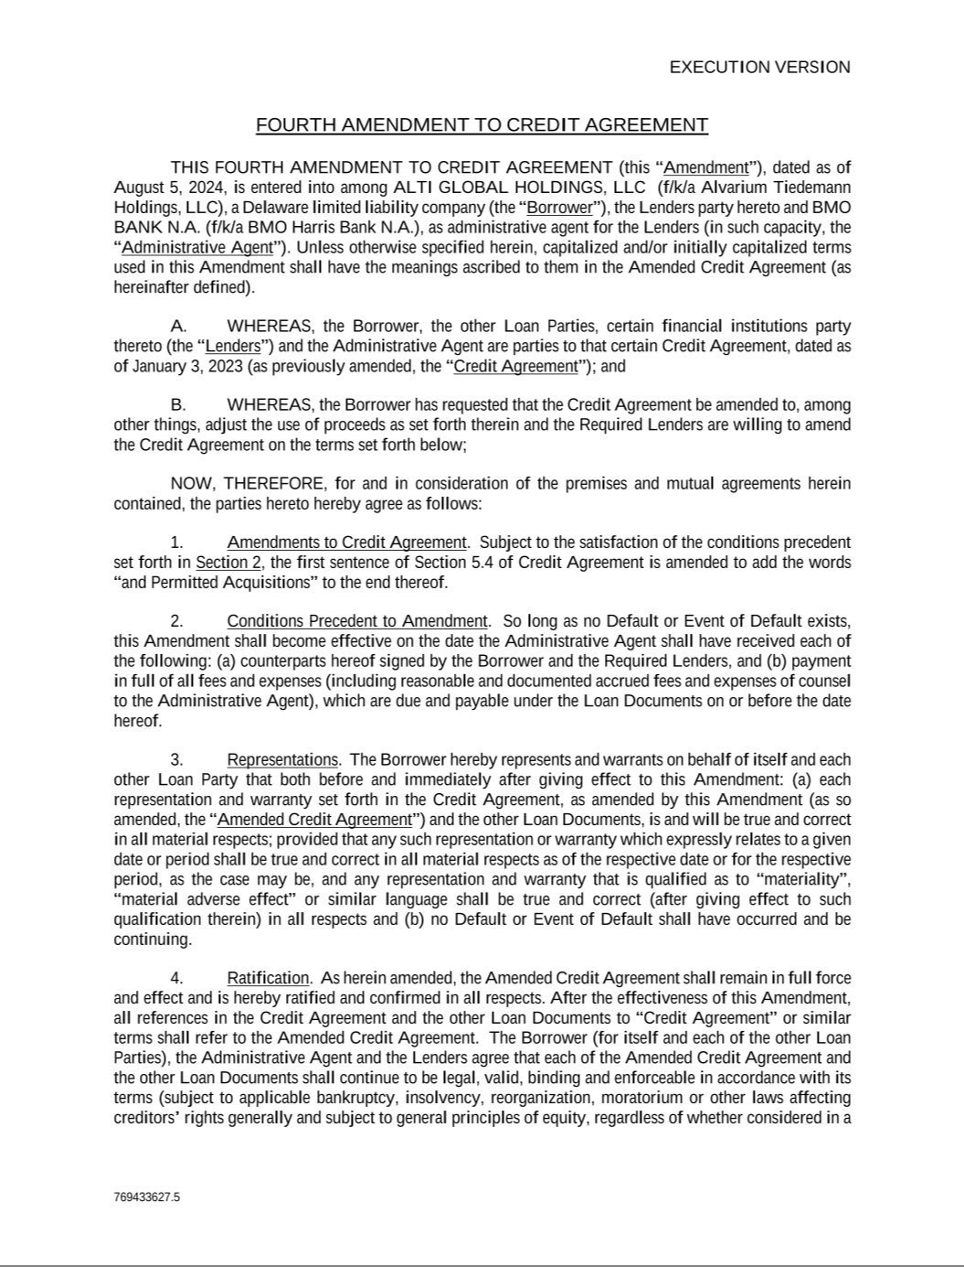

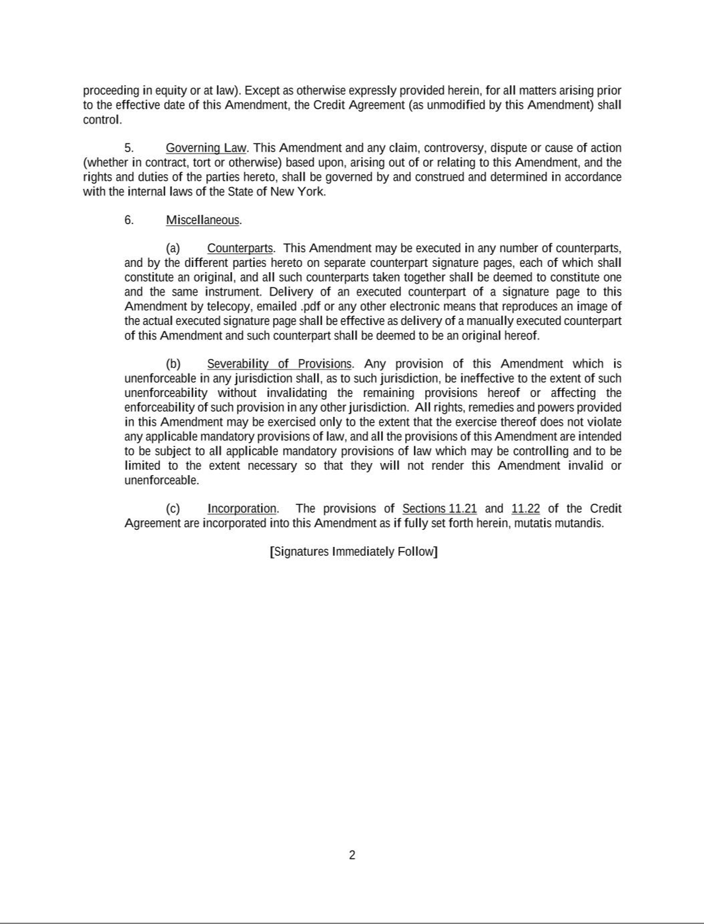





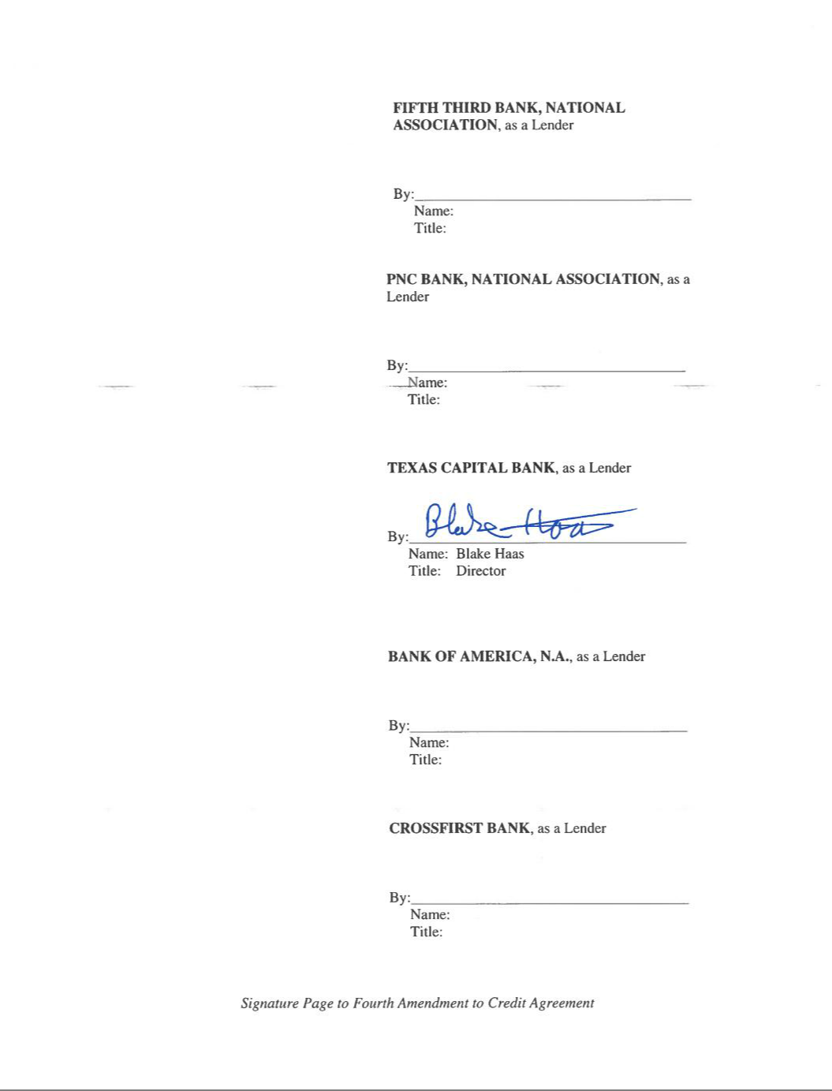

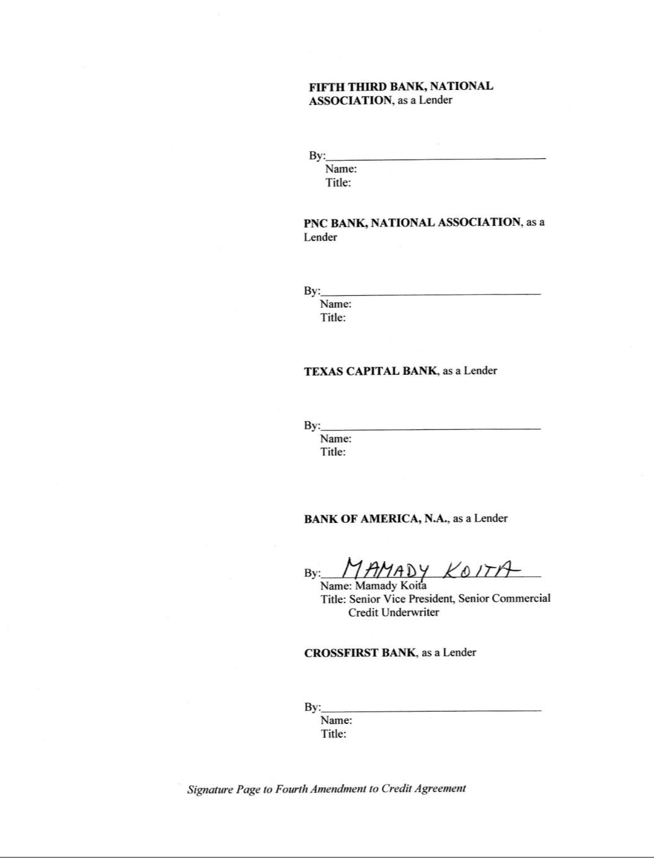

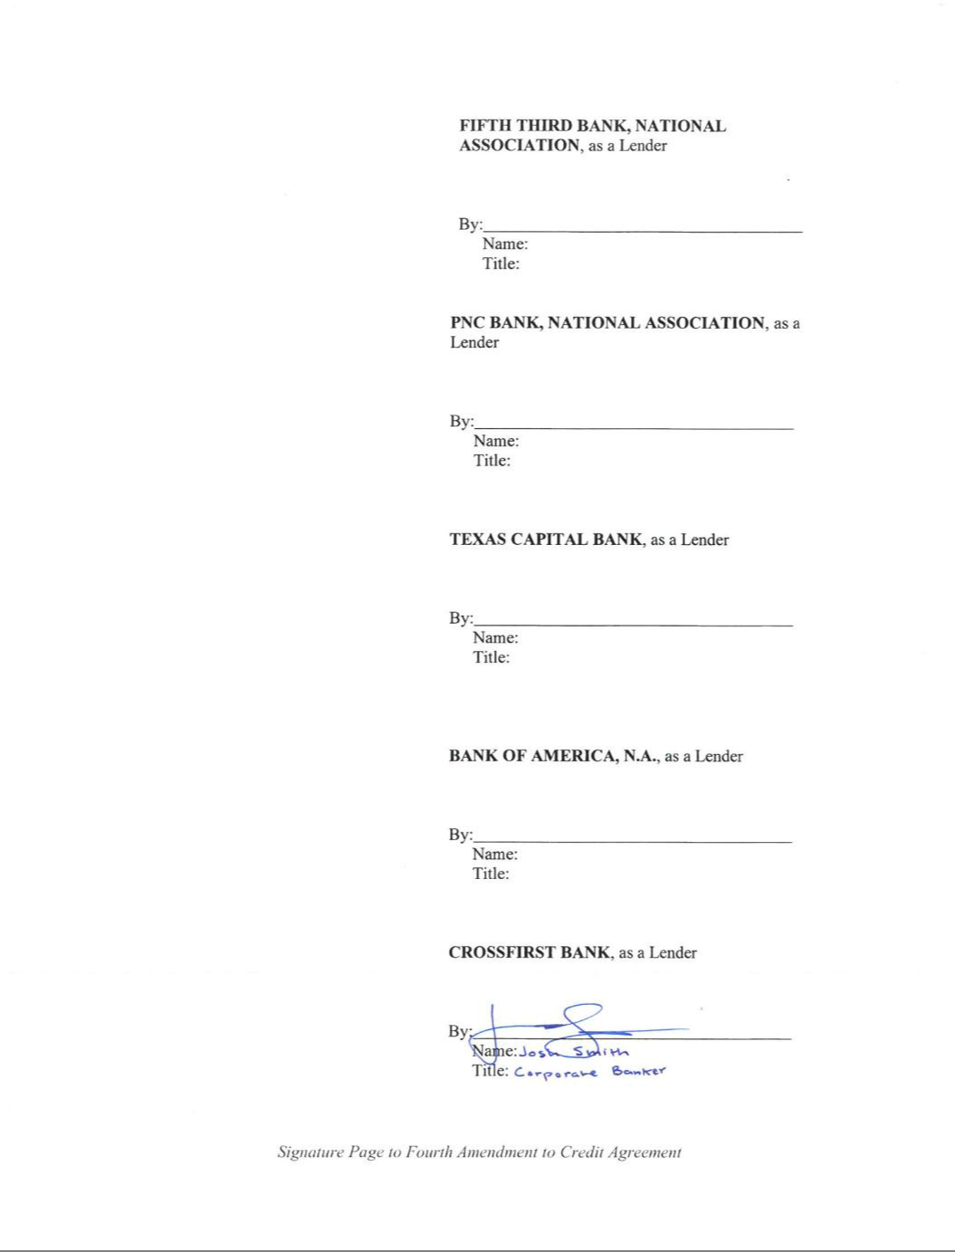



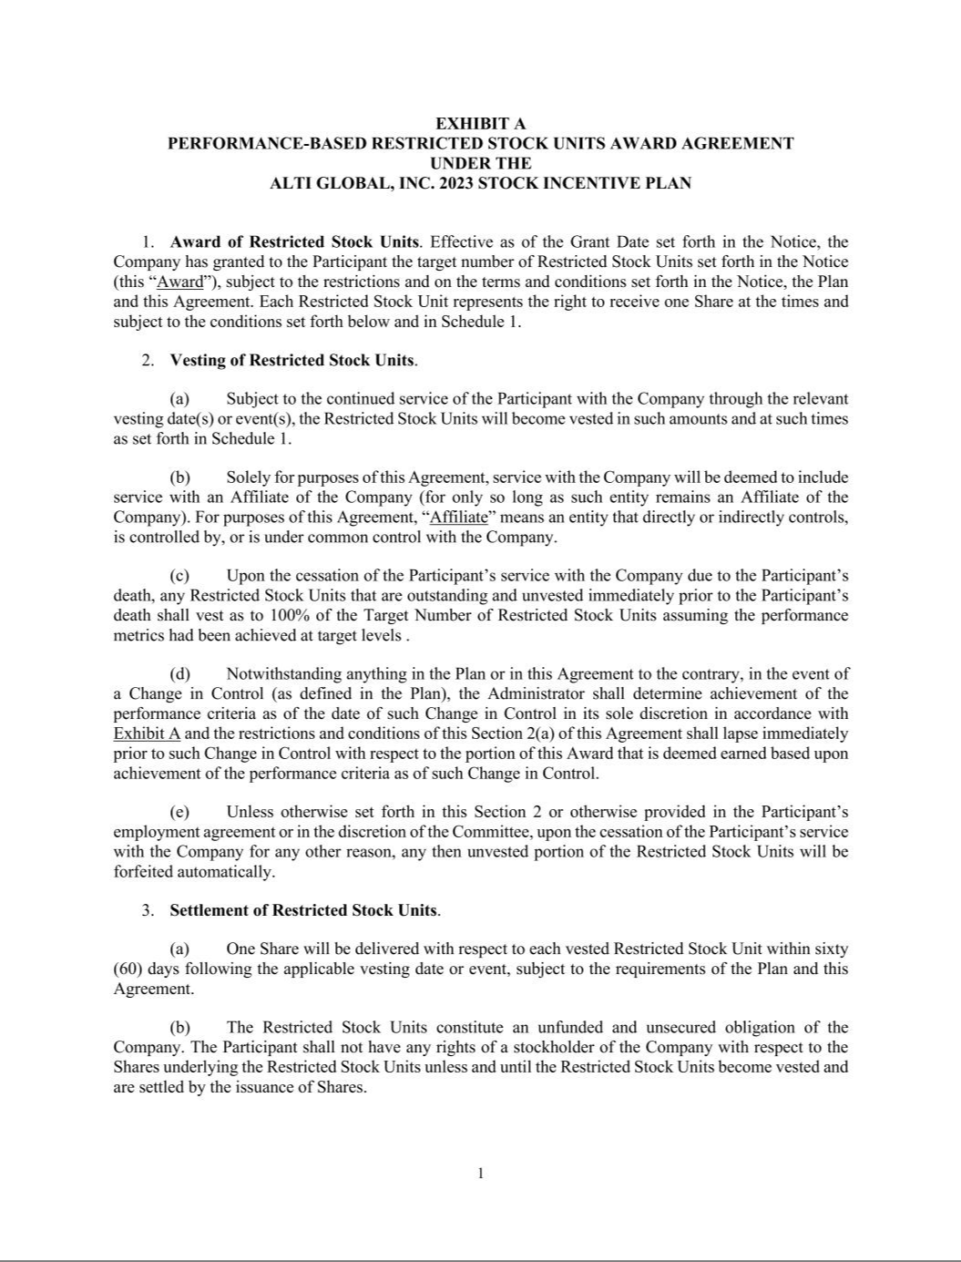

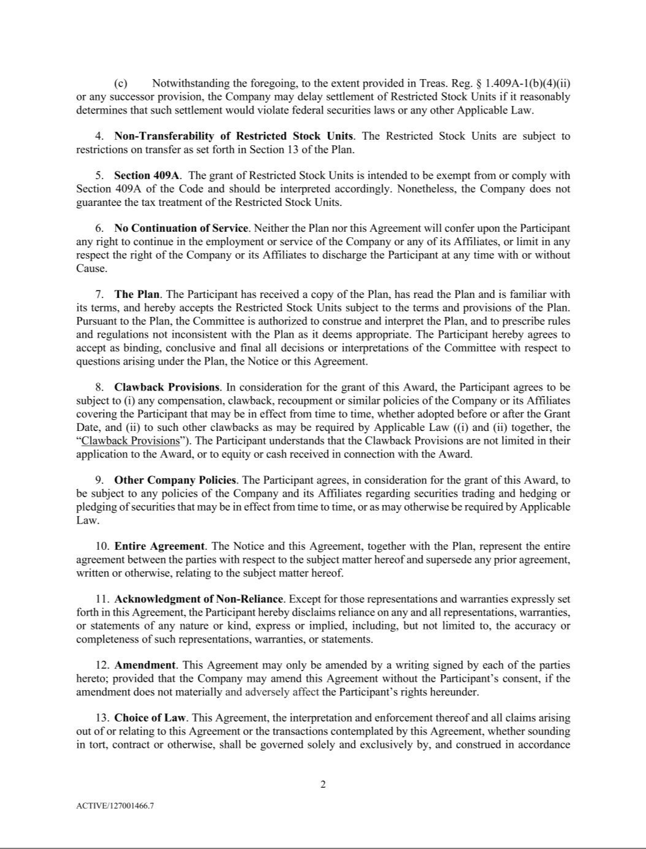

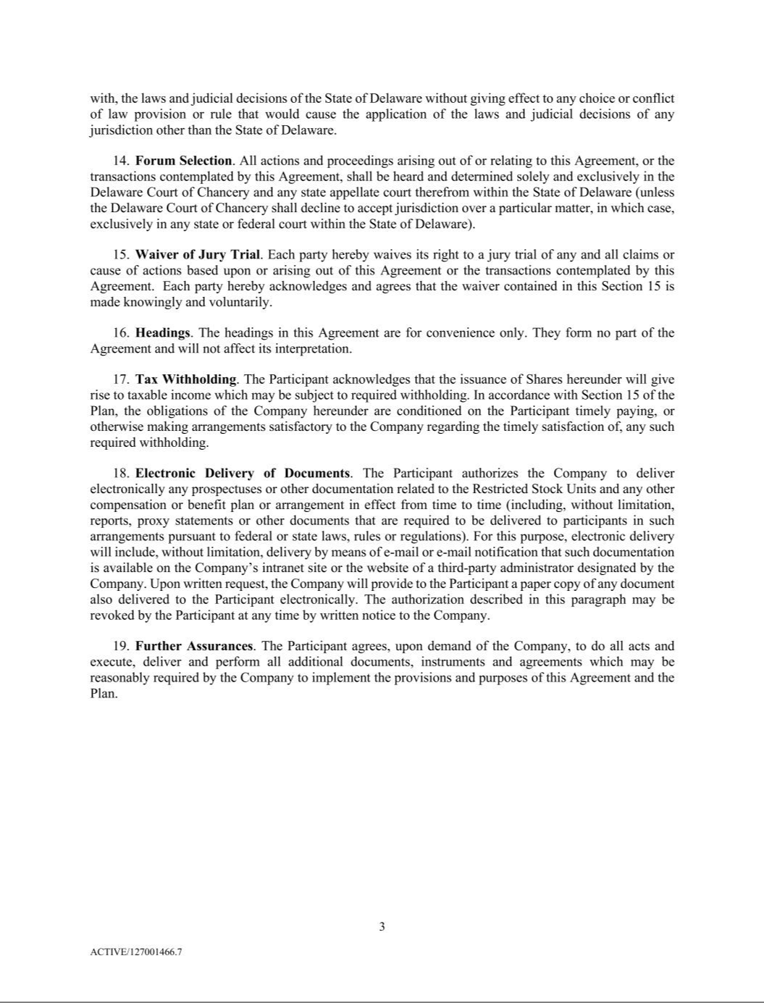

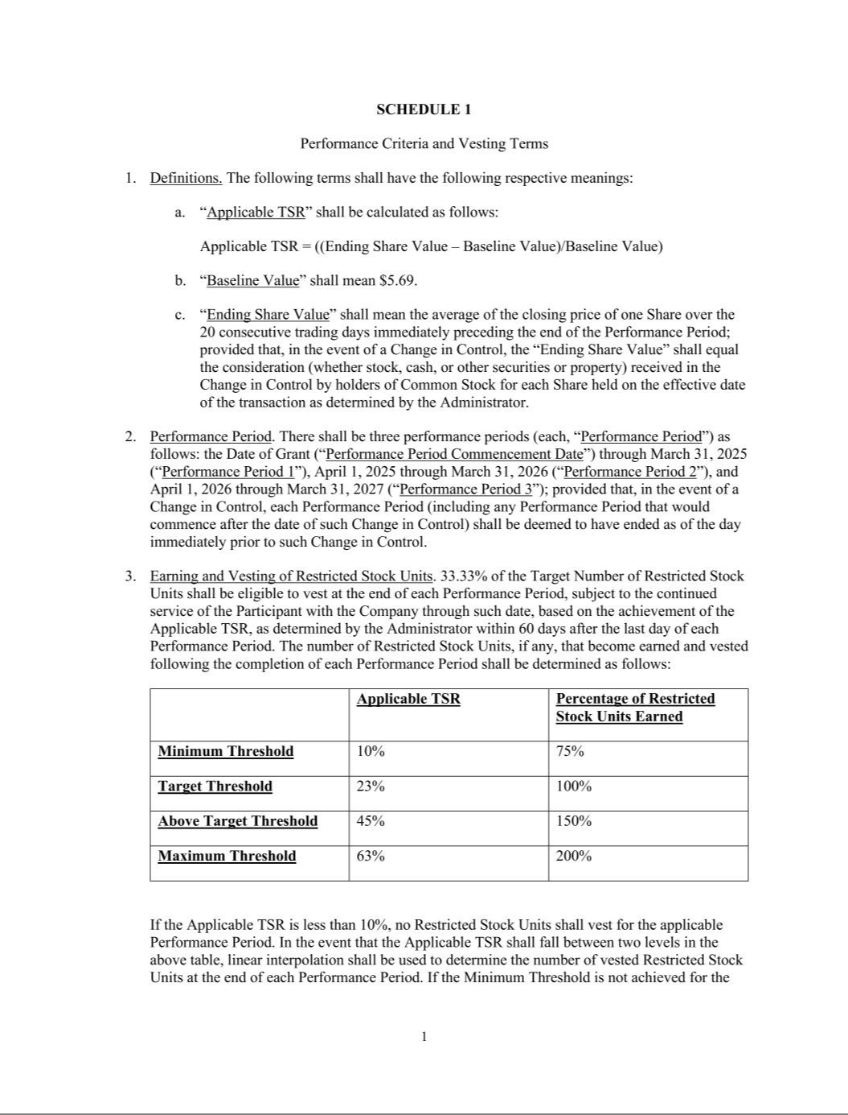



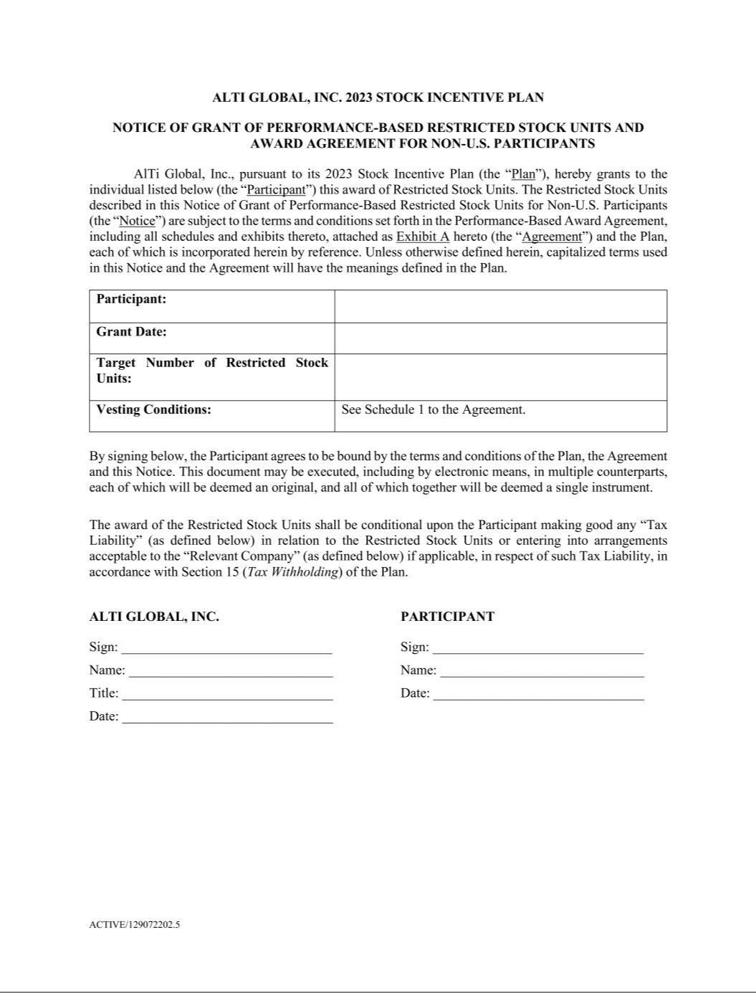

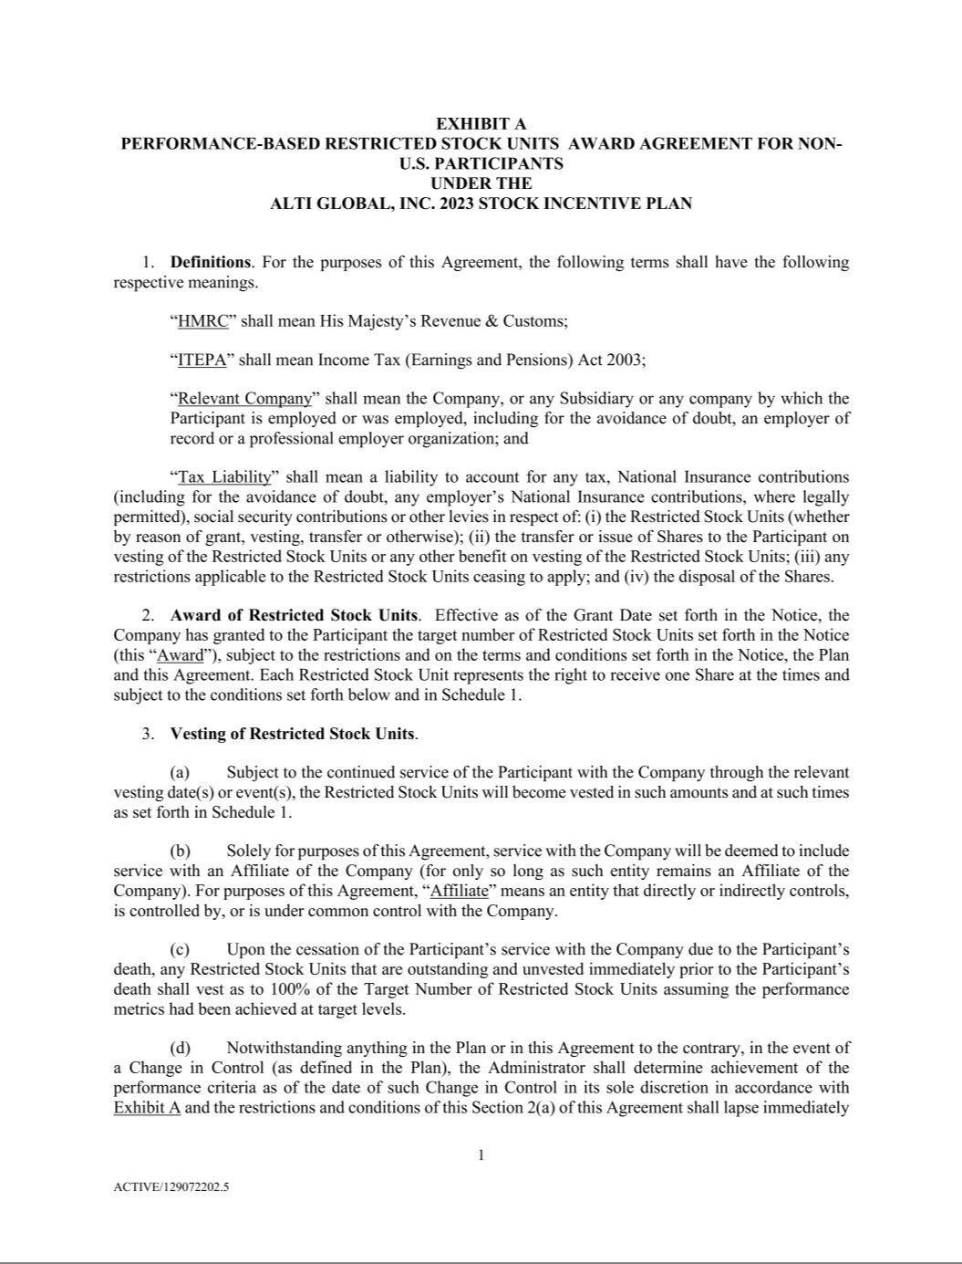

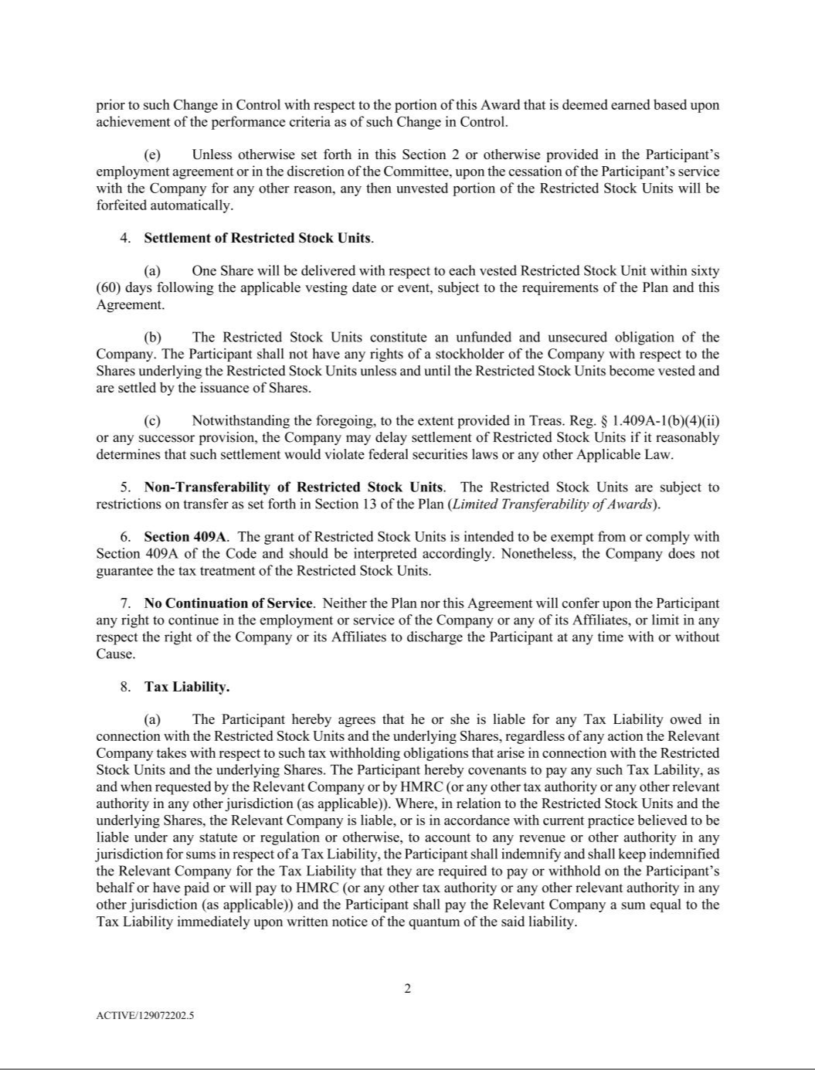

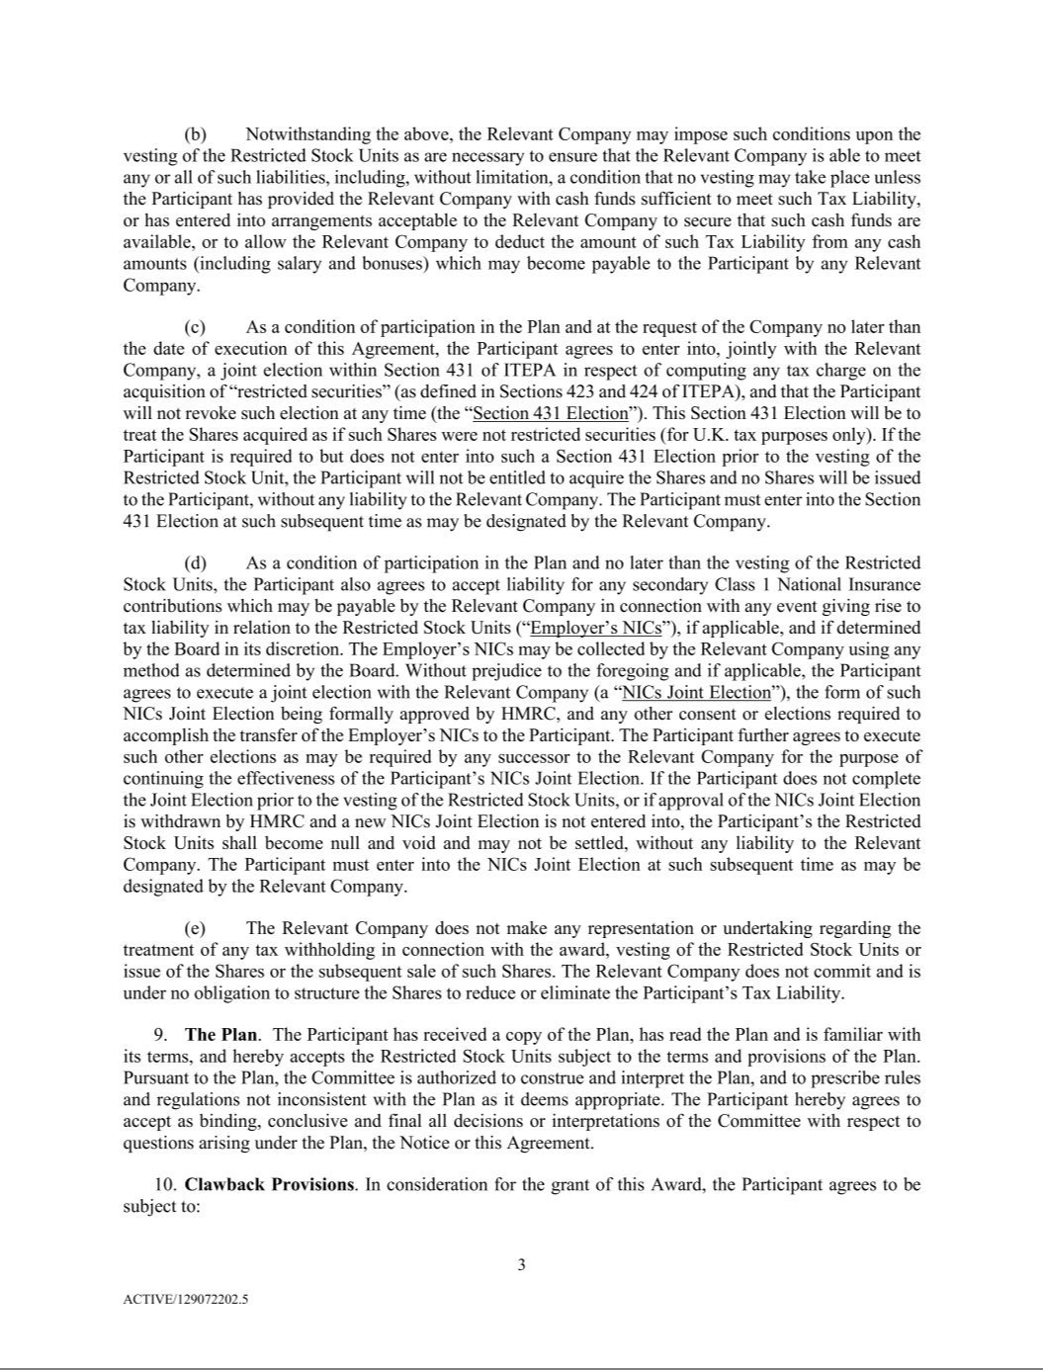

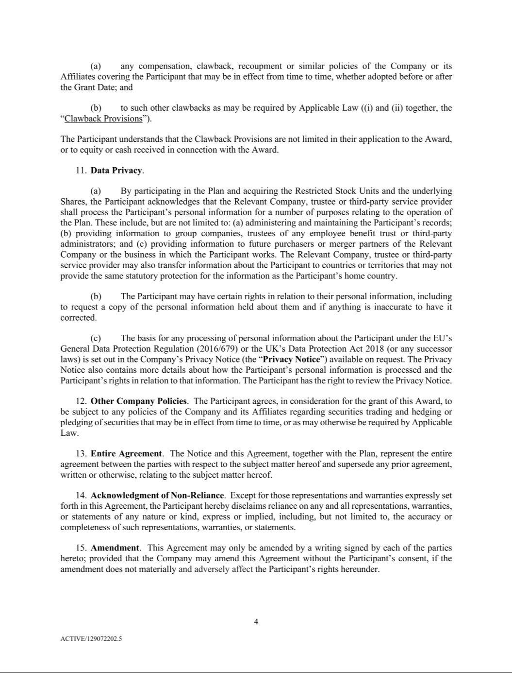

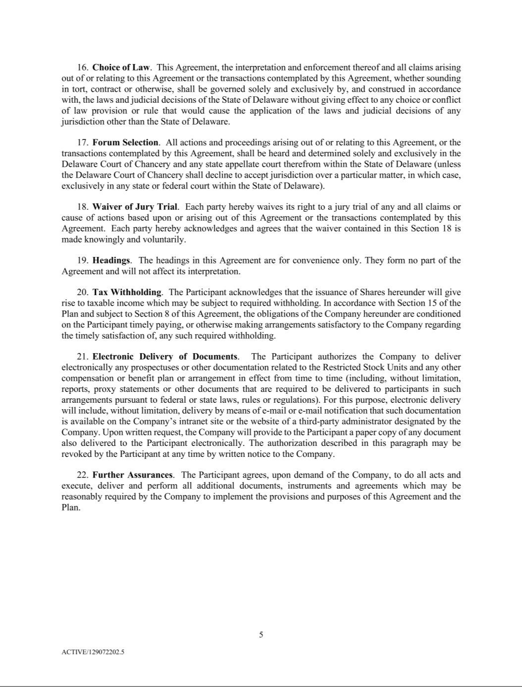

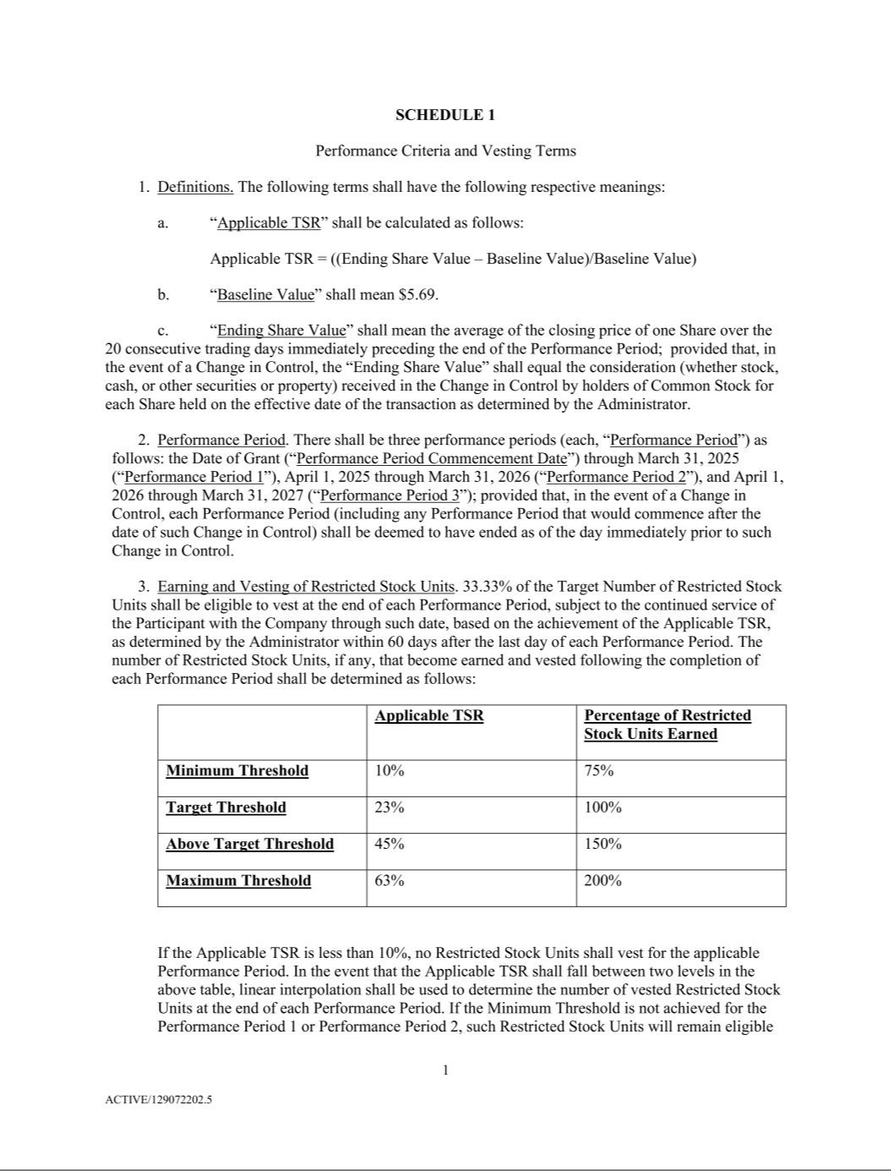



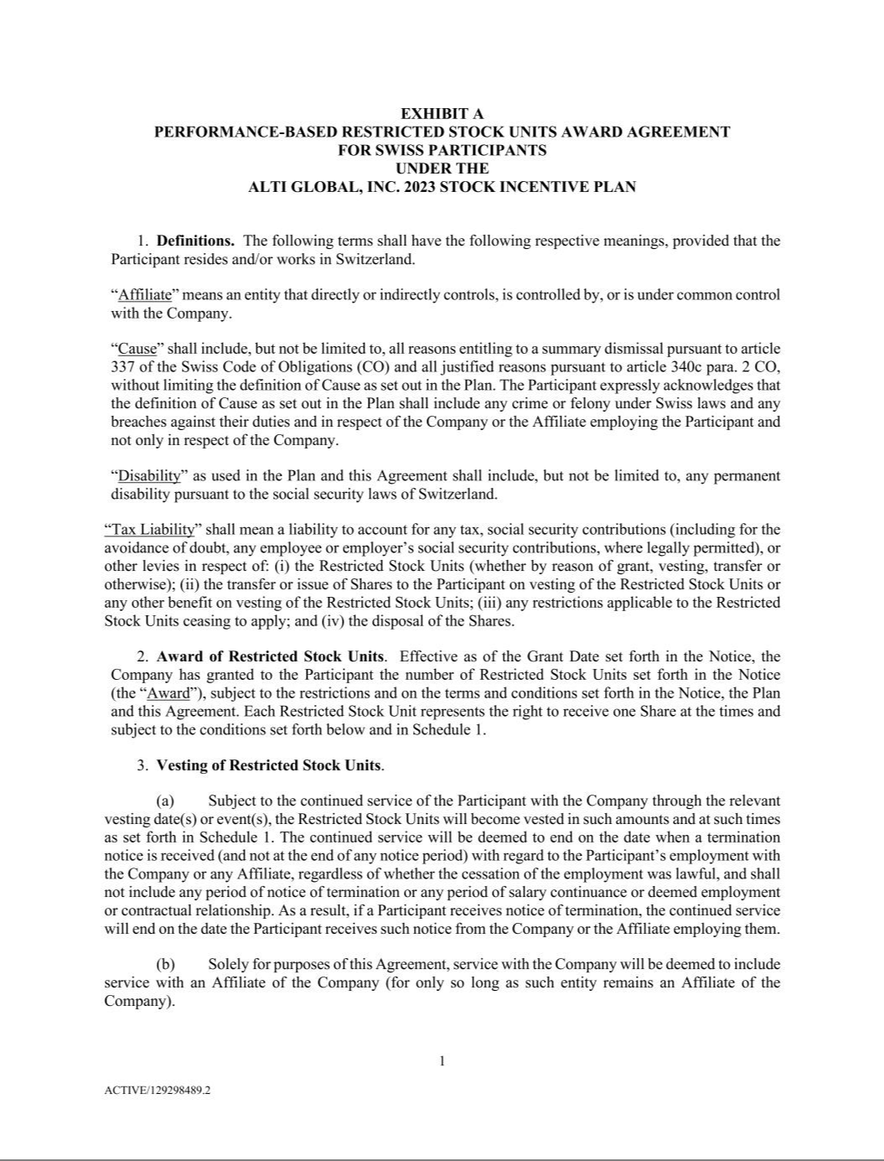

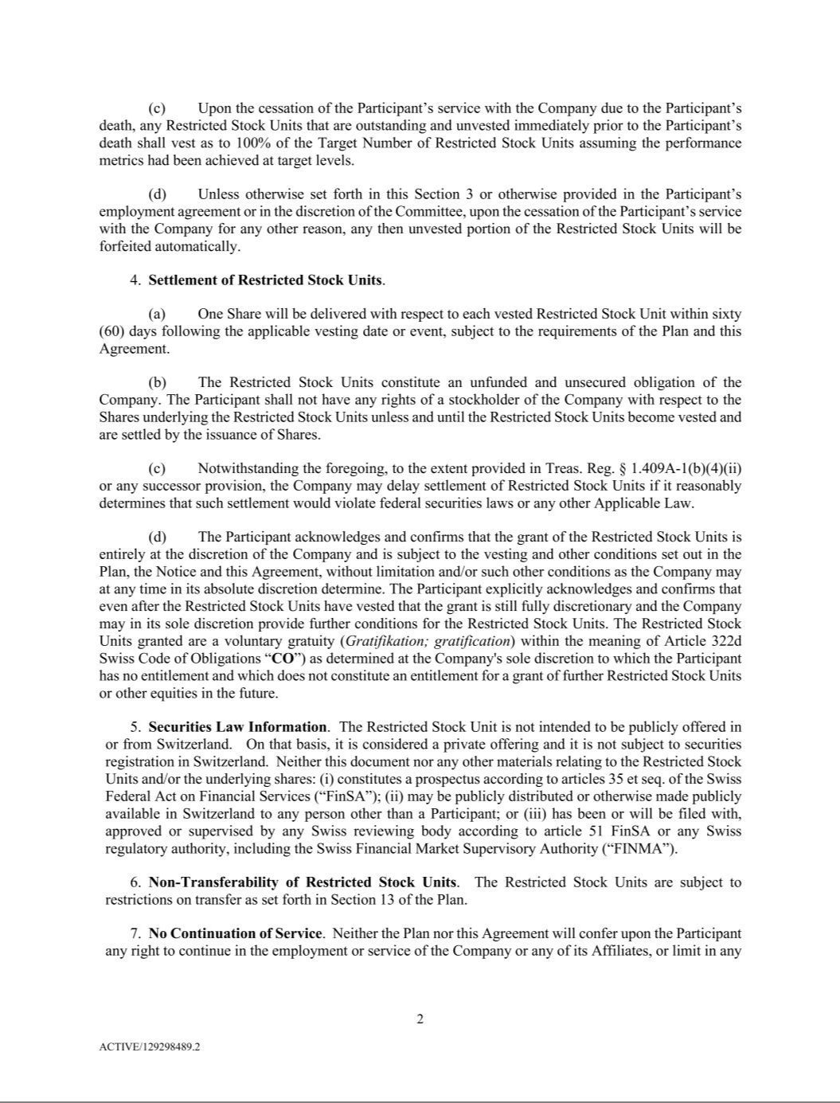

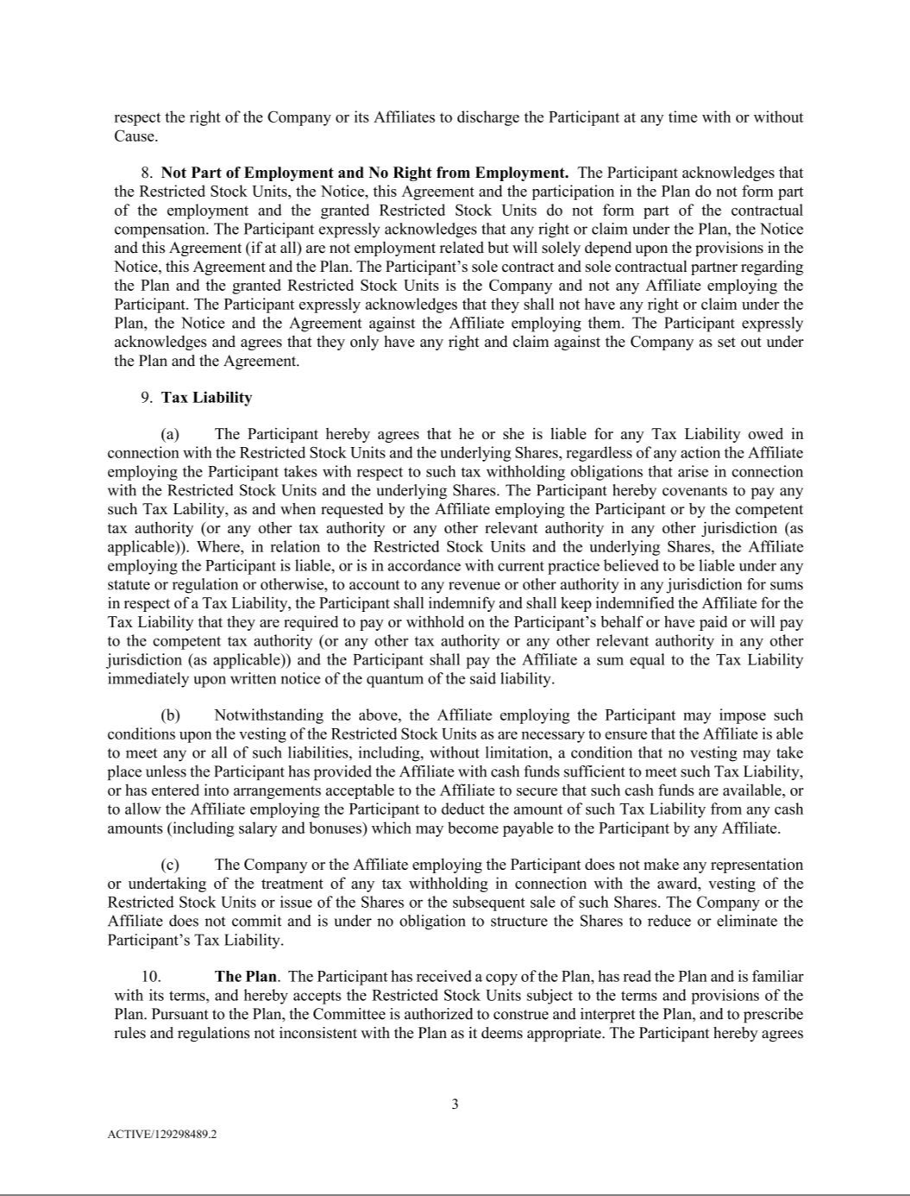

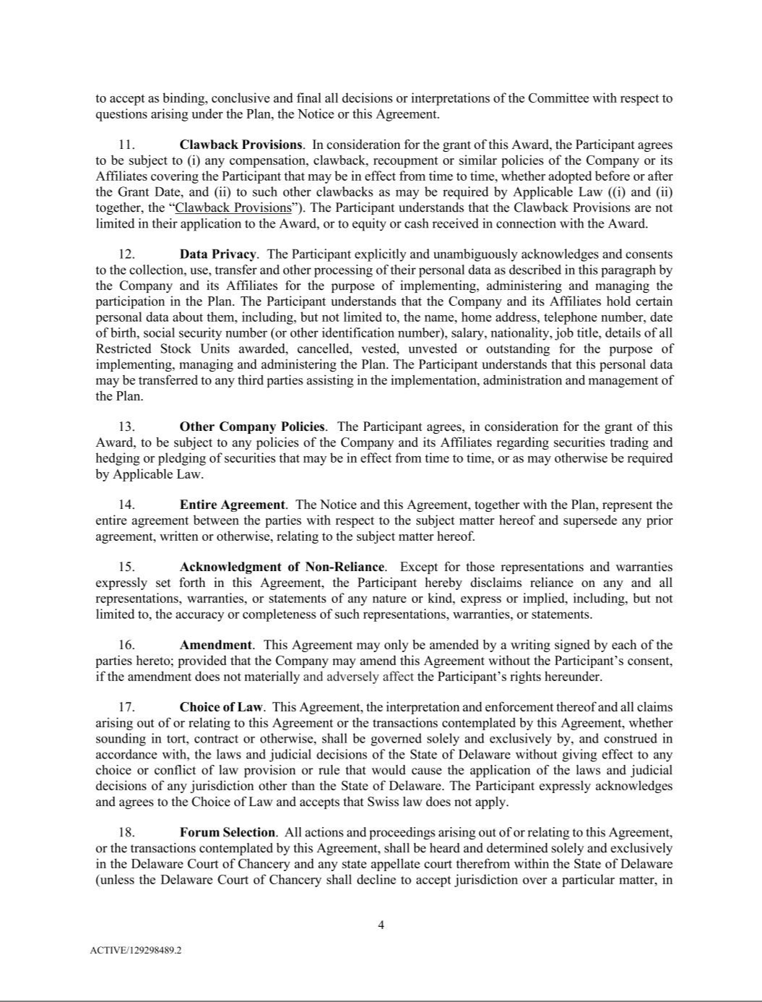

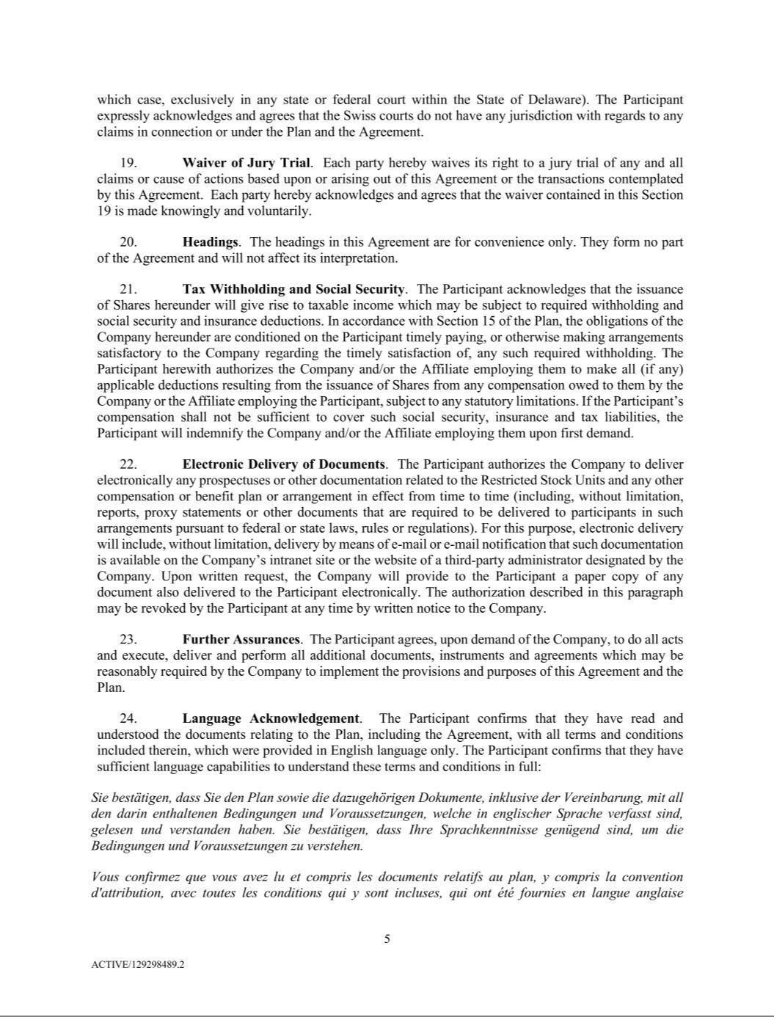



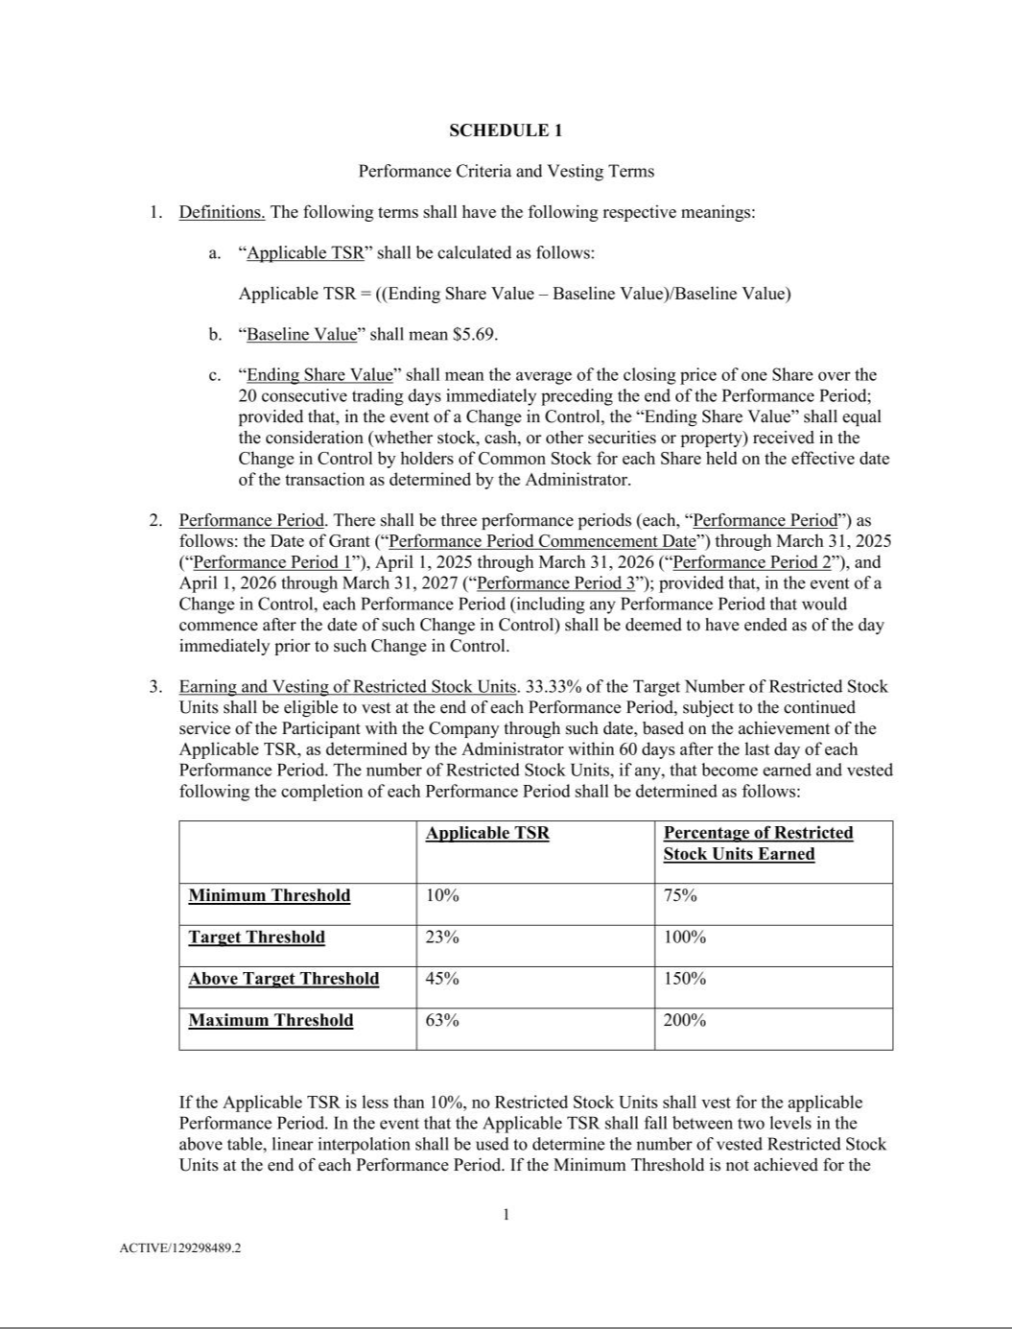



EXHIBIT 31.1

CERTIFICATION OF CHIEF EXECUTIVE OFFICER
PURSUANT TO RULES 13a-14(a) AND 15(d)-14(a) UNDER THE SECURITIES EXCHANGE ACT OF 1934,

AS ADOPTED PURSUANT TO SECTION 302 OF THE SARBANES-OXLEY ACT OF 2002

I, Michael Tiedemann, certify that:

- I have reviewed this quarterly report on Form 10-Q of AlTi Global, Inc.;

- Based on my knowledge, this report does not contain any untrue statement of a material fact or omit to state a material fact necessary to make the statements made, in light of the circumstances under which such statements were made, not misleading with respect to the period covered by this report;

- Based on my knowledge, the financial statements, and other financial information included in this report, fairly present in all material respects the financial condition, results of operations and cash flows of the registrant as of, and for, the periods presented in this report;

- The registrant’s other certifying officer and I are responsible for establishing and maintaining disclosure controls and procedures (as defined in Exchange Act Rules 13a-15(e) and 15d-15(e)) and internal control over financial reporting (as defined in Exchange Act Rules 13a-15(f) and 15d-15(f)) for the registrant and have:

  - Designed such disclosure controls and procedures, or caused such disclosure controls and procedures to be designed under our supervision, to ensure that material information relating to the registrant, including its consolidated subsidiaries, is made known to us by others within those entities, particularly during the period in which this report is being prepared;

  - Designed such internal control over financial reporting, or caused such internal control over financial reporting to be designed under our supervision, to provide reasonable assurance regarding the reliability of financial reporting and the preparation of financial statements for external purposes in accordance with generally accepted accounting principles;

  - Evaluated the effectiveness of the registrant’s disclosure controls and procedures and presented in this report our conclusions about the effectiveness of the disclosure controls and procedures, as of the end of the period covered by this report based on such evaluation; and

  - Disclosed in this report any change in the registrant’s internal control over financial reporting that occurred during the registrant’s most recent fiscal quarter (the registrant’s fourth fiscal quarter in the case of an annual report) that has materially affected, or is reasonably likely to materially affect, the registrant’s internal control over financial reporting; and

- The registrant’s other certifying officer and I have disclosed, based on our most recent evaluation of internal control over financial reporting, to the registrant’s auditors and the audit committee of the registrant’s board of directors (or persons performing the equivalent functions):

  - All significant deficiencies and material weaknesses in the design or operation of internal control over financial reporting which are reasonably likely to adversely affect the registrant’s ability to record, process, summarize and report financial information; and

  - Any fraud, whether or not material, that involves management or other employees who have a significant role in the registrant’s internal control over financial reporting.

Date: August 9, 2024

/s/ Michael Tiedemann

Michael Tiedemann
Chief Executive Officer

(Principal Executive Officer)

EXHIBIT 31.2

CERTIFICATION OF CHIEF FINANCIAL OFFICER
PURSUANT TO RULES 13a-14(a) AND 15(d)-14(a) UNDER THE SECURITIES EXCHANGE ACT OF 1934,

AS ADOPTED PURSUANT TO SECTION 302 OF THE SARBANES-OXLEY ACT OF 2002

I, Stephen Yarad, certify that:

- I have reviewed this quarterly report on Form 10-Q of AlTi Global, Inc.;

- Based on my knowledge, this report does not contain any untrue statement of a material fact or omit to state a material fact necessary to make the statements made, in light of the circumstances under which such statements were made, not misleading with respect to the period covered by this report;

- Based on my knowledge, the financial statements, and other financial information included in this report, fairly present in all material respects the financial condition, results of operations and cash flows of the registrant as of, and for, the periods presented in this report;

- The registrant’s other certifying officer and I are responsible for establishing and maintaining disclosure controls and procedures (as defined in Exchange Act Rules 13a-15(e) and 15d-15(e)) and internal control over financial reporting (as defined in Exchange Act Rules 13a-15(f) and 15d-15(f)) for the registrant and have:

  - Designed such disclosure controls and procedures, or caused such disclosure controls and procedures to be designed under our supervision, to ensure that material information relating to the registrant, including its consolidated subsidiaries, is made known to us by others within those entities, particularly during the period in which this report is being prepared;

  - Designed such internal control over financial reporting, or caused such internal control over financial reporting to be designed under our supervision, to provide reasonable assurance regarding the reliability of financial reporting and the preparation of financial statements for external purposes in accordance with generally accepted accounting principles;

  - Evaluated the effectiveness of the registrant’s disclosure controls and procedures and presented in this report our conclusions about the effectiveness of the disclosure controls and procedures, as of the end of the period covered by this report based on such evaluation; and

  - Disclosed in this report any change in the registrant’s internal control over financial reporting that occurred during the registrant’s most recent fiscal quarter (the registrant’s fourth fiscal quarter in the case of an annual report) that has materially affected, or is reasonably likely to materially affect, the registrant’s internal control over financial reporting; and

- The registrant’s other certifying officer and I have disclosed, based on our most recent evaluation of internal control over financial reporting, to the registrant’s auditors and the audit committee of the registrant’s board of directors (or persons performing the equivalent functions):

  - All significant deficiencies and material weaknesses in the design or operation of internal control over financial reporting which are reasonably likely to adversely affect the registrant’s ability to record, process, summarize and report financial information; and

  - Any fraud, whether or not material, that involves management or other employees who have a significant role in the registrant’s internal control over financial reporting.

Date: August 9, 2024

/s/ Stephen Yarad

Stephen Yarad
Chief Financial Officer
(Principal Financial Officer and
Principal Accounting Officer)

EXHIBIT 32.1

CERTIFICATION PURSUANT TO
18 U.S.C. SECTION 1350
AS ADOPTED PURSUANT TO
SECTION 906 OF THE SARBANES-OXLEY ACT OF 2002

In connection with the Quarterly Report of AlTi Global, Inc. (the “Company”) on Form 10-Q for the quarterly period ended June 30, 2024, as filed with the Securities and Exchange Commission (the “Report”), I, Michael Tiedemann, Chief Executive Officer of the Company, certify, pursuant to 18 U.S.C. §1350, as added by §906 of the Sarbanes -Oxley Act of 2002, that:

- The Report fully complies with the requirements of Section 13(a) or 15(d) of the Securities Exchange Act of 1934; and

- To my knowledge, the information contained in the Report fairly presents, in all material respects, the financial condition and results of operations of the Company as of and for the period covered by the Report.

Dated: August 9, 2024

/s/ Michael Tiedemann

Michael Tiedemann
Chief Executive Officer
(Principal Executive Officer)

EXHIBIT 32.2

CERTIFICATION PURSUANT TO
18 U.S.C. SECTION 1350
AS ADOPTED PURSUANT TO
SECTION 906 OF THE SARBANES-OXLEY ACT OF 2002

In connection with the Quarterly Report of AlTi Global, Inc. (the “Company”) on Form 10-Q for the quarterly period ended June 30, 2024, as filed with the Securities and Exchange Commission (the “Report”), I, Stephen Yarad, Chief Financial Officer of the Company, certify, pursuant to 18 U.S.C. §1350, as added by §906 of the Sarbanes-Oxley Act of 2002, that:

- The Report fully complies with the requirements of Section 13(a) or 15(d) of the Securities Exchange Act of 1934; and

- To my knowledge, the information contained in the Report fairly presents, in all material respects, the financial condition and results of operations of the Company as of and for the period covered by the Report.

Dated: August 9, 2024

/s/ Stephen Yarad

Stephen Yarad
Chief Financial Officer
(Principal Financial Officer and

Principal Accounting Officer)

